EnviroSense – CSIDC Competition 2005
Group #89

By
Fernando Castro 100167236
Jason Prince 100266352
Kevin Friesen 100306340
Stephanie Cox 100306423

Supervisor: Professor Gabriel Wainer

A report submitted in partial fulfillment of the requirements
of SYSC 4907 Engineering Project

Department of Systems and Computer Engineering
Faculty of Engineering
Carleton University

April 8, 2005

Abstract
This project was carried out in accordance with the CSIDC competition of 2005 and the guidelines for the fourth year engineering project for Systems and Computer Engineering at Carleton University. The theme for the CSIDC competition is “Going Beyond the Boundaries”, and requires that the system created should be innovative, original and useful to society. With this in mind, the team proposed the design and implementation of a system, EnviroSense, to assist people with hearing-impairments in obtaining information about the sounds present in their environment.

EnviroSense is used to store information about known sounds that are of importance to the user and to alert the user when one of those sounds occurs. When the device is in operation and a sound occurs, it is analyzed and compared against a database of known sounds. If a matching sound is found, then the user is informed via visual feedback that a particular sound has occurred. If the sound is not in the database, the system goes into stand-by state until it is again triggered into action by the detection of a new sound. The database of recognized sounds is programmable by the user so they may add or remove sounds as needed.

The idea behind the project was to create a device that could be implemented using a PDA and some means to provide feedback to the user. Our team was able to implement a prototype using a PC with Matlab software. While EnviroSense works well under varying levels of background noise there are some limitations to the system. Nevertheless, the device could be of immediate benefit to a hearing-impaired person. Future implementations of the device could be done using portable devices such as a DSP chip and a PDA, further enhancing the usability of the system by making it more portable.

Acknowledgements

We would like to thank the following people for their assistance and support during this project: Professor G. Wainer for his guidance and support; Professor R. Dansereau for his assistance and explanations of some of the concepts behind the Matlab functions pwelch and pyulear, signal identification and the Fast Fourier Transform (FFT); Professor A. Chan for his assistance in clarifying how normalized radial frequency used by the FFT can be mapped to the corresponding analog frequency value; and Mr. T. Fraser, B.Eng., for his assistance and input during the development of the sound analysis function.
Table of Contents

1 Introduction 2
1.1 Problem Motivation 2
1.2 Problem Statement 2
1.3 Proposed Solution 3
1.4 Accomplishments 3
1.5 Overview of Report 5
2 Background 6
3 System Design 10
3.1 Initial Work and Methodology 10
3.2 System Overview 11
3.2.1 Sound Acquisition 12
3.2.2 Sound Analysis 14
3.2.3 Sound Comparison 15
3.2.4 Data Storage and Flow 21
3.2.5 Graphical User Interface 23
3.2.6 Modes of Operation 27
3.2.7 Final Product 31
3.3 Testing 32
3.4 Performance 33
3.5 Compromises and Reasoning 34
3.6 Future Implementation 35
4 Conclusion 36
4.1 Summary of Accomplishments 36
4.2 Recommendations 36
5 References 38
Appendix 39
Appendix A – Acronyms 39

List of Figures

Figure 2.1 pwelch analysis of fire alarm signal. 8
Figure 3.1 Learning Mode Block DiagramFigure 11
Figure 3.2 Listening Mode Block Diagram. 12
Figure 3.3 Sound Capture through use of Trigger. 13
Figure 3.4 Main Screen Box 23
Figure 3.5 Record Sound Name Box 24
Figure 3.6 Recording Box 24
Figure 3.7 Recording 2 Box 25
Figure 3.8 Recorded Successfully Box 25
Figure 3.9 Recorded Unsucessfully Box 25
Figure 3.10 Alert Box 26
Figure 3.11 Remove Sound Name Box 26
Figure 3.12 List of Sounds Box 27
Figure 3.13 EnviroSense Use-Case Diagram 28
Figure 3.14 Record Sequence Diagram (Learning). 29
Figure 3.15 Acquire_sound Use-Case Diagram 30
Figure 3.16 Listening Sequence Diagram. 31

List of Tables

Table 1.1 Summary of Accomplishments 4
Table 3.1 Comparison of Algorithms. 20
Table 3.2 Response Time of the System at Varying Sampling Frequencies. 33

Introduction
This fourth year project was in coherence with the IEEE competition, the Computer Society International Design Competition (CSIDC 2005). The theme for this year’s competition was “Going Beyond the Boundaries”. We were to design and implement a computer-based solution to a real-world problem. The solution had to benefit society in some way. The competition had reports that were due throughout the year, in which teams that had no chance in going to the finals were weeded out. The major judging criterion was originality, quality and creativity.

Problem Motivation
The primary motivation behind our system was the CSIDC theme of “Going Beyond the Boundaries.” A common theme in much of our brainstorming for ideas was sound recognition, so from the desire to do a sound recognition related project we looked at how we could use sound recognition to help society. By helping hearing-impaired persons to recognize when important environmental sounds occur we can help to increase their quality of life and their sense of security.

Problem Statement
The major problem addressed by this project is that hearing-impaired people are unable to acquire important environmental information. By using computers it is possible for them to be notified of the information that they would like to be informed of. Specifically, this project addresses how computers can be made to compare sounds to distinguish if they are from the same source, or a different source. It also addresses the problem that each person has a different set of sounds that are important to him/her. Finally, the system needs to be simple to use.

Proposed Solution
Using MATLAB and its DSP toolbox, sounds can be analyzed and then compared for similar characteristics. Users can record sounds that they want to be informed of, making the system user-specific. Then, using an algorithm for analyzing and comparing sounds, MATLAB will analyse incoming sounds and compare them with those stored by the user. MATLAB also contains GUI functionality, so the user will interact with the GUI to make the system easy to use. When important sounds are detected a notification box appears on the screen.

Accomplishments
The end-product of this project was a prototype of a device that could be used to assist hearing-impaired people attain sound information about their environment. The device was taught to recognize sounds and alert the user whenever any of the sounds occured. Alerts were in the form of a visual cue on a monitor, for the prototype.

As a result of taking on this project, the team was able to become familiar with Matlab and its associated tools to perform data capture, sound and spectral analysis, implement a sound database, create a graphical user interface, and implement the necessary functions that were required by the system. Table 1.1 provides a more detailed overview of individual accomplishments.
Table 1.1 Summary of Accomplishments
Accomplishment | Description | Stephanie | Kevin | Jason | Fernando
Research devices |  | X | X | X | X
Device specifications |  | X | X | X | X
System testing/optimization |  | X | X | X | X
Block diagrams |  | X | X
System integration |  | X | X | X
Use case/sequence diagrams |  | X
Sound comparison | Matlab functions: comparewelchs, how_many_match, CompareToDatabase | X
Sound acquisition | Matlab functions:  Acquire_sound, record_sound | X
Learning/listening modes | Matlab functions: learning1, learning2, learncompare, listening, | X
Sound analysis | Matlab function: analyze | X |  |  | X
Database functions | Matlab functions: addsig, removesound, nameretrieve, getsize, convertname, shortretrieve, longretrieve, listsounds, removename, warninglog |  | X
GUI | Matlab functions: listening2, recording, recording2, recnotsuccess, mainscreen, listeningbox, recsuccess, soundname, warningbox |  |  | X
Final Report | Abstract | X | X |  | X
Final Report | Acknowledgements |  |  |  | X
Final Report | 1 Introduction |  |  | X
Final Report | 1.1 Problem motivation |  | X
Final Report | 1.2 Problem statement | X
Final Report | 1.3 Proposed solution | X
Final Report | 1.4 Accomplishments |  |  |  | X
Final Report | 1.5 Overview of rest of report |  |  |  | X
Final Report | 2 Background | X | X | X | X
Final Report | 3.1 Initial Work and Methodology |  |  | X
Final Report | 3.2 System overview |  | X
Final Report | 3.2.1 Sound acquisition | X
Final Report | 3.2.2 Sound analysis |  |  |  | X
Final Report | 3.2.3 Sound comparison | X
Final Report | 3.2.4 Data storage and data flow |  | X
Final Report | 3.2.5 GUI |  |  | X
Final Report | 3.2.6 Modes of Operation | X
Final Report | 3.2.7 Final product |  |  |  | X
Final Report | 3.3 Testing |  |  |  | X
Final Report | 3.4 Performance |  | X
Final Report | 3.5 Compromises & reasoning |  | X
Final Report | 3.6 Future implementation |  |  | X
Final Report | 4 Conclusion |  |  | X
Final Report | 4.1 Summary of accomplishments | X
Final Report | 4.2 Recommendations |  | X

Overview of Report
The rest of this report is divided into the following sections: Background, System Design, and Conclusion. The background section outlines some principles of Digital Signal Processing, describes the Fast Fourier Transform and explains why Matlab is suitable for implementing the prototype. It also discusses basic sound recognition theory and describes the earlier work performed by the team prior to making the decision to implement EnviroSense.

The System Design section is subdivided into several sections focusing on the methodology, system overview, testing, performance, compromises and trade-offs, and future implementation on a PDA. The system structure is described in detail as are the algorithms used by the different functions. Sound analysis and comparison, and the graphical user interface are also discussed in detail.

The methodology section focuses on the project (EnviroSense) itself from a systems point of view. The system overview section focuses on sound acquisition, analysis and comparison, data storage and data flow, graphical user interface, modes of operation, and the system in its current implementation.

The conclusion section summarizes the accomplishments of the team and provides recommendations, and is followed by references and appendices.

Background

Digital Signal Processing, DSP, is the processing of analog signals by digital means. A signal in the form of an analog electric voltage or current is produced, for example, by a microphone and must first be converted into digital form before DSP techniques can be applied. DSP processing involves manipulating the digital data in order to obtain information that is desired. The processing can include filtering signals, elaborate or simple algorithms, Fourier analysis and many other data analysis techniques [1]. To obtain a digital signal the analog signal is sampled many times, and each of the samples together becomes the digital version of the analog signal. Shannon’s Sampling Theorem, also known as the Nyquist Criterion, is used in DSP to determine the sampling frequency that needs to be used. The theorem states that the sampling frequency must be at least twice the maximum frequency present in the signal [2]. If the criterion is not met, it is not possible for the analog signal to be reproduced from the digital signal, due to aliasing [2]. Aliasing is a false digital representation of an analog signal, which does not obey the Nyquist Criterion.

Fourier analysis and the Fast Fourier Transform FFT are used by the system to obtain important frequency components of sounds. Given a periodic, continuous-time signal, its spectrum can be easily generated by computing its Fourier series, which is a sum of sinusoids. It is also possible to express the frequency-domain of non-periodic signals in terms of the Fourier Transform [3]. The Fourier transform of a continuous-time signal is given by the following equation,
, where -∞ < ω < ∞, and ω = 2πf.

When using DSP techniques a different technique, known as the Discrete Fourier Transform or DFT, is used instead [4]. The DFT is discrete in both time and frequency, rather than continuous. The DFT uses a finite-length of a sampled signal, and evaluates the spectrum at a set of discrete frequencies [5]. Using the DFT we can compute a very good approximation of the Fourier transform of the signal and use it to analyze its spectrum. The DFT of a sample sequence x[n] is given by:

where k = 0,1,…,N-1, and X(k) is zero elsewhere.

The vector X contains a discrete version of the Fourier transform of the sequence x[n]. The Fast Fourier Transform or FFT is the name commonly given to a set of algorithms used to evaluate the DFT more efficiently. It is an important tool in digital signal processing and spectral analysis of signals and is used in this project to analyze sounds and extract significant frequency components. This process is described in section 3.2.2.

MATLAB was chosen as the environment to be used for this project, because it has such vast DSP capabilities. It has a Data Acquisition, DAQ, toolbox that enables sound acquisition through triggers. Using this toolbox, a trigger can be designed in any manner that the programmer wishes. MATLAB has a DSP toolbox that offers a variety of analysis capabilities for the sounds that are acquired. It is also capable of creating and saving text files, which allows for data storage when MATLAB is closed or the computer is turned off. It contains GUI capabilities that allow for the design of a simple user interface to MATLAB functions. Lastly, MATLAB has the ability to communicate with a serial port on a computer. This would allow control of external devices in order to interact with the user of the system. A vibration motor or blinking lights could be connected to the serial port such that when a sound is recognized MATLAB will send a signal to the serial port that will cause the motor to vibrate, or lights to blink.

There are two important functions offered in the DSP toolbox that are used in this project. The first is FFT, which computes the Fast Fourier Transform of a given signal, so that the system may obtain the frequency spectrum of a sound, as described above. Frequencies are important characteristics of sounds that the system uses for comparison purposes in order to detect sounds. The second function is pwelch, which is the most important function for sound recognition in the device. pwelch calculates an estimate of the power spectral density of a given signal [6]. This means that for the spectrum of frequencies being analyzed, it computes an estimate of the power curve. As an example, a plot of the pwelch function for a fire alarm is shown in Figure 2.1. Details of the workings of this function are not important for the project, however for further information consult the reference listed. What is important about the pwelch function is that it gives unique information about each sound, and we can compare pwelch information of two sounds in order to determine if the sounds are similar or not.

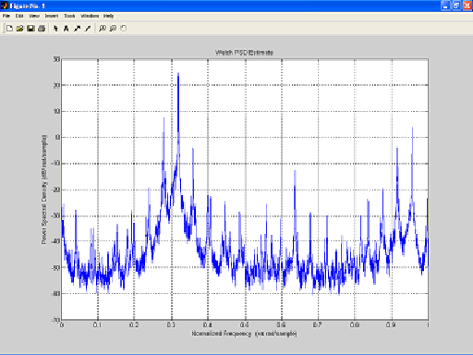
Figure 2.1 pwelch analysis of fire alarm signal.
This graph shows the power of the sound as it relates to the normalized radial frequency. For instance, in this signal there is a lot of power around 0.32Π.

Sound recognition is a relatively new field, and there is still much debate as to the best techniques. A few of the most significant challenges in using a computer to identify sounds are: large variations between different sound classes, sounds can be very ambiguous if they have no context, and noise can also mask the sound that we are trying to identify. Several different techniques have been used to attempt to identify sounds. For speech recognition Hidden Markov Models (HMM) is prominent, as well as Vector Quantization, and Artifical Neural Networks [7].

Vector quantization can be done easily in matlab by using the FFT to obtain the frequency components of a sound. In order to receive all sound audible to humans a sampling frequency of 44100 Hz should be used. The reason 44100 Hz is used, is because humans have a hearing range from about 20Hz – 20 kHz, so 44100 Hz is a little more than double 20kHz and thus satisfies the Nyquist criteria. Vector Quantization for non-speech sounds is fairly accurate (over 50%), but is not perfect so it is best to use this technique along with other techniques to improve accuracy [7].

Another technique that can be used is the analysis of the power spectrum of a sound. By obtaining the power spectrum of a sound one can easily convert this to a decibel scale. Obtaining the power spectrum of a sound can be done in Matlab using the Pwelch function. Using a decibel scale for identification makes recognition easier because the sound can be normalized, making it so that the sound can be identified at different volumes with relative ease [8].

System Design

Initial Work and Methodology
The project began with coming up with a number of possible ideas to design and implement. After establishing a list of ideas, we went to the internet and other resources to find which ideas were unique. When researching was completed, all of our ideas were narrowed down to four device choices. The four choices consisted of a portable water tester, icon glasses for the hearing impaired, a seizure detection device and a sound sensor device that would mute car stereos in response to certain sounds. Upon further research into the final four devices, we decided on the device that would sense sounds and alert the user, a hearing impaired person, of what the sounds were. Reasons for choosing this type of device were that we felt that with the resources available to us, we would be capable of solving this problem. The second reason for choosing this type of device was affordability. The cost of solving this problem could be kept to a minimum by implementing it on a desktop computer, which we had at our disposal, already.

The next step was to find software that could analyze and compare different sounds. We researched and found an open source software package by the name of PRAAT. We downloaded the software, compiled and experimented with it. After looking into the software further, we came to the conclusion that it was much more complex than what we needed for this application. It would be too time consuming to read and learn the vast amount of knowledge that went along with this software, so we turned elsewhere.

Matlab was then looked at for possible uses in this project. Since we had used Matlab before in our studies, and that Matlab had all the tools needed for our device including the GUI, we decided to use it. One of our constraints was that for this project, we would only implement it on a PC, keeping it small and simple to use. We broke the device into blocks, assigning different blocks to different group members for design and implementation. After we had a working prototype, we put it through different tests and optimization.

System Overview
The system is divided into two primary operation modes: listening and learning. The learning mode is used to add new sounds to be recognized by the system. The listening mode is used to detect the sounds that are currently stored in the system.

Refer to Figure 3.2 for a block diagram of the learning mode. When the user puts the system into learning mode they will be prompted to enter the name of the new sound they would like to record. Once the sound has been recorded the user is asked to record it again to ensure that the correct sound is being stored. The two recordings are compared using spectral and pwelch analysis, and then if they match the record is successful.

Record Sound
Analog to digital conversion
Spectral and pwelch analysis
Store frequency and pwelch info in database

Compare sounds
Unsuccessful compare: remove first sound from database

Record sound 2nd time
Analog to digital conversion
Spectral and pwelch analysis
Succesful compare: notify user

Figure 3.2 Learning Mode Block DiagramFigure
In learning mode each sound is recorded twice and compared to ensure that the proper sound has been stored in the database.

Refer to Figure 3.3 for a block diagram of the listening mode. In listening mode the system is in an idle state until a sound is received above a certain threshold in magnitude. Once such a sound is received the system converts the analog sound to a digital sound and does spectral analysis and PWELCH analysis. Next the compare function is used to compare the received sound with the sounds stored in the database. If the received sound matches one of the sounds in the database then the user is notified, otherwise the system goes back into idle mode until a new sound is received.

Receive Sound
Spectral and Pwelch Analysis
Convert analog sound to digital

Compare freq. and pwelch of sound received with those stored in database
Alert user or continue listening for sounds

Figure 3.3 Listening Mode Block Diagram.
In listening mode the system receives a sound and goes through the above sequence to compare the sound to the sounds in the database and alerts the user if necessary. It then continues on in listening mode until commanded to stop by the user.

Sound Acquisition

Sound Acquisition in Listening Mode
One of the significant problems faced was that we could not analyze all incoming sound over all time when the user requests the system to go into listening mode. To overcome this issue research was done to find a method of retrieving data through the use of a trigger in MATLAB, and what was found was the DAQ toolbox, which was discussed in section 2.

Using this toolbox a trigger was designed with a rising threshold of 4.7 mV (see Figure 3.4). This means that when an incoming sound creates a voltage of 4.7 mV in a microphone, and is rising, MATLAB will initiate the sound capture. The sound is captured for a total of two seconds; 0.5 seconds before the trigger to ensure that no information was missed, and 1.5 seconds after the trigger. MATLAB maintains a constant buffer of the microphone information even when a trigger has not occurred, so that when a trigger condition is met, it can save a short sample of the sound that has previously occurred. This enables the system to capture the 0.5 seconds of a recording that occurred before the trigger condition was met. A total sound capture of two seconds was found to be sufficient for getting enough information about each sound including most sounds that change over time. This decision is discussed further in section 3.5.

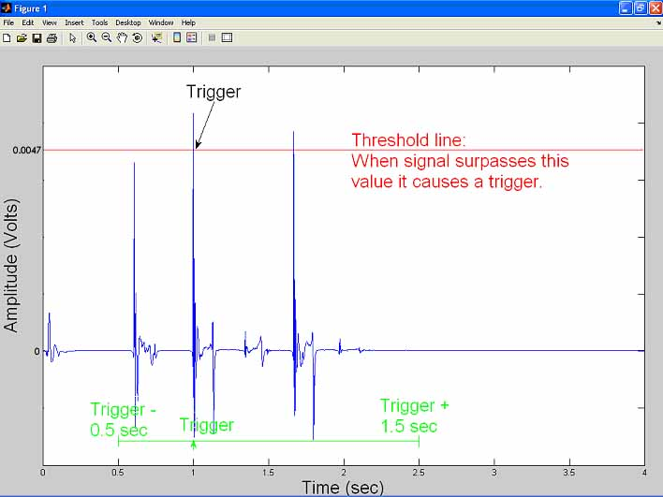
Figure 3.4 Sound Capture through use of Trigger.
When a sound is loud enough to cause the microphone to create a voltage that is above the threshold line, a trigger condition is met. Once the trigger condition is met MATLAB obtains 0.5 secs of the recording that occurred before the trigger from a buffer, as well as 1.5 secs of the recording that occur after the trigger condition. The result is a complete two second recording.

Upon meeting a trigger condition, the system captures the sound and then invokes the listening routine, which will analyse and compare the sound. When the system waits for a trigger condition and one does not happen within a two second period, the system pauses for 0.1 msec in order to process user activity, such as a button press on the GUI. MATLAB has limitations on its processing ability and this pause was therefore required, but because it is so small it does not affect the sound acquisition.

Sound Acquisition in Learning Mode
In learning mode the record_sound(fs, time) function records a sound for the number of seconds specified by the time variable, at a sampling rate specified by the calling function, which is 22050 Hz for this system. It then locates the most important two seconds of the recording by locating the highest amplitude of the sound and saving from 0.5 seconds before that point, to 1.5 seconds after that point, for a total of 2 seconds. If the highest amplitude occurs during the first 0.5 seconds of the five-second recording, it will just save the first two seconds. If the highest amplitude occurs during the last 1.5 seconds of the recording, it will save the last two seconds. The reason for taking a recording longer than 2 seconds is because it may take some time for the user to activate the sound. A trigger was not used here because more precision is needed when sounds are learned than when in listening mode to ensure very precise data storage. The trigger has very small pauses that could cause interference. Although this interference is very small, it is unwanted in order to attain the most accurate recordings possible. Also, threshold requirements could alter the way a sound is stored.

Sound Analysis
EnviroSense identifies sounds based on frequency content and power spectral density, PSD. The sound analysis function, analyze, examines a sequence x[n] of samples, and returns two vectors p and f. Vector f contains three or more analog frequency values corresponding to the frequency components with the largest magnitudes of the input sound. Vector p contains the natural logarithm of the output returned by the pwelch function of the sequence.

The analyze function is invoked with up to three parameters, the sample sequence inSignal, the value of the sampling frequency fs, used to sample the sound, and the number of frequency components to be returned, n. Of these, only inSignal is required. Default values are provided for the other two parameters if they are not provided in the function call.

The analyze function performs a numerical evaluation of the Fourier transform integral via the fft function in Matlab. Given an input signal, the function returns the three most significant frequency components in order of decreasing amplitude.

Analyze performs an N-point fft on the entire sample sequence x[n]. The output of the fft is returned in the vector y, which is defined inside the function’s body. This vector is then divided into equal-length segments. A default value of 40 is used. Each segment is then scanned looking for maxima via the find function. The find function, which is invoked by analyze, scans the absolute value of the vector elements.

The find function returns a vector that contains the maximum value found as well as its corresponding index. Using this information, the analyze function then performs a look up in the analog frequency vector, fr, to map the analog frequency value that corresponds to the maximum value just found. The length of the fft output vector and the value of the sampling frequency are used to set up the analog frequency vector. Each element of the fr vector corresponds to fs/N Hz, where N is the length of the fft vector. For example, if fs is 22050 Hz and N is 44100 points, then each element of fr corresponds to 22050/44100 = 0.5 Hz. Therefore, every two points in the transform vector y span one Hertz in the frequency vector fr.

For example, if the find function returns an index of 3 for a maximum value in the fft vector, then the corresponding analog frequency is found at the same index in the frequency vector. In this example the frequency would be 2f_{s}/N Hz. As each component is found, its value is added to an output vector ff. The step is repeated until the number of components found is equal to either the default value of 3 or the value specified in the function call.

If the analog frequency value retrieved by the function is less than 20 Hz, then it is ignored and the component count is not incremented. This is done because the human hearing range is from 20 Hz to 20KHz. Once the function has found the required number of significant frequency components, it rounds the vector elements in order to return integer analog frequency values.

Sound Comparison
Two sounds can be compared using the data obtained in the analyze function for both sounds. The system uses two functions, how_many_match(match_index, freqs) and comparewelchs(sound1welch, welchs) to determine how many frequencies match and whether or not the PWELCH information matches, respectively. These two functions are used in both the listening and learning modes of the device.

Determining How Many Frequencies Match
The how_many_match function is given an index into the database to determine what stored sound it is comparing with the detected sound. The following is a summary of how the function works:
- Accesses database to obtain important frequencies (those given by the analyze function) of database sound.
- Loops through frequencies to see how many are the same value as frequencies of detected sound, ± 50 Hz.
- Returns the number of matching frequencies.

The 50 Hz tolerance was decided through experimentation to see what worked best.

Determining if PWELCH Information Matches
The comparewelchs function is given the PWELCH information obtained by the analyze function for both the database sound and the detected sound. It uses this information as follows:
- Constant, c, is calculated, to normalize data by subtracting first value of each of the pwelch arrays from each other.
- Subtract all subsequent values and determine if result is c ± 12 units.
- If any result is not in this range then stop comparison immediately, as pwelch does not match. Boolean value = 0 returned.
- If end of arrays are reached then pwelch matches. Boolean value = 1 returned.

The 12 unit tolerance was decided through experimentation to optimize sound comparisons. In order to speed up the calculations it is possible to examine only every second, third, or fourth element of the arrays, rather than every single one. This still gives accurate results.

Sound Comparison in Listening Mode
In the listening mode of the system the compareToDatabase(freqs, welchs) function is used to iterate through the database comparing the detected sound to each of the database sounds. The following is an explanation of the functionality:

- Iterates through database calling how_many_match function for entire database.
- If any result is 3 it immediately retrieves the pwelch information and calls comparewelchs for that database sound.
- If pwelch information matches, retrieves name of database sound and returns it.
- Otherwise moves to next database sound.
- If a result is 2 matching frequencies, store index in match2 array.
- If a result is 1 matching frequency, store index in match1 array.
- Once iterated through entire database append match2 array with match1.
- Iterate through match2 array, retrieving pwelch information from database and comparing with pwelch of detected sound by calling comparewelchs.
- As soon as a pwelch match is found retrieve the name of the sound from the database and stop iterating immediately.
- If no match is found then sound does not match any sound in database.

In the algorithm described above pwelch comparisons are minimized by guessing which sounds most likely match, and comparing those sounds first. Guesses are based on the number of matching frequencies, as sounds that have more matching frequencies are more likely to have similar pwelch values. Specifically, the algorithm compares sounds with three matching frequencies first, followed by two matching frequencies and finally one, stopping at any point as soon as a match is found.

Sound Comparison in Learning Mode
In learning mode the system records the same sound source twice and then compares them to ensure that it is storing accurate information. The comparison is similar to the algorithm explained above, but more simple because it does not have to traverse through the database. The learncompare function handles the comparison part and the following explains how it works:
- Compares the pwelchs of two recorded sounds using comparewelchs, as described earlier in this section
- Finds number of matching frequencies of the sounds by calling how_many_match.
- If comparewelchs returns a Boolean value of one, and at least two matching frequencies exist, then the sound is successfully recorded.
- Otherwise, sound is removed from the database - is not recorded successfully and user notified.

Note that because at least two frequencies are required to match, the learning mode has higher requirements for a sound to match than the listening mode does. The listening mode only requires that at least one frequency match. These stiffer requirements are important to ensure accurate storage of sounds in the database, but mean that sometimes it may take several attempts to successfully record a sound.

Alternative Algorithm
An alternative algorithm for sound comparison in listening mode was also tested. It uses the same comparewelchs and how_many_match functions, but implements them in a different way. This algorithm iterates through the database, comparing the pwelch information of the detected sound with all sounds in the database. If one pwelch comparison matches, then that is the sound. If more than one pwelch comparison matches then a frequency comparison is done to determine which sound matches by finding the one with the most matching frequencies.

In this algorithm a pwelch comparison has to be done for the entire database, and this is a very large comparison since each pwelch array contains 8193 entries for a sampling rate of 22050. The benefit is that it would often not require a frequency comparison at all, however a frequency comparison is very small and quick compared with a pwelch comparison. It was thought that by doing the frequency comparison first, as in the algorithm actually used, the system might miss sounds if they are slightly different. It doesn’t seem to be the case though.

The algorithm that is actually used does the quick frequency comparisons until a likely candidate is found. At this point it does the pwelch comparison with a fairly likely chance of it matching, meaning no further pwelch comparisons would be required.

A simple mathematical comparison was developed to estimate the difference in required processing power for the two algorithms in several different scenarios. Refer to Table 3.2. The following outlines the assumptions and equations used in making the calculations seen in the table:

Assumptions: sampling frequency = 22050;
Five sounds stored in database;
PWELCH = 8193 data pts;
Sounds are stored in random order in database;
P = PWELCH comparison (units = clock cycles);
F = frequency comparison (units = clock cycles);
C = 1 data comparison (units = clock cycles);
A = setup activity (units = clock cycles);
P = 8193C + A; F = 9C + A
Total = #P + #F = xP + yF = x(8193C + A) + y(9C + A)

The result of the calculations shows that, for the scenarios examined, the average processing requirements of the algorithm being used is about 30% of that required by the alternative algorithm. Note that the result of the table is only representative of those scenarios, but many others exist, and as such the results should only be used as very rough estimates. The algorithm being used was chosen because of its reduced complexity, and because it is just as accurate at comparing sounds.

Table 3.2 Comparison of Algorithms.
Below are the results of the number of clock cycles for pwelch, frequency, and complete comparison of sounds being detected when they are stored in various locations in the database. The calculations are done for two different algorithms, the one used by the system and an alternative one, to determine which is more efficient. The last line shows the average of all the scenarios for both algorithms, and that the algorithm that the system uses is more efficient than the alternative.
Scenario |  | Algorithm  Used | Alternative  Algorithms
Sound is not in database  (0 freqs/pwelch match) | # of P | 0 | 5
Sound is not in database  (0 freqs/pwelch match) | # of F | 5 | 0
Sound is not in database  (0 freqs/pwelch match) | Total | 45C + 5A | 40965C + 5A
Sound is first sound in database  (3 matching freqs, no other  freqs / pwelch match) | # of P | 1 | 5
 | # of F | 1 | 0
 | Total | 8202C + 2A | 40965C + 5A
Sound is first sound in database  (1 matching freq, 4 other sounds  have 1 matching freq) | # of P | 1 | 5
 | # of F | 5 | 0
 | Total | 8238C + 6A | 40965C + 5A
Sound is first sound in database  (2 matching freq, 1 other sound  has matching pwelch) | # of P | 1 | 5
 | # of F | 5 | 2
 | Total | 8238C + 6A | 40983C + 7A
Sound is last sound in database  (1 matching freq, 4 other sounds  have 1 matching freq) | # of P | 5 | 5
 | # of F | 5 | 0
 | Total | 41010C + 10A | 40965C + 5A
Sound is last sound in database  (3 matching freqs, no other  freqs / pwelch match) | # of P | 1 | 5
 | # of F | 5 | 0
 | Total | 8238C + 6A | 40965C + 5A
Average of these scenarios |  | 12329C + 6A | 40968C + 5A

Data Storage and Flow
Due to the fact that a person using our system is not likely to have more than about twenty sounds stored for recognition it was deemed unnecessary to use a database program, and the data is simply being stored in text files. Each sound has three major components that are stored as three text files: sound name, frequency information (array of three frequencies), and pwelch information (array of numbers giving power spectral density). All of the information stored in the database is retained when the system is turned off. The only way to remove a sound from the database is using the removesound(name) function.

To add information into the database the function addsound(name, freq, soundinfo) is used. Error checking is included in this function so no duplicate names are allowed to be entered, and it also assures that the three primary fields of the database all have the same number of entries. This function also checks to ensure that there currently is a database, and if one has not yet been created it creates a new one with the current sound as its first entry. Sound names are also further restricted to be twenty characters or less using the function convertname(name), an error is given if the user tries to enter a name with more than twenty characters.

It was important to decide on a standard size for all names, as matlab will not allow rows in an array to have differing lengths, twenty characters was chosen as it was felt that this would be enough to accurately describe any sound for the user. The convertname function ensures that all names are the same length (twenty characters) by adding null characters to the end of the name if it is less than twenty characters, and rejecting the name if it is more than twenty characters. The names are stored in the database in their ascii numerical representation, as this was the easiest way to compare the names in matlab. The convertname function also handles this conversion.

Information from the three different fields of the database is retrieved individually for each sound using the functions: nameretrieve(index), shortretrieve(index), longretrieve(index). These functions retrieve the name of the sound, the frequency array of the sound, and pwelch array of the sound, respectively. The index entry is just an integer corresponding to the sound’s order in the database. Names are returned as text and the frequency and pwelch information are both returned as arrays of numbers. Error checking is also implemented here so a call to retrieve an entry outside of the current index range returns an error message. This is done by making sure that the index is less than or equal to the current database size, which can be found using the getsize() function.

The getsize() function is used by several different parts of the program. Aside from returning the current size of the database it also checks to ensure that all three files storing information have the same number of entries. This ensures that every name in the database has a corresponding frequency array and pwelch array. If the number of entries in one of the files differs from that of the other two then an error is given to the user because the data has been corrupted and will need to be fixed. If such an error were to occur the database would have to be rebuilt or edited manually. It is important to check for this error, because otherwise the sounds could become mixed up in the database resulting in the sounds being improperly identified.

A listnames() function is used in the database to return a list of all of the current names being stored in the database. If no sounds are present in the database then the user is notified that there are currently no sounds being stored. This function is used by the GUI to show the user what sounds they currently have stored, so that they may remove or add new sounds accordingly.

The removesound(name) function is used to remove the desired sound from the database. This function removes all three components of the sound from the database and rearranges the files so there are no gaps in the database. This function also has error checking built in to ensure that the requested sound does exist in the database, and if it does not it returns an error to the user.

Aside from the main sound storage information there is also another set of database functions used to keep track of the sounds that have been successfully detected in the listening mode along with the time that they occurred in separate files from the main database. The function warninglog(name, time) is used to add a sound occurrence. A maximum of ten sound occurrences are stored, if there already are ten in the database then the least recent occurrence is removed to make room for the new occurence. The listsounds() function is used to list all of the sound occurrences in storage. The purpose of these functions is not to add sounds to be recognized by the system, but to keep a short record of the recent sounds that have been detected so the user can be kept aware of sound occurrences beyond just the current sound.

Graphical User Interface
It was decided to use a Graphical User Interface, GUI, for the device to make it user-friendly. In Matlab, there is a built in toolbox called Guide. When guide is typed into the Matlab prompt, another window opens allowing you to start the design of GUI boxes. It allows for design of boxes of any format, by means of pushbuttons, scrolling lists, static texts, colour, size, etc. After you have your box looking the way you want it, having all the buttons and titles you want, you save it. When you save your box, Matlab creates a default m-file for the box. This default m-file contains the code to display the box on the screen if the name of the box was typed into the prompt on Matlab. Also in this default m-file, there were blank default call back functions for each button or text in the GUI box. Every component on the GUI box had to be programmed to do the desired function for the device.

EnviroSense has a main menu screen, shown in Figure 3.5, where the user will control the many functions of the device. This main menu gives the user four options, record a sound, turn on or off the listening mode of the device, remove a recorded sound or see the list of all recorded sounds.

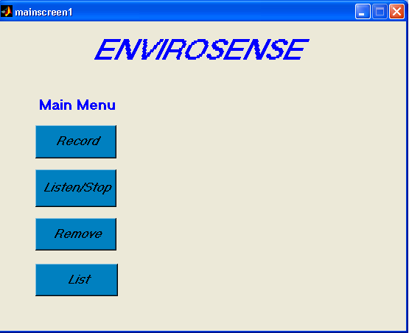
Figure 3.5 Main Screen Box

To record vital sounds in the user’s environment, the Record button is pressed in the main menu of the system. This record button has a function called Record_Callback(). This function calls a box called sound name, Figure 3.6, which appears asking the user to type in the name of the sound to be recorded. The text line in this box has a function called edit1_Callback() in sound name m-file. After the user types in the name of the sound and presses enter, the name of sound is stored. This name is sent to a learning function and the recording begins with the display of a recording box, Figure 3.7. Once the recording is done, the recording box disappears, by a call to the built in close() function, and a box called recording2, Figure 3.8, appears asking the user to record the sound again. The OK button in this box has a call back function called OK_Callback() and what it does is close the box once the OK button is pressed. After the OK button is pressed, the system goes back into recording mode, displaying the recording box once again. After the two sounds are compared by a call to a compare function in the edit1_Callback() function in the sound name m-file, the box called recsuccess, Figure 3.9, is displayed, telling the user that the sound was recorded successfully, the two recordings match, or the box called recnotsuccess, Figure 3.10, is displayed, telling the user that the sound was not recorded successfully, the recordings do not match, and that the user must try again.

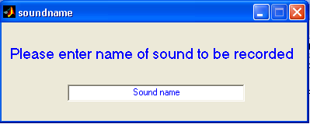
Figure 3.6 Record Sound Name Box

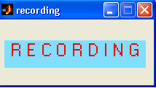
Figure 3.7 Recording Box

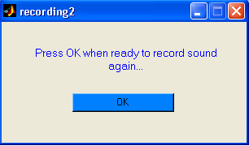
Figure 3.8 Recording 2 Box

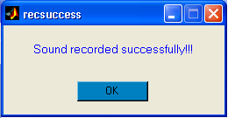
Figure 3.9 Recorded Successfully Box

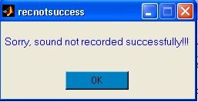
Figure 3.10 Recorded Unsucessfully Box

The Listen/Stop button allows the user to put the device into listening mode. This button has a call back function called Listen_Callback() in the main screen m-file. When pushing this button, which is actually a toggle button, a call is made to the box called listening2, which is then displayed on the screen reminding the user that the device is now listening for a sound. Since this button is a toggle button, when it is pushed down, a call is made to the acquire_sound function to listen for a sound. When the button is released, there is a call to the close() function to close the listening2 box and stop the device from listening for a sound. When a sound is detected and compared to a previously recorded sound, if they match, a built in Matlab function called warndlg() is used to alert the user of the sound by displaying a box called Sound Detected, Figure 3.11, on the screen with the name of sound and a time stamp for the sound in the box, along with the previous nine sounds. Pressing the OK button makes the box disappear.

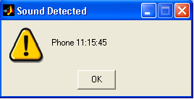
Figure 3.11 Alert Box

As the user’s environment changes, the user may want to remove sounds from the database. To remove a sound from the list, the user presses the Remove button. This button has a call back function called Remove_Callback() in the main screen m-file. This button calls a box called removename, Figure 3.12, which is displayed on the screen, asking the user to type in the name of the sound to be removed. The removename m-file has a call back function called edit1_Callback(). This function, when Enter is pressed, takes in the name of the sound entered by the user and sends the name to the removesound function to remove the sound from the database. Upon completion, a call is made to the close() function to close the box.

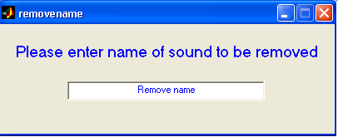
Figure 3.12 Remove Sound Name Box

As sounds are being recorded into the database, they can always be viewed as a list displayed on the screen. To view the list, the user will push the List button. All sound names are printed to the screen in a list in a box called List, Figure 3.13. When the user is done looking at the list, the box is closed by pressing the OK button.

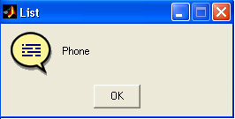
Figure 3.13 List of Sounds Box

There were some problems implementing the GUI in the system. One problem was reaction time when the boxes were to appear or disappear. If the system was too busy processing, the GUI boxes would not appear at the correct times. Small pauses were inserted in the program to deal with this. Also GUI boxes had to be called in different places than planned as the extensive processing power of the system caused boxes to appear at the wrong times.

Modes of Operation
This section explains the implementation of the learning and listening modes and contains system diagrams. Refer to Figure 3.14 for a system use-case diagram. Pressing the ‘Record’ button on the mainscreen of the GUI, and then entering a name for the sound to be stored initiates learning mode. Listening mode is initiated by pressing the ‘Listen/Stop’ button. The ‘List’ and ‘Remove’ buttons both call one single function as mentioned in section 3.2.5. The following describes how the learning and listening modes flow.

Learning Mode
When the ‘Record’ button is pressed and the user enters a name, a sequence of events takes place, as described by Figure 3.15. First the soundname function is called, and it in turn calls the learning1 function, which causes the following events to take place:
- Records sound for five seconds, at sampling rate of 22050, using the record_sound function. ‘Recording’ GUI box is on the screen during this time.
- Uses the analyze function to obtain the pwelch and frequency information.
- Adds the sound information to the database by calling addsig.

Figure 3.14 EnviroSense Use-Case Diagram

The soundname function calls learning2 next where the following occurs:
- Records sound for five seconds, at sampling rate of 22050, using the record_sound function. ‘Recording’ GUI box is on the screen during this time.
- Uses the analyze function to obtain the pwelch and frequency information.
- Returns the pwelch and frequency information to the soundname function.

Next, soundname calls the learncompare function that executes the following actions:
- Obtains the pwelch information from the first sound that was recorded using the longretrieve function.
- Compares pwelch information of both sounds.
- Determines how many frequencies match with how_many_match function.
- If pwelchs match and at least two frequencies match, puts the recsuccess box on the screen to tell user that sound was successfully recorded.
- If these conditions are not met it puts a recnotsuccess box on the screen to tell user that sound was not successfully recorded.
At this point the system leaves the learning mode and goes into standby until another button is pressed.

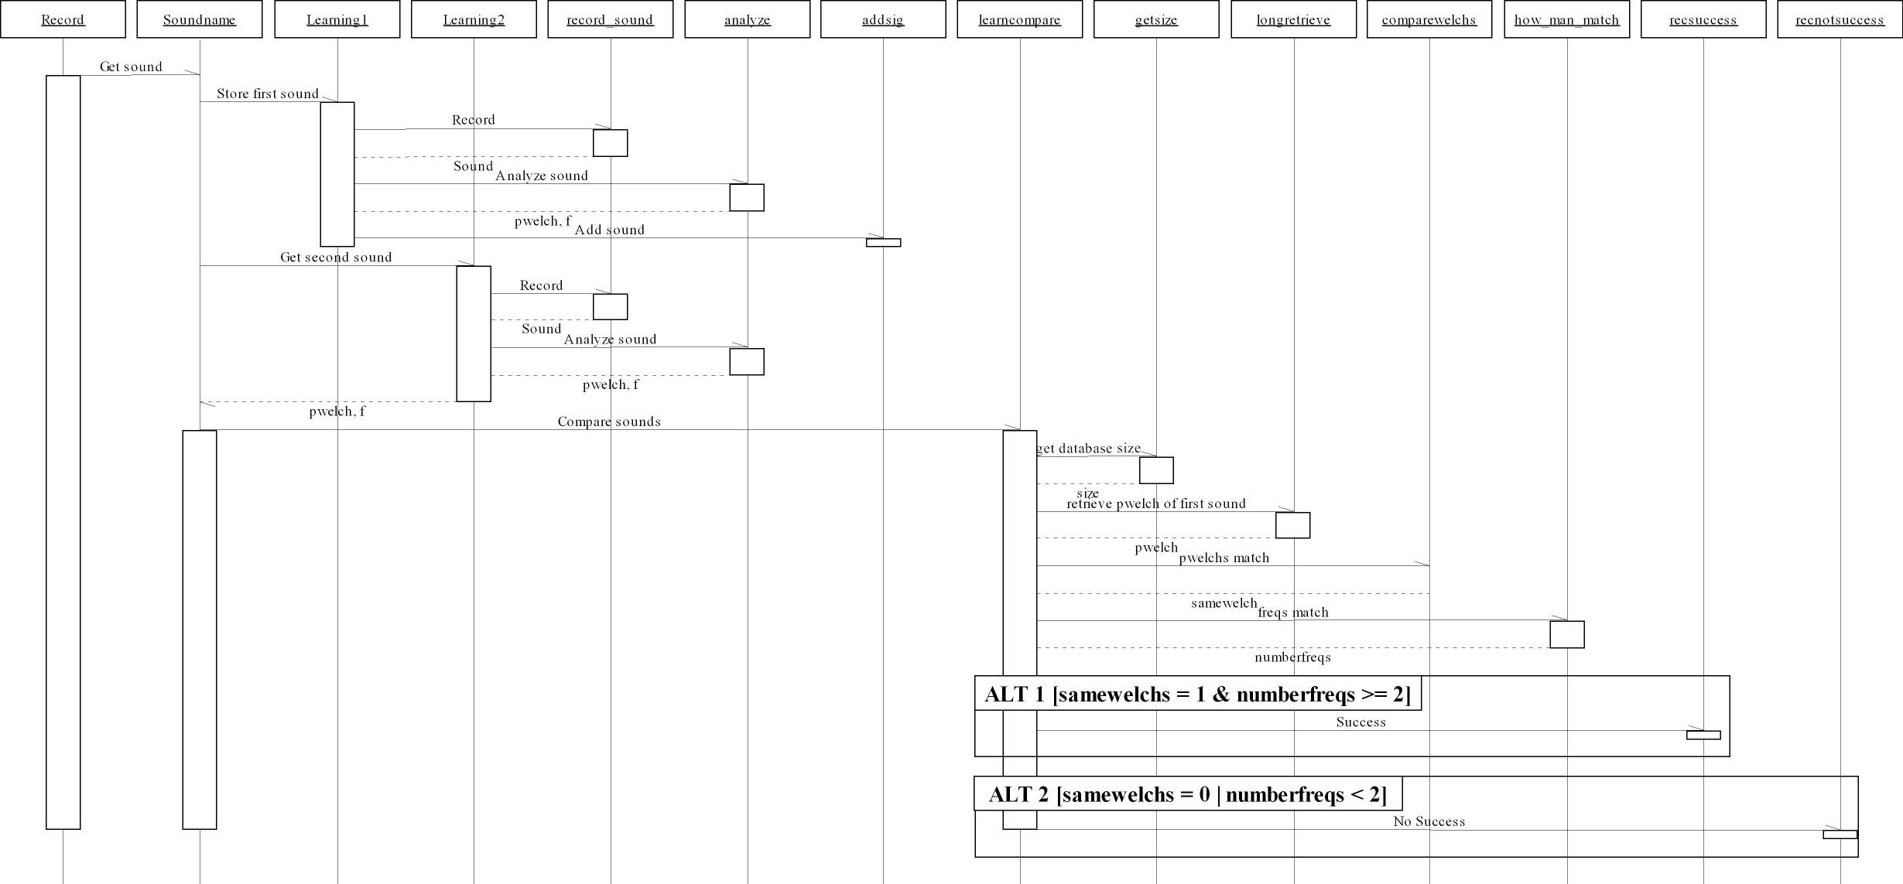
Figure 3.15 Record Sequence Diagram (Learning).
When the record button is pressed on the mainscreen of the GUI, the above sequence of actions occurs. Time is represented vertically and increases in a downward direction. Boxes along the top represent function names that are being called. Words associated with arrows pointing to the right represent actions to be carried out by the function being called. Words associated with arrows pointing to the left represent information being returned by the function.

Listening Mode
While the ‘Listen/Stop’ toggle button is pressed the GUI is calling the acquire_sound function, which is described in section 3.2.1. Please refer to Figure 3.16 for the acquire_sound use-case diagram, which shows that when a sound is captured, the listening function is called. Figure 3.17 is a sequence diagram that shows how the following actions take place when the listening function is called:
- Frequency and pwelch information is obtained using analyze function.
- Sound information is compared with database sounds using compareToDatabase function.
- If Boolean value returned is 1, then the sound name is stored in the warninglog database, along with a time stamp, and a warndlg GUI box is placed on the screen with the current warninglog values.

The function then continues to wait for more sounds even if the user has not acknowledged a previous warndlg box. Figure 3.17 shows the sequence diagram for the system, when the listening function is activated by a sound capture.

Figure 3.16 Acquire_sound Use-Case Diagram

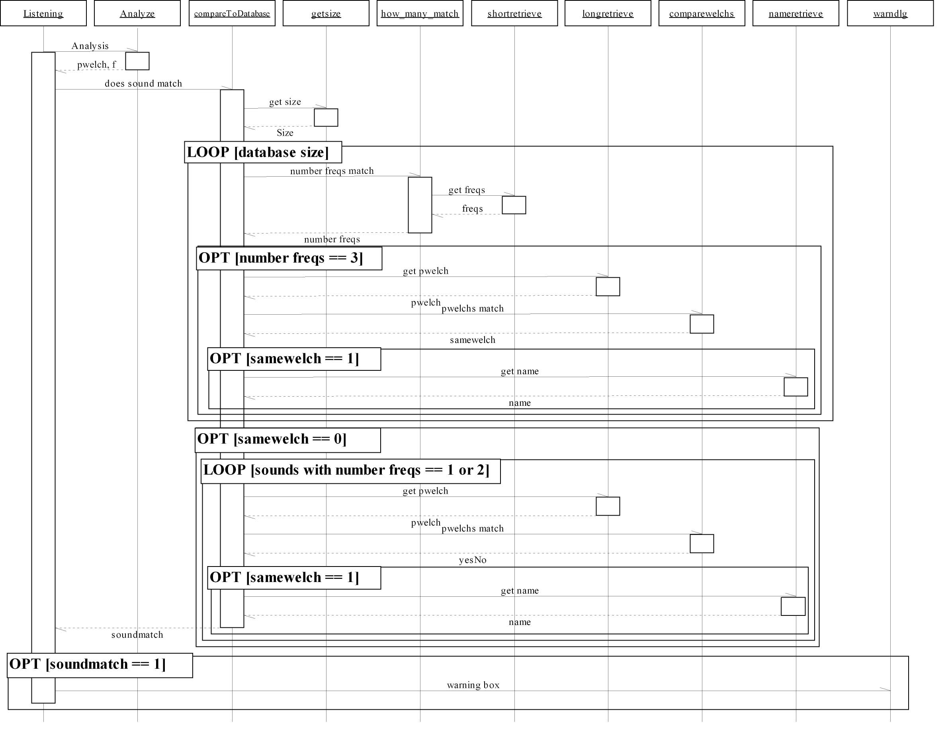
Figure 3.17 Listening Sequence Diagram.
When the listening button is pressed on the mainscreen of the GUI, the above sequence of actions occurs. Time is represented vertically and increases in a downward direction. Boxes along the top represent function names that are being called. Words associated with arrows pointing to the right represent actions to be carried out by the function being called. Words associated with arrows pointing to the left represent information being returned by the function.

Final Product
EnviroSense is currently implemented as a prototype using a personal computer and Matlab software. The system is taught to identify sounds to which the user wants to be alerted when any of these sounds occur. The system is then placed in standby mode until a sound with magnitude above a minimum threshold is detected, causing it to try to identify the sound in listening mode. If a sound is identified as a sound that the user has previously stored in the system’s database, the user is alerted by means of a pop-up window on the computer’s screen.

Although the system currently only provides feedback via the screen, the system is quite usable and has potential to assist hearing impaired users. For example, an office worker who spends most of his or her working hours in front of a computer could benefit from EnviroSense in its current implementation. As such, the main objective of the project has been accomplished. Further development as discussed in section 3.5 could make the system an attractive alternative to existing stationary products.

Testing
EnviroSense is required to accurately identify important sounds under a variety of environmental noise conditions. The system was tested at two separate locations with various levels of background noise, signal strength (loudness), and distance from the source to the system’s microphone. Test sounds used included cellular phones, a bell, a doorbell, a household fire alarm and a knife striking a glass. The system was able to identify them under varying levels of background noise. If two or more sounds occurred in very rapid succession and one of the sounds had a larger amplitude, then the system would identify the most predominant sound.

By varying the distance from the sound source up to three meters, the device was able to correctly identify most sounds. For example, a cellular phone held close to the microphone was accurately identified. However, as the attenuation of the signal became greater due to distance from the source, the system was unable to detect the sound. This could be resolved by adjusting the trigger level of the data capture stage, however this could introduce new problems as unwanted background noise could be detected together with valid input. This issue was one of the compromises and trade-offs made during system design. For more details please see section 3.5.

The system was tested under adverse conditions in a room filled with people and computers. Even though there was a lot of background noise and human speech in the room, the system was still able to identify sounds if the source was either close to the microphone, or at some distance, but with a greater amplitude than the background noise.

The system was tested with ten sounds in the database using three different sampling frequencies. For the results of these tests, please refer to section 3.4.

Performance
In order to evaluate the performance of the system we evaluated the analysis speed at different frequencies. Table 3.3 shows the response time of the system at a sampling frequency of 11025 Hz, 22050 Hz, and 44100 Hz. For this testing the database had ten sounds stored, and we tested five of the ten sounds. There was considerable background noise present during the testing, comparable to what would be experienced in a home or office environment.

Table 3.3 Response Time of the System at Varying Sampling Frequencies.
Sound | 11025 Hz response (seconds) | 22050 Hz response (seconds) | 44100 Hz response (seconds)
Glass | No response | 11.53 | 20
Cellphone beep | 6.5 | 6.61 | 12.58
Microphone tap | 6.7 | 7.29 | 11.89
Cricket ring | 5.5 | 10.48 | 20.1
Quasar ring | No response | 12.1 | 18.97
Average | 6.23 | 9.602 | 16.708

From the above table several conclusions can be made. At 11025 Hz the system loses significant accuracy due to aliasing, and although the response time is fastest when it works it is not reliable. At 22050 Hz the response time is reasonably fast, and the accuracy improves significantly from 11025 Hz. For the sounds we used, no accuracy improvement was observed in moving from a sampling frequency of 22050 Hz to 44100 Hz, however the response time did increase by up to two times. From this set of testing it is quite apparent that the optimal sampling frequency for the system to operate at is 22050 Hz because at 11025 Hz the system is not accurate enough and at 44100 Hz the system is too slow. The average response time of 9.602 seconds at 22050 Hz is not as fast as we would like, but the system is still quite effective with this response time.

The system's ability to identify sounds is also dependent on the microphone being used. We tried using several different microphones, and found that changing the microphone from our original microphone did reduce the system's accuracy considerably. Using a more precise microphone would help to increase the system's accuracy in identifying sounds, but would not change the response time.

In addition to the speed of the system another concern is storage space, because the end goal is to implement it on a PDA. Each sound requires about 50kB of storage, so the user could easily store more than 50 sounds on a PDA. The speed of recognition is not dependent on the sound’s location in the database.

The system works best when analyzing clearly defined sounds that are mechanically or electronically produced, so they are more similar when being compared. It is not intended for voice recognition use, as that would make it too complex.

Compromises and Reasoning
As it can be seen from the performance section it is apparent that the lower the sampling frequency the faster the response time. However by reducing the sampling frequency we also reduce the accuracy of the sound analysis. Any sound that has frequency components above half the sampling frequency will experience aliasing, which could result in identifying the sounds falsely or not identifying the sounds altogether.

The slowest part of our sound comparison function is the comparison of the pwelch analyses. To minimize the need to compare the pwelch analyses we decided to do a preliminary frequency comparison of the dominant three frequencies in each sound. We chose to use three frequencies instead of only one, because this allows for some tolerance of background noise. We did not want to evaluate too many frequencies though because then this would be just like doing two pwelch comparisons and would make the system slower rather than speeding it up. By using this method of comparison we actually increased the accuracy of the system by doing two different types of sound comparison. Doing the pwelch alone it was hard to distinguish certain sounds, but adding in the frequency analysis made these sounds easy to distinguish and thus increased our chances of positively identifying a sound.

Because the storage needed for each sound is relatively small there is currently no need to introduce any data compression for the storage files. However if the user does wish to store more than 100 sounds they will start to use a significant fraction of their PDA memory.
Additionally going beyond 50 sounds will slow down the performance somewhat because no true database software is being used. However it is not likely that a user would need to program more than 20-30 sounds so this compromise was seen as a good choice and results in fast data
access because of the relatively small amount of data.

Another important decision made with regard to sound storage was the length of each sound to be stored. In order to simplify recording for the user and make the sound analysis more manageable it was decided to go with a standard length for each sound. This sound length was chosen to be 2.0 seconds. It was decided that any sound length shorter than 2.0 seconds would reduce the accuracy of the device significantly, because we would not be catching enough of the sound to do an accurate analysis. We also did not want the sound length to be too long, as this would result in a slower response time, because the whole sound must be received in order for analysis to take place.

The threshold for removing background noise was another compromise made. It is currently at 4.7 mV, which is good for relatively quiet environments, but it was slightly problematic at the poster fair because there was far more noise than the device had been exposed to previously. Having the threshold too low means that the device will always be analyzing, using up too much processing time, but if it is too high the device may miss the sounds that are important.

Future Implementation
The device works reasonably well on a desktop computer or a laptop. A future implementation of this device could be on a PDA or as an embedded system. With the PDA approach, the device could be portable. The PDA could be attached to the user’s belt along with a vibrating motor to alert the user of a recognized sound. Upon being alerted, the user could look at the screen of the PDA and the name of the sound would be displayed there, allowing the user to react to the sound. The PDA could be used in conjunction with a DSP chip. The DSP chip would make the processing of the sound comparison faster.

Conclusion
The project device, EnviroSense, has come a long ways from the beginning. We started with just a list of ideas on a piece of paper. After narrowing the ideas down to EnviroSense, we designed and implemented the device using Matlab. During the course of this project, we learned a great deal about DSP and the many tools in Matlab. We now have a working prototype based on a desktop computer, which uses a GUI to make the system user friendly.

Summary of Accomplishments
A working prototype of EnviroSense was developed as a proof of concept. Learning and listening modes enable the user to program the device to listen for sounds specific to their environment. The Database enables storage of sounds, and the GUI provides a simple interface for the user to interact with the program. Sound acquisition through triggering methods was accomplished to reduce the processing needs of the system. Testing was done to determine the effectiveness of the device, and decisions were made to optimize performance. The system works well, as a prototype, for recognizing sounds.

Recommendations
In order to improve accuracy on the frequency analysis it would be advisable to change the way in which the frequencies are found. Currently it is possible to have 2 frequencies returned that are almost identical, so improving this function so no frequencies are within 100 Hz of each other would give us a better overall view of the sounds being received and increase accuracy.

Another way to possibly increase the speed of analysis would be to keep track of the maximum and minimum frequencies stored in the database and then in the listening mode only analyze sounds within that range of frequencies. This would minimize the need of having to search through the entire database for sounds which are obviously not stored in it.

In order to take the project to the next step by implementing it on a PDA we will need to simulate the pwelch and FFT analysis functions in a language that can be used by the PDA. We will then have to convert the current matlab code to match this format as well.

Another feature that could help to improve the performance of the device under high background noise conditions is a calibrate feature. This feature could be used when entering new environments to analyze the background noise levels and accordingly raise the minimal
threshold required for analysis.

References

[1] Bores Signal Processing, “Introduction to DSP”, [online], Available http://www.bores.com/courses/intro/index.html
[2] Amersham Health Medcyclopaedia, “Shannon’s Sampling Theorem”, [online], Available http://www.amershamhealth.com/medcyclopaedia/Volume%20I/SHANNONS%20SAMPLING%20THEOREM.asp
[3] E.W. Kamen and B.S. Heck, Fundamentals of Signals and Systems Using the Web and Matlab, Prentice Hall, Upper Saddle River, N.J., 2000
[4] R.M. Dansereau, “Digital Signal Processing Course Notes”, SYSC 4405
[5] J.H. McClellan, R.W. Schafer and M.A. Yoder, Signal Processing First, Prentice Hall, Upper Saddle River, N.J., 2003
[6] MathWorks, “PWELCH,” [online document], Available http://www-cs.ucsd.edu/matlab/toolbox/signal/pwelch.html
[7] Michael Cowling, "Analysis of Speech Recognition Techniques for use in a Non-Speech Sound Recognition System", [online], Available: http://www.elec.uow.edu.au/staff/wysock/dspcs/papers/004.pdf
[8] Michael Casey, "MPEG-7 Sound Recognition Tools", [online], Available: http://www.cs.bris.ac.uk/home/janko/journalclub/ron5.pdf

Appendix

Appendix A – Acronyms

DAQ – Data Acquisition
DSP – Digital Signal Processing
FFT – Fast Fourier Transform
PWELCH – Matlab function that calculates an estimate of the power spectral density of a given signal.
GUI – Graphical User Interface

