Visualization of Complex Simulations:
A DEVS Visualization Tool

By

Wilson Venhola

Supervisor: Professor Gabriel A. Wainer

A report submitted in partial fulfillment of the requirements of the SYSC 4907 Engineering Project

Department of Systems and Computer Engineering
Faculty of Engineering
Carleton University

April 8, 2005
ABSTRACT

This report presents an application developed to visualize the results of the CD++ modeling and simulation tool. The application developed, DEVSView, allows users to create visualizations from the simulation log files outputted by CD++. DEVSView has implicit support for Cell models and uses OpenGL and the OpenGL Utility Toolkit for hardware accelerated rendering. DEVSView provides a graphical user interface and a text file format for the creation of visualizations. Visualizations, in DEVSView, consist of visual models that translate CD++ log files into animations. Each visual model corresponds directly to an atomic or coupled model from a CD++ simulation. These visual models contain visual states and event animations which are used to represent the simulation graphically. The user can set up the rules, to trigger state changes and event animations, within the GUI or in the visualization file, and the user can use the GUI to playback the visualization. Future work will include loading Maya model files for complex objects, and more advanced model positioning capabilities.
TABLE OF CONTENTS
1 INTRODUCTION AND MOTIVATION 1
2 NON FUNCTIONAL REQUIREMENTS 5
2.1 Small, Efficient, and Standard Implementation 5
2.2 Simple Visualization Creation 5
2.3 Flexible Time Control and Camera Interface. 6
3 FUNCTIONAL REQUIREMENTS AND DESIGN RATIONALE 7
3.1 Functional Requirements 7
3.2.1 ViewerDisplay 10
3.2.2 DEVSViewerDisplay 13
3.2.3 ViewerControl 19
3.2.4 SimulationLink 21
3.2.5 SimulationDatabase 23
4 THE DEVSVIEW VISUALIZATION TOOL 26
4.1 Visual State Transition System 30
4.2 Event animation system 31
4.3 Octary Spatial Partitioning Data Structure 33
4.4 Example Visualizations 36
4.4.1 An ATM Simulation 36
4.4.2 Bouncing Ball Simulation 39
5 CONCLUSION 40
Appendix A: Use Case Descriptions 43
Appendix B: Class Diagrams 44
Appendix C: Visualization file format (.vis extension) 48
Appendix D: DEVSView Tutorial 55
LIST OF FIGURES

Figure 1: Use case diagram for the DEVSView tool 8
Figure 2: DEVSView package diagram 9
Figure 3: The VDWindow class and various controls which subclass it 11
Figure 4: The visualization playback options panel from the DEVSView tool 11
Figure 5: The DEVSView event classes 12
Figure 6: The structure of the DEVSView user interface 14
Figure 7: The main DEVSView window 15
Figure 8: The model list panel and the model edit panel 16
Figure 9: The Visual state edit panel. 17
Figure 10: The transition rule edit panel 18
Figure 11: The ViewerControl classes 20
Figure 12: The SimulationLink classes 21
Figure 13: The three singletons of the SimulationDatabase package 23
Figure 14: The visual model classes. 24
Figure 15: The scene database classes. 25
Figure 16: A visual model in its ‘idle’ visual state. 27
Figure 17: Octtree region divisioning 33
Figure 18: Octtree splitting technique 35
Figure 19: The ATM visual models. 37
Figure 20: A frame in the ATM visualization after a customer arrives. 38
Figure 21: The ATM visual models and their assigned octtree regions. 38
Figure 22: A composite of several frames in the bouncing ball simulation. 39

1 INTRODUCTION AND MOTIVATION
The visualization tool described in this report was implemented to improve the available options for visualizing Discrete Event Systems Specification (DEVS) simulations. DEVS provides a framework for the construction of discrete event hierarchical models in a modular manner. A system modeled with DEVS consists of behavioural (called atomic) models and structural (called coupled) models. A structural model is composed of several atomic or coupled sub-models. The coupled models are composed of atomic models connected through input and output ports defined in their interfaces. The Cell-DEVS formalism extends this behaviour to enable defining cellular models to model systems that operate over area of space [1 & 2].
CD++ is a tool to create simulations that follow the DEVS specifications. The results of CD++ are recorded in simple text based log files. These simulations produce complicated results, which can depict interactions that occur in three dimensions. Theses results require some interpretation and reconstruction to clearly see what is occurring during the simulation. The purpose of all DEVS visualization tools is to provide the capabilities to accomplish this task.
CD++ log files contain an event per each line of the log file. Each event specifies: source model, destination model, time sent, value sent, port over which the value was sent, and event type. The motivation of this project is to provide a tool for visualizing general DEVS simulations in up to three dimensions.
The project currently has a couple methods available to visualize the results of CD++ simulations.
- Java Applet VRML viewers
- Alias Maya 3D Software
These methods have some limitations. The Java applets use Java3D libraries and the VRML specification, both which are no longer actively developed. The current VRML viewers also lack functionality and ease of use. Alias Maya is an excellent tool for creating environments and objects to visualize simulations; however the installation size, workstation requirements, and licensing issues of the Maya software prevent it from being the optimal viewer.
Although all CD++ simulations conform to the DEVS specifications, the results they produce often require different interpretation. For example, some simulations output values over a continuous range, while others may output a sequence of discrete states. Visualizing simulation results requires a tool which provides a flexible methodology to visualize the various simulations appropriately. The limitations of the current CD++ visualization techniques need to be addressed and corrected as well.
The proposed solution, the DEVSView visualization tool, provides several constructs to enable visualizing the results of DEVS simulations. The models from the simulation are directly translated to visual models. These visual models each contain a visual state transition system and an event animation creation system that allow the simulation to be visualized appropriately. DEVSView provides the graphical user interface to define and playback visualizations in three dimensions.

The DEVSView visualization tool provides basic services that enable simple visualizations. The following significant accomplishments have been achieved during creation of this tool:
- Design and Implementation of a windowing system based on the OpenGL Utility Toolkit [3]
  - The windowing system provides buttons, text fields, list boxes, resizable windows, and other controls necessary for a GUI. The rendering of the controls is accelerated by OpenGL [5].
- Visual state transition, and event animation systems
  - The visual state transition system is a collection of visual states and transition rules defining what simulation events trigger state changes. The event animation system is a collection of rules to define which events trigger certain animations.
- Design and Implementation of an octtree scene database to enable efficient view culling
  - The visual models are stored in an octary space partitioning tree. This data structure recursively divides the scene extents into eight regions, which enables efficient algorithms for rendering scenes, object selection, and other frequently used scene operations.
- Flexible file format allowing backwards compatibility with older versions.
  - The file format is a hierarchical organization of information blocks. The parsing mechanism allows a program to skip blocks which it does not recognize.
- User Interface and Functionality to load, save, modify, and playback visualizations
  - The user interface is built on the windowing system described in accomplishment 1). The visualization playback functionality uses accomplishments 2) and 3), and a high resolution timer to display the visual models correctly. The load and save functionality use accomplishment 4).
The tool was designed briefly in UML, and then implemented using C++ and OpenGL. It was initially designed to import Maya 3d models for visualization and was also intended to interface with running simulations to provide interactive visualization. These features were not developed, since the amount of work involved proved too much.
This report discusses the non functional requirements of the tool in section 2 and then continues on to the functional requirements and design of the tool in section 3. The details of the tool are discussed in section 4 and the report will conclude with a summary of the tool and several recommendations for future work. The requirements and design are important in describing the problem being solved, while the design, implementation, and conclusion summarize both the solution to the problem and what parts of the solution the DEVSView tool implements.
2 NON FUNCTIONAL REQUIREMENTS
The non functional requirements of the tool were developed from limitations of the previous visualization tools developed for DEVS. The limitations of the previous tools, as described briefly in the introduction, were the use of standards which became obsolete, size of installation, licensing issues, difficult visualization creation, and difficult camera controls. The issues discussed in the following sections are related to overcoming these limitations.

2.1 Small, Efficient, and Standard Implementation
The tool was implemented in C++ and uses the OpenGL Utility Toolkit (GLUT). OpenGL is supported by many platforms, and is actively developed and extended to accommodate the advancing field of computer graphics. GLUT provides simple windowing services, and doesn’t reduce OpenGL rendering performance. This approach produces a small installation size, and no licensing issues.

2.2 Simple Visualization Creation
The creation of visualizations should be simple and quick. This tool was designed to create visual models automatically from the log file of a simulation, which accelerates their creation. The tool also provides a file format that supports text editing so reusing visualization techniques can be accommodated by copying and pasting.

2.3 Flexible Time Control and Camera Interface.
The time control mechanism uses a high performance timer to control the progression of the visualizations and provides a GUI control for controlling the speed of the playback. There is also a slider for seeking an arbitrary point in the visualization. The camera interface is fairly simple and uses the controls most commonly used in first person camera applications for simple camera manipulation.

3 FUNCTIONAL REQUIREMENTS AND DESIGN RATIONALE
The tool requires the ability to display the output of a DEVS simulation in an appropriate graphical format. The more detailed requirements of the tool all follow from this basic requirement.

3.1 Functional Requirements
The following list contains the intended functionality of the DEVSView tool.
- CD++ log file parser.
  - Extracts DEVS models which may require visual models
  - Extracts any events associated with the extracted visual models
- User interface
  - Specifies the graphical representation of the visual models
  - Provides controls for starting, stopping, and pausing the visualization. Provides speed control and seeking to a specific time in the visualization.
  - Provides for loading and saving visualizations
- Scene database
  - Provides structure for organizing visual models efficiently in three dimensions
The initial requirements were translated into the use cases seen in figure 1.
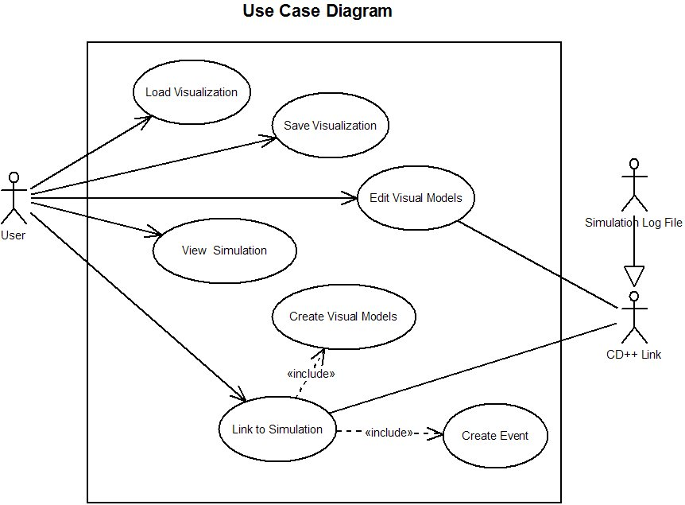
Figure 1: Use case diagram for the DEVSView tool
The actors involved in the use cases are the User, and the CD++ Link. The Simulation Log File actor is a generalization of a CD++ Link. The CD++ Link actor represents a general link to a CD++ simulation through whichever interfaces CD++ supports. Brief use case descriptions can be found in Appendix A. The use cases demonstrate the capabilities of the user to initiate a link to the simulation through a log file, as well as view, edit, load, and save the visualizations
3.2 System Packages
The system has been divided into four conceptual packages shown in figure 2.
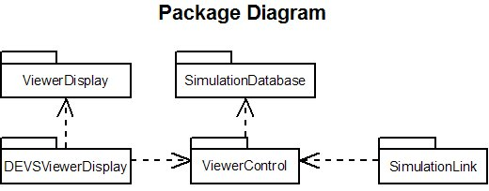
Figure 2: DEVSView package diagram
The DEVSViewerDisplay package is responsible for processing input and converting it to commands for the ViewerControl package. The DEVSViewDisplay package also controls output to the application window for rendering the user interface and three dimensional graphics. This package depends on the services of the ViewerDisplay package for the event driven GUI functionality.
The SimulationLink package is responsible for interacting with simulation results and reporting the necessary results to the ViewerControl package. The responsibilities of the SimulationLink include parsing simulation log files and notifying the ViewerControl package about new events and new visual models.
The ViewerControl package processes the requests from both the DEVSViewerDisplay and SimulationLink packages. The Viewer Control interprets simple commands from both of these packages and then translates them into the proper sequence of interactions with the SimulationDatabase package.
The SimulationDatabase package stores the information necessary for the visualization. The events, visual models, and all corresponding data are stored in the SimulationDatabase. The SimulationDatabase package also stores the visual models in an octtree data structure to cull objects efficiently. The octtree data base is discussed in more detail in section 4.3.
The packages communicate with each other by passing data types which are in the set of common interface types. The interface types allowed include 1) the standard C++ types 2) several basic structures for position and time information and 3) property sets which contain variables of any interface type, including other property sets. The class diagrams for each package are located in Appendix B. The following sections will describe the internal design of each package.

3.2.1 ViewerDisplay
The ViewerDisplay package provides the framework for developing graphical user interfaces on top of GLUT. The package has support for event driven programming using commonly required interface controls, such as buttons, text boxes, scroll bars, list boxes, message boxes, etc. This package has been developed solely for this visualization tool but is not dependant on the other packages and can be easily incorporated into another application which uses GLUT.
The controls supplied by this package are all subclasses of the VDWindow class. Figure 3 shows several controls which subclass the VDWindow class and implement specific functionality. Note that any VDWindow subclass can contain any number of other child windows. User interfaces are created by nesting controls, such as VDButton, VDLabel, VDListBox, etc, in a VDPanel class.
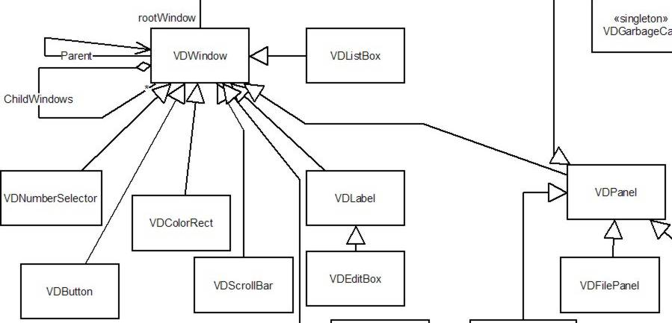
Figure 3: The VDWindow class and various controls which subclass it.
Figure 4 shows a panel with nested window controls from the DEVSView tool.
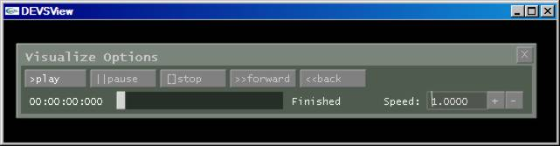
Figure 4: The visualization playback options panel from the DEVSView tool. The panel includes five text buttons, a number selector, a scrollbar, and several labels
Each subclass of VDWindow is required to process GUI events to implement its behaviour. For example, the VDTextButton class processes button press events to determine when the button has been pressed. Figure 5 shows the class structure of the DEVSView event handling mechanism.
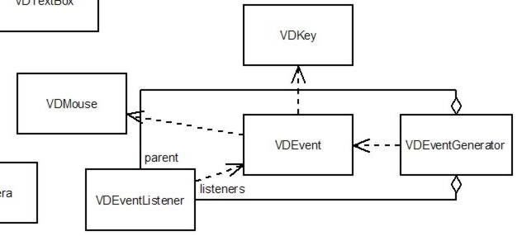
Figure 5: The DEVSView event classes. EventGenerators send events up the hierarchy to the parent listener or down the hierarchy to the child listeners. VDEvent objects may hold mouse, key or other necessary information. There are many types of events which subclass VDEvent but are not shown here for space reasons. These events include VDMouseDownEvent, VDMouseUpEvent, VDMouseMoveEvent, VKeyDownEvent, etc.
An event is passed to the ViewerDisplay package by GLUT, and then it is processed by the root VDWindow object. The VDWindow class inherits from VDEventListener and VDEventGenerator so that any VDWindow object can receive and send events. When an event listener receives an event, it can do each of the following:
- Forward the event to the child windows
- Process the event type and contents
- Send a new event in response. Depending on the type of event created, it may travel up the window hierarchy to the parent window or travel down to the child windows.
After processing the event, the VDWindow object returns a Boolean value to indicate whether the event has been consumed or not. If the event is consumed, the parent window will not pass the event to any other child windows. This gives controls the ability to prevent a single event from being used for multiple purposes. Consider a window that closes when the enter key is pressed. If it contains a multiple line edit field, it must know when the edit field handles the enter key (to make a new line) so that it doesn’t close the window. The next section describes how the DEVSView user interface was created using this package.

3.2.2 DEVSViewerDisplay
The user interface of the DEVSView tool is provided by the DEVSViewerDisplay package. This package contains several ViewerDisplay panels which provide the user interfaces required to interact with the user during each use case. The portion of the DEVSViewerDisplay class diagram shown in Figure 6 displays the structure of the various panels in the user interface.
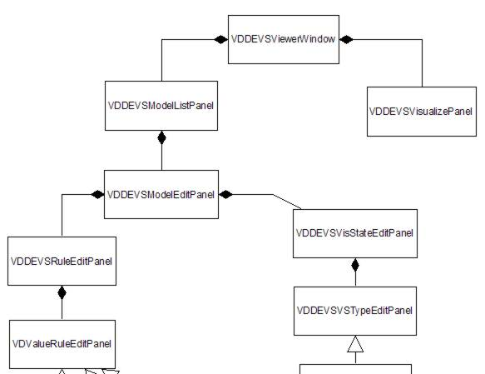
Figure 6: The structure of the DEVSView user interface. The main viewer window contains the panel for controlling the visualization as well as the panel for editing the visual models (i.e. the VDDEVSModelListPanel)
The VDDEVSViewerWindow contains the model list panel and the visualize panel, which was shown in Figure 4. The VDDEVSViewerWindow also contains a panel with various controls to start various common tasks, and a command console. The console is used for logging errors, viewing debug/command information, and entering simple commands. The toolbar panel and the console are shown in figure 7.
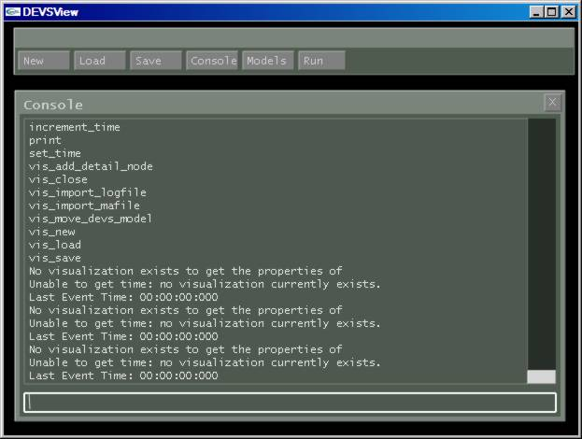
Figure 7: This screen picture shows the main DEVSView window which contains two panels. The toolbar panel has commands for saving/loading/creating a visualization and showing/hiding other panels. The console can execute commands and display the results. The console also displays logging information from DEVSView operations.
The VDDEVSVisualizePanel, which was shown in Figure 4, has controls that enable starting, stopping, pausing, seeking to a specific time (with the scrollbar), and slowing down or speeding up the visualization. The VDDEVSModelListPanel, and the VDDEVSModelEditPanel are shown in figure 8.
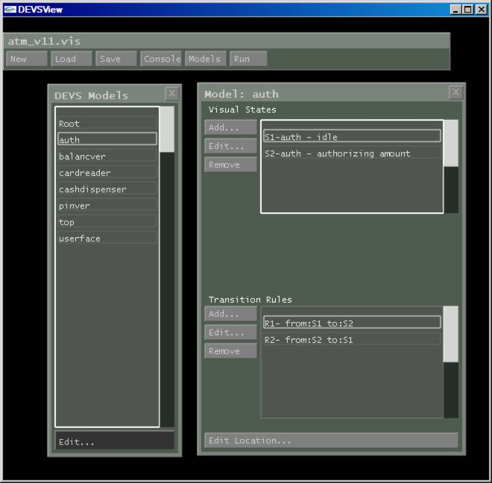
Figure 8: The model list panel and the model edit panel. The model list panel shows the visual models of the visualization. The 'auth' model is currently being edited. The visual states and the transition rules are shown in the model edit panel. States and rules can be added, edited and removed from the visual model using the model edit panel. Also the location of the model can be edited using the ‘Edit Location…’ button.
The VDDEVSModelListPanel is built from a VDListBox and a VDTextButton. The list box contains the list of visual models for the current visualization. The text button creates a VDDEVSModelEditPanel, which is created from list boxes and text buttons, for editing the currently selected visual model. The visual states and transition rules are managed from the model edit panel. The visual states are edited using the VDDEVSVisStateEditPanel that is shown in Figure 9. The transition rules are edited using the VDDEVSRuleEditPanel that is shown in Figure 10.
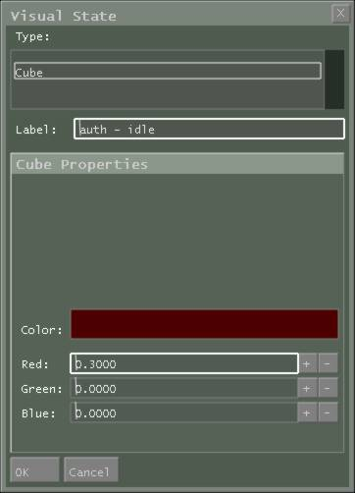
Figure 9: The Visual state edit panel. The panel includes three controls 1) A Visual state type list 2) A Label, and 3) A Visual state properties panel. Depending on the type of the visual state selected, the appropriate properties panel will be shown. In this case, the cube property panel is shown.
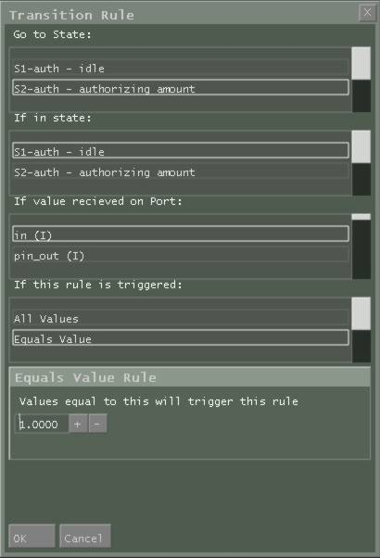
Figure 10: The transition rule edit panel. The rule properties are selected from the list boxes shown. Depending on the value rule type selected (i.e. All Values, Equals Value, etc), the appropriate value rule panel will be shown.
For each visual state type and value rule type, there should be a corresponding properties panel that subclasses VDDEVSVSTypeEditPanel and VDValueRuleEditPanel respectively. These panels provide the required controls to define the properties of their intended objects. The visual state transition system will be described in more detail in Section 4.
The DEVSViewerDisplay package eventually translates all requests from the GUI into commands for the ViewerControl package. The ViewerControl package is described next.

3.2.3 ViewerControl
The ViewerControl package is divided into classes which wrap a corresponding SimulationDatabase class. The requests to modify and/or use the simulation database are channeled through these classes and to the appropriate destination. Each request to the ViewerControl package is initially routed through the VCSimulation class, which translates the requests into the more detailed and complicated interactions with the database. The ViewerControl classes are shown, along with the SimulationDatabase classes they interact with, in figure 11.
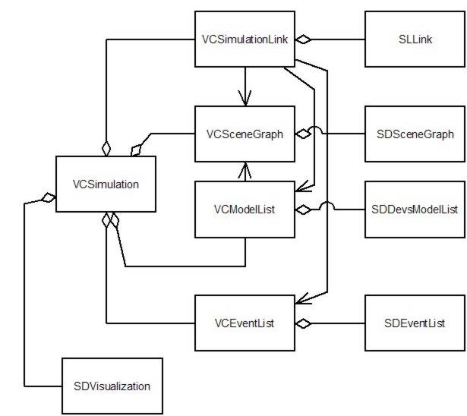
Figure 11: The ViewerControl classes and the SimulationDatabase classes they wrap. The VCSimulation class encapsulates the SDVisualization class as well as the other ViewerControl classes.
The commands received from the DEVSViewerDisplay package are processed by the VCSimulation class. The VCSimulation class forwards these requests to the appropriate control classes or handles them directly. For example, a request to save the visualization is directly handled by the VCSimulation class, while a request to link to a simulation log file is forwarded to the VCSimulationLink class. Various navigable associations exist between the VCSimulationLink class and other ViewerControl classes so that visual models and events can be created and setup without calling the VCSimulation class methods. The VCModelList class has a navigable association to the VCSceneGraph class so that whenever a visual model is modified the appropriate changes to the scene graph can be made efficiently.
The main responsibilities of the ViewerControl package are decoupling and simplifying the interface between the user interface and the visualization functionality.

3.2.4 SimulationLink
The SimulationLink package is a set of classes that implement the SLBase interface. This interface defines the minimum interface required to connect to the ViewerControl package and submit data for visualization. This interface requires for each medium that provides information about a DEVS simulation, a separate class which implements it. The classes which have been created for this package are shown in figure 12.
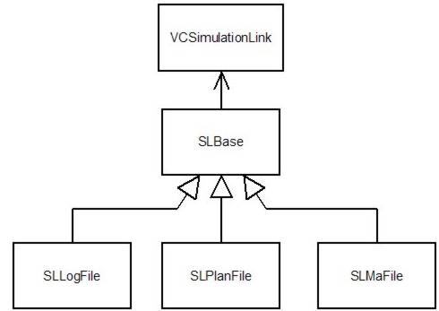
Figure 12: The SimulationLink classes. The SLBase defines the interface over which information is added to the visualization from the various simulation link types. The SLLogFile class loads the events and visual models from a CD++ log file. The SLMaFile class loads cell models and their starting states. The SLPlanFile is not implemented but was intended to load visual models for representing ATLAS system results.
The SLBase class notifies the VCSimulationLink class about new events and new visual models which may be added to the visualization. The VCSimulationLink may choose to reject the models or events if they already exist, or if they do not contain valid information. In some instances, such as loading from a log file, model information is identified in pieces. For example, a CD++ log file is a record of events and each event has a source model, a destination model, and a port name, among other things. Any event indicates that the source model has an output port, and the destination model has an input port. The SLLogFile object, when reading an event, will notify the VCSimulationLink about the new visual models (the source model and the destination model). The VCSimulationLink is responsible for merging the provided visual models with the previously existing database. This usually involves adding new input ports and output ports to models identified in events. Other times it requires converting a DEVS model to a Cell-DEVS model or expanding the cell space of a Cell-DEVS model.
The decision process involved in merging new visual models is the following:
Let NM = the new model added
If NM already exists {
Let EM = the existing model
If EM is a Cell-DEVS model {
If NM is a Cell-DEVS model {
Expand EM’s cell space to include the NM cell space
}
}
else {
If NM is a Cell-DEVS model {
Convert EM to a Cell-DEVS model
Expand EM’s cell space to include the NM cell space
}
}
Add the new ports in NM to EM
}
Else {
Add the NM to the model list
}

3.2.5 SimulationDatabase
The SimulationDatabase package is divided into several important singleton classes. The singletons are shown in Figure 13.
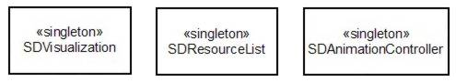
Figure 13: The three singletons of the SimulationDatabase package. The SDVisualization object holds the information for the visual models. The SDResourceList holds the data used for rendering the visual models (fonts, geometry, etc). The SDAnimationController holds the current animations.

These singletons provide the main structure for storing the data necessary for visualization. The main singleton is the SDVisualization class, which contains the scene graph, visual model list, event list, current time, and scene node list. The octtree data structure is contained in the scene graph, and a visual state transition system is stored in each visual model of the model list. The animations currently active in the visualization are stored and animated by the SDAnimationController object. The SDResourceList object contains the resources used for rendering the visual models. The list contains 3d fonts, geometry, textures, and other resources which may be used by many different visual models.
The structural properties of the visual model classes are shown in figure 14. The SDDevsModel class encapsulates the information for each visual model. SDCELLDevsModel subclasses the SDDevsModel class to reuse the functionality it provides.
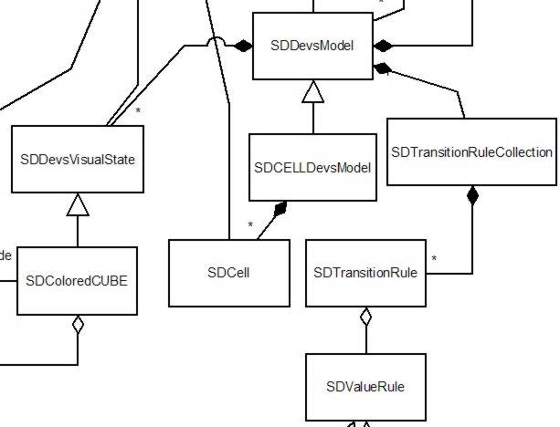
Figure 14: The visual model classes. The SDDevsModel encapsulates the information representing a visual model. The SDCELLDevsModel is a subclass of SDDevsModel to reuse functionality.
Each visual model contains a list of visual states, a list of transition rules, and a list of event animation creation rules. The details of the visual state system and event animation system are discussed in detail in sections 4.1 and 4.2 respectively.
The scene graph and scene node list implement the octtree database. The classes corresponding to these components are shown in Figure 15.
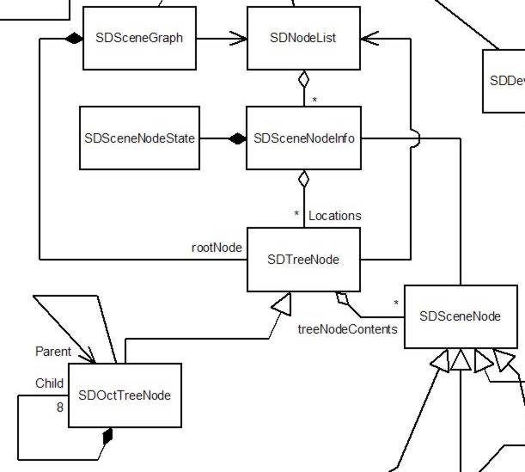
Figure 15: The scene database classes. The SDSceneGraph contains the root SDTreeNode, which is the root node of the Octtree. The SDNodeList class contains a list of SDSceneNodeInfo objects which wrap scene node objects and store the locations of the scene node in the Octtree. Each SDTreeNode may contain many scene nodes.
The SDNodeList object contains every SDSceneNode object, which is wrapped with a SDSceneNodeInfo object. The SDSceneNodeInfo class holds the locations of their scene node in the scene graph. When the SDVisualization object adds objects to the scene graph, the objects are wrapped with a SDSceneNodeInfo object and added to one or more SDOctTreeNode objects. The process of selecting the proper SDOctTreeNode objects and methods for traversing the scene graph will be discussed in section 4.3.

4 THE DEVSVIEW VISUALIZATION TOOL
Each DEVS simulation result consists of several atomic and/or coupled models communicating with each other over ports using messages, which represent events in the simulated system. The DEVSView tool provides a general method of mapping simulation results to a visual representation. The method and data used to map the results are called a Visualization in the DEVSView tool. A Visualization consists of a set of visual models, and a set of events that manipulate these visual models. The set of events used in the Visualization corresponds directly to the external and output events from a CD++ simulation log file. A visualization progresses by sending these events to the visualization models for processing. Events are sent to both the source model and destination model for this processing. The visual model’s transition rules specify how an event affects the visual representation of the model, and the event animation creation rules specify whether an event produces certain event animations.
The tool can create visual representations of systems by parsing the log files of a CD++ simulation and creating visual models for each atomic and coupled model found. Once created, the visual models can be customized to follow a visual state transition system (described in Section 4.1) and/or produce animations following certain events (described in Section 4.2). Alternatively, the visualization models can be created by hand. The format of the visualization file is described in Appendix C. Figure 16 shows an example visual model, named ‘pinver’, in its idle state.
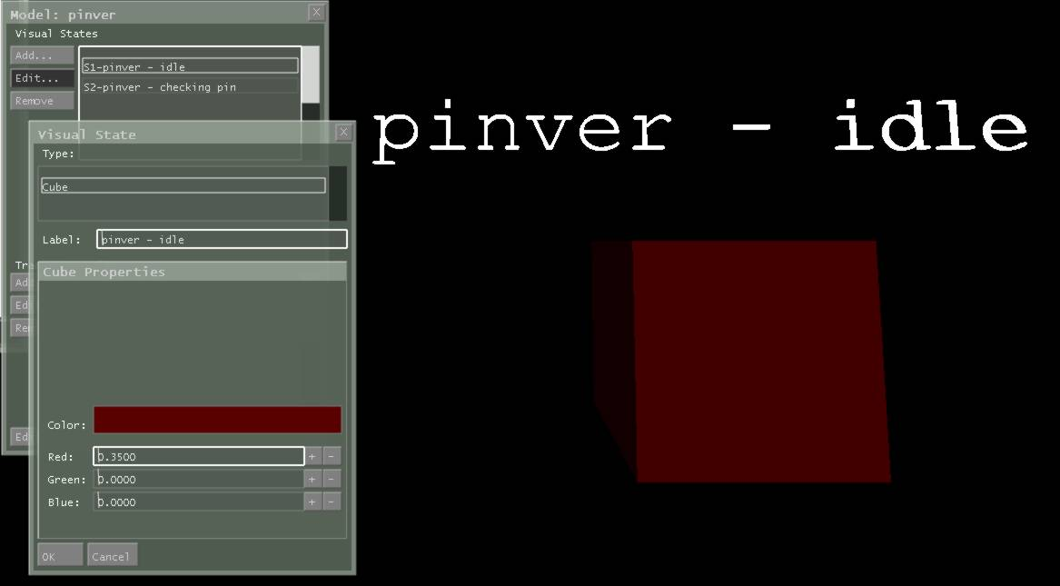
Figure 16: A visual model in its ‘idle’ visual state. This visual state is a cube visual state. The options for selecting the colour are provided in the Visual state edit panel shown in the bottom left.
The visualization models each have:
- Unique name
- List of output ports
- List of input ports
- Information about location, orientation and size
- List of visual states
- List of visual state transition rules
- List of event animation creation rules
- Current visual state
Cell Visualization models extend the regular models by adding a three dimensional array of cells. The cells each store their own current visual state, position, orientation and size; but they all use the same visual states, visual state transition rules, and event animation rules.
Both the following systems described in section 4.1 and 4.2 operate on the events passed to visual models as the Visualization progresses through simulation time. When the Visualization reaches the time an event occurred during the simulation, it is processed by the models involved in the exchange. For example, an event sent from an ATM model to a Customer model will be processed at the ATM visual model and the Customer visual model. Each event contains the following information:
- The source visual model name
- The destination visual model name
- The time the event occurs
- The port the value is sent through
- The value sent
The source and destination visual models use this information to process the event. Typically, this involves comparing the port and value with behavioural rules such as transition rules or event animation rules. These rules use the concept of a DEVSView Value rule to operate. A Value rule is a procedure which accepts a real value, typically the event value, and returns a Boolean indicating whether the value passes the rule or whether it fails. The DEVSView tool currently provides a couple basic value rule types to enable guard conditions on transition rules and conditions for creating event animations. These value rule types are:
- All Values
- This rule returns true for all values passed to it.
- Equals Value
- This rule passes if the value passed to it is equal to a predetermined constant.
- Range of Values
- This rule passes if the value passed to it is greater than the lower pre-determined constant and less than the higher predetermined constant.
The pre-determined constants are entered using the user interface. The transition rule edit panel, which is shown in Figure 10, shows the controls for entering the predetermined constant for the ‘Equals Value’ value rule. Alternatively, the constants can be edited in the visualization file, which is described in Appendix C.

4.1 Visual State Transition System
The visual state transition system of the DEVSView tool assigns a simple state machine to each visualization model. The state machine consists of visual states, and transitions between these states, which are triggered by events in the simulation. The current state defines the visual appearance of the model in three dimensions. All Visual States have the following properties:
- Unique Id (per visual model)
- Label
- Type
Each visual state also implements entry and exit methods to setup their visual appearance according to various inputs. These inputs can be obtained from the event triggering the transition or from other variables internal to the visual model. The visual model specifies a position, scaling and orientation of the model, which a visual state may choose to use or ignore when rendering. The visual model position can be set by using the model edit panel shown in Figure 8. The visual state edit panel provides the services for editing the visual state of the model. This panel is shown in Figure 9 and Figure 16. Depending on the visual state type, the properties provided for editing may change. The other components of the visual state system are the transition rules from state to state.
Each of these transition rules has several properties:
- Port name and direction ( Output or Input )
- Value rule
- Next state
- Unique Id ( per visual model )
When an event is processed by the visual model, each of the transition rules for the current state are evaluated to check if any transitions should be invoked. As well as transition rules for the current state, a separate list of transition rules, which apply for all states, are checked. These special types of transitions are useful for reducing the number of transitions required for certain state machines. A transition rule is invoked when the transition rule port name and direction match the event port name and direction, and the value rule passes given the event value as input. When a transition rule is invoked, the visual state of the model changes to the next state specified in the rule. In addition, the state change is recorded in the visual model history, so the transition can be reversed when the playback is reversed.

4.2 Event animation system
The event animation system allows visual models to create animations which visualize the processing of certain events. Event animations provide facilities to visualize the reasons why visual state transitions occur. Consider a secure login visual model which accepts or rejects a password, and then passes this information to a server visual model. Observing the visual state of the server visual model may show the server repeatedly attempting to validate a password with the secure login model but it will not show why the server is doing so. A text animation which displays ‘password rejected’ at the secure login visual model would clearly indicate the problem. Without such an animation it is difficult to determine why the server is repeating the login process. It could be timing out and resending, it could be validating several passwords sequentially, etc. Event animations solve this problem by creating animations when certain events occur. Event animations can be any sort of visual effect, and are triggered to occur when specific events arrive at a visual model. The only event animation currently provided by the tool is the text animation. A text animation is a three dimensional piece of text which travels from one location to another.
Each visual model contains a list of event animation rules which contain the following information:
- Port name and direction (Output or Input)
- Value rule
- Source state
- Animation length
- Unique Id ( per visual model )
When an event is processed by the visual model, the event animation rules are evaluated to check if any event animations should be created. An animation is created if the current visual state equals the rule source state, the rule port name and direction match the event port name and direction, and the value rule passes given the event value as input. Event animation rules create animations and specify their properties based on the event value and other variables internal to the visual model. After an animation is created it is guaranteed to last the amount of time specified in the event animation rule.

4.3 Octary Spatial Partitioning Data Structure
Each visual model in the visualization has a current visual state and this visual state defines the graphical representation of the visual model. The octtree data structure provides a data structure for organizing the graphical representations by their location in space. This data structure recursively divides the scene into 8 regions of space and assigns scene nodes into the smallest region that contains them completely. Each region is represented by a node in the octtree. The initial region and one subdivision are shown in Figure 17.
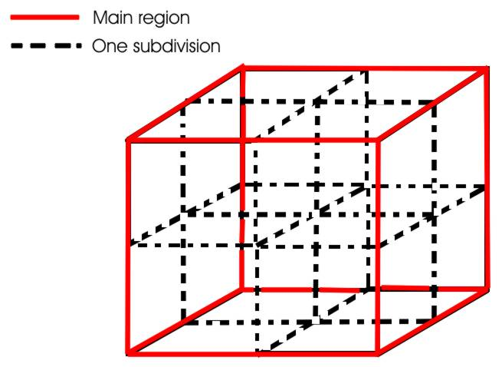
Figure 17: Octtree region divisioning
Each octtree region corresponds to a SDOctTreeNode object in DEVSView. The root node is contained by the SDSceneGraph class. Any graphical object that is added to the scene graph must inherit from SDSceneNode. The SDSceneNode provides the basic interface the SDTreeNode and SDOctTreeNode classes expect.
The reason for using an octtree data structure is that it provides efficient view culling. Complex scenes require significant rendering time and may contain many different objects. Determining what objects to draw is important, since it is inefficient to draw every object every frame. View culling is the process of calculating which objects are in view and therefore require rendering. The octtree data structure can optimize the process of determining what is in view. The process consists of traversing the octtree, and for each node (region) determining whether the node is in view. If the node is out of view, the entire tree extending from that node can be culled, which potentially culls many objects with a single node visibility check. Conversely if the node is completely in view, the entire tree extending from that node is visible and does not require a visibility check. This view culling algorithm is shown in the following pseudo code:
Let ON = the current octtree node
Let ParentON = the parent octtree node of ON
Let VF = the view frustum (i.e. the field of view)
If ParentON intersects VF {
Calculate ON visibility
If ON is not visible {
Stop traversing ON
}
}
Else ParentON is completely visible {
ON is therefore completely visible
}

If ON is completely visible or intersects VF {
Draw each scene node contained in ON
}
If ON has children octtree nodes {
Draw each child octtree node by repeating this pseudocode with ParentON = current ON, and new ON = child octtree node.
}

The octtree also provides the capability for efficient collision detection (Important for object selection), and distance sorting (Important for transparency). Object selection and transparency are features which could be useful for future development but are not currently being used.
The DEVSView implementation of the octtree has the capability of assigning graphical objects to several regions to better define the outline of the object. Consider a small object located at the centre of the root region. This object will only fit completely inside the root region so it must be assigned to that region. The small object will only be culled if the root is culled, despite the fact that it may rarely actually be in view. If the small object were added to the 8 smallest regions that contain it completely, then the small object will be culled much more efficiently by the Octtree. Figure 18 shows the principle in two dimensions.
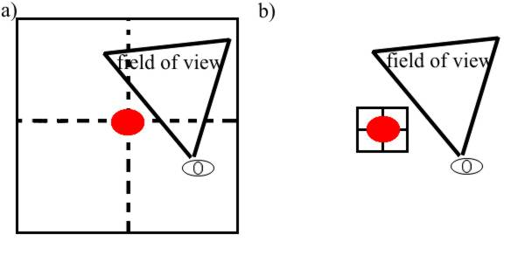
Figure 18: a) the red circle is added to the smallest region that entirely fits it. The field of view does not cull the region so the circle is drawn. b) the red circle is added to the 4 smallest regions that contain it completely. The field of view culls the regions and the circle is not drawn.
For each node in the octtree, it is possible to define the maximum number of times the object is split in order to be added to several child regions. When a scene node is added to the scene graph it is wrapped by an SDSceneNodeInfo object. The SDSceneNodeInfo object is responsible for managing the multiple references to the object. When the scene node reaches an octtree region that it does not fit entirely into, the scene node is added to the child octtree nodes that it intersects. Each of these octtree node locations is recorded in the SDSceneNodeInfo object and the number of times the scene node has been split is incremented. This process repeats until the scene node is split the maximum number of times, or the octtree has no more children. Since there are multiple references to the same scene node in the octtree data structure, the octtree data structure must ensure that scene nodes are only traversed once by the traversal algorithms. The SDSceneNodeInfo makes a record when its scene node has been traversed and ensures its scene node is only traversed once during traversal.

4.4 Example Visualizations
This section demonstrates the application of the DEVSView tool to a sample Devs simulation and a sample CELL-Devs simulation.

4.4.1 An ATM Simulation
The ATM simulation consists of several atomic models interacting with each to approximate the services provided by an ATM machine. The visual models were extracted from the simulation log file and the visual state machines were defined using the DEVSView user interface. Consult Appendix D for more information about using the DEVSView tool to create visualizations. Figure 19 shows the visual models, and the visual state machine interface for the cardreader model.
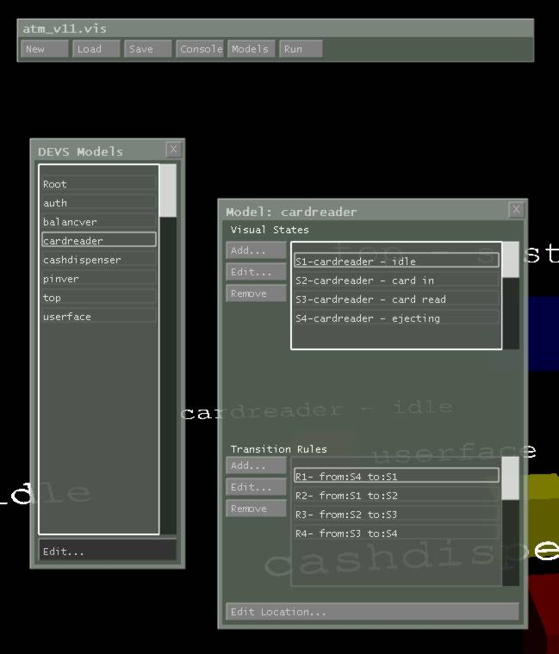
Figure 19: The ATM visualization has several visual models. The visual model ‘Root’ and ‘top’ are always present in DEVS simulations; however they rarely need a visual state. The ATM has other visual models: ‘auth’, ‘balancever’, ‘cardreader’, ‘cashdispenser’, ‘pinver’, and ‘userface’. The visual states and transition rules for the ‘cardreader’ model are shown in the model edit panel. The ‘carderreader’ model can be in four states: ‘idle’, ‘card in’, ‘card read’, ‘ejecting’. There are four transition rules which travel from ‘idle’ to ‘card in’, ‘card in’ to ‘card read’, ‘card read’ to ‘ejecting’, and from ‘ejecting’ back to ‘card in’.
The ATM simulation also provides a text animation which displays “Card Inserted” whenever a bank card is inserted. This text animation was added manually to the visualization file. Consult Appendix C for information about the file format. The text animation can be seen in Figure 20, which shows a frame from the visualization right after a customer arrives at the ATM.
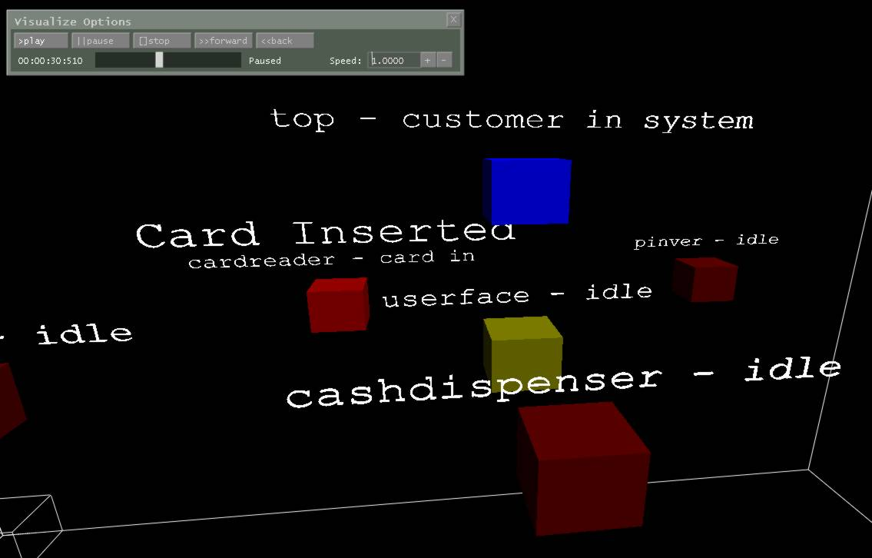
Figure 20: A frame in the ATM visualization after a customer arrives. The text animation, which reads ‘Card Inserted’, can be seen just above the ‘cardreader’ model. Since the card was inserted, the ‘cardreader’ model transitions to the ‘card in’ state and the ‘top’ model transitions to the ‘customer in system’ state.
Figure 21 shows the visual models of the ATM visualization and the Octtree regions they were assigned.
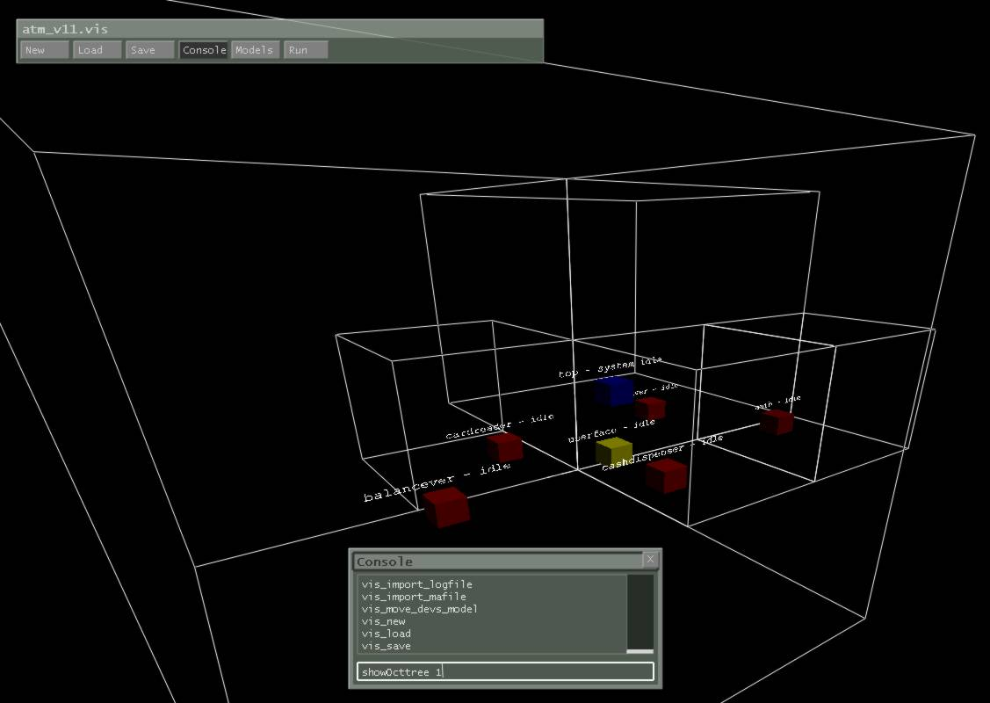
Figure 21: The ATM visual models and their assigned octtree regions. The octtree regions are outlined by the white lines.

4.4.2 Bouncing Ball Simulation
This simulation shows three balls contained in a 2d grid which bounce of the walls. Figure 22 shows a composite of the visualization during playback. The image shows the motion of the balls in the 2d grid. The visualization was created using the same methods as in the ATM visualization. Consult Appendix D for information concerning the creation of visualizations in DEVSView.
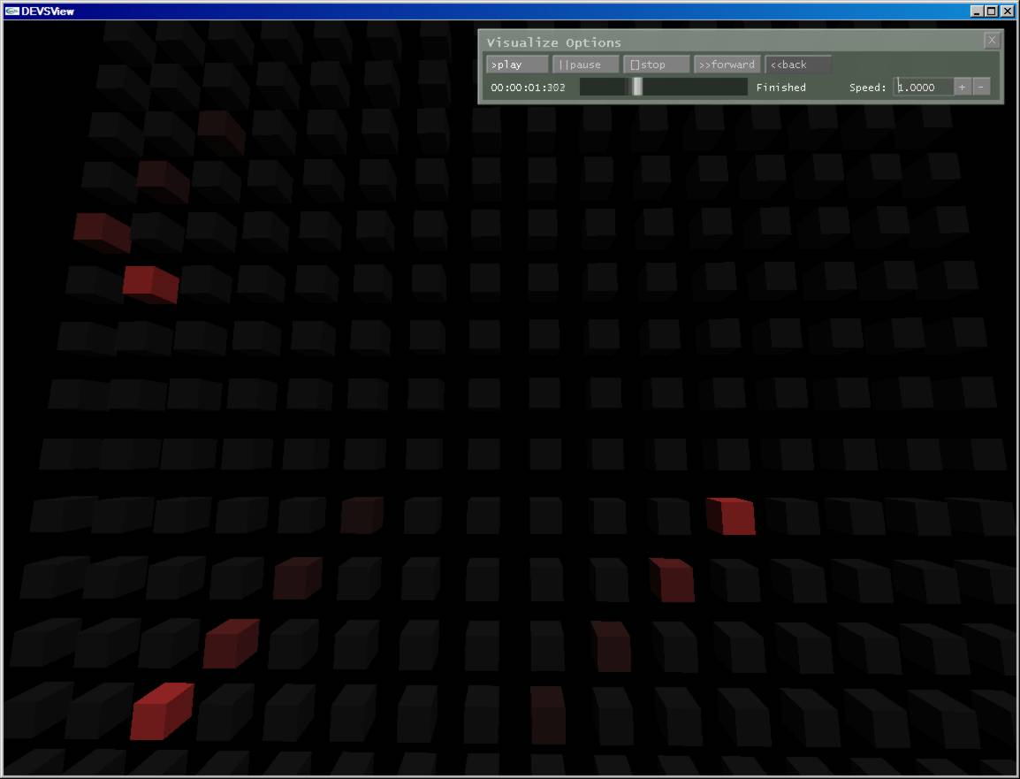
Figure 22: A composite of several frames in the bouncing ball simulation.

5 CONCLUSION
The DEVSView tool provides facilities for creating visualizations of CD++ simulations, which are based on the Devs formalism. The tool reads CD++ simulation log files to create the visual models needed to visualize the simulation. The visual models have visual state transition systems which define how the simulation models are graphically represented during visualization. The visual models also have event animation rules to create animations when certain events occur. These constructs provide the methodology required to visualize Devs or CELL-Devs models. The tool provides a user interface and file format to create these constructs, and several visualizations have been successfully created with the DEVSView tool.
There are several important features that could potentially increase the utility of the DEVSView tool.
- An interface to scripting languages for complicated Value rules, Entry methods, Exit methods, and other state machine operations.
- Maya model loading for complex graphical objects
- Environment detail objects. Terrains, Backdrops, etc
- Cell model alignment and per cell position manipulation. With this feature, one dimensional cell models could be aligned to lines, 2D cell models could be aligned to planes, and 3D cell models could be aligned to containers.
- Multiple camera views and point and click object selection.
- Simulation statistics display
- Graphical visual state machine editing
- Interfacing to a running CD++ simulation for interactive simulations
DEVSView could also benefit from many user interface improvements. The visualization facilities of the DEVSView tool are quite basic, but provide the beginnings of a powerful tool.
References

[1] Wainer, G. 2002. CD++: A toolkit to develop DEVS models. Software, Practice and
Experience 32(3):1261-1306.
[2] Wainer G, Chen W. 2003. A Framework for Remote Execution and Visualization of
Cell-DEVS Models. SIMULATION, Vol. 79, Issue 11.
[3] Mark J. Kilgard. 1996. The OpenGL Utility Toolkit (GLUT) Programming Interface :
API Version 3. Available: http://www.opengl.org/resources/libraries/glut/glut-3.spec.pdf
[4] Gil Gribb, and Klaus Hartmann. 2001. Fast Extraction of Viewing Frustum Planes
from the World-View-Projection Matrix. Available: http://www2.ravensoft.com/users/ggribb/plane%20extraction.pdf
[5] Mark Segal, and Kurt Akeley. 2004. The OpenGL Graphics System: A Specification.
Available: http://www.opengl.org/documentation/specs/version2.0/glspec20.pdf

Appendix A: Use Case Descriptions
Name: Link to Simulation
Description:
The user chooses to link to a simulation through a log file or a .ma file.
The use case Create Visual Model is invoked for the source and destination models of each event read.
The use case Create Event is invoked for each event read.

Name: View Simulation
Description:
The program commences viewing of the simulation results.
The controls for manipulating the progress of the simulation are exposed to the user.

Name: Edit Visual Models
Description:
The program provides a user interface for editing how the visual models appear during visualization

Name: Create Visual Model
Description:
The program creates a new model representing a corresponding Devs model
A default visual state is created for the visual model
Adds the model to model list

Name: Create Event
Description:
The program creates an event from data received from the simulation link
Adds the event to the event list

Appendix B: Class Diagrams
DEVSViewDisplay Class Diagram

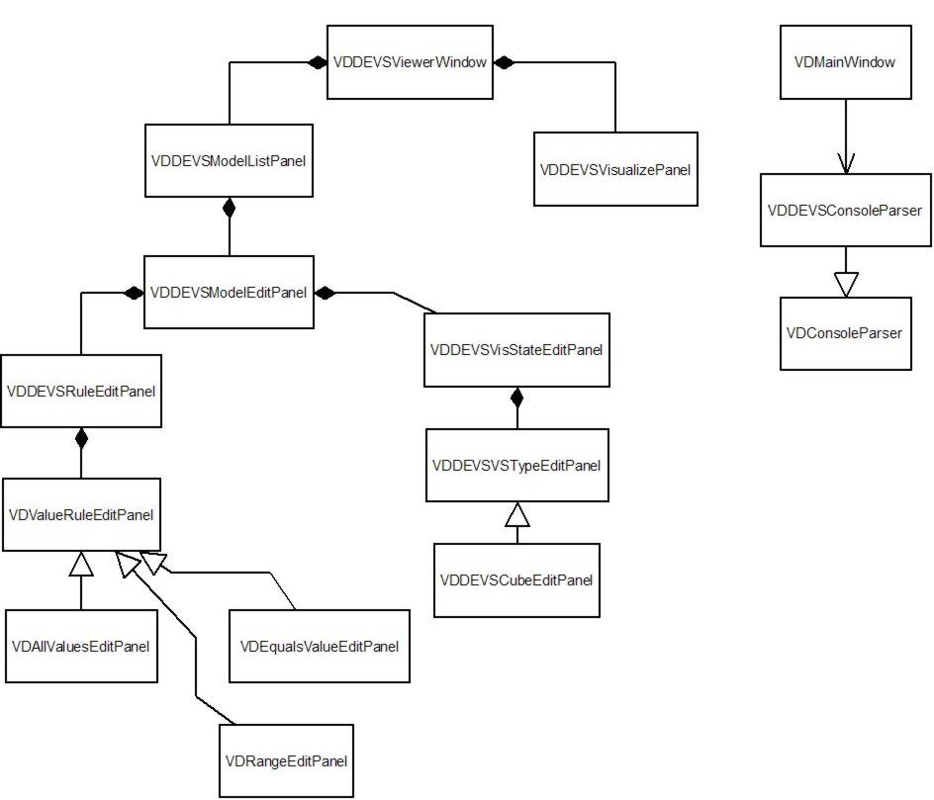
ViewerControl Class Diagram

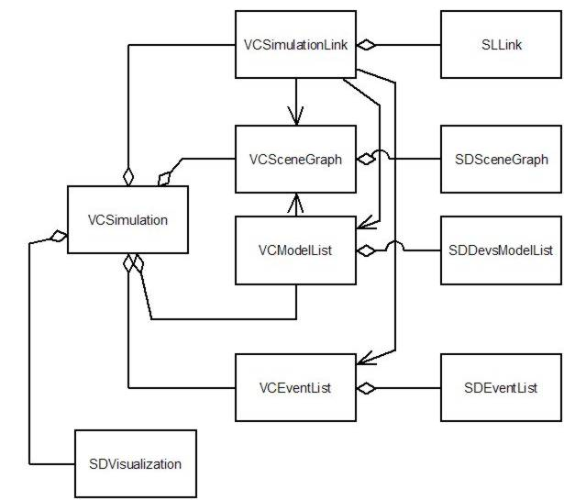

SimulationLink Class Diagram

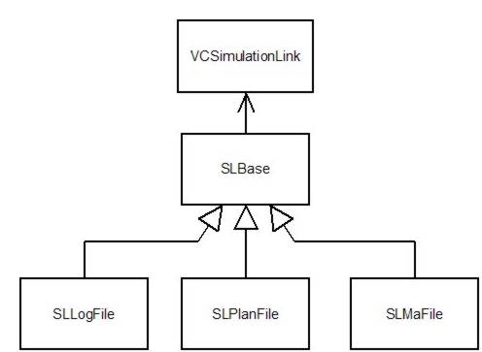
SimulationDatabase Class Diagram

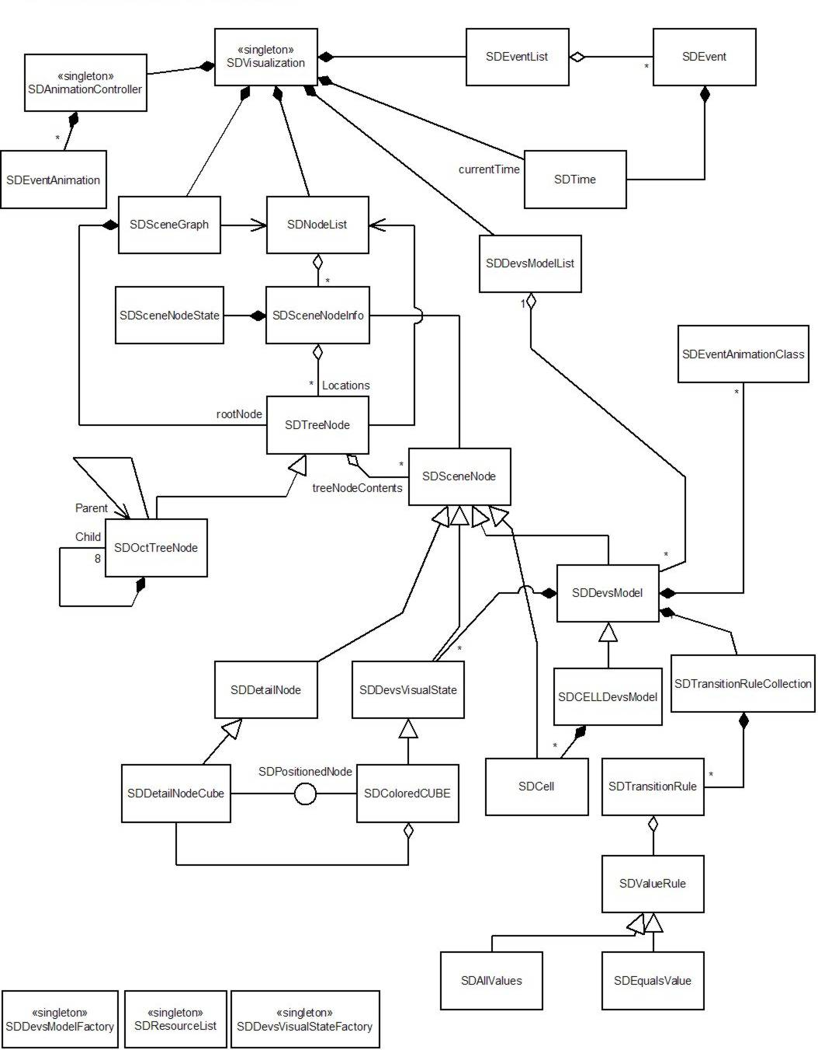
ViewerDisplay Class Diagram

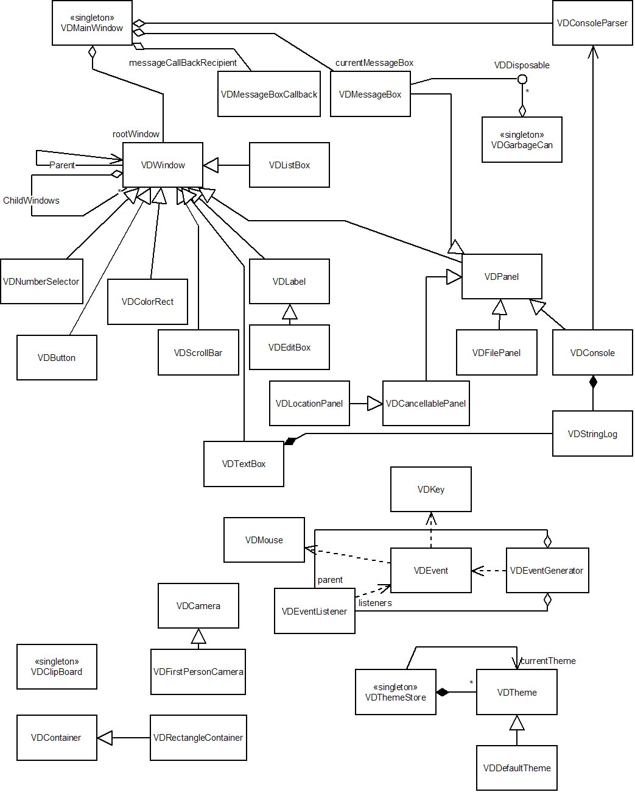

Appendix C: Visualization file format (.vis extension)
The file consists of blocks of information. Each block may contain one or more blocks or it may be basic block which simply contains a basic C++ type.

In the following descriptions:
    - ‘$’ indicates a variable string which contains no spaces.
    - ‘Left || Right’ indicates a choice between two options
    - ‘…’ indicates the contents of a complex block repeats.
    - ‘---‘ indicates the contents of a complex are defined elsewhere.

All blocks begin with ‘{$BlockName’ and end with ‘}’.

Basic Blocks
Example Basic Blocks:
{Name S TestName}
or
{Age I 86}
or
{Probability F 0.5}

Each basic block is of the form:
{$VariableName $Type $Value}

$VariableName is a sequence of characters without spaces.

$Type is one of the following single characters:
‘S’ – a string type
‘I’ – a signed integer
‘U’ – an unsigned integer
‘F’ – a single precision floating point number
‘D’ – a double precision floating point number
‘B’ – a Boolean value

Depending on the value of $Type, the contents of $Value may follow different formats.
If $Type = ‘S’
$Value = A sequence of characters without a space. A ‘}’ followed by a ‘_’ is a special sequence for indicating a space. Two sequential ‘}’ characters are converted to a single ‘}’.
If $Type = ‘I’
$Value = Any string capable of being converted to an integer using the ANSI C sscanf method.
If $Type = ‘U’
$Value = Any string capable of being converted to an unsigned integer using the ANSI C sscanf method.
If $Type = ‘F’
$Value = Any string capable of being converted to an single precision floating point number using the ANSI C sscanf method.
If $Type = ‘D’
$Value = Any string capable of being converted to an double precision floating point number using the ANSI C sscanf method.
If $Type = ‘B’
$Value = ‘F’ for false, and ‘T’ for true.

Complex Blocks
Complex blocks contain other simple or complex blocks.

Example Complex Blocks:
{Color
{Red F 0.5}
{Green F 0.5}
{Blue F 0.2}
}
or
{Car
{Type S Schmord}_Boxcar}
{Wheels U 4}
{Doors U 2}
}

Each complex block is of the form:
{$BlockName
… SubBlocks …
}

Visualization File Format:
The visualization file consists of a complex block named ‘Visualization’. The ‘Visualization’ block consists of the basic block ‘Version’ of type float. The other blocks ‘ModelList’ and ‘EventList’ consist of ‘Model’ and ‘Event’ complex blocks.

{Visualization
{Version F $Version }
{ModelList
{Model
---
}
…
}
{EventList
{Event
---
}
…
}

Model Block Format:
The model block contains a visual model. The model ‘Type’ string can either be Normal or Cell. The ‘ModelProp’ block specifies the properties of the visual model. These include the ‘Id’ string, the ‘NextRuleId’ unsigned integer (which should be one greater than the last transition rule id), the ‘NextStateId’ unsigned integer(which should be one greater than they last visual state id), the ‘NextEAFId’ unsigned integer(which should be one greater than the last event animation factory id), the ‘Position’ vector, the “InputPorts” list of strings, the “OutputPorts” list of strings, and the visual states, transition rules, and the event animation factories.

{Model
{Type S Normal || Cell}
{ModelProp
{Id S $Name }
{NextRuleId U $NextRuleId }
{NextStateId U $NextStateId }
{NextEAFId U $NextEventAnimationFactoryId }
{Position
{X F $XCoord }
{Y F $YCoord }
{Z F $ZCoord }
}
{InputPorts
{InputPort S $PortName }
…
}
{OutputPorts
{OutputPort S $PortName }
…
}
{VisualStateList
{VisualState
---
}
…
}
{TransitionRuleList
{TransitionRule
---
}
…
}
{EventAnimationFactoryList
{EventAnimationFactory
---
}
…
}
}
}

Visual State Block Format:
The Visual state block defines a visual state for a visual model.

{VisualState
{Properties
{Id U $StateId }
{Label S $StateLabel }
{Type S ColoredCube || Formula }
{Variables
---
}
}
}
If the value of ‘Type’ is ColoredCube the ‘Variables’ complex block is defined as:
{Variables
{Color
{R F $RedValue}
{G F $GreenValue}
{B F $BlueValue}
}
}
where each red, green or blue value ranges from 0.0 to 1.0.

If the value of ‘Type’ is Formula the ‘Variables’ complex block is defined as:
{Variables
{Formula S $Formula}
}
where the formula is a standard text string which can include printf style %f to display the event value which triggered the entry to the visual state.

Transition Rule Block Format:
The Transition rule block defines a transition rule for a visual model. Depending on the type of the ValueRule there may be other values defined in the ValueRule complex block.

{TransitionRule
{Properties
{DestinationState U $StateId }
{Id U $RuleId }
{PortDirection U 0 | 1 }
{PortName S $PortName }
{StartState U $StateId }
{ValueRule
{Type S $ValueRule }
}
}
}

For the ‘PortDirection’:
0 = Input
1 = Output

Other Value Rule Block Formats:
{ValueRule
{Type S Equals}
{Value D $Value}
}
or
{ValueRule
{Type S Range}
{HigherVal D $Value}
{LowerVal D $Value}
}

Event Animation Factory Block Format:
This block specifies an event animation factory for a visual model. The only factory type currently supported is the Text type. The following complex block corresponds to the block which defines a text event animation factory.

{EventAnimationFactory
{Properties
{Type S Text }
{Id U $AnimationFactoryId }
{PortName S $PortName }
{PortDirection U 0 | 1 }
{Source S $SourceStateId }
{AnimationLength D $Length }
{ValueRule
{Type S $ValueRuleType }
}
{Formula S $Formula }
{Start
{X F $StartX }
{Y F $StartY }
{Z F $StartZ }
}
{End
{X F $EndX }
{Y F $EndY }
{Z F $EndZ }
}
}
}

Event Block Format:
The events are defined in the ‘EventList’ list. They can either be ‘Ext’ (External) or ‘Out’ (Output) events. The time is specified in the ‘Time’ complex block. The time string is of the format “HH:MM:SS:mmm” where H = Hours, M = minutes, S = seconds, and m = milliseconds.

{Event
{Type S Ext || Out }
{Time
{Val S $TimeString }
}
{Src S $SourceModelName }
{Port S $PortName }
{Val D $ValueSent }
{Dest S $DestModelName }
}

Appendix D: DEVSView Tutorial
The following is a step by step tutorial for creating a visualization in DEVS. This tutorial shows the steps required to create the bounce visualization described in Section 4.4.2.

- Copy the bounceLOG.log and bounceMA.ma file from the bounce simulation directory to the DEVSView directory.
- Start DEVSView. If the console is not already open, open it by pressing ~ or clicking on the console button.
- Create a new visualization by entering the command ‘vis_new bounce’
- Import the log file by entering the command ‘vis_import_logfile bouncelog.log’
- Import the .ma file by entering the command ‘vis_import_mafile bouncema.ma’
- Verify the events were loaded correctly. Enter the command ‘print VIS_EL’, you should see a list of the events loaded from the log file.
- Verify the model was loaded correctly. Enter the command ‘print VIS_ML’, you should see the Cell-DEVS model rebota listed, with the dimensions (16, 20, 1), input ports: /initial and out, output ports: out, neighbourchange
- Save the file as bounce by entering the command ‘vis_save bounce’
- Open the file bounce.vis in wordpad (it handles the end of lines better than notepad).
- Verify the file has the blocks described in Appendix C
- Search for ‘CellSpaceSize’ and set the values of ‘X’, ‘Y’, and ‘Z’ in the complex block to 25.0, 25.0, and 1.0 respectively. The result should look like this:
{CellSpaceSize
{X F 25.0 }
{Y F 25.0 }
{Z F 1.0 }
}
- Search for ‘Label’ and the set the value of ‘Label’ to ‘}0’ (The ‘}0’ sequence is equivalent to an empty string). The 3d text drawing implementation is currently too slow to use with a large cell space, so erasing the label speeds up the program significantly. The result should look like this:
{Label S }0 }
- Save the file and return to DEVSView
- Load the bounce visualization file by entering the command ‘vis_close’ followed by ‘vis_load bounce’
- Click on the Models button in the toolbar. Select the rebota model and click on the ‘Edit…’ button.
- Click on the ‘Add…’ button next to the visual state list. Erase the label of the visual state in the Visual state edit panel that pops up. Set the color of the visual state to red (Red=1.0,Green=0.0,Blue=0.0)
- Select the first visual state in the list (The one that you didn’t just set to red). Click on the ‘Edit…’ button next to the visual state list. Set the colour of this visual state to a dark grey(Red=0.1, Green=0.1, Blue=0.1)
- Add a transition rule by clicking on the ‘Add…’ button next to the transition rule list.
- Select S2 in the ‘Go to State’ list. Select ‘Any’ from the ‘If in State’ list. Select ‘out (O)’ (the O means its an output port) from the port list. Select the ‘Range of Values’ option from the ‘If this rule is triggered’ list. For the lower value select 0.01, for the upper value select 20.0. This creates a rule which transitions the cell visual state from black to red whenever a cell outputs a value from 0.01 to 20.0. A cell space is occupied by a ball if its number is greater than 0.
- Add another transition rule, which transitions from S2 to S1 if the cell outputs a value of 0.0 on the ‘out (O)’ port.
- Save the visualization
- Close the Model edit panel and the model list panel. Click on the Run button in the toolbar.
- Use ‘W’, ‘A’, ‘S’, ‘D’ to move the camera. Left click on the window and drag the mouse to rotate the camera.
- Press play to view the visualization. You should see an animation similar to what is shown in Figure 22.

