DEVSView Performance Evaluation
Wilson Venhola
1.1 Profiling DEVSView

The program selected for profiling is a visualization tool for discrete simulations. The tool is a C++ program that interacts with OpenGL to display visualizations in three dimensions. It is a tool I developed for the requirements of my fourth year project.
The tool is an event driven program and the ‘null’ scenario consists of starting the program and exiting the program by pressing escape to request an exit and then confirming the exit in a confirmation dialog.

1.2 Performance Measurements of the ‘null’ Scenario

Profiling the ‘null’ scenario produces the call graph in Figure 1. This call graph shows the 3 main time consuming sections of the program, and portion of the functions that they call.
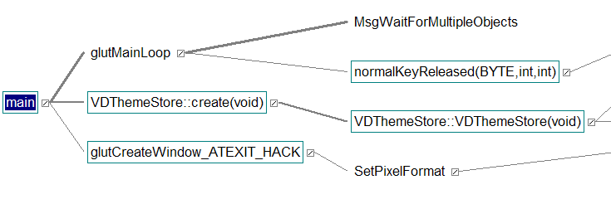
Figure 1: Call graph for 'null' scenario, boxes show functions with source

The first method glutMainLoop is the event driven loop of the program. A large portion of the time in this loop is spent waiting for events in MsgWaitForMultipleObjects. The other portion of glutMainLoop is the time spent responding to the few events in the ‘null’ scenario. Shutting down the system after the exit request takes the majority of the normalKeyReleased F + D time. Figure 2 shows the function time information for the normalKeyReleased function and Figure 3 shows the details of the messageBoxResponse function which takes the majority of the normalKeyReleased descendant time.

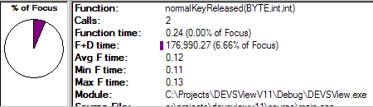
Figure 2: 'normalKeyReleased' function details
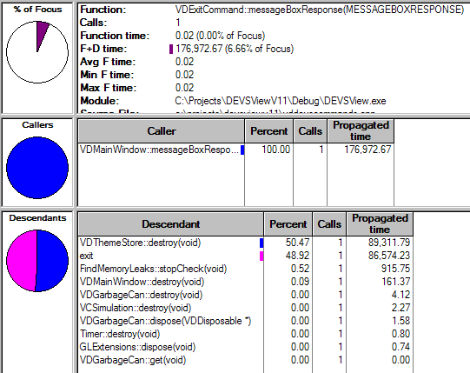
Figure 3: The messageBoxResponse method details

The other two methods, VDThemeStore::create and glutCreateWindow_ATEXIT_HACK, take the majority of the other time in the ‘null’ scenario. Figure 4 shows the ratios of their processing time.

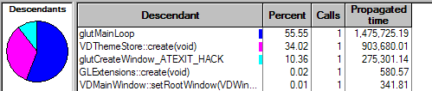
Figure 4: The three important descendants of main
The VDThemeStore::create method creates three dimensional fonts with the OpenGL font routines. This method takes the majority of the theme creation time, as seen in figure 5. This time cannot be reduced since the code is a part of the OpenGL library.

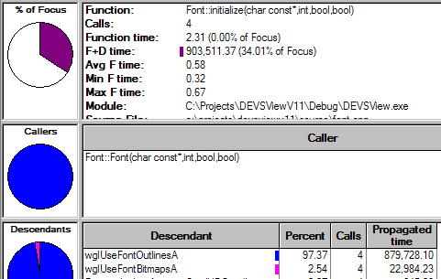
Figure 5: Initializing font time for the themes

The glutCreateWindow_ATEXIT_HACK method creates the window used to display the OpenGL rendering. This takes the other 10% of the programs running time.

  - Inspecting the import log file feature of DEVSView

DEVSView loads the results of simulations by parsing their output in the form of log files. This section will profile the operation of this task using a 238K log file.

The scenario consists of:
- Running DEVSView.exe
- Creating a new visualization
- Importing the 238K log file
- Exiting the program

    - Performance Report

2.1.1.1 Scenario Length

Elapsed Time: 71984 ms
Total Measured F + D time: 11128 ms

The elapsed time of the scenario is significantly higher than the actual measure elapsed time of the program, which shows the overhead required to do the profiling. This overhead may be this high because each line of C++ code was timed in the run.

2.1.1.2 Significant Methods

This section will list and describe the methods which take a significant amount of time in the run. The methods described in the ‘null’ scenario will not be listed since they have been discussed already.

A large amount of time is spent in the MsgWaitForMultipleObjects method. This can be seen from the breakdown of the glutMainLoop method or directly from the thread status shown in Figure 6.

Figure 6: The main thread shows the large amount of time spent waiting for IO or blocked
However, other methods in the program can hog the time spent while not waiting for IO or blocking. These methods are found under VDConsole::processEvent as shown in Figure 7.

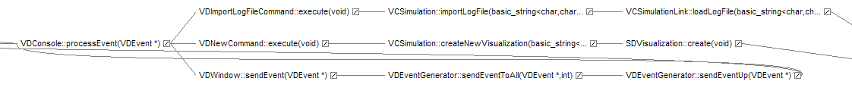
Figure 7: processEvent methods

The VDNewCommand::execute creates a new visualization. Creating a new visualization involves a font initialization method just like the VDThemeStore::create method. Figure 8 shows how creating a visualization is dominated by the creating the resource list, which is dominated by the font initialization method.

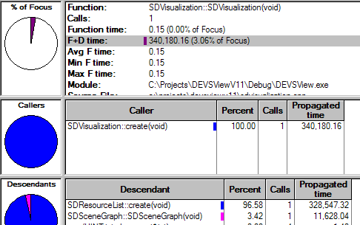
Figure 8: The SDVisualization::create time is dominated by the resource creation

The remaining method times to examine are the times for parsing the log file input. The parsing is done line by line. After parsing a line, it is converted to an event. The source and destination DEVS models of the event are converted to a possible visualization model, and the event is added to a list in the visualization.

The line parsing method descendants are shown in figure 9.

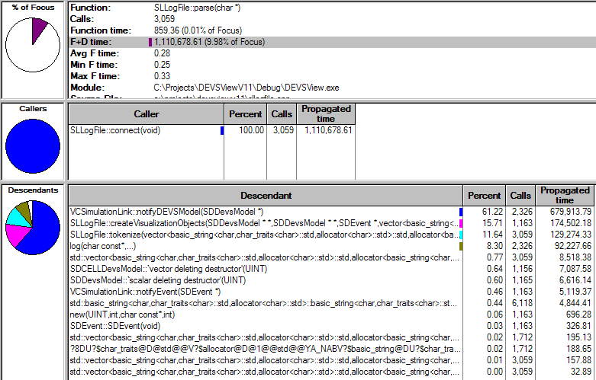
Figure 9: parse method breakdown

The notifyDEVSModel method and its descendants are the largest hogs in the log file parsing code. The descendant that takes the most time is the method VCModelList::addModel.
The length of the log file affects the number of calls to VDModelList::addModel. For each line in the log file, two models are passed to addModel. The main time hogs in VDModelList::addModel is the DEVSView logging method. Each cell model passed to the addModel method is logged. As seen in Figure 10, the method which comprises the majority of the time in addModel is SDCELLDevsModel::log.

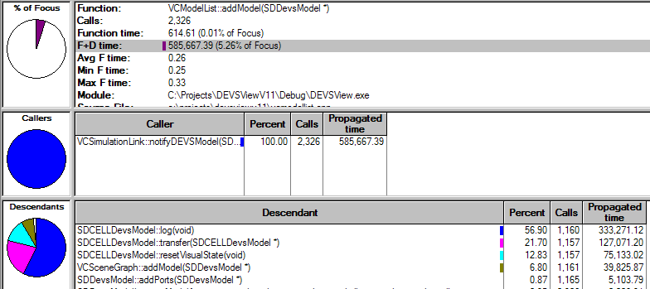
Figure 10: VCModelList::addModel details
The other methods SDCELLDevsModel::transfer and resetVisualState are dependant on the size of the cell model. The dimensions of the cell model in the log file was 4 x 4 x 4 cells in size. If the size of the model increased, this could dominate the processing time used in the parse method because the log method doesn’t depend on the cell model size.
Improvements in the design of the log file parsing would reduce the calls to transfer and resetVisualState. These methods are not really necessary until after the entire log file is completed. Clearly the log method is not necessary, performance of the log file parsing is still mainly limited by waiting for IO with smaller cell models. However, I ran a scenario with a 2.5MB log file for a simulation involving a 40x20x10 cell model and the waiting for IO was no longer the limiting factor. This indicates the methods transfer and resetVisualState should be avoided if possible. To code this change will involve a design change in the parsing method, and is too complicated to list in this document.

2.2 Visualizing the game of life simulation with DEVSView

DEVSView visualizes the information parsed from a log file according to various rules set up in the GUI or hand coded in the visualization file. This section will profile the task of displaying a previously created visualization for the results of a game of life simulation.

The scenario consists of:
- Running DEVSView.exe
- Loading the game of life visualization
- Playing the visualization once
- Exiting the program

This scenario is dominated by the time spent rendering the visualization and waiting for the video card to finish rendering and swap buffers. This can be inferred from the results shown in figures 11 and 12. The main thread spends most of its time blocking waiting for something, and the only device it is using at that point is the video card driver.

Figure 11: Main thread mostly blocked during visualization
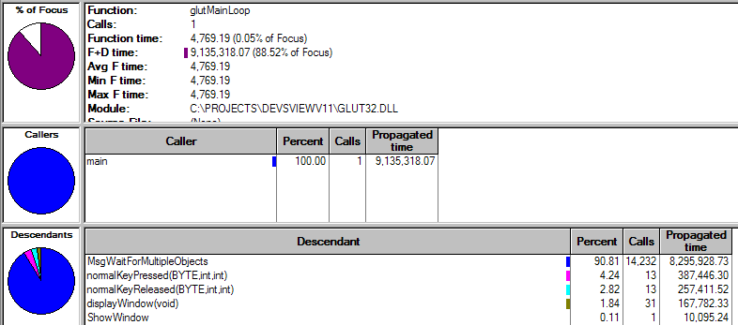
Figure 12: The main loop is mostly spent waiting for the rendering to finish
So it appears the program is limited with by the rendering time of the video card. We can still look at the actual processing time spent each frame of the visualization. The method which updates the visualization each frame is SDVisualization::incrementTime. Figure 13 shows the breakdown for incrementTime and the percentage of focus shows how really little processing work it takes to update this particular visualization each frame. The focus was set to the root when the screen shot was taken.

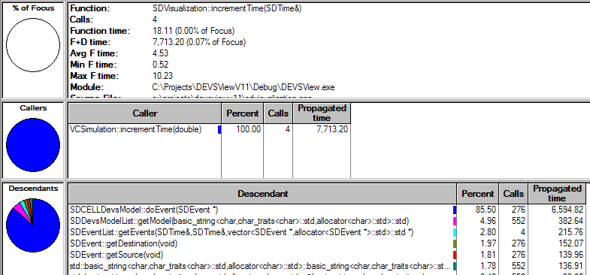
Figure 13: updateTime method breakdown
The doEvent method provides an event for a cell model to update its visual appearance. Figure 14 shows how the doEvent method workload breaks down. Similar to the SDVisualization::addModel method, logging methods in SDCELLDevsModel::doEvent occupy most of the time.
SDCELLDevsModel::doEvent is called for each event parsed in from a simulation log file when that event fires. The processing time of the incrementTime method is proportional to the number of events firing from the end of the last frame to this frame.

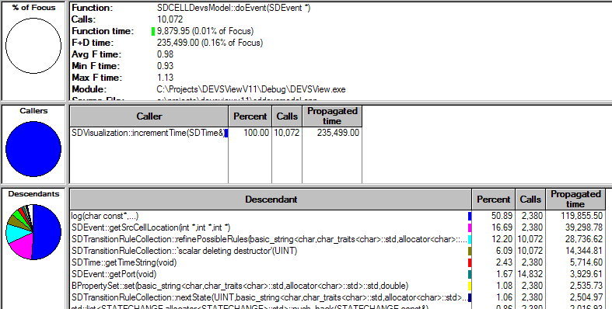
Figure 14: The doEvent method descendants

The processing time of the doEvent method is proportional to the number of transition rules specified in the visual model. Each transition rule must be checked to see if the event triggers that rule. The incrementTime method is therefore proportional to M * ( (R_{src} + R_{dest}) + 2*log(N) ), where M is the number of events in the time slice, R_{src} and R_{dest} are the number of transition rules for the models specified in the event, and N is the number of models in the model database which is a log(N) find operation.
To improve the performance of this component of the visualization, the log statements should be removed, the transition SDEvent::getSrcCellLocation method should be done once when the event is created and the result stored in three integers in the object. The source code for getCellLocation is listed in figure 14.

bool SDEvent::getCellLocation( int* x, int* y, int* z, string location )
{
// Check if its a CELL-Devs model by searching for another '('
unsigned int start = (unsigned int)location.find_last_of("(");
unsigned int right = (unsigned int)location.find_last_of(")");
if( start != string::npos)
{
// Found a CELL devs model
// Store the coordinates of this model
vector<string> coords;
StringHelper::tokenize(&coords, location.substr(start, right), string("(,)"));

// Get the location
*x = 0; *y = 0; *z = 0;
if( coords.size() > 0 )
sscanf(coords[0].c_str(), "%d", x);
if( coords.size() > 1 )
sscanf(coords[1].c_str(), "%d", y);
if( coords.size() > 2 )
sscanf(coords[2].c_str(), "%d", z);

return true;
}

return false;
}
Figure 14: The source code for getCellLocation

After the resulting integers are stored in the event class the call to getCellLocation will be reduced to the overhead of a get method which could easily be inlined. This change can be verified by measurement.
However, altering the source code may introduce memory issues with visualizations that have a large amount of events.

