GIS-Based Algorithms in Support of Post-Earthquake Fire Spread Modeling

Selina W. Lee¹, Rachel A. Davidson², and Arthur J. Lembo, Jr.³

¹Graduate Student, School of Civil and Environmental Engineering, Cornell University, Ithaca, NY. swl8@cornell.edu
²Associate Professor, Dept. of Civil and Environmental Engineering, University of Delaware, Newark, DE, rdavidso@udel.edu
³Assistant Professor, Dept. of Geography and Geosciences, Henson Science Building, Room 157H, Salisbury University, Salisbury, MD 21801, ajlembo@salisbury.edu

ABSTRACT

Post-earthquake fires can cause substantial damage, sometimes developing into conflagrations that can dominate the losses in an event. This paper describes two new GIS algorithms developed to facilitate development of a new physics-based post-earthquake fire spread simulation model. The first estimates a reasonable configuration of rooms within a given building footprint, so that room-based spread models from the compartment fire literature can be adapted for use in post-earthquake fire spread modeling. The second identifies, for each external building wall, the closest external wall of a neighboring building that is within a clear line of sight and therefore is likely to be the primary target of radiation from a fire in the original building. The algorithms were applied to a seven sq. km. case study area in Los Angeles with more than 4,000 buildings and their performance is evaluated.

INTRODUCTION

In the aftermath of a significant earthquake, it is common for multiple fires to ignite simultaneously throughout an urban area as a result of, for example, electric arcing due to short circuits, disrupted gas flames on appliances, and overturned candles (Scawthorn et al. 2005). Exacerbating the problem, these ignitions occur at the same time that fire suppression capabilities are impaired due to damage to water supply systems, communication networks, roads, and fire defenses (e.g., firewalls, sprinklers), and injuries to fire service personnel. The result can occasionally be conflagrations that cause substantial damage, sometimes even more than the earthquake ground shaking itself. In the United States, following the 1906 San Francisco earthquake (M7.8), fire destroyed 492 city blocks and killed more than 3,000 people (Scawthorn et al. 2006). In fact, fire played such a dominant role that the event was also known as the Great San Francisco Fire. In New Zealand, the 1931 Hawke’s Bay earthquake (M7.8) caused an urban conflagration in Napier (Cousins et al. 2002). More recently, after the 1995 Kobe, Japan Earthquake (M6.9), 148 fires were reported in the first 3 days, and fires ultimately caused 500 deaths, and damage to 6,900 buildings in 0.66 sq. km. (Chung et al. 1996). Since damaging earthquakes are rare, computer models of post-earthquake fire spread can be very useful for helping to estimate, understand, reduce, and prepare for post-earthquake fire losses. The spatial configuration of buildings is critically important in determining the likelihood of spread through a region, and thus, such models lend themselves to analysis in a GIS environment.

In this paper, we introduce two new GIS algorithms we developed to enable creation of a new post-earthquake fire spread model. The first algorithm partitions building footprints into reasonable estimations of room areas. The second identifies, for each external building wall, its facing wall, i.e., the closest external wall of a neighboring building that is within a line of sight and therefore is likely to be the primary target of radiation from a fire in the original building. These algorithms, which were developed in Manifold 8.0 using Visual Basic Scripting language, were critical in enabling implementation of a new approach to post-earthquake fire spread modeling. The room partitioning method allows automated estimation of reasonable room configurations so that room-based fire spread models can be employed while the method can still be applied to a large urban region. The facing wall method facilitates rigorous calculation of configuration factors, which determine how much of the radiation emitted from a building fire is received by neighboring buildings.

Previous forest and post-earthquake fire spread modeling efforts are summarized in the next section with an emphasis on GIS issues. The new post-earthquake fire spread model developed by the first two authors is then presented briefly, followed by descriptions of the two new GIS algorithms. The paper concludes with descriptions of application of the algorithms for a case study area in Los Angeles, and evaluations of the algorithms’ performance for that application.

Background on fire spread modeling

Forest Fire Modeling

Many fire spread models using GIS have been developed and are in use currently, but the vast majority relate to the spread of forest (also known as wildland) fires (Lee and Davidson 2006). The basic physical laws governing fire spread are, of course, the same for different types of fires, and forest and post-earthquake fires are similar in their regional scale (as opposed to compartment fires, for example, which are confined to one or a few rooms within a building). Nevertheless, there are some important differences between forest and post-earthquake fires in the relative importance of different issues, and importantly, in the type and arrangement of fuel. The fuel in forest fires is trees and other vegetation. In post-earthquake fires, which spread through urban areas, it is mostly buildings and their contents. Urban areas are made of a heterogeneous mix of building types, separated by roads, parks, and other features. From a GIS perspective, the consequence of this difference is that forest fire simulation models have been predominantly raster-based, whereas post-earthquake fire models are often vector-based.

Many available forest fire models use a cellular automata-based simulation technique, which lends itself to a raster-based representation (e.g., Clarke et al. 1994, Ntaimo et al. 2004, Muzy et al. 2005). Some forest fire simulation models use an elliptical wave propagation technique (e.g., Wallace 1993, Finney 1997), in which the fire front is defined by a set of points, each of which is treated as an independent source of a small elliptical wave. Those models typically use a mix of raster- and vector-based representations. In the FIRE! model, for example, the fire perimeters are treated as continuous vectors, but rasters are still used to represent the underlying landscape (Green et al. 1995). By contrast, if a vector-based approach is used for post-earthquake fire spread through an urban area, each building can be considered a separate vector-based object and the true building footprints and relative orientations, which are important factors in fire spread, can be represented more accurately.

Post-Earthquake and Urban Fire Spread Modeling

Hamada (1951) provided the earliest post-earthquake fire spread model. It assumes that the built environment is comprised of equally-spaced, equal-size square urban blocks of buildings, and that fire spreads in an elliptical shape (Figure 1). It provides empirical equations defining the speed of spread in the upwind, downwind, and crosswind directions as functions of wind speed, average building size and separation, built-upness factor, and building types. Until about 2000, subsequent spread models adapted Hamada’s equations but kept the same basic approach and assumptions (e.g., Scawthorn et al. 1981, FEMA 1999). Recently, several efforts have moved to a physics-based approach that recognizes the different modes of fire spread (e.g., radiation, branding) and represents each separately, adapting models from the compartment fire literature based on physical laws and empirical data (Lee et al. 2008). The physics-based approach has several benefits. Cities are less homogeneous than assumed by Hamada, and while a fire typically has an elliptical shape initially, that does not last as it encounters different fuel loads, suppression efforts, and other fires. Physics-based models are more generally applicable across regions and times; are better grounded in theory so that more accurate estimates of fire spread can be expected; and provide results at a higher resolution. Since the factors contributing to spread are represented explicitly, they can easily be varied to gain insight into how fire spreads and into the effects of specific risk reduction strategies.

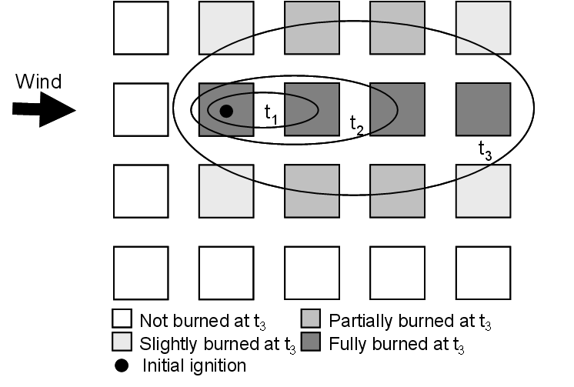
Figure 1. Hamada post-earthquake fire spread model (based on Scawthorn et al. 2005)

A couple of the newer physics-based models use cellular automata with 3m by 3m grid cells (Cousins et al. 2002, Ohgai et al. 2004), but some (e.g., Iwami et al. 2004, Himoto and Tanaka 2008) use a vector-based approach in which each building is a vector object (Lee et al. 2008). While cellular automata is a reasonable approach that can simplify analysis, it does not allow direct implementation of compartment fires models since individual compartments are not represented. Two simplifications are common among vector-based physics models. First, they often either simplify building geometries, assuming they are simple, sometimes equally-sized rectangles or treating an entire building or floor as a compartment. Second, they treat flames and hot gases emitted from a room window as a point source that emits radiation, vastly simplifying the calculation of the configuration factors that determine what percentage of emitted radiation is received by neighboring buildings. As explained in the next section, the new post-earthquake fire spread model uses the GIS analysis described herein to avoid those simplifications.
New post-earthquake fire SPREAD model

The objective of the new fire spread model is to simulate the evolution of fires in an urban post-earthquake environment for use in estimating expected fire damage and losses, gaining insight into the relative importance of factors in the risk, and evaluating potential risk reduction strategies. The model takes as input digitized footprints and other attributes of buildings in the study region. Ignition and wind data are either input by the user or simulated. Detailed results, such as percentage of area burned in each building at each time t, and relative frequencies of the modes of spread are calculated, including randomness in the process. Lee and Davidson (2008a, b) detail the model; here we briefly summarize it, focusing on the features most relevant to the GIS analysis.

The physics-based model includes several modules, representing the primary modes of urban fire spread (Figure 2, Lee and Davidson 2008a): (1) evolution of fire within a room or roof; (2) room-to-room spread within a building through doorways to adjacent rooms, by burn-through to adjacent rooms or a room or roof above, or by leapfrogging through windows to a room or roof above; and (3) building-to-building spread by flame impingement and radiation from window flames, radiation from room gas, radiation from roof flames, and branding. Convection is not included because although it can contribute to heating over short distances, it is not expected to be an important factor compared to radiation.

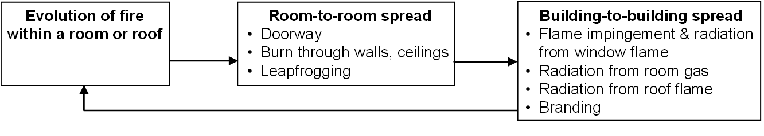
Figure 2. Modes of fire spread included in model

A room-specific temperature-vs.-time curve is used to estimate the evolution of fire within a room, as in Law and O’Brien (1981). When all combustible materials in a burning room suddenly ignite due to radiation from the hot gases in the room, the room is said to have flashed over. After flashover, the temperature and heat flux are at their highest, and the room fire is considered to be capable of spreading to other rooms and buildings. Room-to-room spread within the building is modeled probabilistically, randomly determining if open doors exist in each wall, randomly estimating a time until burn-through for each barrier based on occupancy type-dependent fire resistance ratings, and estimating leapfrogging based on window flame geometry.

When a room with a window flashes over, a flame is ejected out the window. In addition to possibly igniting the room above by leapfrogging, these window flames can cause fire to spread to neighboring buildings by actually contacting the neighboring building (flame impingement), or by emitting radiation. Hot gas ejected from the window emits radiation as well. The effect of the window flame and room gas on neighboring buildings is modeled using a method adapted from Law and O’Brien (1981): (1) estimate the geometry of the window flame and if any rooms are ignited by flame impingement; (2) estimate the configuration factors, which describe the relative positions of the window and any neighboring building that might receive the radiation; and (3) determine if the radiation received by the neighboring building due to the room gas and window flame exceed the critical ignition value.

The geometry of the window flame is described in terms of the height of the flame tip above the top of the window, the horizontal outward projection of flame from the exterior wall, and its width. The configuration factor represents the fraction of radiation emitted from the radiator that is received by the receiver. In this case, the radiator is a vertical rectangle representing either the front of the window flame or the window emitting room gas. Multiple receivers are considered, and a configuration factor is determined for each. The receivers are assumed to be the midpoints of the windows in the facing wall that are on the same floor as the radiator.

When a roof ignites, a flame develops that behaves differently from a flame ejected from a room window. Since no models are available to represent this particular situation, roof flames are treated as large, open pool fires that emit radiation as well. As with window flames, configuration factors are used to estimate the roof flame radiation received by neighboring buildings. We adapt the Mudan (1984) method to capture the effect of roof flame radiation.

Finally, branding is another important mechanism of building-to-building fire spread in post-earthquake fires. Firebrands (embers or small pieces of fuel) are entrained into the atmosphere, may be carried by winds over large distances, and when they land, may ignite the host fuel bed resulting in fire spread to an area far from the original fire. We use empirical data, primarily from Waterman (1969), to estimate the number of brands generated by size, as a function of wind and fire area, and assume they are released only during the fully-developed fire phase. We adapt the Himoto and Tanaka (2005) probabilistic model to estimate the transport of each brand. If a brand lands on a neighboring building, an empirically-based ignition probability is assumed as a function of brand size, based on Waterman and Takata (1969) and other data.

Two key differences between this new model and the few other recent physics-based post-earthquake fire models are our room-based approach and our estimation of configuration factors. While others have assumed a building, story, or 3m by 3m grid cell is the unit of analysis, we developed the GIS algorithm described in this paper to allow automated estimation of reasonable room configurations so that room-based fire spread models (e.g., Law and O’Brien 1981) can be employed while the method can still be applied to a large urban region. Second, while other models have assumed that window flames and room gases are emitted from a point source to simplify calculation of the configuration factors, we model them as vertical rectangles, with the window flame projected outward from the building façade. Automatic determination of the facing wall for each burning room window using the GIS algorithm in this paper enables determination of the multiple targets of the window flame impingement, and window flame and room gas radiation.

Partition buildings into rooms

Objectives

The goal of this algorithm is to estimate a reasonable configuration of rooms within a given building footprint, so that room-based spread models from the compartment fire literature can be adapted for use in post-earthquake fire spread modeling. Specifically, the method takes as input buildings digitized from remote sensing data, a user-specified typical room wall length, and a user-specified minimum allowable room area. The algorithm divides each building area into room areas and produces an associated data table that includes, for each new room, the ID and other inherited attributes of the building the room is a part of, the coordinates of the room’s centroid, the effective width of the room (taken to be the longest wall length), and the room area.

The process had to be entirely automated because it has to be applied to a large region containing thousands of buildings, and because it has to be repeated multiple times to allow investigation of the effect of varying the typical room dimension and resulting room configuration on fire spread. The algorithm was developed so as to ensure that rooms have realistic sizes and shapes. It assumes that room walls intersect at right angles, and that rooms are square, except at the edges of the building, where non-rectangular building footprints lead to non-rectangular room shapes. Further, it ensures that most rooms have a user-specified room wall length (and none have room walls shorter than that), and that no rooms are smaller than a minimum user-specified area.

Algorithm

The task of dividing building areas into room areas includes two subtasks. First, a local grid is created for each building area and is used to partition the building area into smaller room areas. Second, each room with less than a user-defined minimum allowable area (known as sliver areas) is merged into the neighboring room area with which it shares the longest boundary. It was thought to be potentially important to remove sliver areas for a couple reasons. Room dimensions are used in estimating the evolution of a fire within a room and long, narrow sliver areas can lead to strange results. Since the sliver areas also tend to occur on the edge of the building footprints (Figure 4a), they also create more internal, windowless rooms than may be accurate. While in reality buildings may have some odd-shaped or unusually small rooms, without the second subtask, it was thought that too many of these sliver areas were being created.

Partitioning Building Areas into Room Areas (Subtask 1). First, the building footprint (Figure 3a) is enclosed by a rectangle (Figure 3b). The boundary line around this rectangle is created (Figure 3c) and then exploded so that each side of the enclosing rectangle is a separate line (Figure 3d). Points are then created along each rectangle side (Figure 3e). Starting at one corner and moving along a rectangle side, a point is placed at a distance r from the corner, where r is the user-specified typical room wall length. Continuing along the rectangle side, another point is placed at a distance r, and the process is repeated, stopping when the next point would leave a remaining length less than r. While most rooms will have dimensions r by r, therefore, if a side of the enclosing rectangle is not an even multiple of r, some rooms will have a wall length between r and 2r. The process is repeated for the other three sides of the enclosing rectangle, making sure that the points on opposite sides line up properly to make a rectangular grid. Lines connecting points located on opposite sides of the enclosing rectangle are drawn to create a grid over the building footprint (Figure 3f). This grid is then used to divide the building area into smaller room areas (Figure 3g) using a split function. Note that if desired, the algorithm could be modified slightly so that the typical room length r varies by occupancy type.

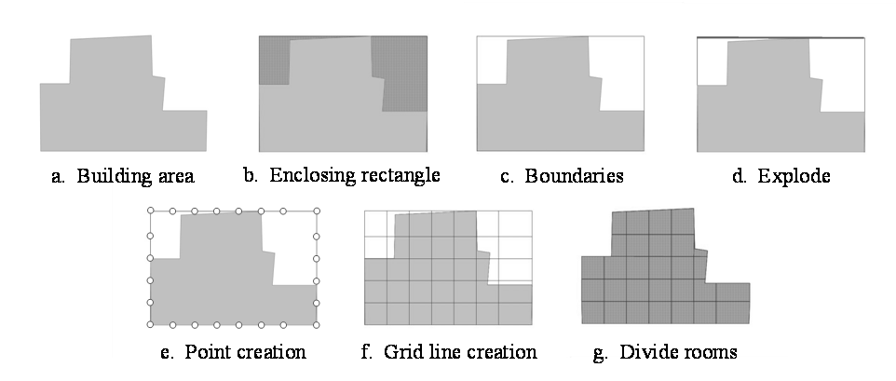
Figure 3. Algorithm to partition building areas into room areas (Subtask 1)

Merging Sliver Areas into Larger Rooms (Subtask 2). First, room areas that are less than the user-specified minimum area are selected. These areas are called slivers (Figure 4a). In the drawing’s table, a new column called “AreaID” is created and used to store the ID value of each object (Figure 4b). Then, boundaries for all room areas are created (Figure 4c) and exploded so that each side of the room boundary is a separate line (Figure 4d). For each sliver area, all lines that are touching the selected sliver area and do not have an “AreaID” value equal to the “AreaID” of the sliver area are selected (Figure 4e). From that selection, the longest line is then identified (Figure 4f) and its “AreaID” is entered into the “AreaID” field of the sliver area (Figure 4g). Lastly, all areas are dissolved and normalized based on the field “AreaID” (Figure 4h). Requiring that each sliver is merged into the neighboring area with which it shares the longest boundary helps ensure that the final rooms have regular shapes.

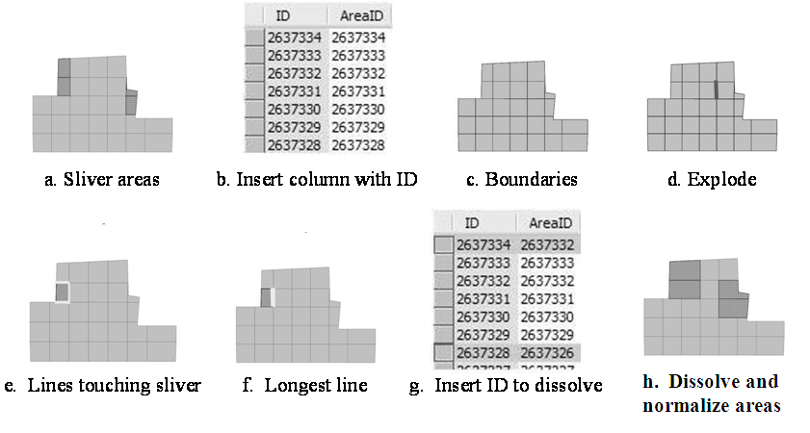
Figure 4. Algorithm to merge sliver areas into larger rooms (Subtask 2)

Determine facing building wall for each external building wall

Objectives

The goal of this algorithm is to find the facing wall associated with each external wall of a building. The facing wall is defined to be the nearest wall of another building such that a line of sight exists between its midpoint and the midpoint of the building wall of interest. Specifically, the input for this method is a drawing of the exploded building footprints (i.e., building walls). After the algorithm is run, for each building wall, its facing wall ID is found and stored as a new field. The algorithm was developed assuming that each external building wall has just one associated facing wall (although this assumption could be relaxed with minor modifications, as discussed below). Like the room partitioning algorithm, the process had to be entirely automated so that it can be applied to large region containing of thousands of buildings.

Algorithm

For each Building Wall A, all building walls within a user-specified threshold distance are identified, and the associated buildings are selected for further analysis (Figure 5a and 5b). This step ensures that in the remaining steps, building walls that are too far away to be affected by radiation emitted from a fire at Building Wall A (and therefore that are not good candidates to be its facing wall) are not considered, avoiding useless computation. Next, in the drawing’s table, the column facingNeighborWalls is added and filled with zeros (Figure 5c). A line is then drawn from the midpoint of Building Wall A to the midpoint of every other building wall and checked to see if it intersects any building areas (Figure 5d). If there is no intersection, that indicates that there is a clear line of vision between the two walls and the neighboring building wall is still a candidate facing wall (Figure 5e). The distances of the lines connecting all remaining candidate walls to Building Wall A are then compared, the one that is closest to Building Wall A is selected as its facing wall (Figures 5f and 5g), and its ID is stored in the facingNeighborWalls column (Figure 5h). After running this algorithm for all building walls within the subarea, each wall’s facing wall has been identified (Figure 5i). Building walls with a zero entry in the facingNeighborWalls column after the algorithm is run do not have a facing wall within the threshold distance that gives a clear line of vision. Note that A being the facing wall of B does not necessarily mean that B is the facing wall of A.

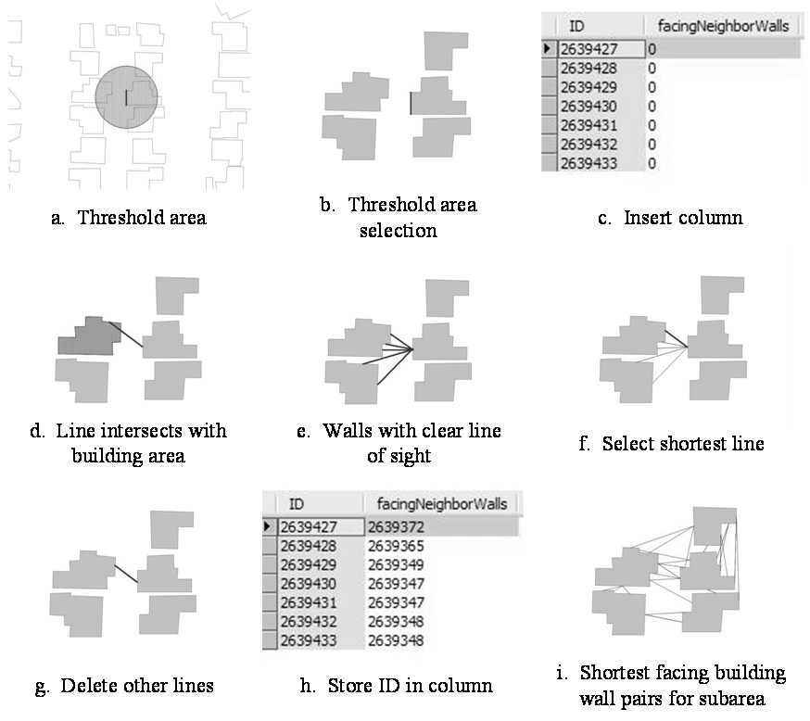
Figure 5. Algorithm to determine facing building wall for each external building wall

Case study analysis

Case study area description

The two new algorithms were applied to a case study area in Los Angeles to demonstrate how they work and assess their performance, and so that the results could be used for a case study analysis with the new post-earthquake fire spread model. The case study area is a 7 sq. km. rectangle bounded by 34°10.31’N and 34°11.48’N latitude and 118°31.33’W and 118°32.79’W longitude that includes 4,108 buildings (Figure 6). The area was selected because it includes a mix of residential, commercial, and industrial buildings, parks, major highways, and different street configurations. The digitized building footprint and other building attributes were obtained for each building from Imagecat, Inc., which developed the data using high-resolution DigitalGlobe Quickbird satellite imagery, supplemented by local and expert opinion and tax assessor’s data. The database includes the following building attributes: (1) structural type (e.g., wood, steel, masonry, concrete); (2) occupancy type (e.g., single-family housing, school, government, light manufacturing, church, mobile home); (3) cladding type (e.g., stucco, glass and concrete, masonry); (4) building height (ft); (5) number of stories; and (6) percentage of external building wall area covered by windows (0-50% or 50%-100%).

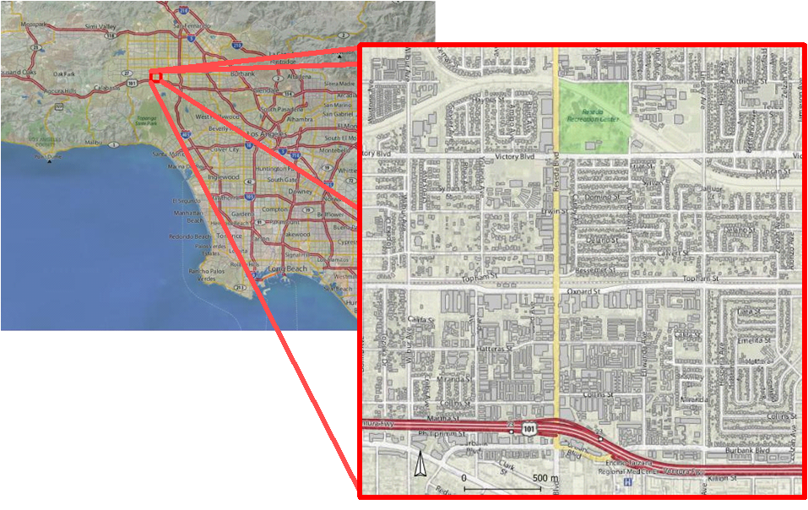
Figure 6. Case study area

Algorithm Performance

Examining the results for the entire case study area, we find that 98.5% of the 4,108 buildings are divided into regular rectangles with walls roughly parallel to the building’s external walls, as desired (Figure 7a). A small number of building footprints (1.5%), are divided so as to produce room walls that are not roughly parallel to the building walls (Figure 7b). Since the room configurations are only estimations and one would not expect all buildings to have exactly regular room layouts, these results were considered to be more than satisfactory for use in the post-earthquake fire spread model.

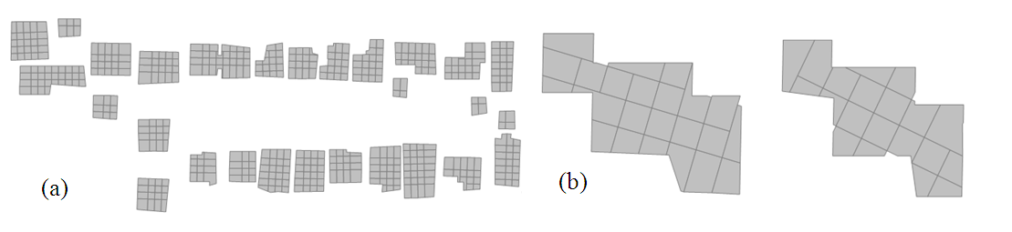
Figure 7. Sample case study results of room partitioning algorithm showing (a) predominant regularly oriented rooms, and (b) rooms oriented at an angle to building walls.

To evaluate the speed of the algorithms, they were run for the entire case study area, as well as subsets of different sizes using an Intel (R) Core (TM) 2 Duo CPU at 2.66 GHz with 3.23 GB RAM (Table 1). The results of these runs suggest that the relationship between the number of buildings and the runtime for the room division algorithm is linear (Figure 8a), whereas the relationship between the number of buildings and the runtimes for the merging slivers (Figure 8b) and facing wall algorithms are nonlinear. The relationships between room length and the runtimes for the room division and merging slivers algorithms are nonlinear. As expected, the room length has no effect on the facing wall algorithm runtime. As the number of slivers found increases, the merging slivers algorithm dominates the total runtime (Table 1). At a small number of slivers, however, the facing wall algorithm dominates. The room division algorithm is relatively fast.

Table 1. Algorithm runtimes

Number of buildings | User-specified room length (m) | Number of slivers found | Number of rooms after merging slivers | Run duration (h:m:s)
 |  |  |  | Room division (subtask 1) | Merging slivers (subtask 2) | Facing  wall  (subtask 3) | Total
100 | 3 | 273 | 1471 | 0:0:23 | 1:16:34 | 0:28:11 | 1:45:8
100 | 5 | 25 | 552 | 0:0:16 | 0:2:15 | 0:27:53 | 0:30:24
100 | 7 | 9 | 282 | 0:0:14 | 0:0:27 | 0:27:50 | 0:28:31
100 | 9 | 1 | 135 | 0:0:13 | 0:0:3 | 0:28:14 | 0:28:30
250 | 5 | 58 | 1911 | 0:0:58 | 0:18:59 | 0:39:26 | 0:59:23
500 | 5 | 89 | 3373 | 0:1:52 | 0:49:15 | 0:58:26 | 1:49:33
2500 | 5 | 192 | 7525 | 0:2:49 | 3:51:15 | 1:35:58 | 5:30:2
4000 | 5 | 634 | 20802 | 0:7:11 | 37:28:51 | 3:26:43 | 41:2:45
* Minimum room area used to define a sliver was 7 m² for all runs.

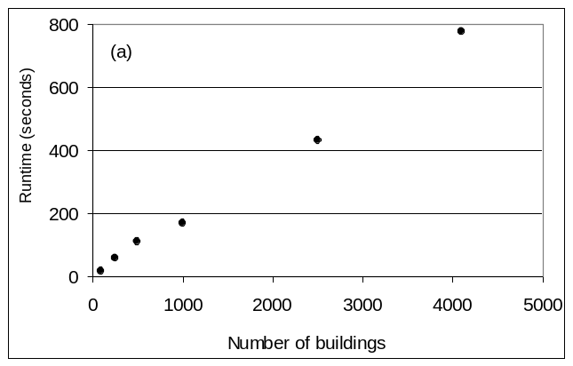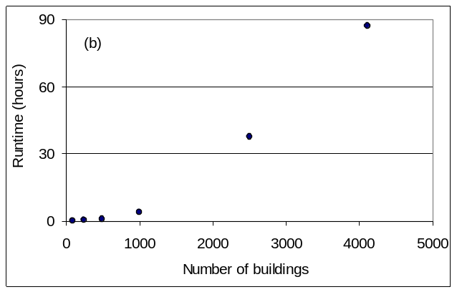
Figure 8. Relationships between algorithm runtimes and number of buildings, for the (a) room division and (b) merging slivers algorithms.

Conclusions

This paper describes two newly developed GIS algorithms. The first algorithm partitions building footprints into reasonable estimations of room areas. The second identifies, for each external building wall, the facing wall, i.e., the closest external wall of a neighboring building that is within a line of sight and therefore is likely to be the primary target of radiation from a fire in the original building. These two algorithms helped make possible development of a new simulation model of post-earthquake fire spread. The algorithms provide reliable results and computational speed sufficiently fast to allow application to a large urban region. The algorithms could be used directly or adapted for other applications in which it would be useful to have an estimate of room configurations within buildings or identification of facing walls for external building walls.

ABOUT THE AUTHORS

Selina W. Lee is a Ph.D. student concentrating in Civil Infrastructure Systems in the School of Civil and Environmental Engineering at Cornell University. She received her Bachelor of Science and Master of Engineering (Structural Engineering) degrees from Cornell University, is affiliated with MCEER, and is a member of the Earthquake Engineering Research Institute and the International Society of Fire Science Safety.

Rachel A. Davidson is an Associate Professor in the Department of Civil and Environmental Engineering at the University of Delaware and a core faculty member in the University’s Disaster Research Center. Her research interests include natural disaster risk modeling and civil infrastructure systems.

Arthur J. Lembo, Jr. is an Assistant Professor in the Department of Geography and Geosciences at Salisbury University. His research interests are in spatial analysis, spatial databases, and enterprise based GIS development.

ACKNOWLEDGEMENTS

The authors gratefully acknowledge partial support for this research from the Earthquake Engineering Research Centers Program of the National Science Foundation under award number EEC-9701471.

References

Chung, R., D. Ballantyne, E. Comeau, T. Holzer, D. Madrzykowski, A. Schiff, W. Stone, J. Wilcoski, R. Borcherdt, J. Cooper, H. Lew, J. Moehle, L. Sheng, A. Taylor, I. Buckle, J. Hayes, E. Leyendecker, T. O'Rourke, M. Singh and M. Whitney, 1996, January 17, 1995 Hyogoken-Nanbu (Kobe) Earthquake: Performance of Structures, Lifelines, and Fire Protection Systems, NIST SP 901 (ISCCS TR18) (Gaithersburg, MD: National Institute of Standards and Technology).
Clarke, K., J. Brass and P. Riggan, 1994, A Cellular Automata Model of Wildland-Fire Propagation and Extinction. Photogrammetric Engineering and Remote Sensing, 60, 1355-1367.
Cousins, W., D. Heron and S. Mazzoni, 2002, Estimating Risks from Fire Following Earthquake, Client Report 60 (New Zealand: Institute of Geological and Nuclear Sciences).
Federal Emergency Management Agency (FEMA), 1999, HAZUS99 Technical Manual (Washington, D.C.: FEMA).
Finney, M., 1997, FARSITE Fire Area Simulator, Users Guide and Technical Documentation Version 3.0 (Missoula, MT: Systems for Environmental Management).
Green, K., M. Finney, J. Campbell, D. Weinstein and V. Laudrum, 1995, FIRE! Using GIS to Predict Fire Behaviour. Journal of Forestry, 93(5), 21-25.
Hamada, M., 1951, On Fire Spreading Velocity in Disasters (Tokyo: Sagami Shobo), in Japanese.
Himoto, K. and T. Tanaka, 2008, Development and Validation of a Physics-Based Urban Fire Spread Model. Fire Safety Journal, in press (available online).
Himoto, K. and T. Tanaka, 2005, Transport of Disk-Shaped Firebrand in a Turbulent Boundary Layer. Fire Safety Science—Proceedings of the 8th International Symposium, Beijing, September 2005, 433–444.
Iwami, T., Y. Ohmiya, Y. Hayashi, K. Kagiya, W. Takahashi and T. Naruse, 2004, Simulation of City Fire. Fire Science and Technology, 23(2), 132-140.
Law, M. and T. O’Brien, 1981, Fire Safety of Bare External Structural Steel (London: Constrado).
Lee, S. and R. Davidson, 2008a, Modeling Different Modes of Post-Earthquake Fire Spread. Proceedings of the 14th World Conference on Earthquake Engineering, Beijing, China, October 2008, in press.
Lee, S. and R. Davidson, 2008b, Physics-based Simulation Modeling of Post-Earthquake Fire Spread, Dept. of Civil and Environmental Engineering, University of Delaware, working paper.
Lee, S. and R. Davidson, 2006, Simulation-Based Model of Fire Following Earthquake. Proceedings of the 8th U.S. National Conference on Earthquake Engineering, San Francisco, CA, April 2006, DVD.
Lee, S., R. Davidson, N. Ohnishi and C. Scawthorn, 2008, Fire Following Earthquake–Reviewing the State-of-the-Art of Modeling. Earthquake Spectra, 24(4), 1-35.
Mudan, K., 1984, Thermal Radiation Hazards from Hydrocarbon Pool Fires. Progress Energy Combustion Science, 10(1), 59-80.
Muzy, A., E. Innocenti, A. Aiello, J-F Santucci and G. Wainer, 2005, Specification of Discrete Event Models for Fire Spreading. Simulation, 81(2), 103-117.
Ntaimo, L., B. Zeigler, M. Vasconcelos and B. Khargharia, 2004, Forest Fire Spread and Suppression in DEVS. Simulation, 80(10), 479-500.
Ohgai, A., Y. Gohnai, S. Ikaruga, M. Murakami and K. Watanabe, 2004, Cellular Automata Modeling For Fire Spreading As a Tool to Aid Community-Based Planning for Disaster Mitigation. In Van Leeuwen, J. and H. Timmermans (eds.), Recent Advances in Design and Decision Support Systems in Architecture and Urban Planning, (Dordrecht: Klumer Academic), 193-209.
Scawthorn, C., J. Eidinger and A. Schiff, 2005, Fire Following Earthquake, Technical Council on Lifeline Earthquake Engineering Monograph No. 26 (Reston, VA: American Society of Civil Engineers).
Scawthorn, C., T. O’Rourke and F. Blackburn, 2006, The 1906 San Francisco Earthquake and Fire—Enduring Lessons for Fire Protection and Water Supply. Earthquake Spectra, 22(S2), S135-S158.
Scawthorn, C., Y. Yamada and H. Ieumra, 1981, A Model for Urban Post-Earthquake Fire Hazard. Disasters, 5(2), 125-132.
Wallace, G., 1993, A Numerical Fire Simulation Model. International Journal of Wildland Fire, 3(2), 111-116.
Waterman, T., 1969, Experimental Study of Firebrand Generation, Project J6130 (Chicago, IL: IIT Research Institute)
Waterman T. and A. Takata, 1969, Laboratory Study of Ignition of Host Materials by Firebrands, Project J6142 (Chicago, IL: IIT Research Institute).

