Distributed Simulation of DEVS

Gabriel Wainer Loïc Quinet Julien Chazal

Abstract 2
Introduction 3
1. DEVS Formalism 5
1.1. Web Service-Enabled CD++ 9
1.2. Service architecture 13
1.3. CD++ Web Service supplying 16
2. Simulation Service GUI 19
3. A visualization tool for the CD++Builder Eclipse plugin 22
4. Modification of CD++ plug-in for Eclipse 26
5. Distributed Simulation across the Atlantic Ocean 28
6. Distributed Simulation using Internet connection 30
6.1. Fire spread model 32
6.1.1. Performance analysis on the local machine (in Ottawa) 34
6.1.2. Performance analysis on the distant machine (in Clermont-Ferrand) 36
6.1.3. Comparison between the machines used to run Fire model simulation 38
6.1.4. Distributed Simulation on Internet for Fire model 40
6.2. Sand pile model 45
6.2.1. Performance analysis on the local machine (in Ottawa) 46
6.2.2. Performance analysis on the distant machine (in Clermont-Ferrand) 48
6.2.3. Comparison between the machines used to run Sand-pile model simulation 50
6.2.4. Distributed Simulation on Internet for Sand Pile model 52
6.3. Summary of the results 56
7. Distributed Simulation using UCLP 57
Conclusion 58
References 59

Abstract

This paper presents the work done by the French students Loïc Quinet and Julien Chazal under Professor Gabriel Wainer.
It presents improvements done to the Web Services for the CD++ toolkit [Mad06] (a modeling and simulation toolkit developed to execute DEVS and Cell-DEVS models) and a session of simulation tests realized across the Atlantic Ocean between two machines, one located in Canada and the other in France using theses Web Services and a commodity Internet connection. The fire spread model [Ame01] and the sand-pile model [Saa03] were used.
Introduction

Modeling and simulation is a key domain in modern science. One of the fields of Modeling and Simulation is discrete event simulation which is related to studying systems that exist in finite set of discrete states over continuous periods of time. Some examples of these systems include customer queues in a bank, computer networks or manufacturing facilities. Discrete Event System Specification (DEVS) [Zei00] is a modeling and simulation formalism that has been used to study discrete event systems. Timed Cell-DEVS [Wai01] is an extension to the traditional cellular automata [Wol86] who allows for representing each cell in the cell space as a DEVS model that is only activated when it receives external inputs from its neighboring cells.

Scientists need more and more tools to analyze these complex systems. The CD++ toolkit [Wai02] is a modeling and simulation toolkit that was developed to execute DEVS and Cell-DEVS models. That tool was created to study this kind of systems by using a discrete-event approach. It gives us many useful possibilities to simulate discrete events and was successfully employed to define a variety of models for complex applications.

But the complexity of the systems modeled and, thus, the complexity of the simulations tends to increase. This causes more resources to be needed in order to execute the model and that requires powerful computers. At the same time, as more and more systems got connected through the Internet, a framework (Grid computing) to integrate their resources to execute complex models started to gain the attention of the research community. Some of the grid middleware adopted web services to facilitate grid application development and to expose the application functionality in a platform-independent manner.

The answer has been a research in the area of parallel and distributed simulation in order to use the hardware resources in distributed environments to execute complex models that represent natural and artificial systems. This is why Web Services have been developed for CD++ [Wai06], allowing to run a simulation on a cluster or between two or more computers. The next step was to improve these Web Services and to integrate then into the CD++ Builder plug-in for Eclipse in a user friendly way.

Another recurrent problem is the visualization of the results. These increasingly complex models produced hard to understand results and the user is not always proficient in interpreting the simulation results. The examples in which a way to visualize these results can help to better understand the system under study are countless. So a tool able to interpret the log files generated by the simulation was needed. That tool was created (using the Blender program) and integrated into the CD++ Builder plug-in for Eclipse.

The final result of all this work is a complete framework to modeling, simulate and visualize complex DEVS and CELL-DEVS models.

This framework allows running distributed simulation on any network, for example Internet. However, it introduced some overhead that affects the execution time of the models. The time it takes for a local message (implemented as a C++ object) to be transmitted between two local processors is much shorter than the time it takes for a SOAP message carrying the same information to be transmitted between two remote processors. In order to study the performance of the simulator across the Atlantic Ocean, different distributed simulation sessions were executed using two machines: one located in Canada, the other in France. These machines were connected using a commodity Internet connection.

- DEVS Formalism

Discrete Event System Specification (DEVS) [Zei00] is a M&S specification that is aimed to study discrete event systems. The formal definition of DEVS models is given as [Zei00]:

M = < X, S, Y, δ_{int}, δ_{ext}, λ, ta >

The model exists initially in state s, and it was scheduled to remain in that state for duration of ta(s). However, before ta(s) is elapsed, the model receives an external input (x), which causes the model to execute its external transition function (δ_{ext}) in order to evaluate the model’s new state after receiving the input. The external transition function takes into account the model’s total state (Q), which is defined by the model state (s) and the time elapsed since the model was in that state (e). Had the model not received an external input, it would have executed the output function (λ) after being in state s for ta(s) time units. This would have been followed by the internal transition function (δ_{int}), which determines the model’s next state because of an internal transition.

An exceptional case may take place if the states of two different models connected together expire at the same time. The decision of whom to evaluate next may have some implications on the correctness of the model. This situation may have a serialization effect on the model, and the decision as of which model to evaluate first is left to the modeler through the select function. In order to overcome this issue, Parallel-DEVS (P-DEVS) [Cho94a] formalism executes all the imminent models (models with the earliest scheduled state change) in parallel. This has a major effect on allowing the DEVS simulator to take advantage of the parallelism that might be available in the model and in the hardware resources (in the case of using parallel machines to run the model). In P-DEVS, the model has two message bags, one to store the external input messages, and the other is used to store the output messages. The formal definition of a P-DEVS model is presented in [Cho94]:

M = < X, S, Y, δ_{int}, δ_{ext}, δ_{conf}, λ, ta >

The main difference between DEVS and P-DEVS formalisms is the addition of the confluent function (δ_{conf}), which is responsible for determining the next state of the model when an external input arrives at the same time of an internal transition. The definition of the confluent function is determined by the modeler so that the correct behavior can be modeled depending on the system under study. The physical system model is created by integrating the different DEVS models together though their input and output ports; resulting in a coupled DEVS model. A coupled DEVS model consists of atomic and/or other coupled models connected together.

Cell-DEVS [Wai01] is an extension to cellular automata [Wol86] that depends on defining the cell as an atomic DEVS model. The asynchronous evaluation of the cells provides the modeler with powerful means to define complex temporal behaviors. Two types of delays can be defined; transport delay simulates queued future states. Another type of delay is inertial delay. Using the inertial delay, the newly evaluated state will pre-empt the scheduled one if they were different. Since each cell is represented as an atomic DEVS model, the cell behavior is defined by the various functions used to define an atomic DEVS model. Once an external input arrives to the cell from one of its neighbors, it activates the external transition function, which calculates the next state of the model. The time advance function is represented by the delay associated with the cell. Once the delay expires, the output function is triggered to generate the cell’s output, followed by the internal transition function, which evaluates the cell’s new state. The limitation associated with the original DEVS model definition, in terms of activating only one DEVS model at a time (through the select function) restricts the capabilities of the coupled Cell-DEVS model. The Parallel Cell-DEVS formalism [Wai00] was introduced to extend the functionality of the Cell-DEVS formalism taking advantage of the features provided by the Parallel-DEVS formalism; which include, executing imminent models in parallel avoiding the serialization problem that can lead to incorrect execution of the model. Coupled Cell-DEVS models can be formed by connecting different cells together. The cell space can take different dimensions and shapes. For example, 2D cell space can be used to model the spread of fire in a forest; 3D cell space can be used to model the spread of a specific type of viruses in a city. The borders of the coupled cell DEVS model can be one of two types; a wrapped border indicates that the cells at the edge of the cell space are neighbored by the cells on the opposite side. On the other hand, non-wrapped border indicates that the cells at the borders have special rules that need to be defined by the modeler.

CD++ [Wai02] is an object-oriented modeling and simulation toolkit capable of executing DEVS and Cell-DEVS models. CD++ executes the model by creating a collection of model and simulator classes following [Zei00]. In order to run in distributed environments, the model is decomposed into components that are executed by different simulators running on multiple machines.

The success of the DEVS/Cell-DEVS formalism in modeling and simulating different complex systems, has attracted a lot of researchers to extend the basic abstract simulator presented in [Zei00] into a parallel/distributed one:
- DEVS/Grid [Seo04] implements a grid-enabled DEVS simulator following a layered approach.
- Grid [Kha03] is an overall architecture for running DEVS and Cell-DEVS models in grid environments.
- DEVS/P2P [Che04] is a distributed DEVS simulator aimed to peer-to-peer networks. It exploits JXTA [Jxt06] as an implementation of P2P communication middleware with the DEVS modeling and simulation capabilities.
- DEVS/RMI [Zha05] is a distributed DEVS simulator based on Java Remote Method Invocation (RMI). It aims at providing a fully re-configurable distributed simulation environment with the capability of load-balancing and fault-tolerance.
- DEVS/Cluster [Kim04] is multi-threaded distributed DEVS simulator based on CORBA.
- PCD++ [Tro03] [Gli04] is a parallel simulation engine developed using WARPED [War06] middleware and uses MPI [Mpi95] for communications. PCD++ uses Time Warp [Jef85] protocol for synchronization among the different nodes participating in the simulation.
  - Web Service-Enabled CD++

The methodology followed to design and implement a distributed simulation engine depends on extending the CD++ toolkit in two dimensions. In one dimension, the toolkit was wrapped by a web service wrapper to expose its functionality to remote users/services using SOAP. We use the main web service standards such as XML [Bra04], SOAP [Gud03], Web Service Description Language (WSDL) [Chr01] for storing and parsing the configuration files used by the service, describing and exposing the service functionality, and messaging among the simulation services themselves as well as with the users, respectively. In another dimension, the simulation web service and the CD++ engine were extended to execute distributed models in a grid environment. The model is decomposed into different partitions, each of which is assigned to a machine for execution with SOAP being used for messaging among the machines. The difference between the approaches followed by other grid-based DEVS simulation engines and our approach, is that we aim to implement the simulation services in a modular manner to provide the flexibility required for integration with larger systems with minimal or no changes to the simulation services.

Web services are group of standards and languages aiming to facilitate developing, publishing, and discovering web-enabled applications. In other words, a web service is a software system designed to support interoperable machine-to-machine interaction over a network. It has an interface described in a machine-understandable format (specifically Web Service Description Language WSDL [Chr01]). Client systems interact with the web service in a manner prescribed by its description using SOAP [Gud03] messages, typically conveyed using HTTP with an XML serialization in conjunction with other standards [Alo03]. WSDL documents include enough information for the web service clients in order to know the operations it offers, the parameters required to invoke an operation, and the return type of the operation. SOAP plays an important role in any web service transaction. It is the messaging protocol used to convey information to and from the web service. It was designed in a manner that enables decentralized communication among multiple parties.

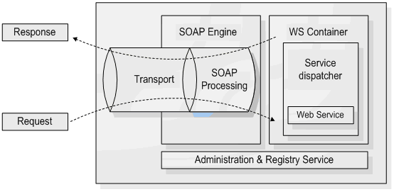
Figure 1: A web service container [Glo05]

CD++ was developed as traditional command-line application to run on Unix/Linux platform. It is capable of executing two kinds of models, DEVS and Cell-DEVS. To execute DEVS models, the modeler needs to define each atomic DEVS model as a C++ class (defined in header (h) and implementation (.cpp) files) that is to be integrated in the class hierarchy of CD++. For coupled DEVS models, and Cell-DEVS models, the modeler needs to provide a model definition file in a text format. The model definition file includes (among other things) the coupling scheme for the coupled model, initial values for the cells, rule definition to calculate the state of the cells, etc. In a regular invocation of CD++, the user submits the model definition and configuration files to the simulator as arguments. Once the simulation is over, the user gets the results in the form of output and log files. The output file contains the events that were generated through the output ports of the model; the log files contain detailed information about the progress of the simulation and can be used for debugging or animating the results using a visualization engine [Kha05]. In the context of our modeling and simulation environment, web services are introduced to serve two main purposes:
- To expose the functionality of the CD++ toolkit as a web service, allowing for executing simulations and retrieving the results through web services, as shown in Figure 2.
- Using SOAP as a messaging protocol to enable distributed CD++ to execute complex models on multiple machines.

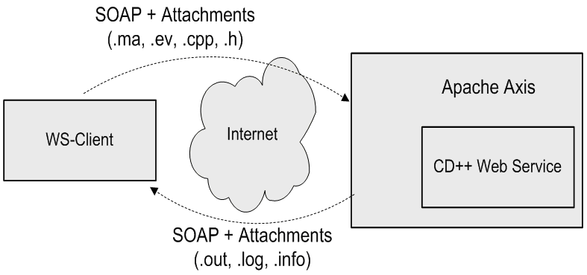
Figure 2: A typical invocation of the simulation web service

The simulation web service was redesigned to avoid the limitations of the JVM and provide a robust environment for running different simulation sessions concurrently and independently. The simulation service was split into two independent and separate parts: the web service components (implemented in Java) are used to handle the web service activities of the simulation service, and the simulation components (implemented in C++) are used to interact with CD++ by accessing and manipulating its internal objects and data structures. Both parts interact with each other though message queues maintained by the Linux kernel (through the WrapperProxy).

The advantages of this approach are that:
- It provides a separate running workspace for each simulation session; the simulator runs as an operating system process independent from the simulators running other sessions.
- It allows for extending the functionality of each part with minimal or no change to the other part. For example, the simulation components of the service were developed to work with the parallel version of CD++ (PCD++) with minimal changes to the web service components.

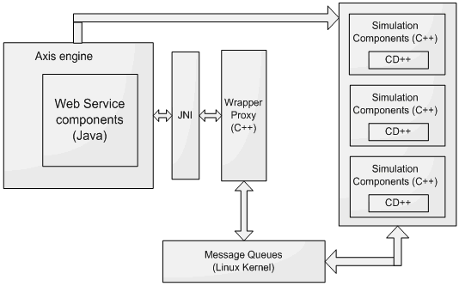
Figure 3: Simulation service using JNI/message queues

The web service components of the simulation service are compiled into Java archive (.jar) files and deployed in an Axis server, which in turn runs within an Apache Tomcat server [Tom07]. When the Tomcat server is started, it automatically starts the Axis engine. Axis loads all the libraries available in the directory of deployed services, which include the JavaWrapper (the backbone of the web service components), the server-side stubs, and the client-side stubs. In addition, when the JavaWrapper class is loaded, it loads the WrapperProxy, which is implemented as a collection of C/C++ procedures, and is loaded as a shared native library into the JVM. At this point the simulation service is considered ready to receive client requests.
  - Service architecture

The web service components were developed as a collection of Java classes; they fall into three main categories:
  - The web service wrapper (WS-Wrapper): is responsible for most of the functionality of the web service components. This is the backbone of the web service components since it is linked to the server-side stubs deployed within the Axis server. When Axis receives a web service request from the client, it passes the request to the server-side stub, which in turn retrieves the instance of the JavaWrapper class associated with the user’s session, before executing the corresponding method in the JavaWrapper object to fulfill the client’s request.
  - Utility classes: are used to perform secondary functions required by the WS-Wrapper such as parsing the users and configuration files. This takes place at two points: when the service is started, the users file is parsed to load the user information such as usernames, passwords, etc; and when the user submits a grid configuration file, the file is parsed to retrieve the model partition information as well as the addresses of the nodes participating in the simulation.
  - Stub classes: include the client-side and server-side stubs. The server-side stub classes are required by the Axis server and are part of the code required to define and deploy the service. The client-side stubs are required by the JavaWrapper class to invoke the services offered by the slave nodes when running distributed simulations.

Some of the operations performed by the JavaWrapper include:

- User authentication.
- Session initialization: Part of the session creation process includes creating a JavaWrapper instance to handle the newly created session; this instance will be used by the server-side stub class deployed within the Axis server to fulfill the requests submitted by the user.
- Setting the model definition.
- Setting configuration information for distributed sessions.
- Starting the simulation: this includes some initialization to take place such as compiling the submitted DEVS models with the source code of the simulator, sending the model definition to slave machines, and starting the slave sessions.
- Checking the status of the simulation: This is used since some models might take long time to be executed; in which case, the client can start the simulation and do some other processing until the simulation is over. In addition, the user can kill the simulation process (if needed).
- Retrieving the results of the simulation: In case of running distributed simulations, the JavaWrapper will utilize the services running on the slave machines in order to retrieve and archive all the log files.
- Logging off: This method will cause the JavaWrapper class to reclaim the resources used by the session and to send messages to the slave sessions to do the same.

In general, the services offered by the simulation service through its WSDL interface, are mapped into methods invoked on the JavaWrapper class/instance. Parts of the methods defined in the JavaWrapper class are actually native methods that were implemented in C/C++. Those constitute the WrapperProxy component of the service, and are implemented as procedures written in C/C++ since Java can’t access the Linux message queues. These methods are interfaced to the JavaWrapper class using the Java Native Interface (JNI) [Lia99].

The JavaWrapper class uses utility classes to handle tasks such as parsing the users and grid configuration files. The Parser class is the main class used for parsing and it uses the SAXParser, SAXParserFactory, and MyContentHandler classes to do so. The users file is used for authentication and it contains the usernames, passwords, and roles for all the users that are authorized to use the service. The grid configuration file is an XML file that contains:
  - URLs of the simulation services participating in a session;
  - Model partitioning information, which includes the parts of the model running on each machine in a distributed session.

Client and server-side stubs are required for the deployment and utilization of the simulation service. While the client stubs are not a must for using the simulation service, the client can create the SOAP requests dynamically, the server stub classes are required by the Axis server in order to properly deploy the service. The CDppPortTypeSoapBindingImpl represents the server-side stub; when the Axis server receives a request from the client in the form of a SOAP message, it does some processing on the SOAP message and extracts the attributes necessary to execute the service. Once the attributes are extracted, it invokes a method in the JavaWrapper class corresponding to the operation requested by the client. The CDppPortTypeService and CDppPortTypeServiceLocator are used to locate the web service using its Unified Resource Locator (URL). The former is an interface that is implemented by the latter and it is usually used at the beginning of any web service invocation process. The CDppPortTypeSoapBindingStub is a client-side stub that can be used by the program accessing the simulation service. It defines the attributes and methods that allow the client to deal with the web service as if it was local classes residing on his machine.
  - CD++ Web Service supplying

The CD++ Web Service is deployed and can be accessed at these URL:
- <http://deepthought.sce.carleton.ca:8080/axis/services/CDppPortType>
- <http://deepthought.sce.carleton.ca:8080/axis/services/PCDppPortType>

The second URL allows the user to run his simulation on a parallel remote machine (a processor cluster).

Thus, the CD++ Web Service specifically offers these operations:
- authenticate: it is responsible for authenticating users and initializing a new session for each successful login.
- setMAFile: it is used to set the model definition file.
- setDEVSModel: it is used to set a DEVS model by C++ header and implementation files.
- setEventFile: set the external input events file.
- setSupportFile: set support files that need to be available to the simulator, such as a file containing the initial values of the cells (in case of Cell-DEVS models).
- setExecutionTime: set the simulation end time.
- enableParsingInfo: informs the simulator to generate information for debugging the Cell-DEVS model.
- startSimulationService: it starts the simulation.
- isSimRunning: check whether the simulation is running.
- getCurrentSimulationTime: checks the current simulation time.
- insertExternalEvent: it is used to insert external events to the model while the simulation is running.
- killSimulation: it is used to terminate the simulation.
- retreiveLogFile: it is used to retrieve the log file generated by the simulator.
- retreiveOutputFile: it is used to retrieve the output file generated by the simulator.
- retrieveParsingInfoFile: retrieves the generated information file that can be used to debug Cell-DEVS models.
- retrieveSessionLogFile: retrieves the session log file which includes the output messages generated by the simulator while running.
- logoff: logs the current user off and terminate the session.

Two others methods was recently added for the use of macros and to retrieve a specific file on the remote server.

The first one is needed when the user builds his model definition files (which are usually called .MA files) with macros. CD++ has a pre-processor that expands macros. Macros are defined in one or several separate file(s) (called also include files, identified by the .inc extension) that must be included in the model definition file. Pre-processor directives are also employed as fallow: #include(fileName), where file name is the name of the include file that contains the definition of the macro. More than one #include directive could be used in a model definition, but no include files can have themselves this directive. The definition of a macro is done in an include file with a specific syntax [Wai05]. So, the setIncludeFile method has been added to the CD++ Web Service.

The second method allows the user to retrieve a specific file: the temporary model definition file built by the CD++ pre-processor. The pre-processor analyses the initial model definition file written by the user and expand all the macros that are specified in. The method retrieveTmpFile was implemented, activated and published on the CD++ Web Service. The user can easily recover the temporary model definition file generated and can check if his model definition has been well done with the use of macros.

Another update was done on the session log file that can be retrieved by using the retrieveSessionLogFile method. In the first version of the CD++ Web Service, the user can retrieve the session log file that shows the trace of the simulation execution and/or compilation (if the simulation is based on a cell DEVS model, compilation is not needed). This kind of file is very useful in case of a “crash” during the simulation process. Several tests including right and deliberated wrong simulations were executed. In all the cases, the user could retrieve the session log file without problem. But if a simulation given to CD++ Web Service was wrong, the session log file only mentioned that the simulation has been aborted, without underline the cause by showing a specific error message to the user. To show this kind of message, an update has been done on the session log file to really show errors that can append during the simulation (errors given by the CD++ simulator).
- Simulation Service GUI

A first Graphical User Interface (GUI) was implemented to permit the user to exploit methods given by the CD++ Web Service in an ergonomic and simple way. The GUI integrates all the methods furnished by the Web Service. Prior to the integration of this GUI into Eclipse, an update has been done in order to include the new implemented methods: setIncludeFile and retrieveTmpFile. A new panel has been added at the bottom of the main frame to allow the user to select and send include files. In the same way an additional button was created and put in the GUI toolbar, giving the possibility to the user to retrieve the temporary definition model file built by CD++ pre-processor during the simulation.

This GUI has afterwards been integrated in the CD++ Builder eclipse plug-in. A button has been added in the CD++ Builder perspective (and also in sub perspectives DEVS perspective and CELL-DEVS perspective) as shown on figure 4. When the user presses this button, a new window appears (figure 5). This window allows him to use all the features of the program.

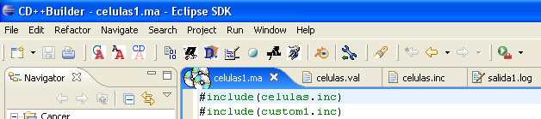
Launch GUI button
Figure 4: Simulation Service button integrated in CD++ Builder perspective.

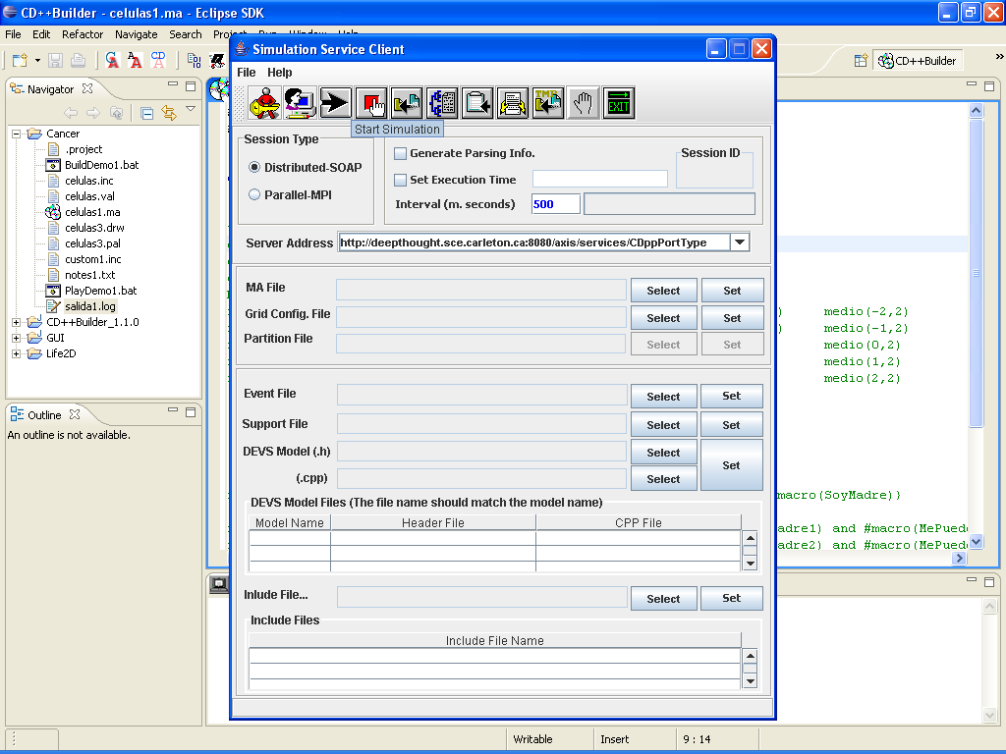
Include files management
Retrieve temp. MA file button
Figure 5: Simulation Service Graphical User Interface.

The first thing to do is to log on the server. The server address is defined in the Server Address field and can be changed in this place. After a click on the Log On button, the user enters his login and password and a new session is created on the server. It is also possible to log on an existing session with its identification number.

According to the type of simulation, different files are needed. The file that can be uploaded on the server are a model definition file (.MA file), a grid configuration file, a partition file, an event file, a support file, one or more DEVS models (defined by couples of .h and .cpp files) and one or more include files. To put files needed on the remote machine, the user must press Select button in the GUI. A file chooser dialog window appears with which the user has to search and choose the file he wants to add. Once the file is chosen, the user must press the Set button in the same section. The file is sent to the remote machine. A message is displayed in the GUI status bar to show if the send has been accomplished or not. When files are added in the DEVS Model Files or Include File section, they are then shown in the corresponding list box. To add other files, the user has just to repeat these operations.

Clicking on Start Simulation launch the simulation on the server with the files sent on it and the option chosen (Distributed or Parallel simulation, parsing info file, execution time and interval). The simulation stop by itself when it is finish or after the execution time set in the Set Execution Time field. It is also possible to stop the simulation with the Stop Simulation button. There is also a simulation state bar that shows the different states of the simulation: “IDLE”, “Compiling”, “Running” or “Done”.

When the simulation is terminated, the buttons Retrieve Log Archive, Retrieve Output File, Retrieve Session Log, Retrieve Parsing Info File and Retrieve Temporary MA File allow the user to retrieve all the files he needs and save them on his computer. He can then log off or directly exit.
- A visualization tool for the CD++Builder Eclipse plugin

When a DEVS or CELL-DEVS model is simulated, locally or remotely, the resulting files are not easy to read and to understand. However, the analysis of the results is the goal of any simulation (figure 6). Thus, a visualization tool has been developed with the program Blender.

Mensaje I / 00:00:00:000 / Root(00) para top(01)
Mensaje I / 00:00:00:000 / top(01) para life(02)
Mensaje I / 00:00:00:000 / life(02) para life(0,0)(03)
Mensaje I / 00:00:00:000 / life(02) para life(0,1)(04)
Mensaje I / 00:00:00:000 / life(02) para life(0,2)(05)
Mensaje I / 00:00:00:000 / life(02) para life(0,3)(06)
Mensaje I / 00:00:00:000 / life(02) para life(0,4)(07)
Mensaje I / 00:00:00:000 / life(02) para life(0,5)(08)
Mensaje I / 00:00:00:000 / life(02) para life(0,6)(09)
Mensaje I / 00:00:00:000 / life(02) para life(0,7)(10)
Mensaje I / 00:00:00:000 / life(02) para life(0,8)(11)
Mensaje I / 00:00:00:000 / life(02) para life(0,9)(12)
Mensaje I / 00:00:00:000 / life(02) para life(0,10)(13)
Mensaje I / 00:00:00:000 / life(02) para life(0,11)(14)
Mensaje I / 00:00:00:000 / life(02) para life(0,12)(15)
Figure 6: Result of a simulation (Part of a log file).

This tool was integrated in the CD++Builder plugin for Eclipse. The CD++Builder installation package now contains Eclipse, Java, Cygwin, CD++Builder plug-in, Python and Blender with the CD++ improvements. During the installation of the package, Blender can be installed on the location chosen by the user (figure 7). This location is saved in the plug-in preferences and can be modified in this place (Window => Preferences => CD++Builder Preference Page figure 9). Python, required for Blender, can also be installed on the computer (figure 8).
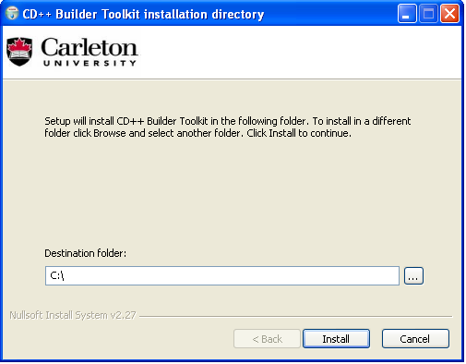
Figure 7: Installation of CD++Builder Toolkit

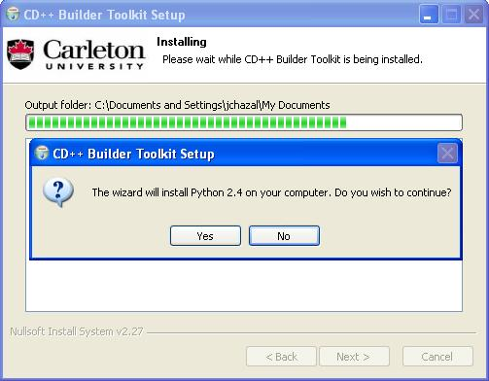
Figure 8: Installation of Python during the CD++Builder Toolkit installer

Blender can also be installed separately from Eclipse. In this case, the path to the .exe file must be defined in the plugin preferences page (Window => Preferences => CD++Builder Preference Page figure 9).

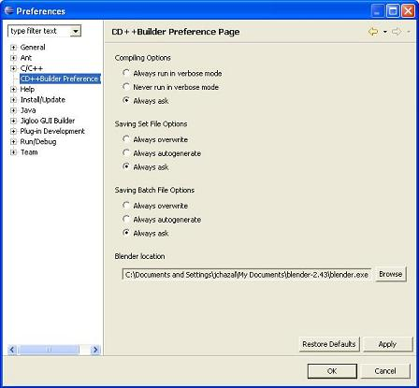
Figure 9: CD++Builder Preference Page (Eclipse).

To launch Blender, the user just has to click on the Blender Launch button (figure 10), which is available in CD++Builder, DEVS and CELL-DEVS perspectives. The plugin checks if the path saved in the preferences links to an existing valid executable file and then launch the Blender program in another window. If the path is not set when the user clicks on the Blender Launch Button, an alert message reminds him to do it (figure 11).

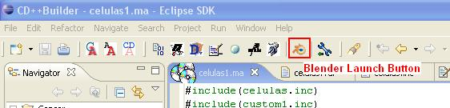
Figure 10: The Blender button in CD++Builder perspective (Eclipse).

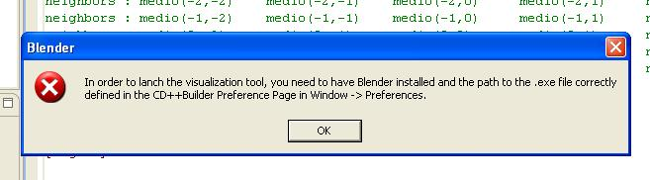
Figure 11: Error message (Eclipse).

It is possible to work independently on Blender and Eclipse. The user can, for example, run a simulation and visualize the result of another with Blender while waiting for the end of the simulation. The Blender visualization tool itself is described in the last part of this document.
- Modification of CD++ plug-in for Eclipse

As said in the two previous parts of this document, the Web Service Graphical User Interface and the Blender program (with the CD++ simulation add-on) have been added in the CD++Builder plug-in for Eclipse in order to build a complete toolkit.

Eclipse plug-ins are programmed with a special Eclipse perspective: the Plug-in Development perspective. (A perspective is a set of view in Eclipse.) This is available by going to the menu Window => Open perspective => Other, and choosing Plug-in Development from the list. This is similar to the Java perspective, but has a Plug-in view that displays all detected plug-ins.

The work was to add the two new buttons by modifying the XML file who controls the plug-in and to program the tasks start by these buttons. Some option must be chosen, like the position of the button, his label and his icon for example. The tasks are defined in Java files, one for each button.

For the Blender Launch Button, the tasks are:
- Get the Blender path from the preferences.
- Check if the path is filled.
- If not, throw an error message.
- Else, try to launch the .exe file.
- If it doesn’t work, throw an error message.
- Else, return to Eclipse.

For the Interface for Remote Simulation, the tasks are:
- Get the path to the CD++ Builder plug-in for Eclipse
- Retrieve the Simulation Service Java Archive that contains classes to launch the Graphical User Interface.
- Build the classpath needed by Simulation Service Java Archive main class.
- Execute Simulation Service Java Archive in new process.

- Distributed Simulation across the Atlantic Ocean

The aim of this work was to launch a distributed simulation between a Canadian and a French university. It’s a part of the DEVS-World project, a platform for developing advanced discrete-event simulations at a worldwide scale. This project involves universities from several countries (Canada, USA, France and Spain) and will be used by research communities all around the world.
This platform will provide a state-of-the-art environment that will be available for the general scientific community (with specific emphasis on bioinformatics, city planning – architecture, construction and emergency – and environmental sciences). It will also provide experience with the interoperation of software tools that could be employed by other developers pursuing similar goals in the future. The goal is to create a common user interface, enhancing usability and improving the development experiences for first-time users.

The tests we have made will prove that a distributed simulation across the ocean is possible and viable. We also have collected the time statistics in order to compare the different type of simulation (local, distant and distributed). One of the machines is located in Canada and belongs to Department of Systems and Computer Engineering from Carleton University, Ottawa. The other machine, placed in France, is located in the LIMOS Laboratory from Blaise Pascal University, Clermont-Ferrand.

Figure 12: Sending remote messages in distributed simulation

- Distributed Simulation using Internet connection

Readings obtained during the runs:
- The simulation time required to execute the models.
- The average time it takes in each run to transmit a SOAP message from Ottawa to Clermont-Ferrand.
- The average time it takes in each run to transmit a message within the Linux kernel using message queues.
- The average time it takes in each run to transfer a local message within a single machine.

Power of the machines:
- Configuration of the machine in the lab of Carleton University of Ottawa:
- Processor: dual PIV 3.2 GHz
- RAM: 512 MB
- Configuration of the machine in the lab of Blaise Pascal University of Clermont-Ferrand:
- Processor: single PIV 1.8 GHz
- RAM: 256 MB

Trace route (chart of the trace route):
- Report for 193.55.95.51 [devslimos1.isima.fr] (machine located in Clermont-Ferrand).
- The host '193.55.95.51' (known as devslimos1.isima.fr) has been found, and is reachable in 19 hops.
- Roundtrip time to 193.55.95.51, average = 136ms, min = 136ms, max = 137ms.

Hop | Node Name | Location | Time | Network
0 | ARS-1.cunet.carleton.ca | * | * | Carleton University CARLETON1
1 | - | Ottawa, ON, Canada | 0 | Carleton University CARLETON1
2 | - | … | 0 | (private use)
3 | - | … | 0 | (private use)
4 | - | Ottawa, ON, Canada | 0 | Carleton University CARLETON1
5 | - | Ottawa, ON, Canada | 0 | Carleton University CARLETON1
6 | - | … | 0 | (private use)
7 | orion-carleton-rne.dist1-otwa.ip.orion.on.ca | Toronto, ON, Canada | 1 | ORANO ORION
8 | C4-mon01.canet4.net | Ottawa, ON, Canada | 3 | Canarie Inc CANARIE
9 | C4-tor01.canet4.net | Ottawa, ON, Canada | 18 | Canarie Inc CANARIE
10 | carnarie-t.rt1.nyc.us.geant2.net | (United Kingdom) | 33 | DANTE Ltd.
11 | so-7-0-0.rt1.ams.nl.geant2.net | (United Kingdom) | 112 | IP allocation for GEANT network
12 | so-4-0-0.rt1.lon.uk.geant2.net | (United Kingdom) | 120 | IP allocation for GEANT network
13 | so-4-0-0.rt1.par.fr.geant2.net | (United Kingdom) | 129 | IP allocation for GEANT network
14 | renater-gw.rt1.par.fr.geant2.net | (United Kingdom) | 127 | DANTE Ltd.
15 | lyon-pos6-0.cssi.renater.fr | Lyon, France | 135 | French education and research network
16 | clermont-pos2-0.cssi.renater.fr | Clermont-Ferrand, France | 135 | French education and research network
17 | - | (France) | 135 | French education and research network
18 | - | (France) | 136 | Universite Blaise Pascal
19 | devslimos1.isima.fr | (France) | 136 | Institut Superieur d'Informatique de Modelisation et de leurs Applications
Table 1: Trace route between the machines

The trace route chart shows the connection between the two machines for the simulation. The way is not a classic Internet like the Internet network provided for public people. The networks used are provided by the government of each country as follow:
- CANARIE: Canadian non-profit collaboration between business and government coordinates improved Internet access and network connectivity throughout Canada.
- RENATER: French educational and research network.
- DANTE plans, builds and operates advanced networks for research and education. It is owned by European NRENs (National Research and Education Networks), and works in partnership with them and in cooperation with the European Commission. DANTE provides the data communications infrastructure essential to the development of the global research community. DANTE ensures the connectivity between the Canadian and the French research networks.

Once the Internet connectivity was effective and that all the tools were well set up, two types of models were used for the performance analysis across the Atlantic Ocean: fire spread model [Ame01] and sand-pile model [Saa03].
  - Fire spread model

This model represents fire spread in a forest [Ame01]. It is composed of 30x30 cell space; each cell represents a square area of the forest. The cell is considered to be burned if its temperature exceeds a specific value. The fallowing figure (figure 2) shows an excerpt of the model definition file with possible initial values of the cells.

[top]  components : fire  [fire]  type : cell  dim : (30,30)  delay : inertial  defaultDelayTime : 0  border : nowrapped  neighbors : fire(-1,-1) fire(-1,0) fire(-1,1)  neighbors : fire(0,-1) fire(0,0) fire(0,1)  neighbors : fire(1,-1) fire(1,0) fire(1,1)  initialvalue : 0  initialCellsValue : fire.val  localtransition : FireBehavior | 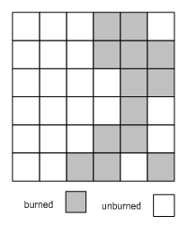
Figure 13: An excerpt of the fire model definition

The cell space is using inertial delay. The neighborhood of the cell is defined by the neighbors construct, the cell is neighbored by 8 cells from all sides. Fire(-1,1) represents the cell in the North West side (NW), Fire(0, -1) represents the cell in the west (W), etc. The rules that define the state of the cells in each simulation cycle are defined are shown in Figure 3:

[FireBehavior]
rule : {(1,-1)+(21.552615/17.967136)} {(21.552615/17.967136)*60000} {(0,0)=0 and (1,-1)!=? and 0<(1,-1)}

rule : {(1,0)+(15.24/5.106976)} {(15.24/5.106976)*60000} {(0,0)=0 and (1,0)!=? and 0<(1,0)}

rule : {(0,-1)+(15.24/5.106976)} {(15.24/5.106976)*60000} {(0,0)=0 and (0,-1)!=? and 0<(0,-1)}

rule : {(-1,-1)+(21.552615/1.872060)} {(21.552615/1.872060)*60000} {(0,0)=0 and (-1,-1)!=? and 0<(-1,-1)}

rule : {(1,1)+(21.552615/1.872060)} {(21.552615/1.872060)*60000} {(0,0)=0 and (1,1)!=? and 0<(1,1)}

rule : {(-1,0)+(15.24/1.146091)} {(15.24/1.146091)*60000} {(0,0)=0 and (-1,0)!=? and 0<(-1,0)}

rule : {(0,1)+(15.24/1.146091)} {(15.24/1.146091)*60000} {(0,0)=0 and (0,1)!=? and 0<(0,1)}

rule : {(-1,1)+(21.552615/0.987474)} {(21.552615/0.987474)*60000} {(0,0)=0 and (-1,1)!=? and 0<(-1,1)}

rule : {(0,0)} 0 { t }
Figure 14: Fire model rule definition

The rules define the time it takes for the cell to be burned if one of its neighbors is burned. For example, the first rule indicates that if the cell in the south west side of the cell is burned (0 < (1, -1)), the cell will take ((21.552615/17.967136)*60000) milliseconds to be burned. The value of (21.552615) represents the diagonal distance of each cell (measured in meters), and the value of (17.967136) is the speed (measured in meters/minute) as presented in the model definition [Ame01]. By dividing the distance that the fire has to spread through by the speed of the fire spread, the time it takes for fire spread is evaluated in minutes and by multiplying it with 60,000 the time in milliseconds is obtained as the delay of the cell. If the condition in the first rule holds, the cell state is updated to the value of Fire(1,-1) + (21.552615/17.967136) when the delay elapses.

In order to study the performance of the Simulation Service Web Service and to compare the machine powerful, a session of 20 runs has been first realized on each machine.
    - Performance analysis on the local machine (in Ottawa)

 | Average | Std. Deviation | Confidence Interval 95%
Local Msg. (us) | 3.716 | 0.135 | 3.657 | ≤ X ≤ | 3.775
Init. Time (ms) | 101.602 | 3.197 | 100.200 | ≤ X ≤ | 103.003
Simulation Time (s) | 2.891 | 0.011 | 2.886 | ≤ X ≤ | 2.896
Total Exec. Time (s) | 2.993 | 0.012 | 2.987 | ≤ X ≤ | 2.998
Table 2: Execution results of the fire model using the local machine (Ottawa)

The Local Message time is the time required to transmit a message from one processor (simulation processor) to another in the same machine. The transmission of a local message in a single machine is implemented as a method call (receive) in the receiving processor, which explains the short time required to communicate between two local processors (average of 3.716 microseconds).

The Initialization time is the time required by the simulator to load the model into memory, parse the configuration files, etc.; this is done before starting the simulation process.

The Simulation Time is the time of running the simulation which begins before processing the first event and ends after processing the last event.
Figure 15: Fire model simulation time using the local machine (Ottawa)

Figure 16: Fire model total execution time using the local machine (Ottawa)
    - Performance analysis on the distant machine (in Clermont-Ferrand)

The followings tables and figures show the performance result tests for the fire model done on the distant machine located in Clermont-Ferrand, France.

 | Average | Std. Deviation | Confidence Interval 95%
Local Msg. (us) | 1.269 | 0.054 | 1.245 | ≤ X ≤ | 1.293
Init. Time (ms) | 189.049 | 8.064 | 185.515 | ≤ X ≤ | 192.583
Simulation Time (s) | 4.177 | 0.528 | 3.945 | ≤ X ≤ | 4.408
Total Exec. Time (s) | 4.366 | 0.529 | 4.134 | ≤ X ≤ | 4.598
Table 3: Execution results of the fire model using the distant machine (Clermont-Ferrand)

Figure 17: model simulation time using the distant machine (Clermont-Ferrand)

Figure 18: Fire model total execution time using the distant machine (Clermont-Ferrand)
    - Comparison between the machines used to run Fire model simulation

Figure 19: Simulation Time comparison between local and distant machines

Figure 20: Total Execution Time comparison between local and distant machines

The latest figures show that the result test differences between the machines. The distant machine is an half less powerful than the machine located in Ottawa, as it’s mentioned in the part 5 of this document (Distributed Simulation across the Atlantic Ocean). The total execution time average for the local machine is 2.992 seconds whereas this for the distant machine is 4.365 seconds. This kind of differences is not really significant for this study, that matter is SOAP delay measured between the two machines during a distributed simulation.
    - Distributed Simulation on Internet for Fire model

The third great and the most interesting experiment is based on the distributed simulation across the Atlantic Ocean between the two machines. To do this, the cell space of the fire model was split into two equal parts (15x30) and each part was assigned to run on a different machine.

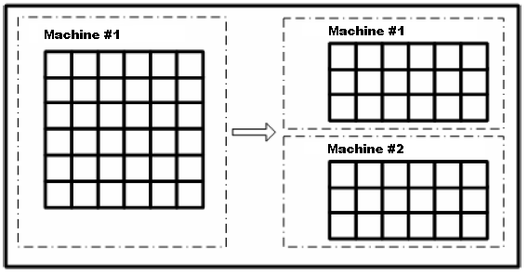
Figure 21: Fire model partitions on two machines

 | Average | Std. Deviation | Confidence Interval 95%
Local Msg. (us) | 3.719 | 0.094 | 3.678 | ≤ X ≤ | 3.760
Kernel Msg. (ms) | 1.015 | 0.673 | 0.720 | ≤ X ≤ | 1.310
SOAP Msg. (ms) | 8240.111 | 1244.400 | 7694.738 | ≤ X ≤ | 8785.484
Init. Time (ms) | 99.801 | 1.138 | 99.303 | ≤ X ≤ | 100.300
Simulation Time (s) | 895.274 | 84.420 | 858.276 | ≤ X ≤ | 932.272
Total Exec. Time (s) | 895.374 | 84.420 | 858.376 | ≤ X ≤ | 932.372
Table 4: Execution results of the fire model using two machines via Internet

Figure 22: Simulation time for the fire model using 1&2 machines via Internet

Figure 23: Total execution time for the fire model using 1&2 machines via Internet

The local message transfer is close to that when using a single machine since the messages are sent between local processors. When two machines are used to run distributed simulation, sending a message from one processor to another remote one involves sending it through the Linux kernel first to reach the web service components of the simulation service, then sending it as a SOAP message through the network (Internet), and finally from the web service components to the simulator at the receiving end (through the Linux kernel). The average time for message transfer through the kernel is 1.015 milliseconds.

On the other hand, the time for SOAP transfer from one machine to another is much longer than the kernel message transfer time, and it is the main contributing factor to the overhead associated with the distributed simulator. Another point to notice is that the initialization time is longer when running distributed simulation; this is due to the extra processors created to manage message passing among multiple machines (master and slave coordinators). By comparing the execution time when using one and two machines, the overhead introduced by the distributed simulator can be visualized, as shown in Figure 13:

Figure 24: Comparing the simulation time for the fire model using 1&2 machines via Internet

Figure 25: Comparing the total execution time for the fire model using 1&2 machines via Internet

As it’s shown on the latest figures, the simulation and total execution times of the model are almost identical. The difference between the two is the time necessary to initialize the model which is insignificant compared to the time required to execute the model (average of 99.801 milliseconds compared to an average of 895.274 seconds). It is worth mentioning that the initialization time is measured for the local machine (in Ottawa) since the model in the distant machine (in Clermont-Ferrand) is loaded before starting the simulation in local machine. In addition, the time for loading the model in local machine is very close to that in distant machine due to the symmetric portioning of the model.

  - Sand pile model

The sand-pile model [Saa03] consists of a DEVS model representing a sand particle generator and a coupled Cell-DEVS model that simulates the sand-pile formation. The output of the generator is connected to the input of the coupled Cell-DEVS model, which in turn is connected to the input of one of the cells (sandpile(5,5)). An excerpt of the definition of the sand-pile model is shown in the following figure 15:

[top]  components : sandpile particleGenerator@Generator  link : out@particleGenerator in@sandpile  out : out  link : out@particleGenerator out  [sandpile]  type : cell  dim : (10, 10)  delay : inertial  defaultDelayTime : 100  border : nowrapped  neighbors : sandpile(0,1) sandpile(1,0) sandpile(0,-1)  neighbors : sandpile(-1,0) sandpile(0,0)  in : in  link : in in@sandpile(5,5)  initialvalue : 0  localtransition : sandpile-rule  portInTransition : in@sandpile(5,5) NewParticle-rule | 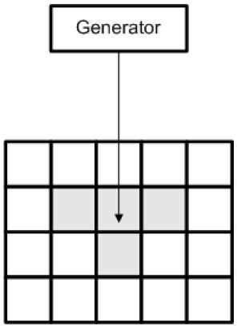
Figure 26: An excerpt of the Sand-pile model definition

NB: We can notice that all the simulation tests for the sand-pile use an execution time arbitrary fixed at 2 minutes (by using the setExecutionTime(“00:02:00:000”) method from the Simulation Service web service), due to that the sand generator perpetuity provides sand particles.
    - Performance analysis on the local machine (in Ottawa)

The sand-pile model was first executed on the local machine, located in Ottawa:

 | Average | Std. Deviation | Confidence Interval 95%
Local Msg. (us) | 3.730 | 0.167 | 3.657 | ≤ X ≤ | 3.803
Init. Time (ms) | 22.625 | 2.445 | 21.553 | ≤ X ≤ | 23.696
Simulation Time (s) | 0.066 | 0.002 | 0.065 | ≤ X ≤ | 0.067
Total Exec. Time (s) | 0.089 | 0.001 | 0.088 | ≤ X ≤ | 0.089
Table 5: Execution results of the sand-pile model on the local machine (Ottawa)

Figure 27: Simulation time of the sand-pile model on the local machine (Ottawa)

The initialization time was less than that for the fire model due to the smaller cell space used, which resulted in smaller number of models to be initialized. However, the time required to load the models seems to be significant compared to the simulation time (the average initialization time is 22.625 milliseconds and the average simulation time is 66 milliseconds), which resulted in a longer execution time as the following figure (Figure 17). On the other hand, the variations in the simulation and execution times are insignificant (the standard deviation of the execution time is 0.001 second with an average of 0,089 seconds) and are due to different processes and daemons running on the machine.

Figure 28: Total execution time of the sand pile model using the local machine (Ottawa)

    - Performance analysis on the distant machine (in Clermont-Ferrand)

The followings tables and figures show the performance result tests for the sand-pile model done on the distant machine located in Clermont-Ferrand, France.

 | Average | Std. Deviation | Confidence Interval 95%
Local Msg. (us) | 1.271 | 0.067 | 1.242 | ≤ X ≤ | 1.300
Init. Time (ms) | 36.211 | 4.913 | 34.058 | ≤ X ≤ | 38.364
Simulation Time (s) | 0.119 | 0.003 | 0.118 | ≤ X ≤ | 0.121
Total Exec. Time (s) | 0.156 | 0.004 | 0.154 | ≤ X ≤ | 0.157
Table 6: Execution results of the sand-pile model using the distant machine (Clermont-Ferrand)

Figure 29: Simulation time of the sand-pile model using the distant machine (Clermont-Ferrand)

Figure 30: Total execution time of the sand-pile model using the distant machine (Clermont-Ferrand)
    - Comparison between the machines used to run Sand-pile model simulation

Figure 31: Simulation Time comparison for the sand-pile model between local and distant machines
Figure 32: Total Execution Time comparison for the sand-pile model between local and distant machines
    - Distributed Simulation on Internet for Sand Pile model

In order to run the distributed simulation of the sand-pile model, this model was detached into two parts. The first part contains the sand pile generator (DEVS) and the second includes the sand-pile formation model (Cell-DEVS). Each part was assigned to run on one machine and the two machines were connected using a commodity Internet connection.

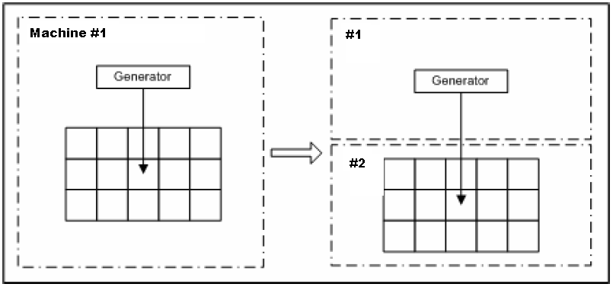
Figure 33: Sand-pile model partition on two machines

 | Average | Std. Deviation | Confidence Interval 95%
Local Msg. (us) | 4.458 | 0.172 | 4.383 | ≤ X ≤ | 4.533
Kernel Msg. (ms) | 1.522 | 3.023 | 0.198 | ≤ X ≤ | 2.847
SOAP Msg. (ms) | 7653.817 | 148.520 | 7588.726 | ≤ X ≤ | 7718.907
Init. Time (ms) | 21.720 | 1.732 | 20.961 | ≤ X ≤ | 22.479
Simulation Time (s) | 132.714 | 0.956 | 132.295 | ≤ X ≤ | 133.133
Total Exec. Time (s) | 132.735 | 0.956 | 132.316 | ≤ X ≤ | 133.155
Table 7: Execution results of the sand-pile model using local and distant machine via Internet

The results obtained are consistent with the ones obtained when running the fire model. The initialization time is longer when running distributed simulation since more processors need to be initialized. The simulation time is longer than that for a single machine due to the delay caused by sending SOAP messages between the remote processors.

Figure 34: Simulation time for the sand-pile model using 1&2 machines via Internet

Figure 35: Total execution time for the sand-pile model using 1&2 machines via Internet

Figure 36: Comparing the simulation time for the sand-pile model using 1&2 machines via Internet

Figure 37: Comparing the total execution time for the sand-pile model using 1&2 machines via Internet

  - Summary of the results

The following table presents a summary of the execution results for the models used in this study.

 | Fire#1 (Ars1) | Fire#1 (Limos) | Fire#2 (Internet) | SandPile#1 (Ars1) | SandPile#1 (Limos) | SandPile#2 (Internet)
Local Msg. (us) | 3.700 | 1.269 | 3.719 | 3.730 | 1.271 | 4.458
Kernel Msg. (ms) | NA | NA | 1.0147565 | NA | NA | 1.523
SOAP Msg. (ms) | NA | NA | 8240.111 | NA | NA | 7653.817
Init. Time (ms) | 103.238 | 189.048 | 99.801 | 22.624 | 36.211 | 21.720
Simulation Time (s) | 2.889 | 4.176 | 895.273 | 0.066 | 0.119 | 132.714
Total Exec. Time (s) | 2.992 | 4.365 | 895.373 | 0.088 | 0.156 | 132.735
Table 8: Summary of the execution results of the Fire and Sand-pile models

- Distributed Simulation using UCLP

The User-controlled Lightpath (UCLP) is a suite of networking middleware designed to provide user empowerment of networks.
The UCLP software allows end-users - either people or sophisticated applications - to treat network resources as software objects and provision and reconfigure lightpaths within a single domain or across multiple, independently managed, domains. Users can also join or divide lightpaths and hand off control and management of these larger or smaller private sub-networks to other users.
The UCLP software is designed to enable end-users to create their own discipline or application-specific IP network, particularly in support for high-end e-science and grid applications. For example, a community of high energy physicists could create their own independent IP network (as a subset of a larger optical network) - the topology and architecture would be optimized for their particular grid application needs and requirements. More importantly these networks can be reconfigured by the end-user and do not require the permission of the optical network manager-operator.

A common misconception is to compare UCLP to scheduling, bandwidth on demand, and control plane systems. Because UCLP makes software objects out of network resources these functionalities are/will be provided by UCLP however, it is not the main objective of this architecture.

A further development should be to test distributed simulations using light path connection and see the amount of time that could be gained this way.
Conclusion

Gabriel

References

[Alo03] Alonso, G. Web services: concepts, architectures and applications. Springer. 2003.

[Ame01] Ameghino, J.; Troccoli, A.; Wainer, G. “Models of complex physical systems unsing Cell-DEVS”. Proceedings of the 34th Annual Simulation Symposium, Seattle, WA. USA. 2001.

[Bra04] Bray, T.; Paoli, J.; Sperberg-McQueen, C.M.; Yergeau, F. “Extensible Markup Language, XML 1.0 (Third Edition)”. February, 2004. Available via <http://www.w3.org/TR/2004/REC-xml-20040204/>. [Accessed October, 2005].

[Che04] Cheon, S.; Seo, C.; Park, S.; Zeigler, B.P. “Design and Implementation of Distributed DEVS Simulation in a Peer to Peer Network System”. Advanced Simulation Technologies Conference, Arlington Virginia. April, 2004.

[Cho94] Chow, A.; Zeigler, B. “Parallel DEVS: A parallel, hierarchical, modular modeling formalism”. Proceedings of the Winter Computer Simulation Conference. Orlando, FL. USA. 1994.

[Chr01] Christensen, E; Curbera, F.; Meredith, G.; Weerawarana, S.” Web Service Desctiption Language (WSDL) 1.1”. March, 2001. Available via < http://www.w3.org/TR/wsdl>. [Accessed December, 2005].

[Gli04] Glinsky, E. “New Techniques for Parallel Simulation of DEVS and Cell-DEVS Models In CD++”. Master Thesis. Carleton University 2004.

[Glo05] “A Globus Primer”. Available via <http://www.globus.org/toolkit/docs/4.0/key/GT4_Primer_0.6.pdf>. [Accessed January, 2006].

[Gud03] Gudgin, M.; Hadley, M.; Mendelsohn, N.; Moreau, J.; Nielsen, H. “SOAP Version 1.2 Part 1: Messaging Framework”. June, 2003. Available via <http://www.w3.org/TR/soap12-part1/>. [Accessed November, 2005].

[Jef85] Jefferson, D.R. “Virtual time”. ACM Transactions on Programming Languages and Systems. vol. 7(3), pp. 404-425. July, 1985.

[Jxt06] <www.jxta.org>. [Accessed June, 2006]

[Kha03] Khargharia, B.; Hariri, S.; Parashar, M.; Ntaimo, L.; Kim, B. “vGrid: A Framework for Building Autonomic Applications”. International Workshop on Challenges for Large Applications in Distributed Environments (CLADE 2003), pp. 19-26. June, 2003.

[Kha05] Khan, A.; Wainer, G. “A visualization engine based on Maya for DEVS models”. Proceedings of SISO Fall Interoperability Workshop. San Diego, CA. U.S.A. 2005.

[Kim04] Kim, K.; Kang, W. “CORBA -Based, Multi-threaded Distributed Simulation of Hierarchical DEVS Models: Transforming Model Structure into a Non-hierarchical One”. International Conference on Computational Science and Its Applications (ICCSA). Assisi, Italy. 2004.

[Lia99] Liang, S. Java Native Interface (JNI), Programmer’s Guide and Specification. Addison-Wesley. 1999.

[Mad06] Madhoun, R. “Web Service-based distributed simulation of Discrete Event Models”. Thesis, Carleton University, Ottawa, ON. Canada. 2006.

[Mpi95] Message Passing Interface Forum. MPI: A Message-Passing Interface standard (version 1.1). Technical report. Available via: <http://www.mpi-forum.org >. [Accessed May, 2006].

[Saa03] Saadawi, H.; Wainer, G. “modeling a sand pile application using Cell-DEVS”. Proceedings of the 2003 Summer Computer Simulation Conference. Montreal, QC. Canada. 2003.

[Seo04] Seo, C.; Park, S.; Kim, B.; Cheon, S.; Zeigler, B. “Implementation of Distributed high-performance DEVS Simulation Framework in the Grid Computing Environment”. Advanced Simulation Technologies conference (ASTC). Arlington, VA. USA. 2004.

[Tom07] Apache Tomcat. Available via <http://tomcat.apache.org/>. [Accessed May, 2007].

[Tro03] Troccoli, A., Wainer, G. “Implementing Parallel Cell-DEVS”. Proceedings of 36th IEEE/SCS Annual Simulation Symposium. Orlando, FL. USA. 2003.

[Wai00] Wainer, G. “Improved Cellular Models with Parallel Cell-DEVS“. Transactions of the Society for Computer Simulation International. Vol. 17(2), pp. 73-88. June, 2000.

[Wai01] Wainer, G.; Giambiasi, N. “Timed Cell-DEVS: modelling and simulation of cell spaces”. Invited paper for the book Discrete Event Modeling & Simulation: Enabling Future Technologies. Springer-Verlag. 2001.

[Wai02] Wainer, G. “CD++: a toolkit to develop DEVS models”. Software - Practice and Experience. vol. 32, pp. 1261-1306. 2002.

[Wai05] Wainer, G. “CD++ - A tool for DEVS and Cell-DEVS Modeling and Simulation - User’s Guide”. August 2005.

[Wai06] Wainer, G.; Madhoun, R. “Studying the Impact of Web-Services Implementation of Distributed Simulation of DEVS and Cell-DEVS Models”

[War06] Warped: A Time Warp Simulation Kernel. Warped Documentation for version 1.0. Available via <www.ececs.uc.edu/~paw/warped/>. [Accessed April, 2006].

[Wol86] Wolfram, S. Theory and applications of cellular automata. Advances Series on Complex Systems. World Scientific. Singapore. 1986.

[Zei00] Zeigler, B.; Kim, T.; Praehofer, H. Theory of Modeling and Simulation: Integrating Discrete Event and Continuous Complex Dynamic Systems. Academic Press. 2000.

[Zha05] Zhang, M.; Zeigler, B.; Hammonds, P. “DEVS/RMI-An Auto-Adaptive and Reconfigurable Distributed Simulation Environment for Engineering Studies”. ITEA Journal. July. 2005.

LIMOS : “Laboratoire de recherche d'Informatique, de Modélisation et d'Optimisation des Systèmes” - Complexe scientifique des Cézeaux, 63177 AUBIERE cedex, FRANCE. http://www.isima.fr/limos/
CANARIE: http://www.canarie.ca
RENATER: “REseau NAtional de télécommunications pour la Technologie l'Enseignement et la Recherche”. http://www.renater.fr/
DANTE: “Delivery of Advanced Network Technology to Europe”. http://www.dante.net/
Canarie’s UCLP webpage: http://www.canarie.ca/canet4/uclp/

