Remote simulation and visualization tool
for CD++ Builder Toolkit

Gabriel Wainer Emil Poliakov Julien Chazal Loïc Quinet

Abstract

Introduction

Modeling and simulation is a key domain in modern science. One of the fields of Modeling and Simulation is discrete event simulation which is related to studying systems that exist in finite set of discrete states over continuous periods of time. Some examples of these systems include customer queues in a bank, computer networks or manufacturing facilities. Discrete Event System Specification (DEVS) [Zei00] is a modeling and simulation formalism that has been used to study discrete event systems. Timed Cell-DEVS [Wai01] is an extension to the traditional cellular automata [Wol86] who allows for representing each cell in the cell space as a DEVS model that is only activated when it receives external inputs from its neighbouring cells.

Scientists need more and more tools to analyse these complex systems. The CD++ toolkit [Wai02] is a modeling and simulation toolkit that was developed to execute DEVS and Cell-DEVS models. That tool was created to study this kind of systems by using a discrete-event approach. It gives us many useful possibilities to simulate discrete events and was successfully employed to define a variety of models for complex applications.

But the complexity of the systems modeled and, thus, the complexity of the simulations tends to increase. This causes more resources to be needed in order to execute the model and that requires powerful computers. At the same time, as more and more systems got connected through the Internet, a framework (Grid computing) to integrate their resources to execute complex models started to gain the attention of the research community. Some of the grid middleware adopted web services to facilitate grid application development and to expose the application functionality in a platform-independent manner.

The answer has been a research in the area of parallel and distributed simulation in order to use the hardware resources in distributed environments to execute complex models that represent natural and artificial systems. This is why Web Services have been developed for CD++ [Wai06], allowing to run a simulation on a cluster or between two or more computers. The next step was to improve these Web Services and to integrate then into the CD++ Builder plugin for Eclipse in a user friendly way.

Another recurrent problem is the visualization of the results. These increasingly complex models produced hard to understand results and the user is not always proficient in interpreting the simulation results. The examples in which a way to visualize these results can help to better understand the system under study are countless. So a tool able to interpret the log files generated by the simulation was needed. That tool was created (using the Blender program) and integrated into the CD++ Builder plug-in for Eclipse.

The final result of all this work is a complete framework to modeling, simulate and visualize complex DEVS and CELL-DEVS models.

DEVS Formalism

Discrete Event System Specification (DEVS) [Zei00] is a M&S specification that is aimed to study discrete event systems. The formal definition of DEVS models is given as [Zei00]:

M = < X, S, Y, δ_{int}, δ_{ext}, λ, ta >

The model exists initially in state s, and it was scheduled to remain in that state for duration of ta(s). However, before ta(s) is elapsed, the model receives an external input (x), which causes the model to execute its external transition function (δ_{ext}) in order to evaluate the model’s new state after receiving the input. The external transition function takes into account the model’s total state (Q), which is defined by the model state (s) and the time elapsed since the model was in that state (e). Had the model not received an external input, it would have executed the output function (λ) after being in state s for ta(s) time units. This would have been followed by the internal transition function (δ_{int}), which determines the model’s next state because of an internal transition.

An exceptional case may take place if the states of two different models connected together expire at the same time. The decision of whom to evaluate next may have some implications on the correctness of the model. This situation may have a serialization effect on the model, and the decision as of which model to evaluate first is left to the modeller through the select function. In order to overcome this issue, Parallel-DEVS (P-DEVS) [Cho94a] formalism executes all the imminent models (models with the earliest scheduled state change) in parallel. This has a major effect on allowing the DEVS simulator to take advantage of the parallelism that might be available in the model and in the hardware resources (in the case of using parallel machines to run the model). In P-DEVS, the model has two message bags, one to store the external input messages, and the other is used to store the output messages. The formal definition of a P-DEVS model is presented in [Cho94]:

M = < X, S, Y, δ_{int}, δ_{ext}, δ_{conf}, λ, ta >

The main difference between DEVS and P-DEVS formalisms is the addition of the confluent function (δ_{conf}), which is responsible for determining the next state of the model when an external input arrives at the same time of an internal transition. The definition of the confluent function is determined by the modeller so that the correct behaviour can be modeled depending on the system under study. The physical system model is created by integrating the different DEVS models together though their input and output ports; resulting in a coupled DEVS model. A coupled DEVS model consists of atomic and/or other coupled models connected together.

Cell-DEVS [Wai01] is an extension to cellular automata [Wol86] that depends on defining the cell as an atomic DEVS model. The asynchronous evaluation of the cells provides the modeller with powerful means to define complex temporal behaviours. Two types of delays can be defined; transport delay simulates queued future states. Another type of delay is inertial delay. Using the inertial delay, the newly evaluated state will pre-empt the scheduled one if they were different. Since each cell is represented as an atomic DEVS model, the cell behaviour is defined by the various functions used to define an atomic DEVS model. Once an external input arrives to the cell from one of its neighbours, it activates the external transition function, which calculates the next state of the model. The time advance function is represented by the delay associated with the cell. Once the delay expires, the output function is triggered to generate the cell’s output, followed by the internal transition function, which evaluates the cell’s new state. The limitation associated with the original DEVS model definition, in terms of activating only one DEVS model at a time (through the select function) restricts the capabilities of the coupled Cell-DEVS model. The Parallel Cell-DEVS formalism [Wai00] was introduced to extend the functionality of the Cell-DEVS formalism taking advantage of the features provided by the Parallel-DEVS formalism; which include, executing imminent models in parallel avoiding the serialization problem that can lead to incorrect execution of the model. Coupled Cell-DEVS models can be formed by connecting different cells together. The cell space can take different dimensions and shapes. For example, 2D cell space can be used to model the spread of fire in a forest; 3D cell space can be used to model the spread of a specific type of viruses in a city. The borders of the coupled cell DEVS model can be one of two types; a wrapped border indicates that the cells at the edge of the cell space are neighboured by the cells on the opposite side. On the other hand, non-wrapped border indicates that the cells at the borders have special rules that need to be defined by the modeller.

CD++ [Wai02] is an object-oriented modeling and simulation toolkit capable of executing DEVS and Cell-DEVS models. CD++ executes the model by creating a collection of model and simulator classes following [Zei00]. In order to run in distributed environments, the model is decomposed into components that are executed by different simulators running on multiple machines.

The success of the DEVS/Cell-DEVS formalism in modeling and simulating different complex systems, has attracted a lot of researchers to extend the basic abstract simulator presented in [Zei00] into a parallel/distributed one:
- DEVS/Grid [Seo04] implements a grid-enabled DEVS simulator following a layered approach.
- vGrid [Kha03] is an overall architecture for running DEVS and Cell-DEVS models in grid environments.
- DEVS/P2P [Che04] is a distributed DEVS simulator aimed to peer-to-peer networks. It exploits JXTA [JXT06] as an implementation of P2P communication middleware with the DEVS modeling and simulation capabilities.
- DEVS/RMI [Zha05] is a distributed DEVS simulator based on Java Remote Method Invocation (RMI). It aims at providing a fully re-configurable distributed simulation environment with the capability of load-balancing and fault-tolerance.
- DEVS/Cluster [Kim04] is multi-threaded distributed DEVS simulator based on CORBA [OMG02].
- PCD++ [Tro03] [Gli04] is a parallel simulation engine developed using WARPED [War06] middleware and uses MPI [MPI95] for communications. PCD++ uses Time Warp [Jef85] protocol for synchronization among the different nodes participating in the simulation.

Web Service-Enabled CD++

The methodology followed to design and implement a distributed simulation engine depends on extending the CD++ toolkit in two dimensions. In one dimension, the toolkit was wrapped by a web service wrapper to expose its functionality to remote users/services using SOAP. We use the main web service standards such as XML [Bra04], SOAP [Gud03], Web Service Description Language (WSDL) [Chr01] for storing and parsing the configuration files used by the service, describing and exposing the service functionality, and messaging among the simulation services themselves as well as with the users, respectively. In another dimension, the simulation web service and the CD++ engine were extended to execute distributed models in a grid environment. The model is decomposed into different partitions, each of which is assigned to a machine for execution with SOAP being used for messaging among the machines. The difference between the approaches followed by other grid-based DEVS simulation engines and our approach, is that we aim to implement the simulation services in a modular manner to provide the flexibility required for integration with larger systems with minimal or no changes to the simulation services.

Web services are group of standards and languages aiming to facilitate developing, publishing, and discovering web-enabled applications. In other words, a web service is a software system designed to support interoperable machine-to-machine interaction over a network. It has an interface described in a machine-understandable format (specifically Web Service Description Language WSDL [Chr01]). Client systems interact with the web service in a manner prescribed by its description using SOAP [Gud03] messages, typically conveyed using HTTP with an XML serialization in conjunction with other standards [Alo03]. WSDL documents include enough information for the web service clients in order to know the operations it offers, the parameters required to invoke an operation, and the return type of the operation. SOAP plays an important role in any web service transaction. It is the messaging protocol used to convey information to and from the web service. It was designed in a manner that enables decentralized communication among multiple parties.

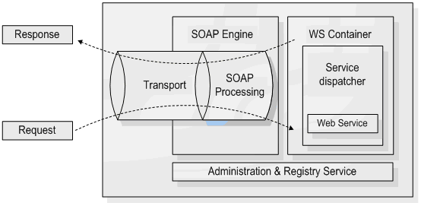
Figure 1. A web service container [Glo05]

CD++ was developed as traditional command-line application to run on Unix/Linux platform. It is capable of executing two kinds of models, DEVS and Cell-DEVS. To execute DEVS models, the modeller needs to define each atomic DEVS model as a C++ class (defined in header (h) and implementation (.cpp) files) that is to be integrated in the class hierarchy of CD++. For coupled DEVS models, and Cell-DEVS models, the modeller needs to provide a model definition file in a text format. The model definition file includes (among other things) the coupling scheme for the coupled model, initial values for the cells, rule definition to calculate the state of the cells, etc. In a regular invocation of CD++, the user submits the model definition and configuration files to the simulator as arguments. Once the simulation is over, the user gets the results in the form of output and log files. The output file contains the events that were generated through the output ports of the model; the log files contain detailed information about the progress of the simulation and can be used for debugging or animating the results using a visualization engine [Kha05]. In the context of our modeling and simulation environment, web services are introduced to serve two main purposes:
- To expose the functionality of the CD++ toolkit as a web service, allowing for executing simulations and retrieving the results through web services, as shown in Figure 2.
- Using SOAP as a messaging protocol to enable distributed CD++ to execute complex models on multiple machines.

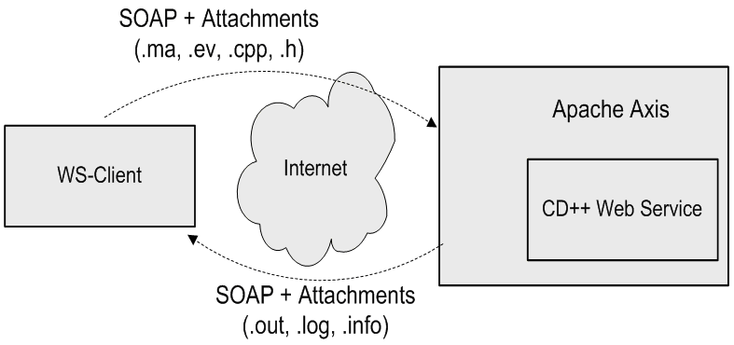
Figure 2. A typical invocation of the simulation web service

The simulation web service was redesigned to avoid the limitations of the JVM and provide a robust environment for running different simulation sessions concurrently and independently. The simulation service was split into two independent and separate parts: the web service components (implemented in Java) are used to handle the web service activities of the simulation service, and the simulation components (implemented in C++) are used to interact with CD++ by accessing and manipulating its internal objects and data structures. Both parts interact with each other though message queues maintained by the Linux kernel (through the WrapperProxy).

The advantages of this approach are that:
- It provides a separate running workspace for each simulation session; the simulator runs as an operating system process independent from the simulators running other sessions.
- It allows for extending the functionality of each part with minimal or no change to the other part. For example, the simulation components of the service were developed to work with the parallel version of CD++ (PCD++) with minimal changes to the web service components.

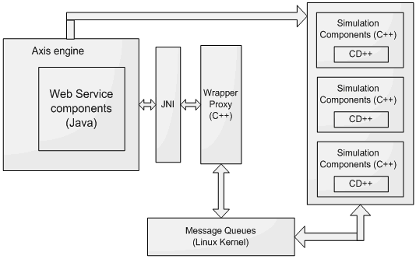
Figure 3. Simulation service using JNI/message queues

The web service components of the simulation service are compiled into Java archive (.jar) files and deployed in an Axis server, which in turn runs within an Apache Tomcat server [Tom07]. When the Tomcat server is started, it automatically starts the Axis engine. Axis loads all the libraries available in the directory of deployed services, which include the JavaWrapper (the backbone of the web service components), the server-side stubs, and the client-side stubs. In addition, when the JavaWrapper class is loaded, it loads the WrapperProxy, which is implemented as a collection of C/C++ procedures, and is loaded as a shared native library into the JVM. At this point the simulation service is considered ready to receive client requests.

Service architecture

The web service components were developed as a collection of Java classes; they fall into three main categories:
- The web service wrapper (WS-Wrapper): is responsible for most of the functionality of the web service components. This is the backbone of the web service components since it is linked to the server-side stubs deployed within the Axis server. When Axis receives a web service request from the client, it passes the request to the server-side stub, which in turn retrieves the instance of the JavaWrapper class associated with the user’s session, before executing the corresponding method in the JavaWrapper object to fulfill the client’s request.
- Utility classes: are used to perform secondary functions required by the WS-Wrapper such as parsing the users and configuration files. This takes place at two points: when the service is started, the users file is parsed to load the user information such as usernames, passwords, etc; and when the user submits a grid configuration file, the file is parsed to retrieve the model partition information as well as the addresses of the nodes participating in the simulation.
- Stub classes: include the client-side and server-side stubs. The server-side stub classes are required by the Axis server and are part of the code required to define and deploy the service. The client-side stubs are required by the JavaWrapper class to invoke the services offered by the slave nodes when running distributed simulations.

Some of the operations performed by the JavaWrapper include:

- User authentication.
- Session initialization: Part of the session creation process includes creating a JavaWrapper instance to handle the newly created session; this instance will be used by the server-side stub class deployed within the Axis server to fulfill the requests submitted by the user.
- Setting the model definition.
- Setting configuration information for distributed sessions.
- Starting the simulation: this includes some initialization to take place such as compiling the submitted DEVS models with the source code of the simulator, sending the model definition to slave machines, and starting the slave sessions.
- Checking the status of the simulation: This is used since some models might take long time to be executed; in which case, the client can start the simulation and do some other processing until the simulation is over. In addition, the user can kill the simulation process (if needed).
- Retrieving the results of the simulation: In case of running distributed simulations, the JavaWrapper will utilize the services running on the slave machines in order to retrieve and archive all the log files.
- Logging off: This method will cause the JavaWrapper class to reclaim the resources used by the session and to send messages to the slave sessions to do the same.

In general, the services offered by the simulation service through its WSDL interface, are mapped into methods invoked on the JavaWrapper class/instance. Parts of the methods defined in the JavaWrapper class are actually native methods that were implemented in C/C++. Those constitute the WrapperProxy component of the service, and are implemented as procedures written in C/C++ since Java can’t access the Linux message queues. These methods are interfaced to the JavaWrapper class using the Java Native Interface (JNI) [Lia99].

The JavaWrapper class uses utility classes to handle tasks such as parsing the users and grid configuration files. The Parser class is the main class used for parsing and it uses the SAXParser, SAXParserFactory, and MyContentHandler classes to do so. The users file is used for authentication and it contains the usernames, passwords, and roles for all the users that are authorized to use the service. The grid configuration file is an XML file that contains:
- URLs of the simulation services participating in a session;
- Model partitioning information, which includes the parts of the model running on each machine in a distributed session.

Client and server-side stubs are required for the deployment and utilization of the simulation service. While the client stubs are not a must for using the simulation service, the client can create the SOAP requests dynamically, the server stub classes are required by the Axis server in order to properly deploy the service. The CDppPortTypeSoapBindingImpl represents the server-side stub; when the Axis server receives a request from the client in the form of a SOAP message, it does some processing on the SOAP message and extracts the attributes necessary to execute the service. Once the attributes are extracted, it invokes a method in the JavaWrapper class corresponding to the operation requested by the client. The CDppPortTypeService and CDppPortTypeServiceLocator are used to locate the web service using its Unified Resource Locator (URL). The former is an interface that is implemented by the latter and it is usually used at the beginning of any web service invocation process. The CDppPortTypeSoapBindingStub is a client-side stub that can be used by the program accessing the simulation service. It defines the attributes and methods that allow the client to deal with the web service as if it was local classes residing on his machine.

CD++ Web Service supplying

The CD++ Web Service is deployed and can be accessed at these URL:
- <http://deepthought.sce.carleton.ca:8080/axis/services/CDppPortType>
- <http://deepthought.sce.carleton.ca:8080/axis/services/PCDppPortType>

The second URL allows the user to run his simulation on a parallel remote machine (a processor cluster).

Thus, the CD++ Web Service specifically offers these operations:
- authenticate: it is responsible for authenticating users and initializing a new session for each successful login.
- setMAFile: it is used to set the model definition file.
- setDEVSModel: it is used to set a DEVS model by C++ header and implementation files.
- setEventFile: set the external input events file.
- setSupportFile: set support files that need to be available to the simulator, such as a file containing the initial values of the cells (in case of Cell-DEVS models).
- setExecutionTime: set the simulation end time.
- enableParsingInfo: informs the simulator to generate information for debugging the Cell-DEVS model.
- startSimulationService: it starts the simulation.
- isSimRunning: check whether the simulation is running.
- getCurrentSimulationTime: checks the current simulation time.
- insertExternalEvent: it is used to insert external events to the model while the simulation is running.
- killSimulation: it is used to terminate the simulation.
- retreiveLogFile: it is used to retrieve the log file generated by the simulator.
- retreiveOutputFile: it is used to retrieve the output file generated by the simulator.
- retrieveParsingInfoFile: retrieves the generated information file that can be used to debug Cell-DEVS models.
- retrieveSessionLogFile: retrieves the session log file which includes the output messages generated by the simulator while running.
- logoff: logs the current user off and terminate the session.

Two others methods was recently added for the use of macros and to retrieve a specific file on the remote server.

The first one is needed when the user builds his model definition files (which are usually called .MA files) with macros. CD++ has a pre-processor that expands macros. Macros are defined in one or several separate file(s) (called also include files, identified by the .inc extension) that must be included in the model definition file. Pre-processor directives are also employed as fallow: #include(fileName), where file name is the name of the include file that contains the definition of the macro. More than one #include directive could be used in a model definition, but no include files can have themselves this directive. The definition of a macro is done in an include file with a specific syntax [Wai05]. So, the setIncludeFile method has been added to the CD++ Web Service.

The second method allows the user to retrieve a specific file: the temporary model definition file built by the CD++ pre-processor. The pre-processor analyses the initial model definition file written by the user and expand all the macros that are specified in. The method retrieveTmpFile was implemented, activated and published on the CD++ Web Service. The user can easily recover the temporary model definition file generated and can check if his model definition has been well done with the use of macros.

Another update was done on the session log file that can be retrieved by using the retrieveSessionLogFile method. In the first version of the CD++ Web Service, the user can retrieve the session log file that shows the trace of the simulation execution and/or compilation (if the simulation is based on a cell DEVS model, compilation is not needed). This kind of file is very useful in case of a “crash” during the simulation process. Several tests including right and deliberated wrong simulations were executed. In all the cases, the user could retrieve the session log file without problem. But if a simulation given to CD++ Web Service was wrong, the session log file only mentioned that the simulation has been aborted, without underline the cause by showing a specific error message to the user. To show this kind of message, an update has been done on the session log file to really show errors that can append during the simulation (errors given by the CD++ simulator).

Simulation Service GUI

A first Graphical User Interface (GUI) was implemented to permit the user to exploit methods given by the CD++ Web Service in an ergonomic and simple way. The GUI integrates all the methods furnished by the Web Service. Prior to the integration of this GUI into Eclipse, an update has been done in order to include the new implemented methods: setIncludeFile and retrieveTmpFile. A new panel has been added at the bottom of the main frame to allow the user to select and send include files. In the same way an additional button was created and put in the GUI toolbar, giving the possibility to the user to retrieve the temporary definition model file built by CD++ pre-processor during the simulation.

This GUI has afterwards been integrated in the CD++ Builder eclipse plug-in. A button has been added in the CD++ Builder perspective (and also in sub perspectives DEVS perspective and CELL-DEVS perspective) as shown on figure 4. When the user presses this button, a new window appears (figure 5). This window allows him to use all the features of the program.

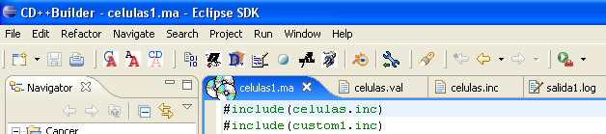
Launch GUI button
Figure 4. Simulation Service button integrated in CD++ Builder perspective.

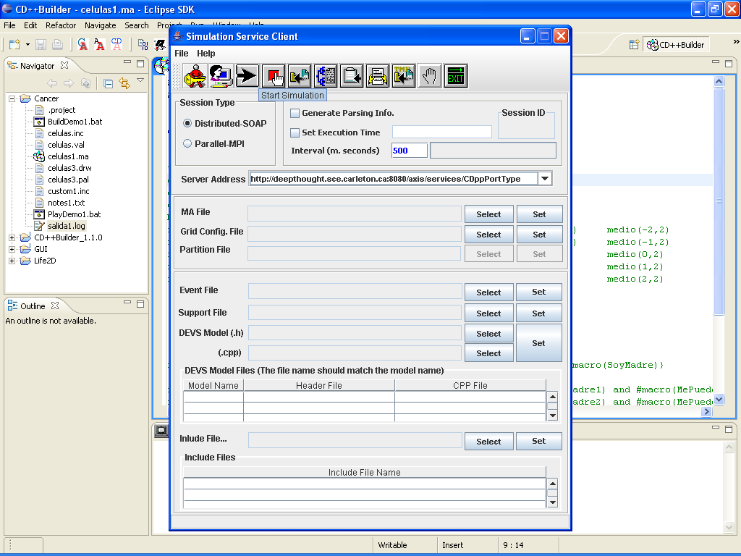
Include files management
Retrieve temp. MA file button
Figure 5. Simulation Service Graphical User Interface.

The first thing to do is to log on the server. The server address is defined in the Server Address field and can be changed in this place. After a click on the Log On button, the user enters his login and password and a new session is created on the server. It is also possible to log on an existing session with its identification number.

According to the type of simulation, different files are needed. The file that can be uploaded on the server are a model definition file (.MA file), a grid config file, a partition file, an event file, a support file, one or more DEVS models (defined by couples of .h and .cpp files) and one or more include files. To put files needed on the remote machine, the user must press Select button in the GUI. A file chooser dialog window appears with which the user has to search and choose the file he wants to add. Once the file is chosen, the user must press the Set button in the same section. The file is sent to the remote machine. A message is displayed in the GUI status bar to show if the send has been accomplished or not. When files are added in the DEVS Model Files or Include File section, they are then shown in the corresponding list box. To add other files, the user has just to repeat these operations.

Clicking on Start Simulation launch the simulation on the server with the files sent on it and the option chosen (Distributed or Parallel simulation, parsing info file, execution time and interval). The simulation stop by itself when it is finish or after the execution time set in the Set Execution Time field. It is also possible to stop the simulation with the Stop Simulation button. There is also a simulation state bar that shows the different states of the simulation: “IDLE”, “Compiling”, “Running” or “Done”.

When the simulation is terminated, the buttons Retrieve Log Archive, Retrieve Output File, Retrieve Session Log, Retrieve Parsing Info File and Retrieve Temporary MA File allow the user to retrieve all the files he needs and save them on his computer. He can then log off or directly exit.

A visualization tool for the CD++Builder Eclipse plugin

When a DEVS or CELL-DEVS model is simulated, locally or remotely, the resulting files are not easy to read and to understand. However, the analysis of the results is the goal of any simulation (figure 6). Thus, a visualization tool has been developed with the program Blender.

Mensaje I / 00:00:00:000 / Root(00) para top(01)
Mensaje I / 00:00:00:000 / top(01) para life(02)
Mensaje I / 00:00:00:000 / life(02) para life(0,0)(03)
Mensaje I / 00:00:00:000 / life(02) para life(0,1)(04)
Mensaje I / 00:00:00:000 / life(02) para life(0,2)(05)
Mensaje I / 00:00:00:000 / life(02) para life(0,3)(06)
Mensaje I / 00:00:00:000 / life(02) para life(0,4)(07)
Mensaje I / 00:00:00:000 / life(02) para life(0,5)(08)
Mensaje I / 00:00:00:000 / life(02) para life(0,6)(09)
Mensaje I / 00:00:00:000 / life(02) para life(0,7)(10)
Mensaje I / 00:00:00:000 / life(02) para life(0,8)(11)
Mensaje I / 00:00:00:000 / life(02) para life(0,9)(12)
Mensaje I / 00:00:00:000 / life(02) para life(0,10)(13)
Mensaje I / 00:00:00:000 / life(02) para life(0,11)(14)
Mensaje I / 00:00:00:000 / life(02) para life(0,12)(15)
Figure 6. Result of a simulation (Part of a log file).

This tool was integrated in the CD++Builder plugin for Eclipse. The CD++Builder installation package now contains Eclipse, Java, Cygwin, CD++Builder plug-in, Python and Blender with the CD++ improvements. During the installation of the package, Blender can be installed on the location chosen by the user (figure 7). This location is saved in the plug-in preferences and can be modified in this place (Window => Preferences => CD++Builder Preference Page figure 9). Python, required for Blender, can also be installed on the computer (figure 8).
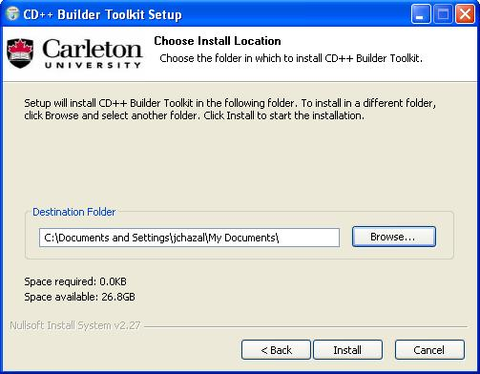
Figure 7. Installation of CD++Builder Toolkit

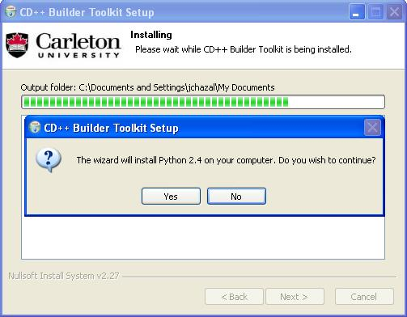
Figure 8. Installation of Python during the CD++Builder Toolkit installer

Blender can also be installed separately from Eclipse. In this case, the path to the .exe file must be defined in the plugin preferences page (Window => Preferences => CD++Builder Preference Page figure 9).

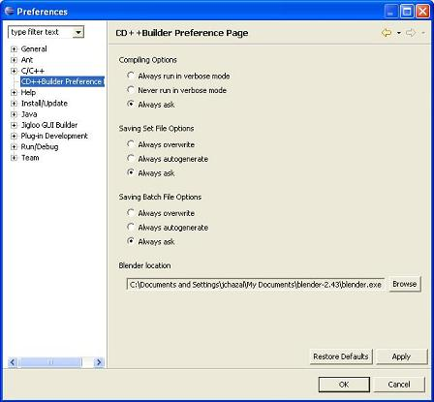
Figure 9. CD++Builder Preference Page (Eclipse).

To launch Blender, the user just has to click on the Blender Launch button (figure 10), which is available in CD++Builder, DEVS and CELL-DEVS perspectives. The plugin checks if the path saved in the preferences links to an existing valid executable file and then launch the Blender program in another window. If the path is not set when the user clicks on the Blender Launch Button, an alert message reminds him to do it (figure 11).

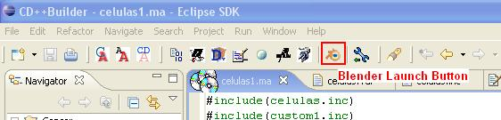
Figure 10. The Blender button in CD++Builder perspective (Eclipse).

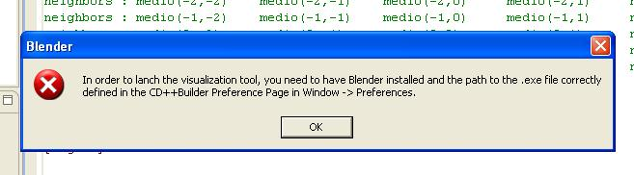
Figure 11. Error message (Eclipse).

It is possible to work independently on Blender and Eclipse. The user can, for example, run a simulation and visualise the result of another with Blender while waiting for the end of the simulation. The Blender visualization tool itself is described in the last part of this document.

Modification of an Eclipse plug-in

As said in the two previous parts of this document, the Web Service Graphical User Interface and the Blender program (with the CD++ simulation add-on) have been added in the CD++Builder plug-in for Eclipse in order to build a complete toolkit.

Eclipse plug-ins are programmed with a special Eclipse perspective: the Plug-in Development perspective. (A perspective is a set of view in Eclipse.) This is available by going to the menu Window => Open perspective => Other, and choosing Plug-in Development from the list. This is similar to the Java perspective, but has a Plug-in view that displays all detected plug-ins.

The work was to add the two new buttons by modifying the XML file who controls the plug-in and to program the tasks start by these buttons. Some option must be chosen, like the position of the button, his label and his icon for example. The tasks are defined in Java files, one for each button.

For the Blender Launch Button, the tasks are:
- Get the Blender path from the preferences.
- Check if the path is filled.
- If not, throw an error message.
- Else, try to launch the .exe file.
- If it doesn’t work, throw an error message.
- Else, return to Eclipse.

For the Interface for Remote Simulation, the tasks are:
- Get the path to the CD++ Builder plug-in for Eclipse
- Retrieve the Simulation Service Java Archive that contains classes to launch the Graphical User Interface.
- Build the classpath needed by Simulation Service Java Archive main class.
- Execute Simulation Service Java Archive in new process.

Blender Part (Emil)

References

[Alo03] Alonso, G. Web services : concepts, architectures and applications. Springer. 2003.

[And03] Andrews T.; Curbera, F.; Dholakia, H.; Goland, Y.; Klein, J.; Leymann, F.; Liu, K.; Roller, D.; Smith, D.; Thatte, S.; Trickovic, I.; Weerawarana, S. “Business Process Execution Language for Web Services version 1.1”. May, 2003. Available via <http://www-128.ibm.com/developerworks/library/specification/ws-bpel/>. [Accessed February, 2006].

[Arn03] Arnaud, B.; Wu, J.; Kalali, B. “Customer Controlled and Managed Optical networks”. IEEE/OSA Journal of Lightwave Technology, special issue on Optical Networks. Vol. 21(11), pp. 2804-2810. November, 2003.

[Bra04] Bray, T.; Paoli, J.; Sperberg-McQueen, C.M.; Yergeau, F. “Extensible Markup Language, XML 1.0 (Third Edition)”. February, 2004. Available via <http://www.w3.org/TR/2004/REC-xml-20040204/>. [Accessed October, 2005].

[Che04] Cheon, S.; Seo, C.; Park, S.; Zeigler, B.P. “Design and Implementation of Distributed DEVS Simulation in a Peer to Peer Network System”. Advanced Simulation Technologies Conference, Arlington Virginia. April, 2004.

[Cho94] Chow, A.; Zeigler, B. “Parallel DEVS: A parallel, hierarchical, modular modeling formalism”. Proceedings of the Winter Computer Simulation Conference. Orlando, FL. USA. 1994.

[Chr01] Christensen, E; Curbera, F.; Meredith, G.; Weerawarana, S.” Web Service Desctiption Language (WSDL) 1.1”. March, 2001. Available via < http://www.w3.org/TR/wsdl>. [Accessed December, 2005].

[Gli04] Glinsky, E. “New Techniques for Parallel Simulation of DEVS and Cell-DEVS Models In CD++”. Master Thesis. Carleton University 2004.

[Glo05] “A Globus Primer”. Available via <http://www.globus.org/toolkit/docs/4.0/key/GT4_Primer_0.6.pdf>. [Accessed January, 2006].

[Gud03] Gudgin, M.; Hadley, M.; Mendelsohn, N.; Moreau, J.; Nielsen, H. “SOAP Version 1.2 Part 1: Messaging Framework”. June, 2003. Available via <http://www.w3.org/TR/soap12-part1/>. [Accessed November, 2005].

[Jef85] Jefferson, D.R. “Virtual time”. ACM Transactions on Programming Languages and Systems. vol. 7(3), pp. 404-425. July, 1985.

[JXT06] <www.jxta.org>. [Accessed June, 2006]

[Kha03] Khargharia, B.; Hariri, S.; Parashar, M.; Ntaimo, L.; Kim, B. “vGrid: A Framework for Building Autonomic Applications”. International Workshop on Challenges for Large Applications in Distributed Environments (CLADE 2003), pp. 19-26. June, 2003.

[Kha05] Khan, A.; Wainer, G. “A visualization engine based on Maya for DEVS models”. Proceedings of SISO Fall Interoperability Workshop. San Diego, CA. U.S.A. 2005.

[Kim04] Kim, K.; Kang, W. “CORBA -Based, Multi-threaded Distributed Simulation of Hierarchical DEVS Models: Transforming Model Structure into a Non-hierarchical One”. International Conference on Computational Science and Its Applications (ICCSA). Assisi, Italy. 2004.

[Lia99] Liang, S. Java Native Interface (JNI), Programmer’s Guide and Specification. Addison-Wesley. 1999.

[MPI95] Message Passing Interface Forum. MPI: A Message-Passing Interface standard (version 1.1). Technical report. Available via: <http://www.mpi-forum.org >. [Accessed May, 2006].

[Seo04] Seo, C.; Park, S.; Kim, B.; Cheon, S.; Zeigler, B. “Implementation of Distributed high-performance DEVS Simulation Framework in the Grid Computing Environment”. Advanced Simulation Technologies conference (ASTC). Arlington, VA. USA. 2004.

[Tom07] Apache Tomcat. Available via <http://tomcat.apache.org/>. [Accessed May, 2007].

[Tro03] Troccoli, A., Wainer, G. “Implementing Parallel Cell-DEVS”. Proceedings of 36th IEEE/SCS Annual Simulation Symposium. Orlando, FL. USA. 2003.

[Wai00] Wainer, G. “Improved Cellular Models with Parallel Cell-DEVS“. Transactions of the Society for Computer Simulation International. Vol. 17(2), pp. 73-88. June, 2000.

[Wai01] Wainer, G.; Giambiasi, N. “Timed Cell-DEVS: modelling and simulation of cell spaces”. Invited paper for the book Discrete Event Modeling & Simulation: Enabling Future Technologies. Springer-Verlag. 2001.

[Wai02] Wainer, G. “CD++: a toolkit to develop DEVS models”. Software - Practice and Experience. vol. 32, pp. 1261-1306. 2002.

[Wai05] Wainer, G. “CD++ - A tool for DEVS and Cell-DEVS Modeling and Simulation - User’s Guide”. August 2005.

[Wai06] Wainer, G.; Madhoun, R. “Studying the Impact of Web-Services Implementation of Distributed Simulation of DEVS and Cell-DEVS Models”

[War06] Warped: A Time Warp Simulation Kernel. Warped Documentation for version 1.0. Available via <www.ececs.uc.edu/~paw/warped/>. [Accessed April, 2006].

[Wol86] Wolfram, S. Theory and applications of cellular automata. Advances Series on Complex Systems. World Scientific. Singapore. 1986.

[Zei00] Zeigler, B.; Kim, T.; Praehofer, H. Theory of Modeling and Simulation: Integrating Discrete Event and Continuous Complex Dynamic Systems. Academic Press. 2000.

[Zha05] Zhang, M.; Zeigler, B.; Hammonds, P. “DEVS/RMI-An Auto-Adaptive and Reconfigurable Distributed Simulation Environment for Engineering Studies”. ITEA Journal. July. 2005.

