CD++ Builder Toolkit Installer
- Installation Guide -

Gabriel Wainer Loïc Quinet Julien Chazal

2007/07/17 – Version 1.0 – Draft

This paper provides users with a step-by-step instruction set about how to install the CD++Builder Toolkit, in a Windows environment. It contains all the instructions to install CD++ Builder Toolkit, including the following tools:
- Java: JDK 1.6
- Cygwin
- Eclipse 3.1
- CD++ Builder plug-in for Eclipse

1. Welcome

When the user launches CD++ Builder Toolkit installer, a splash screen appears, introducing the department of Systems and Computer Engineering. After, a welcome page appears, as it is shown on figure 1:

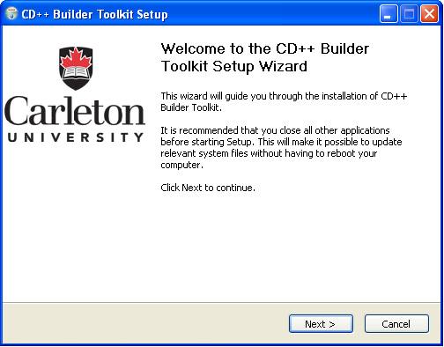

Figure 1: Welcome page

The user has just to click if he agrees to install CD++ Builder Toolkit.

2. License

Once the welcome page agreed, the installer shows the license of the tools. The user must agree this license page to continue the installation.

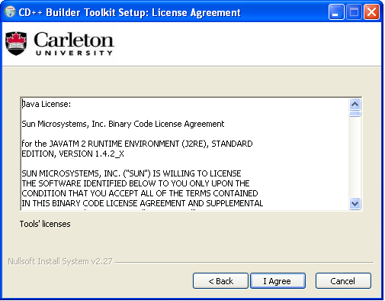

Figure 2: License page

3. Information

This page presents the tools that will be installed on the machine for running CD++ Builder. The user can access to the user guide by letting checked the check-box called “View Installation Guide”, and then if the user clicks on the “Next” button, the installer will open the installation guide (i.e. this paper) by launching an application able to read .doc files, like Microsoft Word. If the user unchecks the “View Installation Guide” check-box, the installation continues, but he will have to pay attention of the configuration of the tools, especially for Cygwin (the Cygwin installation is presented on 6. Cygwin part).

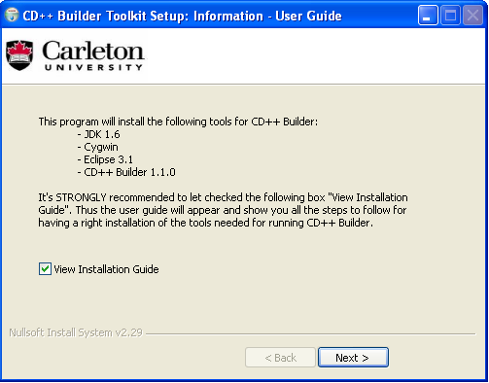

Figure 3: Information page - Access to the user guide

By clicking “Next” button, the user has to choose the installation directory.

4. Installation directory

By default (and it’s strongly recommended to install CD++ Builder Toolkit) the installation directory that is chosen is the root of the local drive, C:\. The user can also choose a specific installation directory by clicking on the “…” button. Thus, a folder chooser dialog appears and the user can specify where he wants to install CD++ Builder Toolkit. Once he has chosen the folder, he must click on the “Install” button.

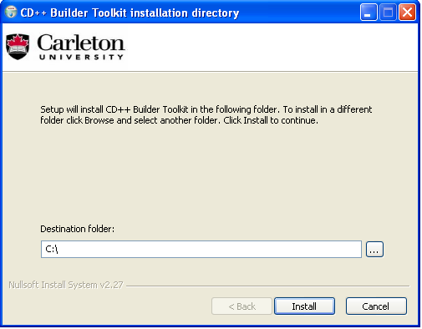

Figure 4: Choose installation directory

5. Java

At this step, the install will check if a Java Virtual Machine is already installed on the user’s machine. An information dialog window appears if a JVM is detected (cf. figure 5), otherwise the installer proposes to the user to install a JVM (JDK 1.6).

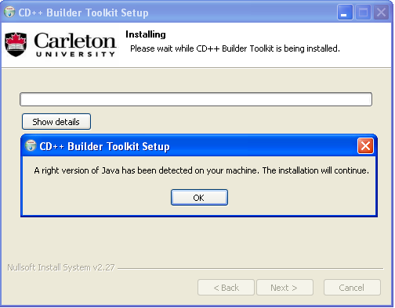

Figure 5: A JVM has been detected

Notice: if this screen appears, please go to 6. Cygwin part to install Cygwin. Otherwise, follow the next procedure (JVM installation):

JVM installation:
- Accept the License Agreement, and click Next.
- Wait, while the Java installer is running. It could take several minutes.
- A new window appears. Click Next.
- Wait, while the Java installer is running. It could take several minutes.
- Click Finish. The installation will now proceed.

6. Cygwin

Now the installer proposes to install Cygwin. The user can decline to install it if Cygwin is already installed on the machine, but it’s strongly recommended to use this procedure.

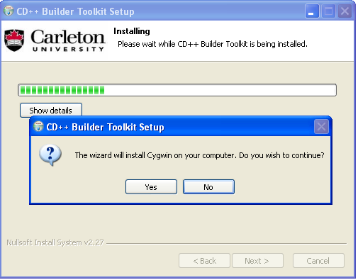

Figure 6: Cygwin installation

Notice: by clicking next, the user must follow the Cygwin installation procedure which is next. If the user clicks on “No”, please go on 7. Eclipse part, to install Eclipse.

Cygwin installation procedure:
- The folowing window will appear:
For information on what Cygwin is please visit http://www.cygwin.com

- Click next and select install from local directory
- If you are installing this for other accounts to use as well click on install for ALL and press next. The next window will show the location of where it is installing from. You should point to the folder where you unzipped the pack (in our example, C:\cygwin”).
- Look for “Devel” under the Category column. Some of the tools under this category must be installed (underlined in red in the following figure). To install a particular tool click on the word “skip” under the New column, until it changes to the tool’s version to be installed.
- Click on “next” to begin installation. When this is done, the installation tool will ask you to create shortcuts on the desktop and startup menu.

Notice: to properly configure Cygwin, the user has to read 10. After installation tasks part.

7. Eclipse

The installer asks the user if he wants to install Eclipse 3.1 on his computer, as follow on figure 7:

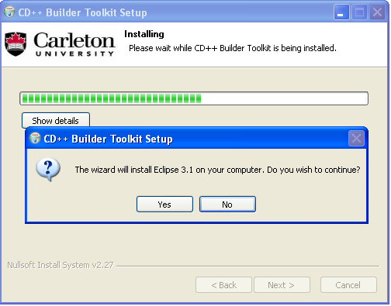

Figure 7: Eclipse 3.1 installation

If the user clicks “Yes”, the installer will place Eclipse in the folder that has been chosen on step 4. Installation directory.

8. CD++ Builder

The installer will now install CD++ Builder plug-in for Eclipse.

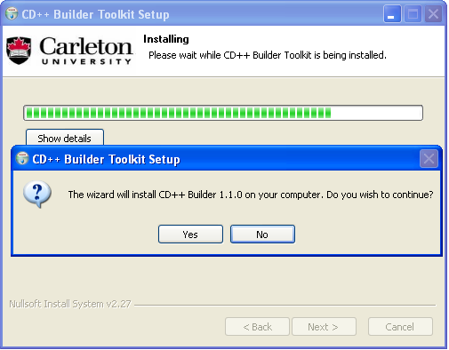

Figure 8: CD++ Builder plug-in installation

9. Finish page

If all the steps presented have been strongly followed, the installation is finished. The following screen appears:

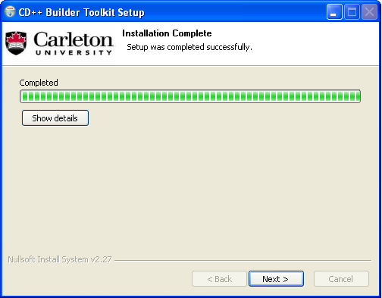

Figure 9: End of installation

The user must click “Next” to continue. Then a finish appears to point out that the installation has been well realized, as it’s shown on figure 10:

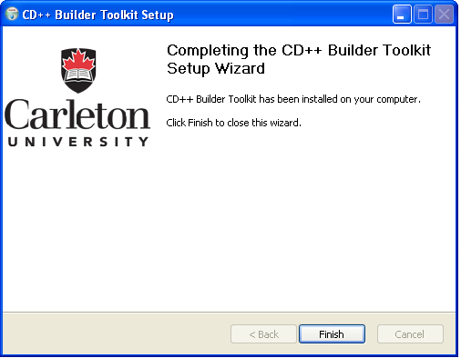

Figure 10: Finish page

10. After installation tasks

This section presents the things that the user must do after the installation. This part shows how to configure Cygwin.

- To properly configure Cygwin, first, go to Control Panel > System. (Note for Windows XP users: double-click My Computer, within “System Tasks”, click View System Information.) In the System Properties window, within the “Advanced” tab, click on the Environment Variables button.

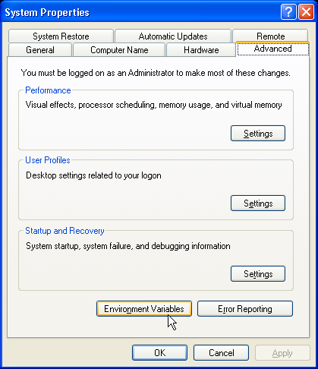

In the Environment Variables window, within “System variables”, double-click the Path variable.

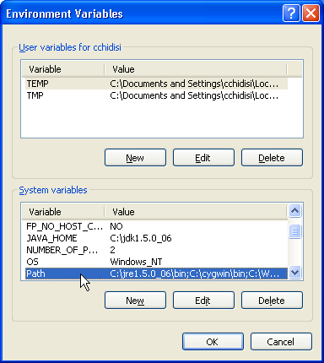
In the Edit System Variable window, ensure the “Variable name:” is Path. At the end of “Variable value:”, add C:\cygwin\bin; . Do not forget to include the semicolon (“;”). (Note for Windows XP users: in “Variable value:”, add C:\cygwin\bin; between %SystemRoot%\system32 and %SystemRoot% . This should result in the following order: %SystemRoot%\system32; C:\cygwin\bin; %SystemRoot%; … )
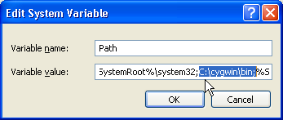

Click OK to close the Edit System Variable window. Click OK to close the Environment Variables window. Click OK to close the System Properties window.

You may need to logout and re-login for the change occur.
- Create a folder “C:\tmp” (do not confuse with c:\temp). Give read/write access to C:\tmp, ie. from C:\, right-click tmp, select Properties, within the “General” tab, listed under “Attributes:”, un-click Read-only.

- Define cygwin’s working directory in the drive where eclipse is installed on. To insure that this path has been set correctly, open a cygwin shell window (double-click on cygwin’s icon on your desktop or startup menu). Assuming eclipse is installed on the C: drive, if you type in 'pwd', the output should be “/cygdrive/c” (i.e., the c: drive if eclipse was installed on this drive). If the path appears, for instance, as “/cygdrive/m” (or some other drive), you must modify the “home” environment variable.

- To set the path to the “c:” drive, please go to the “C:\cygwin\etc” folder. Within this folder you will find a file called “profile”. Open it with an editor (e.g. notepad, wordpad etc.). Skip one line below this line:

USER=“`id -un`”
Now you must type the following (there should not be any spaces in the first line):
HOME=“/cygdrive/c”
Export HOME
The result should look as following:

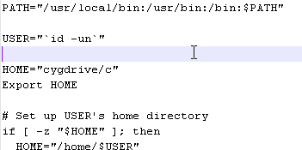
- Save the “profile” file.

- To check if the changes have been made, close all cygwin windows and open a new one. Type pwd, and hit Enter. If “/cygdrive/c” is output, Cygwin should now be installed and configured, so proceed to STEP 4: Installing the CD++ Builder Plugin.

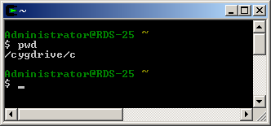
- To finish up, and to make sure that every feature of the plugin works normally check that you have the file <cat.exe> in the folder <C:\cygwin\bin\>(if cygwin is installed in C:) if not then go to:

http://programming.ccp14.ac.uk/ftp-mirror/programming/cygwin/pub/cygwin/latest/textutils/ and download the file called textutils-2.0.21-1.tar.tar (495 Kb in size).

- Unpack the file you downloaded using WinRar and go to “user→bin→cat.exe”.

- Copy cat.exe in to your cygwin bin folder. For instance, if cygwin has been installed in the C: drive, then copy cat.exe over to C:\cygwin\bin to completely install cygwin.

11. Launch CD++ Builder Toolkit

The user can now launch Eclipse. To do that, he just has to go into the folder where Eclipse is installed (chosen at step 4. Installation directory), and execute the file eclipse.exe.

During the first run of Eclipse, a screen appears and asks the user where he wants to create the workspace for Eclipse. The workspace must be created in eclipse folder (for instance in “C:\eclipse\”), as fallow:

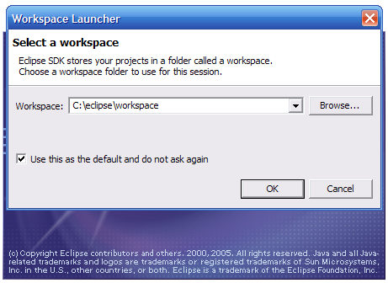

Figure 11: Fixing the workspace

To use CD++ Builder, please refer to the user’s guide (“CD++, A tool for DEVS and Cell-DEVS Modeling and Simulation, User’s Guide - Gabriel A. Wainer).

