CD++ Builder NSIS Installer
- Developer’s Guide -

Gabriel Wainer Loïc Quinet Julien Chazal

Abstract 2

Introduction 2

1. Eclipse NSIS 2

1.1. Presentation 2
1.2. Installation 3

2. How to retrieve and load CD++ Builder Toolkit Installer 3

3. CD++ Builder Toolkit Installer architecture 7

Abstract

This paper is a guide for developers to create a simple installer of all the tools needed by CD++ Builder. It includes a presentation of EclipseNSIS, an eclipse plug-in used to create the CD++ Builder installer.

Introduction

NSIS (Nullsoft Scriptable Install System) is a professional open source system to create Windows installers. It is designed to be as small and flexible as possible and is therefore very suitable for internet distribution. In order to provide a simple way to install all the tools for CD++ builder, this kind of install system has been chosen.

1. Eclipse NSIS

1.1. Presentation

EclipseNSIS is a plug-in for the Eclipse platform which enables editing, compiling and testing NSIS scripts.

Features included in EclipseNSIS:
- Syntax highlighting editor, with customization.
- Outline view for quick navigation.
- Script Wizard for generating NSIS scripts. This includes support for templating.
- Code template support with replaceable parameters for reusing common script fragments.
- Integrated help, including quick and detailed hover help, as well as access to complete NSIS documentation.
- Full support for compiling and testing scripts. Includes automatic generation of error and warning markers in scripts.
- Support for NSIS script-based launch configurations and project builders.
- Automatic generation of task markers (TODO items).
- Integrated update support within Eclipse.
- Integrated NSIS update support.
- InstallOptions GUI designer.

1.2. Installation

Only 4 tools are needed for developing a NSIS installer: Eclipse 3.2, NSIS 2, GEF eclipse plug-in and EclipseNSIS.

Eclipse 3.2:
- Download Eclipse at http://download.eclipse.org/eclipse/downloads/drops/R-3.2-200606291905/download.php?dropFile=eclipse-SDK-3.2-win32.zip
- Extract Eclipse from the .zip archive to a right place. For instance C:\eclipse-3.2

Notice: a Java Virtual Machine is needed to run Eclipse. You can find a right version on the following link: http://java.sun.com/javase/downloads/index.jsp

NSIS 2:
- Download NSIS 2 nsis-2.29-setup.exe on the following link: http://sourceforge.net/project/showfiles.php?group_id=22049&package_id=15374
- Run the file that has been downloaded and install NSIS by default.

GEF 3.2:
- Download GEF 3.2: http://download.eclipse.org/tools/gef/downloads/drops/R-3.2-200606270816/
- Extract the archive
- Browse the folders which have been extracted and copy the folders plug-in and features in the eclipse folder. For instance C:\eclipse-3.2

EclipseNSIS:
- Download net.sf.eclipsensis_0.9.5.1 from the web site http://sourceforge.net/project/showfiles.php?group_id=116143
- Extract the archive, copy and paste the folders plugin and feature into the eclipse folder. For instance C:\eclipse-3.2
- Download net.sf.eclipsensis.installoptions_0.9.5.1 from the web site http://sourceforge.net/project/showfiles.php?group_id=116143
- Extract the archive, copy and paste the folders plugin and feature into the eclipse folder. For instance C:\eclipse-3.2

Create a workspace:
- Once the tools are correctly installed, you can launch Eclipse and create a workspace (the workspace is asked when you launch eclipse for the first time).

2. How to retrieve and load CD++ Builder Toolkit Installer

The EclipseNSIS project is located on the CD we have burned. So, you just have to copy the directory CD++BuilderToolkit_1.1.0_Installer in the Eclipse workspace. The latest directory is located in the directory Tools\CD++Builder Installer - EclipseNSIS\ which is on the CD.

- Now you have to load the CD++ Builder Toolkit Installer project (which includes all the source code). Restart Eclipse and make a right-click on the Package Explorer and click on “Import…”, as it’s shown on figure 1.

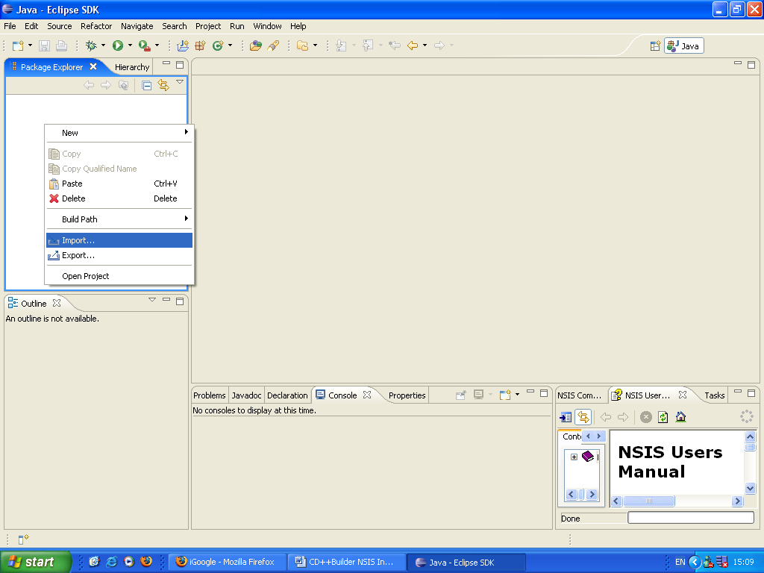

Figure 1: Right-click on the Package Explorer - Click Import...

- Choose the option Existing projects into workspace as fallow on figure 2
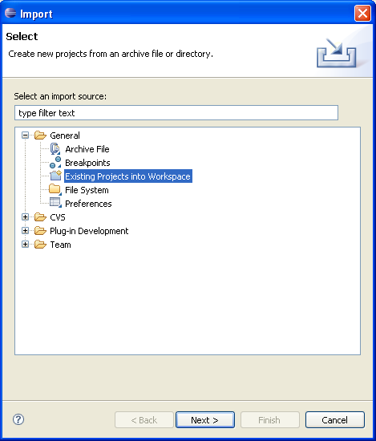

Figure 2: Choose import: "Existing Projects into Workspace"

- Search for the project by pressing browse button and click on finish (cf. figure 3)

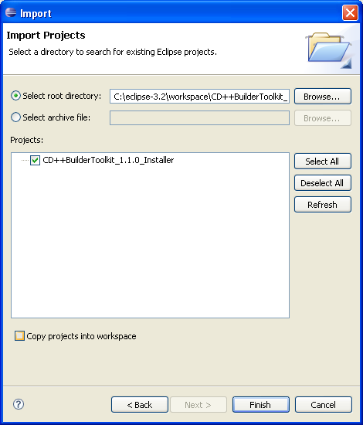

Figure 3: Select the project directory
- Now you have imported the project into eclipse. Collapse the Package explorer window tree on Eclipse interface and double-click on the file “setup_JCECDpp.nsi”: thus the NSIS perspective is open ad shown on figure 4:

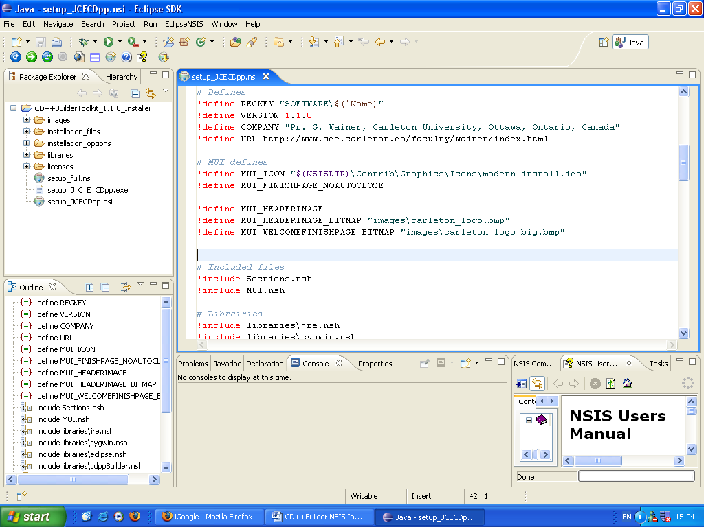
Package explorer

NSIS file editor

NSIS user manual

Figure 4: EclipseNSIS edit file interface

- You can collapse the installation_options directory located on the Package Explorer. Double-click on the file before_installation.ini. The InstallOptions designer is opened: you could now create your own NSIS pages by drag and drop (cf. figure 5):
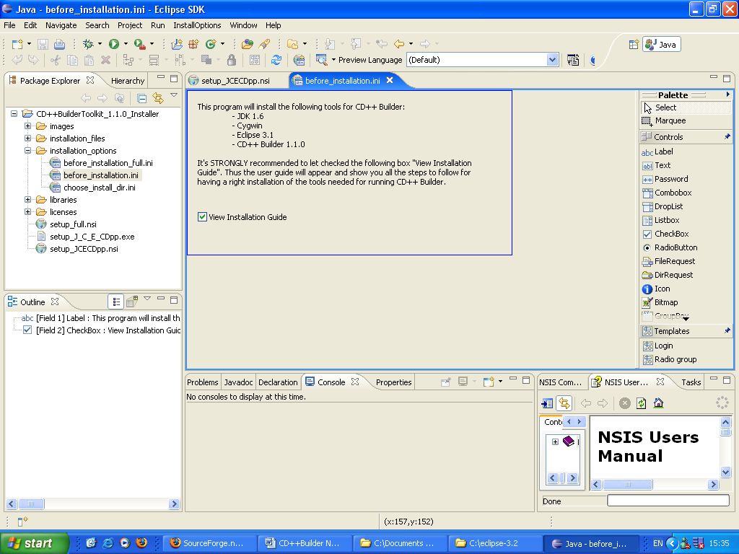

Figure 5: Eclipse NSIS InstallOptions Designer

3. CD++ Builder Toolkit Installer architecture

The Installer has a specific architecture. It is “cut” into several directories to permit the developer to easily modify and develop it. The architecture is shown on figure 6:
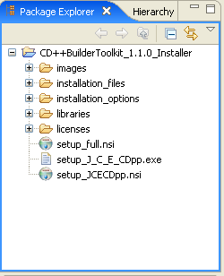

Figure 6: Project architecture
The project root contains 5 directories and 3 files:
- Images: this directory contains all the images used for the installer, in order to have a friendly interface and to promote Carleton University and Department of Systems and Computer Engineering.
- Installation_files: it contains the entire files needed for installing CD++ Builder Toolkit. Thus it contains the programs like Eclipse 3.1, CD++ Builder plug-in, Cygwin…
- Installation_options: this directory contains the NSIS pages that the developer can customized.
- Libraries: this directory contains the libraries developed for this installer. These libraries correspond in fact at each needed tool: then, there a library for each tool, for instance a library for Eclipse 3.2, Cygwin, Java…
- Setup_full.nsi: this file is a script that defines an full installer for all the tools (Java, Cygwin, Eclipse 3.2, CD++ Builder, Blender, Python)
- Setup_J_C_E_CDpp.exe: this is the execution file which is generated by compiling the Setup_JCECDpp.nsi file. This .exe is executed by the user for installing the toolkit.
- Setup_JCECDpp.nsi: this script configures all the things to obtain an executable installer.

To create a new .exe installer, the developer has just to open the .nsi file that he needs and click on the compile button, as it’s shown on figure 7:

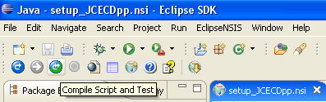

Figure 7: Compile, Run or Run/Compile

You can find more information about NSIS, especially for NSIS script:
- http://nsis.sourceforge.net/Main_Page: NSIS main page.
- http://nsis.sourceforge.net/Developer_Center: Developper Center, which contains a lot of example, documentation and ressources.
- http://samisd2003.free.fr/WinLAMP/NSIS/IndexPage.html: French user manual for NSIS.

