CD++Modeler
Using the CD++ Modeler Graphical User Interface (GUI), atomic and coupled models can be created for the CD++ toolkit. The basic functions of the GUI include: creating atomic and coupled models, exporting the models to different formats, and animating the simulations. The GUI also includes: - a simple text editor to directly modify Cell-DEVS models, - the RUN/SIMU commands to execute the simulation with the CD++ toolkit, and - the DRAWLOG command to generate the draw information from the simulation. This section describes in detail how to use the GUI for inputting DEVS model, and for visualizing the results of the Cell-DEVS, Atomic-DEVS, and Coupled-DEVS models.
Since the GUI is coded in Java (JDK1.4.1), it is platform portable and can be run in various environments, such as Eclipse or JBuilder (with JDK 1.4.1). Although this tool is a standalone program, it can also be accessed through CD++Builder by clicking on , located in menus of CD++Builder, CELL-DEVS, DEVS, and GGAD perspectives.

To install and run the standalone GUI:
Note: If you are using CD++Builder, you don’t have to install the standalone version. You can access CD++ Modeler directly from the Cellae’s perspective, by clicking on .
1) Download the cdModeler.zip file, which contains source code, class files, and some example files. Decompress the cdModeler.zip file in the Windows environment.
2) Install JDK 1.4.1 or above.
3) Set up the JAVA_HOME environment variable to point to the JDK directory.
To do this, modify the PATH environment variable by adding " %JAVA_HOME%\bin; ".
Note: To modify environment variables, go to Control Panel > System > Advanced > Environment Variables.
In the cdModeler directory, double click the run.bat file to start the program.
When the program has started, it will display a dialog as seen in Figure 1.

Using CD++Modeler
Once the CD++Modeler tool is running, the following screen will appear.

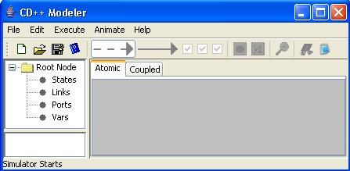
Figure 1: CD++ Modeler window.

Figure 2: CD++ Modeler menu bar.

1 2 3 4 5 6 7 8 9 10 11 12 13 14
Figure 3: CD++ Modeler button bar.

The button bar contains the following buttons (in order from left to right):
- New - new project
- Open - open project
- Save - save current activity
- Help -
- Internal Link - only used for the atomic model design space
- External Link - only used for the atomic model design space
- Show Link Expressions - only used for the atomic model design space
- Show Link Actions - only used for the atomic model design space
- Show Link Ports - only used for the coupled model design space
- Add new Atomic Model Unit - only used for the coupled model design space
- Add new Coupled Model Unit - only used for the coupled model design space
- Close Exploded Unit - only used for coupled model design space
- Simulate - only used for coupled mdoel design space
- Editor - Doesn’t work when modeler is exported as a JAR

Please see the Help files (in Atomic>Distribution and Coupled>Distribution) for a more detailed description of the button bar.
The following sections explore the functions of the GUI with examples.

Creation of DEVS Models (using the design space)
Models can be defined within the design space. First select the appropriate design space (Atomic or Coupled) for the model by clicking on the appropriate tab.

Create Atomic Model
The basic steps required for creating an atomic model are as follows:
1) Choose the atomic design space by clicking once on the Atomic tab in the interface.
(The atomic design space consists of a central panel and two lateral panels.)
2) Select File > New from the main menubar.
3) Position the mouse within the design space, and right-click. The following popup menu will be displayed.
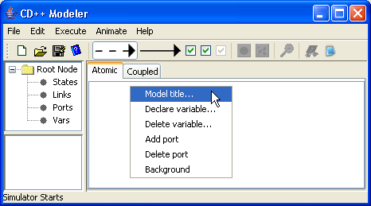
Figure 4: Creating an atomic model

Setting the Model Title
1) Left-click on Model title. The Set Title ("Model ClassName") dialog will be displayed.
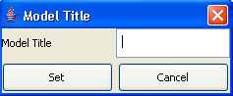
Figure 5: Entering the model title
2) Type in the appropriate Model Title, and press Set.

Adding Units
1) Left double-click on the design space. A circular unit will be drawn in blue.
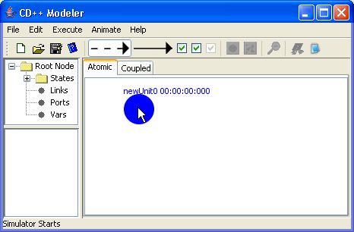
Figure 6: Adding Units to an Atomic Model
2) Left double-click on the circular unit. This will select the circular unit, as represented by the unit becoming red.
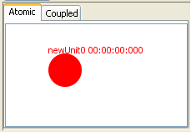
Figure 7: Selecting a unit
3) Left double-click on the selected unit. This will de-select the circular unit, as represented by the unit returning to blue.

Setting Properties of Units
4) Right-click on the circular unit. The following popup menu will be displayed.
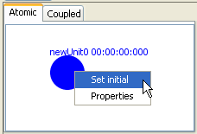
Figure 8: Setting initial property units
5) To set this unit as the initial unit of the model, left-click on Set initial.
When another unit is set as the initial unit of the model, the previous unit is automatically de-selected as the initial unit.
6) To set the properties of this unit, left-click on Properties. The State Properties ("Atomic Unit properties") dialog will be displayed. Type in the appropriate state ID and state Time-to-Leave. Press OK.
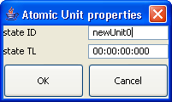
Figure 9: Entering State ID and state TL

Deleting Units
7) Select the circular unit (ie. left double-click on the circular unit). After the unit becomes red, press the Delete button on the keyboard, or select Edit>Delete from the main menubar.
When a unit is deleted, all links connected to the unit will also be deleted.
To delete multiple units, select the multiple units (ie. left double-click on each of the units), and press Delete or Edit>Delete.

Adding Ports
1) Right-click within the "canvas" (design space). The following popup menu will be displayed.
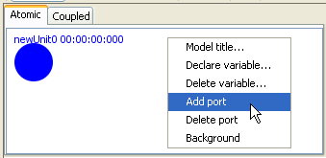
Figure 10: Adding ports
2) Left-click on Add port. The Add Port dialog will be displayed. Type in the appropriate PortID, select the direction of the port (In or Out), and select the port type (Integer or Float). Press OK.
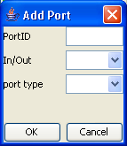
Figure 11: Entering Port ID
Repeat this procedure to add all the necessary ports for a unit.

Deleting Ports
3) Right-click within the "canvas" (design space). The following popup menu will be displayed.
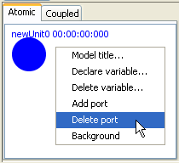
Figure 12: Deleting Ports
4) Left-click on Delete port. The Delete Port dialog will be displayed. Choose the appropriate port to be deleted from the Port ID dropdown menu. Press Delete to delete the selected port.
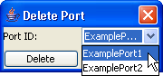
Figure 13: Delete Port Dialog box

Adding Links
Links represent transitions between different or similar units. After creating all the necessary atomic units, links can be made between the units or be created as a selflink.
Two types of links are available for atomic models:
Internal link (representing an internal transition): Transition happens automatically as a timer runs out.
External link (representing an external transition): Transition happens when a certain expression returns true.
Steps to creating a link:
1) Before drawing a link, the user should select the desired link type by clicking either the internal or external link button on the toolbar.
2) To draw a link between two units, position the mouse on one of the units, press and hold the left mouse button on one unit, drag the mouse to the other unit, and release the left mouse button. A link with the pre-selected type will be drawn.
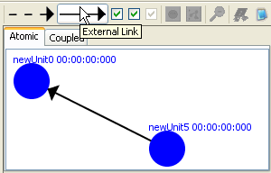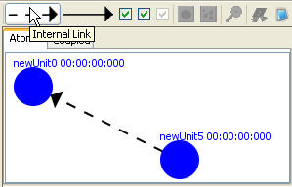
Figure 14: Adding links (external and internal)
3) To create a 'self link' (a link between an atomic unit and itself), position the mouse cursor on the unit. Make shure that the unit is not selected [unit is not coloured in red]. Press and hold the left mouse button. Drag the mouse away from and back to the unit with the left mouse button being held. Release the left mouse button to finish creating the self link.
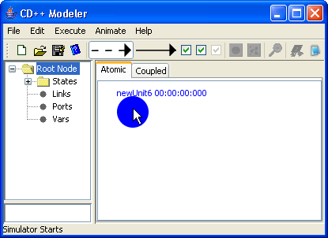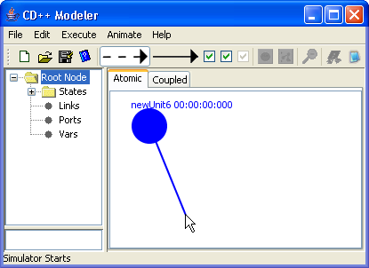
Figure 15: Creating a self link

A Warning Message dialog will be displayed, verifying the creation of a self link. Click OK.
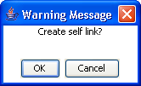
Figure 16: Warning message for creating a self link
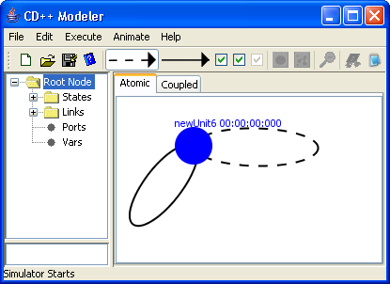
Figure 17: Example of internal and external selflinks attatched to an atomic unit

Adding Transition Events to Internal and External Links
Internal Link Transition: To attach a port and value assignment to an internal link, right-click on the link. The following popup menu will be displayed.
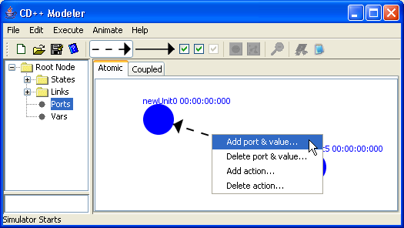
Figure 18: Attaching a link to a port
Left-click on Add port & value. The Add port & value dialog box will be displayed (See Figure 19). Select the appropriate port [output ports are for internal transition], and type in the appropriate value for the port. Press OK. When an internal transition occurs the selected output port will receive the assigned value which is set in the Add port & value dialog box.
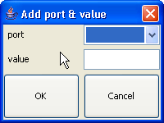
Figure 19: Adding port and value dialog box

External Link Transition: These transitions will allow transitions between different atomic units [states]. In general the transition happens when a user-defined value is received on a specific input port.
To add an expression to an external link [represented by a solid arrow] the following must be done:
- Right click on the on the external link. And select Edit Expression....
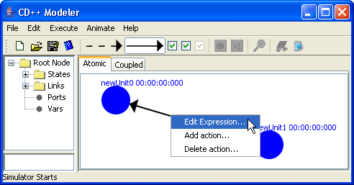
Figure 20: Adding an expression to an external link
- Expressions can be either added manually [if you know what to type] or with the help of the Add Function button. Inorder to use the Add Function button first select a function to add from the bottom text field then click on the Add Function button. Now a dialog box will pop up asking for parameters required in the function. Fill in the parameters and click ok. Now that a function is added, user must MANUALLY configure the rest of the expression by typing “?value” [without the quotes] after the expression. The “value” represents any number. An example external transition expression would be: Value(in)?2 . This simply means that when the value at the port “in” [represented by the Value(port) function] is equal to “2” then make a transition to the other state.
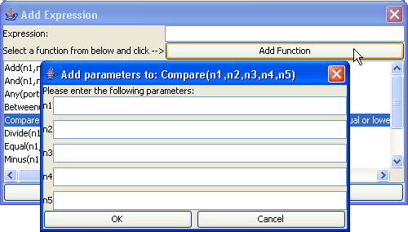
Figure 21: Showing a dialog window when the Add Function button is clicked.

Deleting Links
5) Select the link (ie. left double-click on the link). After the link becomes red, press the Delete button on the keyboard, or select Edit>Delete from the main menubar.
To delete multiple links, select the multiple links (ie. left double-click on each of the links), and press Delete or Edit>Delete.

Saving and exporting the model
1) To save the model to disk, select File>Save or File>Save As from the main menubar. The model will be saved as a .gam file.
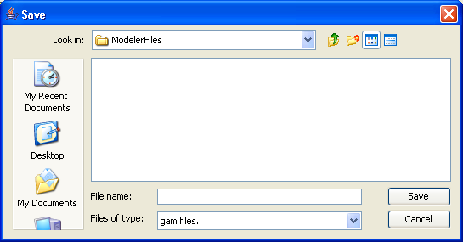
Figure 22: Save file Dialog box
2) In order to use the model in the other CD++ tools, the model must be exported to a standard .cdd file. To export the model, select File>Export. *.cdd must be the file name extension.
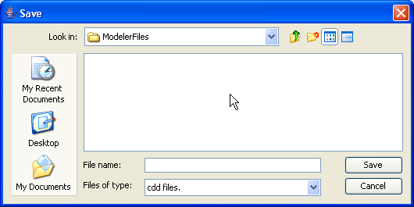
Figure 23: Choosing cdd files only
3) To save and export the model in one step, select File>Save and Export.

Create Coupled Model
The basic steps required for creating a coupled model are similar to those for creating an atomic model.
Open CD++ Modeler and choose the coupled design space by clicking once on the Coupled tab in the interface.
The coupled design space consists of a central panel and three lateral panels:
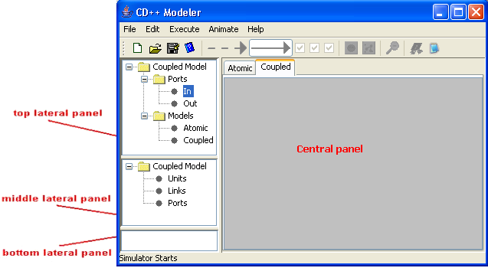
Figure 24: The coupled design space
The central panel displays the objects (in graphical form) of the coupled model. Objects (such as ports, atomic models, and coupled models) can be added, and links can be connected between the objects.
The top lateral panel displays the types of objects that are available for defining the model. It is divided into ports (input and output), predefined atomic models, and predefined coupled models.
The middle lateral panel displays the objects (in textual form) that define the model. (The textual form of the objects in the middle lateral panel correspond to the graphical form of the objects in the central panel.)
When an object/element is selected in the middle lateral panel, the description/details of the element will be displayed in the bottom lateral panel. (ie. The bottom lateral panel displays a description of the element currently selected in the middle lateral panel.)
The central panel is referred to as the 'Modeling Panel'.
The middle lateral panel is referred to as the 'Units Panel/Tree'.

Adding Atomic Units
1) To add a new atomic model that is not yet defined, click once on the Add new Atomic Model Unit button. The new atomic model unit will be drawn in the upper-left corner of the Modeling Panel, and will be given a default name (eg. newAtomicModel0).
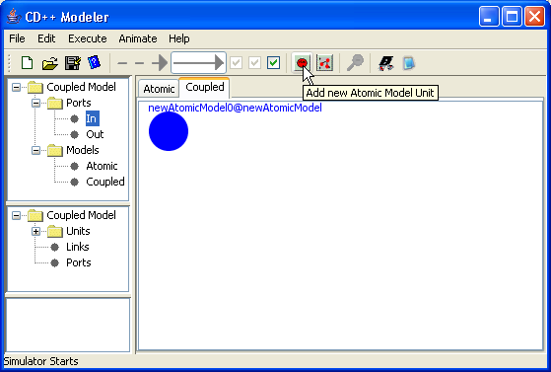
Figure 25: Adding atomic units

2) To edit the atomic model unit, right-click on the unit. The following popup menu will be displayed.
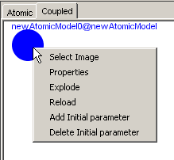
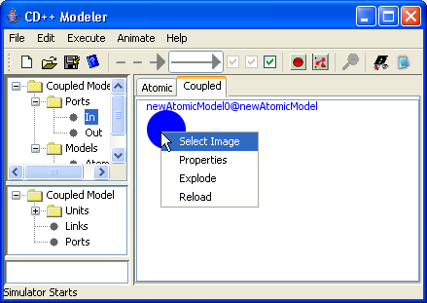
Figure 26: Right clicking on the image to edit

Select Image - change the icon for the unit
Properties - change the unit name
Explode - explode the unit for its definition
Reload - reload the unit if its definition has been modified

3) To change the unit name, left-click on Properties. The Model Properties dialog will be displayed. Type in the appropriate Unit ID. Press OK.
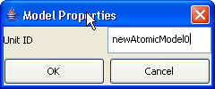
Figure 27: Changing unit name

The Explode and Reload options will be described in later sections.

Adding Coupled Models
1) To add a new coupled model that is not yet defined, click once on the Add new Coupled Model Unit button. The new coupled model unit will be drawn in the upper-left corner of the Modelling Panel, and will be given a default name (eg. newCoupledModel2).
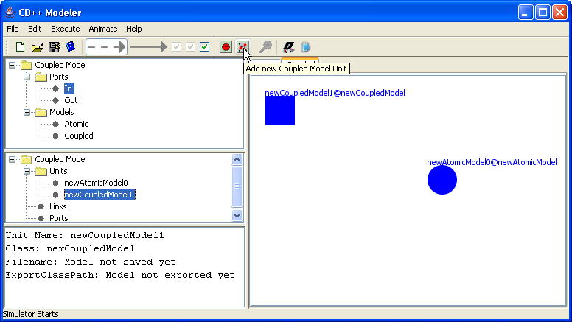
Figure 28: Adding coupled models

2) To edit the coupled model unit, right-click on the unit. The following popup menu will be displayed.
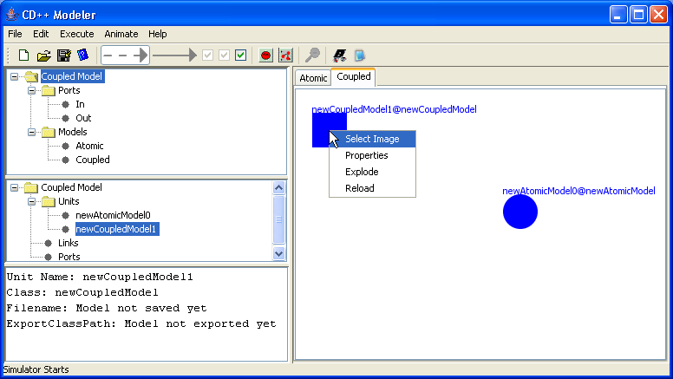
Figure 29: Editing a coupled model
Select Image - change the icon for the unit
Properties - change the unit name
Explode - explode the unit for its definition
Reload - reload the unit if its definition has been modified

3) To change the unit name, left-click on Properties. The Model Properties dialog will be displayed. Type in the appropriate Unit ID. Press OK.
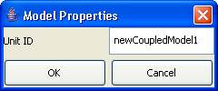
Figure 30: Changing the unit name
The Explode and Reload options will be described in later sections

Adding Ports
Two types of ports are available for coupled models: Input and Output.

1) To add a port, first select the type of port in the top lateral panel. Within the canvas (design space), position the mouse cursor at the desired location of the port. Left double-click. The selected port type will be drawn, and will be given a default name. For example, Port0 represents an input port, while Port1 represents an output port.
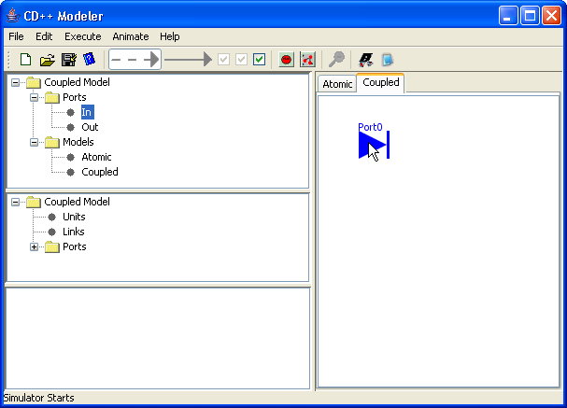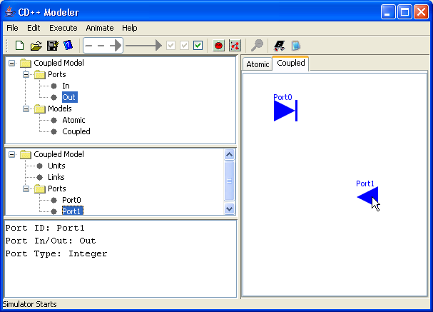
Figure 31: Adding ports

The name of the port can be changed in two ways:
2a) Right-click on the appropriate port. The following popup menu will be displayed. Left-click on Properties.
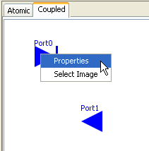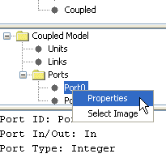
Figure32: Changing the name of the port
2b) In the Units Tree (the middle lateral panel), expand the Ports folder. Left double-click on the appropriate port. An alternative method is to right click on the appropriate port and select properties as seen in Figure32.

3) The Port Properties dialog will be displayed. Type in the appropriate PortID. Press OK.
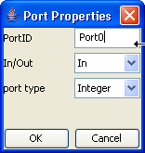
Figure 33: Entering port ID

Adding Links
To add a link between two objects, position the mouse cursor on the first object (the origin of the link). Press and hold the left mouse button. Drag the mouse to the second object (the destination of the link). Release the left mouse button. The link will be drawn form the origin to the destination. For example, the origin of the link is Port 2, while the destination of the link is newAtomicModel0.
The link will be created only if both the origin and destination are valid.
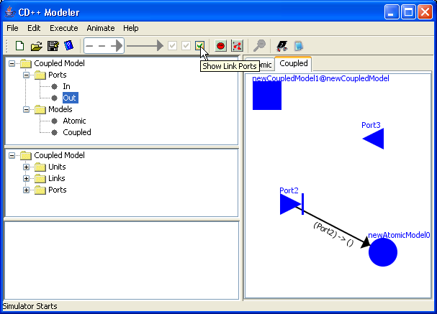
Figure 34: Adding links
NOTE: If you uncheck the Show link port checkbox then (Port2)->0 will not be displayed.
Selflinks can also be created for coupled models. One can add selflinks to the coupled or atomic model unit as seen in Figure 35. Selflinks are added in the same way as one would add a selflink to an atomic model (See section 8.16.2.1.7).
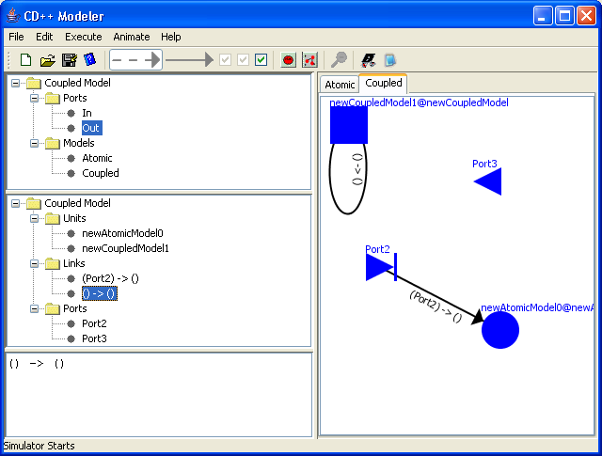
Figure 35: Example selflink starts and ends at newCoupledModel1

Importing Models
A coupled model is composed of other atomic and coupled models, which can be imported as predefined models. Three model types are valid for importing:
- predefined coupled models (.ma)
- predefined atomic models (.cdd)
- basic atomic models (from register.cpp)

For example, let’s consider the ATM model.
You can download the necessary files for the ATM model here: http://chat.carleton.ca/~jcao/blog/cd++files/ATM%20MODEL%20USING%20NEW%20CD%20MODELER.zip
Continue reading once you have extracted the zip files.
Open CDModeler, click on the coupled tab, click File>New to start the creation of a new coupled model.
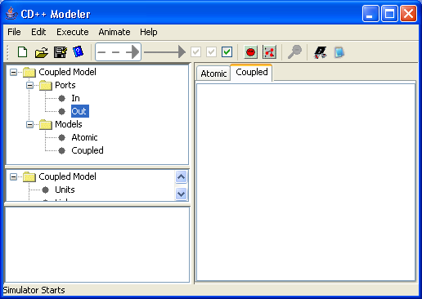
Figure 36: Fresh new coupled design space.
A predefined model can be imported by selecting File>Import. The Import dialog will be displayed. (Only .ma, .cdd, and .cpp files can be imported.)
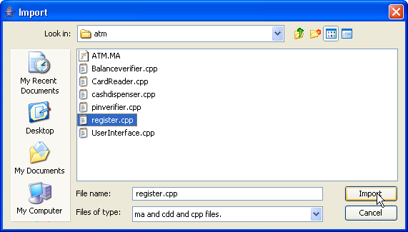
Figure 37: Import dialog box
Browse to the extracted folder containing ATM files, select register.cpp, and press Import. Now, a dialog box will popup as a reminder that one must create ports to the model(s) before adding them to the design space. Click OK.
In the top lateral panel browse to Models>Atomic. The CDmodeler window should now look like the following:
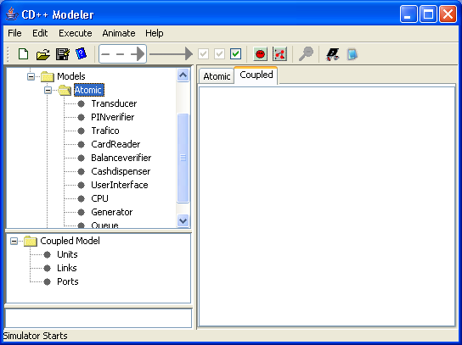
Figure 38: Showing imported models.
The name of the imported models will be displayed in the top lateral panel, within the appropriate folder (Atomic or Coupled). In this example the Register.cpp corresponds to a series of atomic models and thus expanding the atomic subfolder one can find all the models associated with Register.cpp.
For example: When a coupled model definition file (.ma) is imported, the name of the imported model is displayed in the top lateral panel under Models>Coupled. When an atomic model definition file (.cdd) is imported, the name of the imported model is displayed in the top lateral panel under Models>Atomic.
To add a unit of the imported model to the definition of the current coupled model, first select the imported model name (PINverifier) in the top lateral panel. Within the canvas (design space), at the desired location of the unit, left double-click. A unit of the imported model will be drawn.
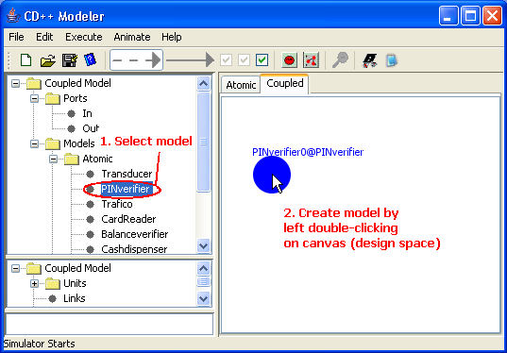
Figure 39: Creating a model on the canvas (design space)
NOTE: Units of imported models cannot be modified.
Importing an *.ma file:
Continuing from the previous example, click File>Import. Browse to the ATM folder again but this time select atmNEW.ma and click on import.
A coupled model definition file (.ma) named "ATM" is imported:
(1) The name "ATM" is displayed in the top lateral panel under Models>Coupled.
(2) “ATM9” (a unit of "ATM") is added to the definition of the current coupled model [This is done by selecting ATM in the top lateral panel and double clicking on the canvas (design space)].
(3) The predefined ports of “ATM9” are displayed in the middle lateral panel. (For "ATM", there are two output ports: 'cash_out' and 'card_out'. There is also one input port: ‘in’.)
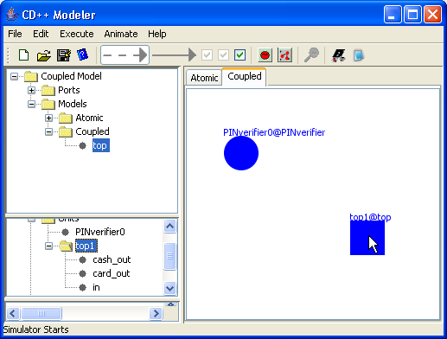
Figure 40: Importing and creating a coupled model.

NOTE: Importing a *.cdd file undergoes the same process as importing a *.cpp file the only difference is that one will need to select a *.cdd file and the model imported will still be found in the Atomic subfolder.
Adding ports to imported atomic models:

Ports can be added to any unit of the imported atomic models.
To do so, follow the steps:
- Open CDModeler
- Click on the Coupled tab
- Cick on File>New
- Import Register.cpp
- Expand the Atomic Subfolder by clicking on the ‘+’ beside the Atomic folder
- Left click to select the model one wishes to add ports to. In this case select “Transducer”.
- Right click on “Transducer” and select Add port from the popup menu to add a port to “Transducer”. (See Figure 41)

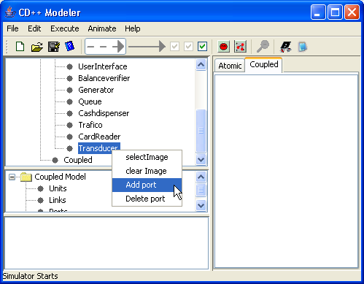
Figure 41: Adding a port to imported model.

Exploding Models
A coupled model (henceforth referred to as "current coupled model") is composed of other atomic and coupled models (henceforth referred to as "component models"), which (as demonstrated in previous sections) can be added as blank models from the button bar or imported as predefined models.
These component models (within the current coupled model) can be inspected, or "exploded", for the purposes of definition and modification.

1) To explode a component model, right-click on the model. The following popup menu will be displayed. Left-click on Explode. A new model editor (henceforth referred to as "exploded editor") will be displayed, in which the exploded model can be edited. (The original model editor will be temporarily hidden, and will become visible again after the exploded editor has been closed.)
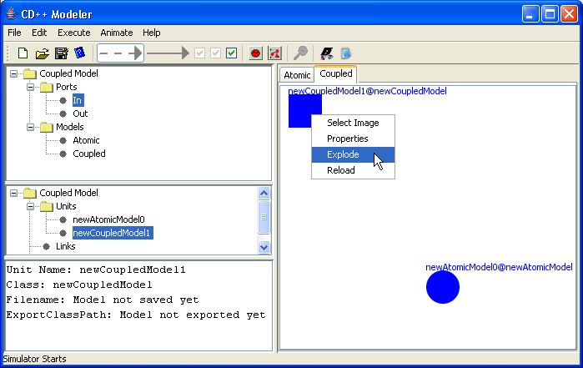
Figure 42: Explode model menu

If an atomic model is exploded, an atomic model editor will be displayed. If a coupled model is exploded, a coupled model editor will be displayed.
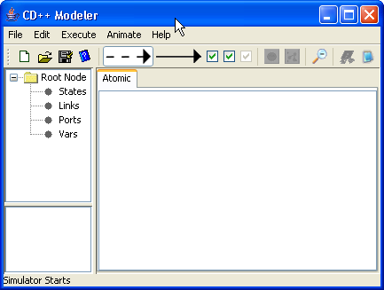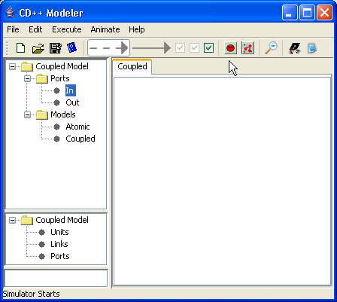
Figure 43: Atomic and Coupled editor corresponding to exploded model
Note that within the exploded editor, the exploded model type (ie. atomic or coupled) cannot be changed.
2) The exploded model can be edited using the same procedures as for non-exploded models.
For example, consider the following exploded coupled model, which was created for newCoupledModel1 (seen in step 1).
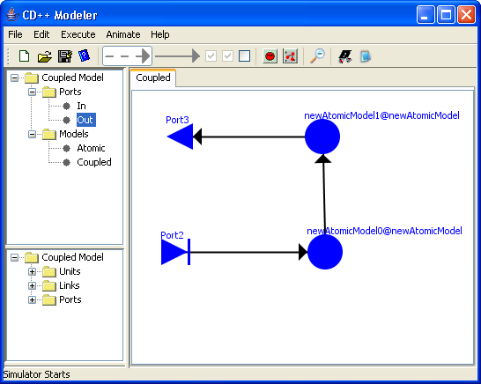
Figure 44: Editing exploded models

3) When the definition/modification of the exploded model is complete one must close the exploded model and choose to save/cancel the changes made in order to return to the original model editor.
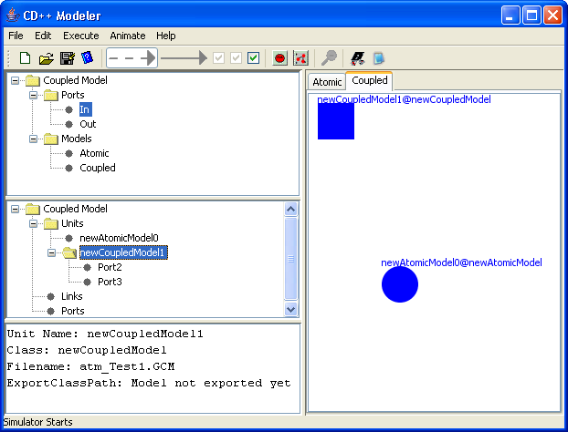
Figure 45: Original Model Editor
The ports from the exploded model (shown in step 2) are now available in the original model editor (after saving). For example, the ports for newCoupledModel1 (ie. input Port2 and output Port3) are displayed in the middle lateral panel, under Coupled Model>Units>newCoupledModel1 (See Figure 45).

4) Once all remaining component models are defined, links can be added between the ports of the component models.

For example, once newAtomicModel0 has been exploded and defined/modified, the ports for newAtomicModel0 (ie. input portA and PortB, and output PortC) will be displayed in the middle lateral panel, under CoupledModel>Units>newAtomicModel0.
Additional ports (ie. input Port3 and output Port4) can be added to the current coupled model, and will be displayed in the middle lateral panel, under CoupledModel>Ports.

Links can be added between the ports of the current coupled model and the ports of the component models. These links will be displayed in the middle lateral panel, under CoupledModel>Links.

In the current coupled model seen below, there are three links:
(1) output PortC of newAtomicModel0 is connected to input Port2 of newCoupledModel1
(2) input Port3 of the current coupled model is connected to input Port2 of newCoupledModel1
(3) output Port3 of newCoupledModel1 is connected to output Port4 of the current coupled model
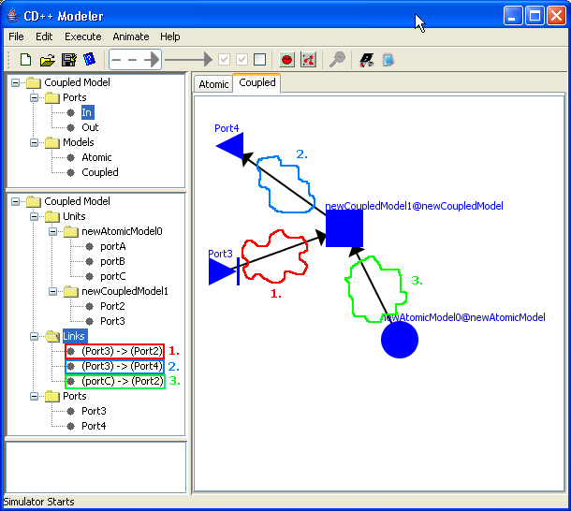
Figure 46: Coupled model with links

5) If a component model is exploded for modification after links have been connected, the links connected to the ports of the component model will be disengaged. This will prevent unpredictable changes from occurring.
For example, if newCoupledModel1 is exploded, the links connected to the ports of newCoupledModel1 (i.e. input Port2 and output Port3) will be disengaged.
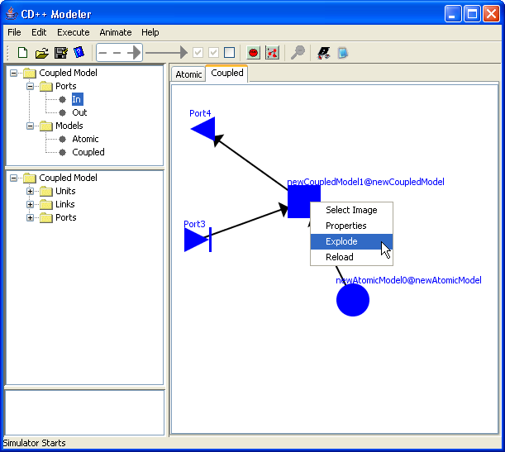
Figure 47: Disengaged links on an exploded coupled model
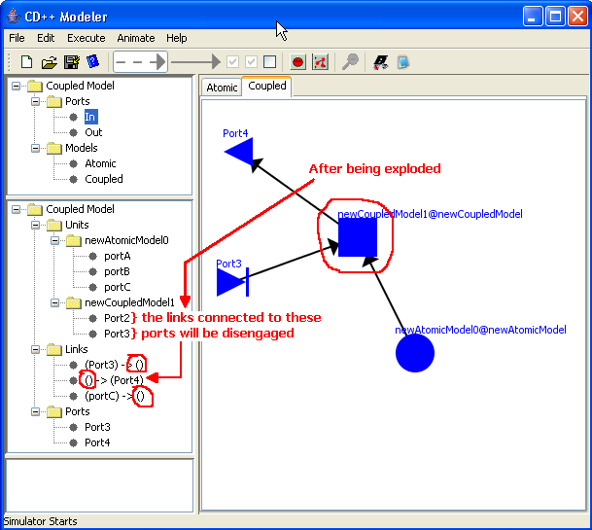
Figure 48: Detailed visualization of disengaged links

Adding Images to Models
Images can be added to a model in two ways. One way is to set an image as a background, the second way is to set an image to represent a unit within the model.

Adding Background
To add a background to the canvas; right click on the canvas [white space] and select background (see Figure 49). When the file browser window pops up select an image file to load and click Set.
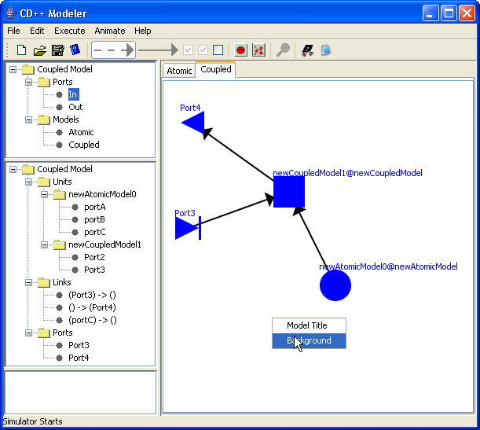
Figure 49: Loading Background
Note: The menu you get when right clicking on the canvas may be different than the one shown in Figure 49. This is because you are adding the background to the atomic canvas and not the coupled canvas. However, the steps to add the image is all the same. [Hint: click on Background]
Alter an image has been set as background you should see the background image stretched to cover the whole canvas. (See Figure 50)
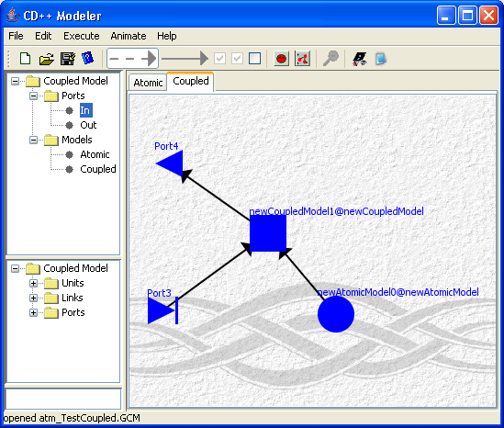
Figure 50: Image of a car set as background

Adding Image to Units on Coupled Canvas
Note: Images can only be added to units [any object that is not a link] on the coupled canvas.
Images can be added to atomic units, coupled units, input ports and output ports.
To add an image right click on the unit and click Select Image (see Figure 51).
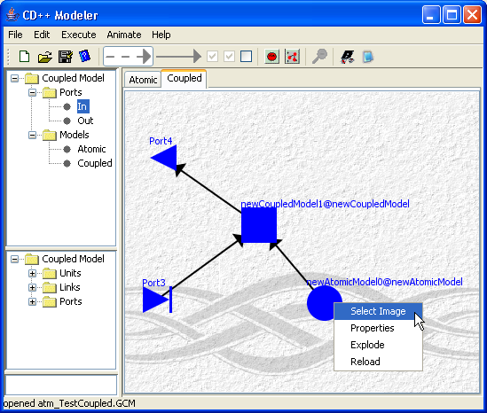
Figure 51: Adding image to unit
In the the file browser window select an image you wish to set as the image for the unit and click Set.
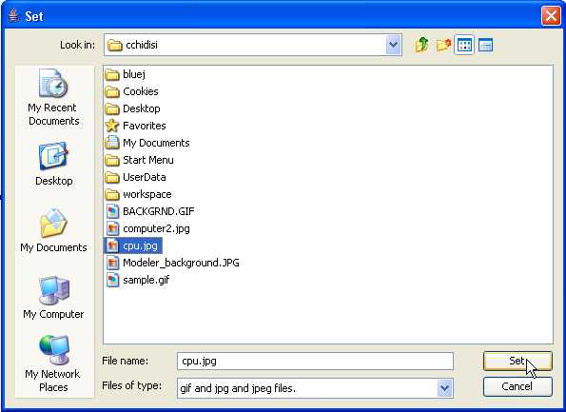
Figure 52: Choosing an image
The following is an example of having an image representing a unit [note the yellow car].
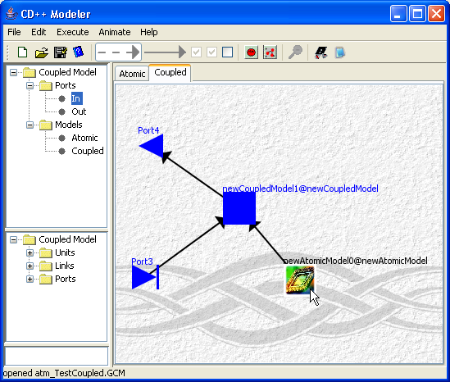
Figure 53: Image added to atomic unit

Visualization of DEVS models (using the Animate menu commands)

This section describes how to visualize the result files of atomic Cell-DEVS models, atomic-DEVS models, and coupled-DEVS models.

Model type selection
From the main menubar, left-click on Animate. The following menu will be displayed. Select the appropriate option, depending on the model type to be visualized:
Cell-DEVS animation - atomic Cell-DEVS models
AtomicAnimate - atomic-DEVS models
CoupledAnimate - coupled-DEVS models

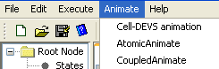
Figure 54: Animate menu

The following sections describe the commands of the Animate menu for the version of CD++ Modeler included in the CD++ Builder plugin for Eclipse, not the stand-alone version of CD++ Modeler.

AtomicAnimate using: Atomic-DEVS, Coupled-DEVS, Atomic Cell-DEVS

A DEVS model must include at least one atomic model. After simulating the DEVS model, a .log file is generated. The .log file records all the messages sent between DEVS components. This includes all messages sent/received by all atomic models in the coupled model. The message values sent/received by a specific atomic model can be extracted from the .log file and visualized.

The steps required for visualizing the message values sent/received by a specific atomic model are as follows:

1) In the Animate menu, left-click on AtomicAnimate. An atomic animate dialog box will be displayed.
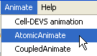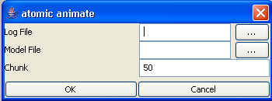

Figure 55: Atomic Aniamte Options

2) Left-click on the browse button. A Set dialog will be displayed. Select the .log file that contains the messages sent/received by the atomic-DEVS model to be visualized. (The atomic-DEVS models that send/receive messages within the selected .log file will be available for visualization.) After choosing the appropriate .log file, left-click on Set.
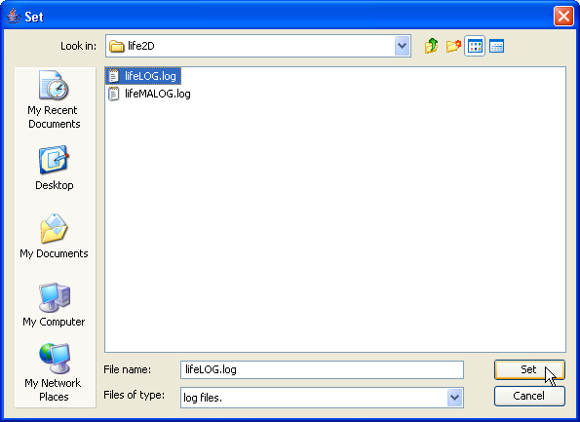
Figure 56: Set dialog box

If an invalid file type is chosen, the (blank) visualization window will be displayed as follows:
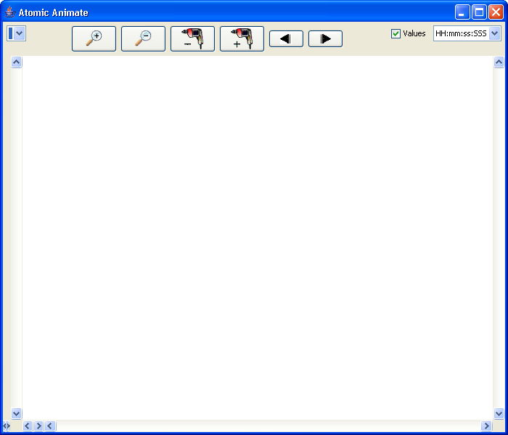
Figure 57: Empty visualization window due to invalid file type

The following example demonstrates the functionality of the Atomic Animate visualization window, using the atomic-DEVS model FunctionEval (which was extracted from the Hybrid model). Additional examples for a coupled-DEVS model (4BitCounter) follows.

AtomicAnimate Example of Atomic-DEVS: FunctionEval
To run this example, download the FunctionEval project. Where would one download this?
FunctionEval is an atomic-DEVS model that contains one output signal.

In the Set and atomic animate dialogs, open tester_caso1.log.
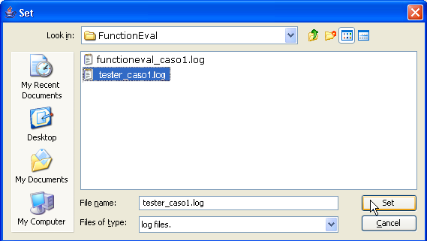

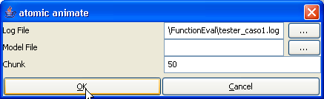
Figure 58: Opening tester_caso1.log

The atomic-DEVS models that send/receive messages within tester_caso1.log will be available for visualization. Since tester_caso1.log only contains the messages sent/received by the function@FunctionEvaluator model, the only atomic-DEVS model available for this example is the function model.

The following Atomic Animate visualization window will be displayed.
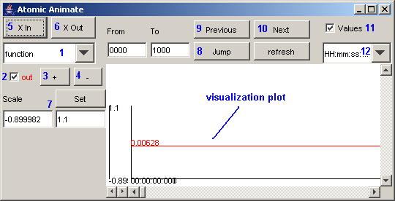
Figure 59: Atomic Animate visualization window

The Atomic Animate visualization window has several functions for modifying the appearance of the visualization, such as:
-select the atomic-DEVS model to be visualized (1)
-select the output signals (of the selected atomic-DEVS model) to be plotted (2)
-zoom in/out on the vertical axis (3, 4) and the horizontal axis (5, 6) of the plot
-set the upper and lower bounds of the vertical scale (7)
-jump to the specified time interval (8)
-go to the previous/next time interval (9, 10)
-show the values of the output signal on the plot (11)
-select the time format to be displayed on horizontal axis (12)

Select the atomic-DEVS model to be visualized
1) Left-click on the drop-down list. From the drop-down list, select or left-click the atomic-DEVS model to be visualized. The output signals of the selected atomic-DEVS model will be displayed.
In this example, the only atomic-DEVS model available for visualization is the function model.
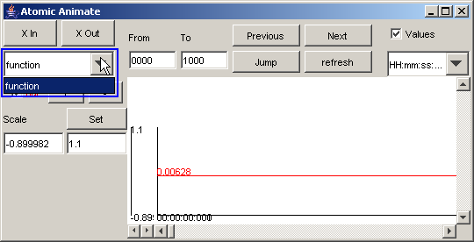
Figure 60:Atomic DEVS model visualization

Select the output signals to be plotted
1) To remove a signal from the visualization, uncheck or left-click the box beside the signal name. The plot of the output signal will be removed from the visualization window.
In this example, the function model has one signal, out.
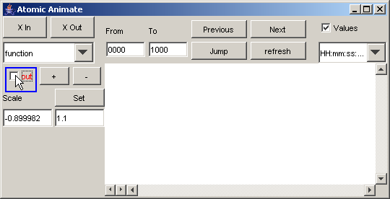
Figure 61: Removing output signal from visualization window

2) To include a signal in the visualization, check or left-click the box beside the signal name.

Select the time format for the horizontal axis
1) Left-click on the drop-down list located below the Values checkbox. From the drop-down list, select or left-click the appropriate time format to be displayed on the horizontal axis.
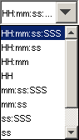

HH - represents hours

mm - represents minutes

ss - represents seconds

SSS - represents milliseconds

Figure 62: Values drop down menu

In this example, the time selected time format is SSS (which represents milliseconds).
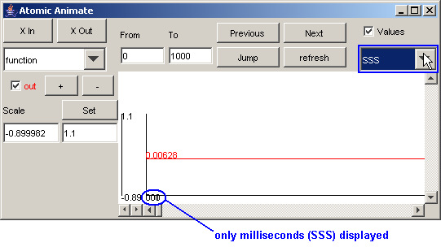
Figure 63: Specifying time

The entire visualization plot for the out signal of function model appears as follows:
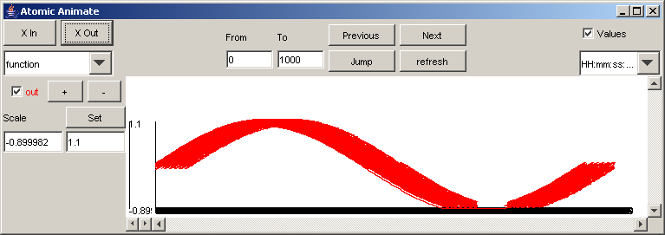
Figure 64: Visualization of the out signal

For upcoming sections, the following plot will be modified:
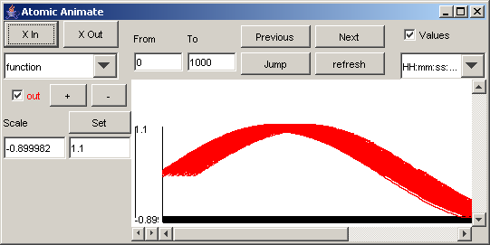
Figure 65: Plot to be modified

Show the values of the output signal on the plot
1) To remove the output signal values from the plot, uncheck or left-click the box beside Values. The values of the output signal(s) will be removed from the visualization.
In this example, the values of the signal out are removed, and so are no longer visible.
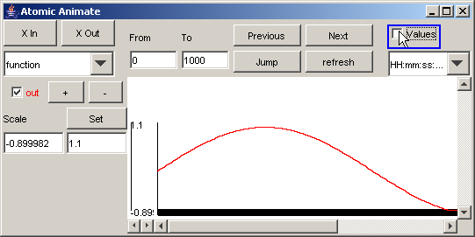
Figure 66: Removing values of the out signal

2) To include the output signal values in the plot, check or left-click the box beside Values. The values of the output signal(s) will be added to the visualization.
In this example, the values of the signal out are added, and so are visible. (The values are not legible due to their proximity.)
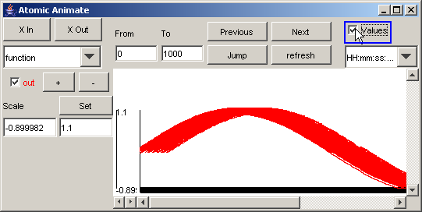
Figure 67: Adding the values of the out signal (making the signal visible)

Note: When the plot is zoomed in (and the time format changed), the values can be made legible:
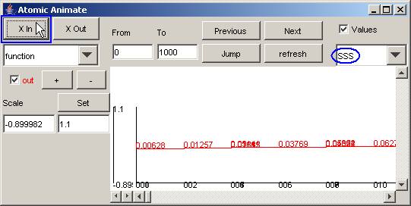
Figure 68: Viewing the values only
(Zooming in and out of the horizontal axis is described in the following section.)

Zoom in or out of the horizontal axis of the plot
1) To 'zoom in' or stretch the horizontal scale, press the X In button. The length of the horizontal scale will increase.
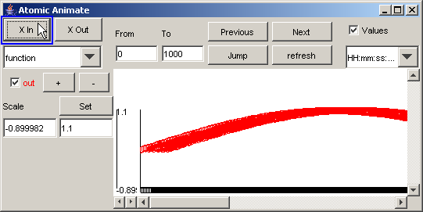
Figure 69: Zooming in on the horizontal scale

2) To 'zoom out' or compress the horizontal scale, press the X Out button. The length of the horizontal scale will decrease.
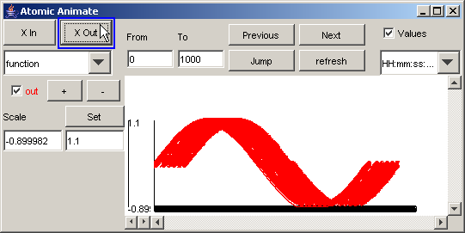
Figure 70: Zooming out on the horizontal scale

Zoom in or out of the vertical axis of the plot
1) To 'zoom in' or stretch the vertical scale, press the + button. The length of the vertical scale will increase.
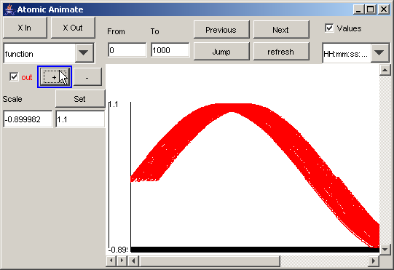
Figure 71: Zooming in on the vertical scale

2) To 'zoom out' or compress the vertical scale, press the - button. The length of the vertical scale will decrease.
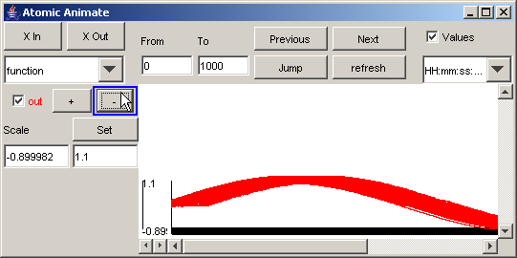
Figure 72: Zooming out on the vertical scale

Set the lower and upper bounds of the vertical scale
1) To set the lower and upper bounds of the vertical scale, first specify the desired lower and upper bounds in the Scale fields.
In this example, the upper bound is specified as 2.0, while the lower bound remains unchanged.
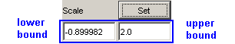
Figure 73: Setting lower and Upper bounds

2) Press the Set button. The parts of the output signal that fall within the lower and upper bounds will be displayed. (The values for the lower and upper bounds are visible on the vertical axis.)
In this example, the parts of the output signal that fall within -0.899982 and 2.0 on the vertical scale are displayed.
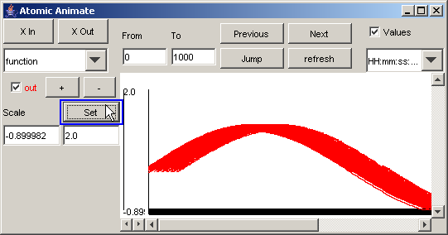
Figure 74: Displaying the signal between the lower and upper bounds

Jump to the specified time interval
1) To go directly to a particular time interval of the visualization, first specify the desired range of the time interval in the From and To fields.
In this example, the To field (or upper bound of the time interval range) is specified as 100, while the From field (or lower bound of the time interval range) remains unchanged.
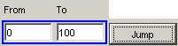
Figure 75:Specifying desired range of time

2) Press the Jump button. The parts of the output signal that occur at times that fall within the From and To range will be displayed. (The values for the time interval range are visible on the horizontal axis.)
In this example, the parts of the output signal that occur between 0 and 100 (milliseconds) are displayed.
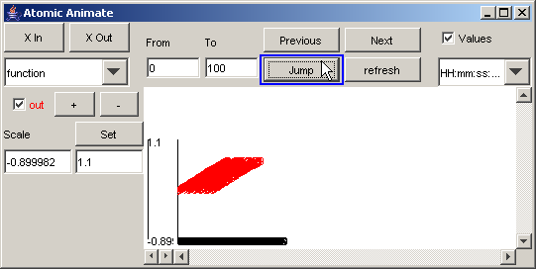
Figure 76: Viewing only the specified time range
Note: When zoomed in (ie. by pressing the X In button several times), the plot from the previous figure will appear as follows:
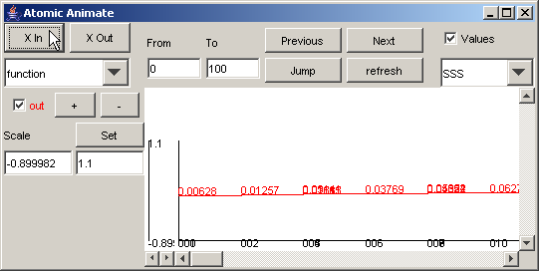
Figure 77: Zooming in to the previous plot

Go to the previous/next time interval
1) To go to the next increment of the specified interval, press the Next button.
In this example, using the same time interval as previously specified, when the Next button is pressed, the parts of the output signal that occur between 100 and 200 (milliseconds) are displayed.
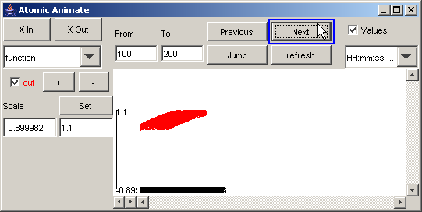
Figure 78: Going to the next time interval

In this example, when the Next button is pressed again, the parts of the output signal that occur between 200 and 300 (milliseconds) are displayed.
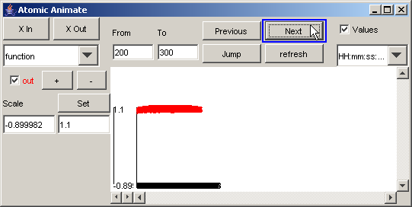
Figure 79: Signal between 200 and 300 milliseconds

2) To go to the previous increment of the specified interval, press the Previous button.
In this example, when the Previous button is pressed, the parts of the output signal that occur between 100 and 200 (milliseconds) are displayed. This is the same plot as the first plot seen in step 1.
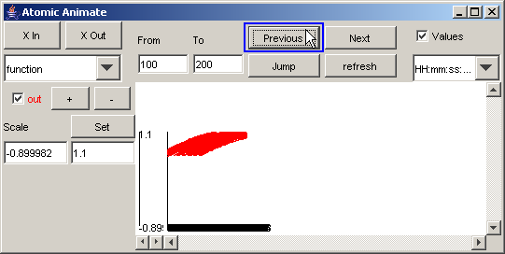
Figure 80: Going to the previous increment

Jump to a specific time
1) To go directly to a specific instance of time of the visualization, first specify the instance in both the From and To fields.
In this example, the specific instance to be plotted is 200.

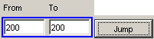
Figure 81: Jumping to a specific instance

2) Press the Jump button. The part of the output signal that occurs at the specified instance will be displayed. The value for the specified instance of time will be visible on the horizontal axis. The output value for the signal at the specified instance will be visible on the plot.
In this example, the part of the output signal that occurs at the instance of 200 (with a corresponding time of 196 milliseconds) is displayed. The output value of the signal at 196 milliseconds is 0.94299.

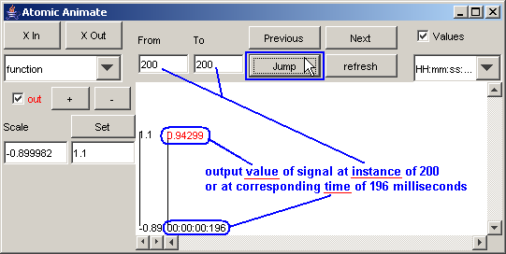
Figure 82: Viewing a specific instance

Note: When the From and To fields contain the same value, the Previous and Next buttons are inoperable.

Note: As demonstrated earlier, when output signal values are removed from the plot (by unchecking the Values checkbox), no output values will be displayed. A red line representing the range of values of the output signal will be visible.
In this example, when the single output signal value is removed from the plot, the red line is barely visible, since the "range" of the output signal is limited to one single value.
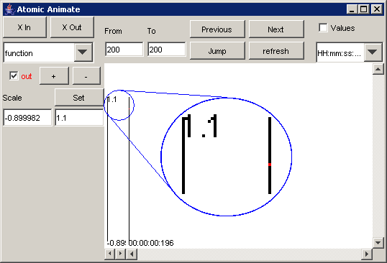
Figure 83 : Range of output signal limited to one value

AtomicAnimate Example of Coupled-DEVS: 4BitCounter
To run this example, download the 4BitCounter project.
4BitCounter is a coupled-DEVS model composed of multiple atomic-DEVS models that each contain multiple output signals.

The main functionality of the Atomic Animate visualization window described in the previous example (FunctionEval) also applies for this example. However, while the previous example (FunctionEval) illustrated the visualization of a single atomic-DEVS model, this example (4BitCounter) illustrates the visualization of (a coupled-DEVS model composed of) multiple atomic-DEVS models.

Using the same procedure as in the previous example, in the Set and atomic animate dialogs, open 4Counter.log.
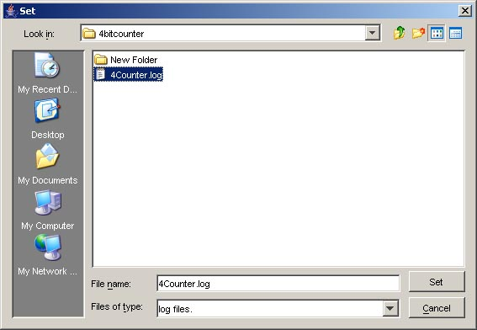

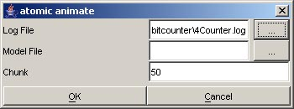
Figure 84: Opening 4Counter.log

The models that send/receive messages within 4Counter.log will be available for visualization. The file 4Counter.log contains the messages sent/received by the top model, which is composed of the following models: 4count@Process_4_Counter, b1@Signal, b2@Signal, b3@Signal, b4@Signal, clock. Whereas the first four models are atomic-DEVS models, the fifth model, clock, is a coupled-DEVS model composed of the atomic-DEVS models: inv@Process_Inv, sig1@Signal. So, for this example, the following models/components are available for visualization: clock, 4count, inv, b4, b3, top, b2, b1, sig1.

The following Atomic Animate visualization window will be displayed.
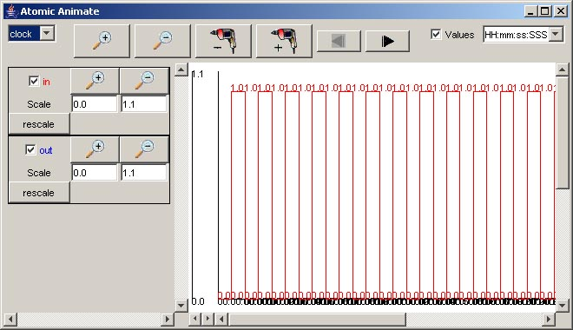
Figure 85: Atomic Animate Visualization Window

By default, the signals of the first model/component in the list - in this example, clock - will be displayed.
Also by default the visualization plot will display the range of output values of the selected signals for the time interval spanning the entire simulation. In this example, the time interval of [00:00:00:000, 00:00:00:400] corresponds to the entire simulation, and the in and out signals of clock each have a range of [0.0,1.0] for this interval.
Also by default, the lower/upper bounds of the vertical Scale will initially correspond to the minimum/maximum of the output value range. So, the vertical scale for an output signal will automatically be set such that the entire range of output values for the signal (for the initial time interval) will be visible in the visualization plot. In this example, the in and out signals of clock each initially have a vertical scale with bounds [0.0,1.1].

The differences in the functions of the Atomic Animate visualization window, when used for displaying multiple atomic-DEVS models, will be described:
-select the model/component to be visualized
*availability of signals for the selected model/component (explanation)
-select the (available) signals of the selected model/component to be plotted

Note: The plot can be more clearly viewed by zooming out (ie. pressing the “-“ Magnification button), and changing the time format appropriately. The format of the time (horizontal axis) values was changed to SSS, since the simulation ends at 00:00:00:400 (according to the last message time in the .log file).
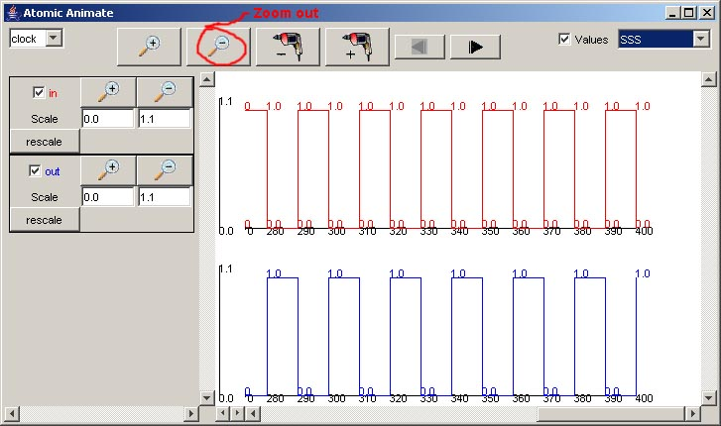
Figure 86: Formatted output

Select the model/component to be visualized
1) The models/components available for visualization can be seen in the drop-down list.
To select a model/component to be visualized, first left-click on the drop-down list.
Note: The order of the models/components in the drop-down list is arbitrary.
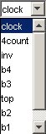
Figure 87: Selecting a model component

2) From the drop-down list, select or left-click the model/component to be visualized. The signals of the selected model/component will be displayed.
Note: For each component, the order of the available signals (in the column below the drop-down list) is arbitrary.
Also for each component, the colors of the available signals are automatically assigned based on their order. The first available signal will be red, the second blue, the third green, etc.
The order of the visible visualization plots will correspond to the order of available signals that are selected for visualization.

In this example, 4count is selected, and the signals available are: q1 (green), q4 (brown), q3 (pinkn), and q2 (light blue). Since all the available signals are checked, all the signals are plotted.

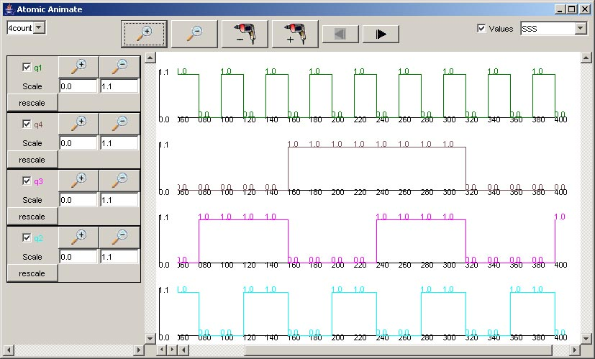
Figure 88: Viewing all signals

For the rest of the components in the drop-down list, the available signals and range of output values for the entire simulation can be seen in the following figures.
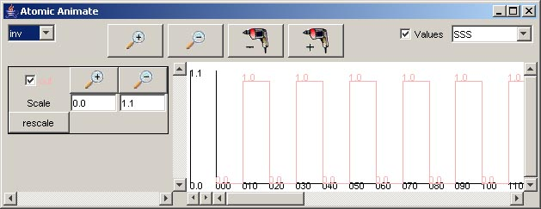

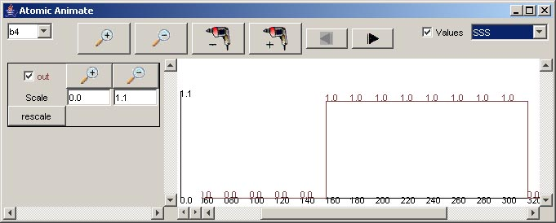

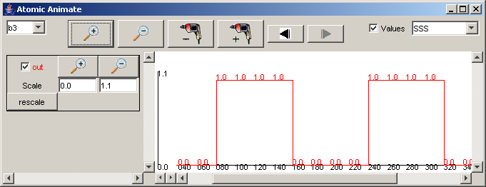

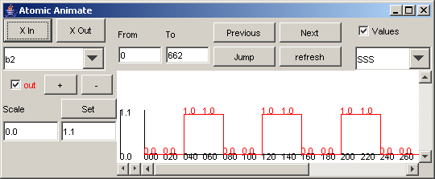

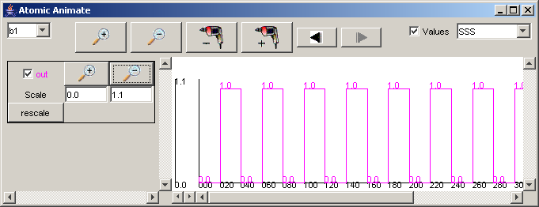

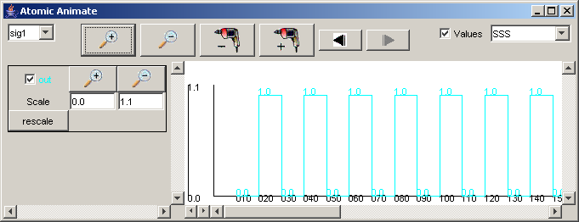
Figure 89: Available signals and range of output values

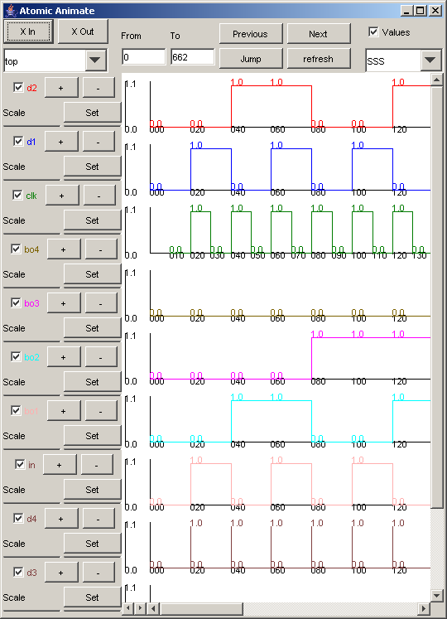

When the top component is selected, the signals available are: in, clk, d1, d2, d3, d4, bo1, bo2, bo3, bo4.

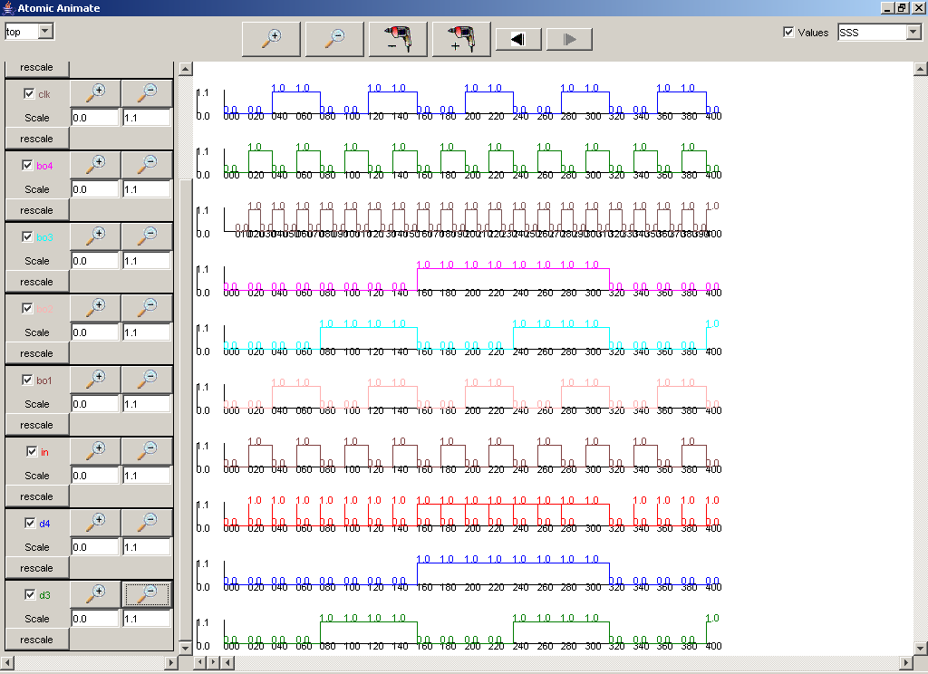
Figure 90: Viewing all signals in one window

Note: When the top component is selected, since the time interval is initially set to correspond with the entire simulation, all the available signals of the top component will be checked. Due to the number of available signals in the top component, the space required to display the Scale fields of the signals exceeds the height of the Atomic Animate visualization window. The Scale fields can be made visible if the height of the visualization window is increased.

It may not always be possible to increase the height of the visualization window to accomodate the Scale fields. (Please see Appendix B - 4BitCounter for more details.)

The visualization plots of the checked signals also exceed the height of the Atomic Animate visualization window. The vertical scrollbar can be used to view the visualization plots that are located beyond the bottom edge of the window.

Availability of signals for the selected model/component

A selected component can have multiple signals (usually called ports).
When a component is selected, the signal associated with the component can be selected to be displayed as a plot in the visualization.
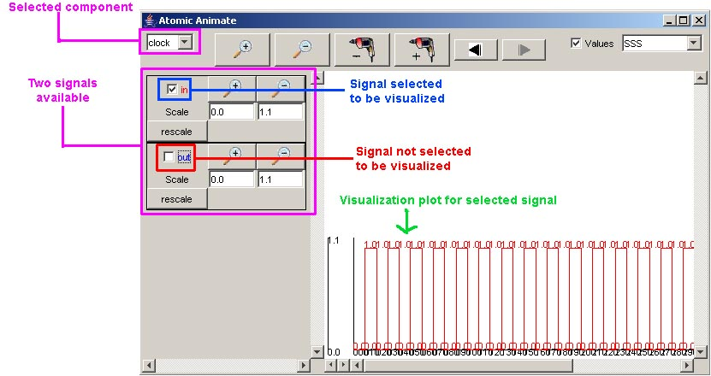
Figure 91: Selecting a signal to be displayed

A component will be displayed in the drop-down list if values are being sent to at least one signal of the component. (ie. if at least one signal is available for the component)

The following behaviour still applies: For a selected component, the order of the available signals is arbitrary. The colours of the available signals are automatically assigned based on their order. The first available signal will be red, the second blue, the third green, etc. The order of the visible visualization plots will correspond to the order of available signals that are selected for visualization.

CoupledAnimate using: Coupled-DEVS

The message values sent/received via ports within a coupled model can be visualized using the graph (.gcm file) of the coupled model. The visualization displays the output values with the corresponding output ports, superimposed on the coupled model's graph.

The steps required for visualizing the message values sent/received via the ports of a coupled model are as follows:

1) In the Animate menu, left-click on CoupledAnimate. A coupled animate dialog box will be displayed.
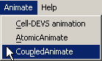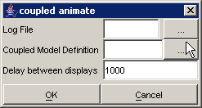
Figure 92:Choosing coupled animate

2) Specify the Log file that contains the messages sent/received by the coupled-DEVS model to be visualized (using the same procedure as for AtomicAnimate).

- Left-click on the browse button for the Coupled Model Definition. A Set dialog will be displayed. Select the .gcm file that corresponds to the coupled-DEVS model to be visualized. After choosing the appropriate .gcm file, left-click on Set.

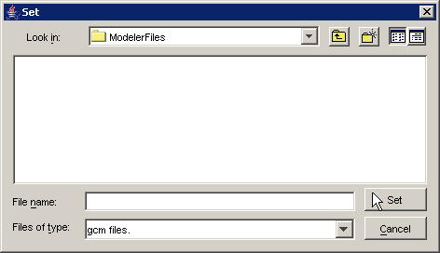
Figure 93: Set dialog box

4) Type in the appropriate Delay between displays. The Delay value (milliseconds) will be the amount of time the visualization waits between each update of the display. (The speed of the visualization is determined by the Delay value.) By default, the Delay is 1000 milliseconds (or 1 second).

If an invalid file type is chosen, the (blank) visualization window will be displayed as follows:
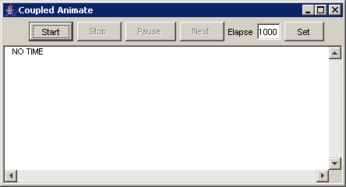
Figure 94: Blank view for invalid file type
The following example demonstrates the functionality of the Coupled Animate visualization window, using the coupled model 4BitCounter.

CoupledAnimate Example of Coupled-DEVS: 4BitCounter
To run this example, download the 4BitCounter project from: http://www.angelfire.com/sc3/schao2/projects/4BitCounter.zip
4BitCounter is a coupled-DEVS model composed of multiple atomic-DEVS models that each contain multiple output signals.

In the Set and coupled animate dialogs, open 4Counter.log and 4counter.gcm as the Log File and Coupled Model Definition, respectively.
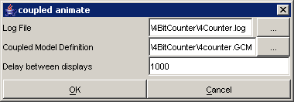
Figure 95: Opening the coupled model files

The coupled-DEVS model that sends/receives messages within 4Counter.log, and that is represented in graphical form in 4counter.gcm, will be available for visualization.

The following Coupled Animate visualization window will be displayed.
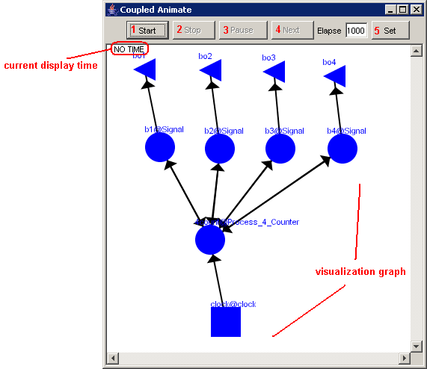
Figure 96: Coupled model visualization for 4bitcounter

The Coupled Animate visualization window has several commands for the visualization, such as:
-start the visualization (1)
-stop the visualization (2)
-pause the visualization (3)
-go to the next display of the visualization (4)
-set the delay between displays (5)

Start the visualization
1) Left-click the Start button. The visualization will start and continue updating the graphical display, along with the corresponding display time (according to the message times of the .log file).

In this example, the visualization has been started, and has the current display time of 00:00:00:070, with the output values visible alongside their corresponding ports.
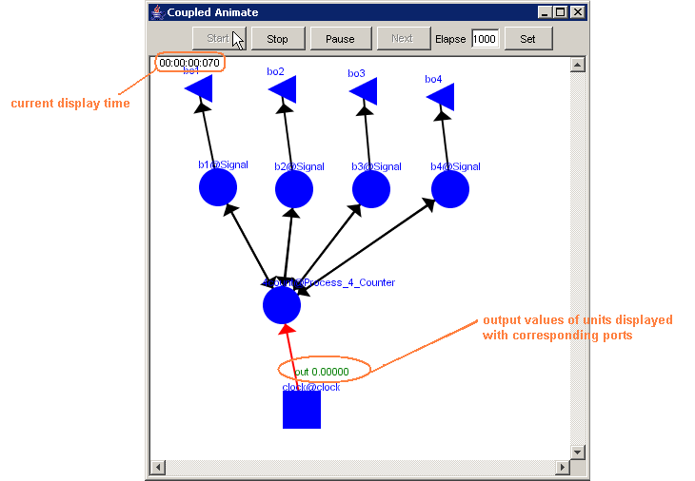
Figure 97: Viewing the current display time and output values of units

2) After the visualization has started, it can be run to the end of the simulation time, stopped, or paused.

- After the visualization has started, if no other buttons are pressed, the visualization will continue until it reaches the end of the simulation (ie. the last message time in the .log file).
In this example, after pressing the Start button, if no other buttons are pressed, the visualization will continue until it reaches 00:00:00:400, which is when the simulation ends in the .log file.
- The Stop and Pause buttons are described in the following sections.

Stop the visualization
1) Left-click the Stop button. The visualization will stop at the current display time. The output values occurring at the current display time will remain visible on the graph.

In this example, the visualization has been stopped at the current display time of 00:00:00:260, with the output values visible alongside their corresponding ports.
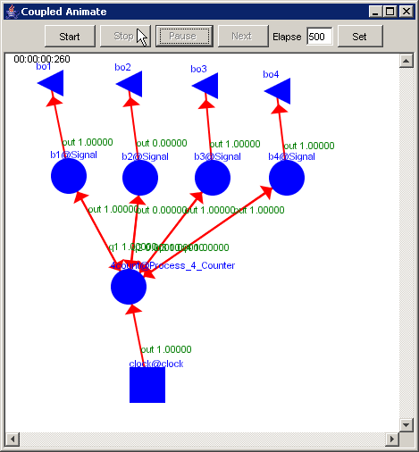
Figure 98: Stopped visualization

2) After the visualization has stopped, it can be restarted (at the beginning of the simulation).

- After the visualization has stopped, if the Start button is pressed, the visualization will restart only at the beginning of the simulation, ie. at 00:00:00:000. The visualization will not restart at the current display time.
- The Start button is described in the preceding section.

Pause the visualization
1) Left-click the Pause button. The visualization will pause at the current display time. The output values occurring at the current display time will remain visible on the graph.

In this example, the Pause button is pressed after the current display time of 00:00:00:380, pausing the visualization at 00:00:00:390, with the output values visible alongside their corresponding ports.

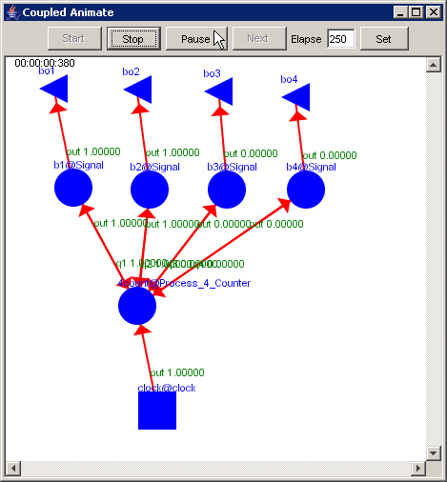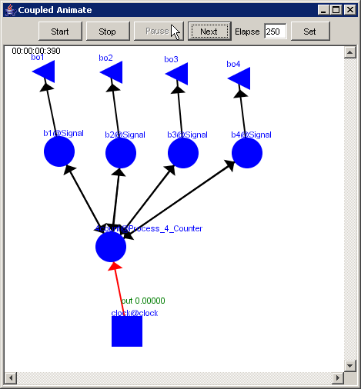
Figure 99: Pausing the visualization

2) After the visualization has paused, it can be restarted (at the current display time), stopped, or incremented to the next display.

- After the visualization has paused, if the Start button is pressed, the visualization will restart at the current display time.
- The Start and Stop buttons are described in the preceding sections. The Next button is described in the following section.

Go to the next display of the visualization
1) Left-click the Next button. The visualization will increment to the next display, updating the current display time and the output values visible on the graph.

This example continues from the second graph in the previous section - 'Pause the visualization'. In this example, with the visualization paused at 00:00:00:390, the Next button has been pressed. The visualization is incremented to the next display at 00:00:00:400, updating the current display time and the output values displayed on the graph.

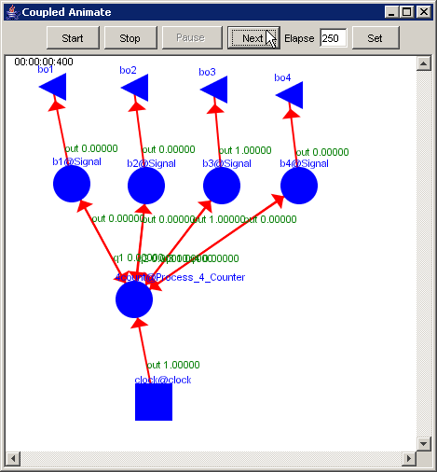
Figure 100: Resumed visualization

2) After the visualization has incremented to the next display, it can be restarted (at the current display time), stopped, or incremented again to the next display.

- After the visualization has incremented to the next display, if the Start button is pressed, the visualization will restart at the current display time.
- The Start and Stop buttons are described in the preceding sections. The Next button is described in this section.

Set the delay between displays
1) Type the appropriate delay length (milliseconds) in the Elapse field. Press Set.
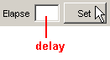

The delay can be set while the visualization is running (ie. after the visualization has been started), after the visualization has been stopped, or while the visualization is paused (ie. after the visualization has been paused).

Cell-DEVS animation using: Atomic Cell-DEVS, Coupled-DEVS

The steps required for visualizing the cell values of an atomic cellular model are as follows:

1) In the Animate menu, left-click on Cell-DEVS animation.
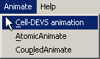
Figure 101: Cell-DEVS animation menu

The following Cell-DEVS animation visualization window will be displayed.
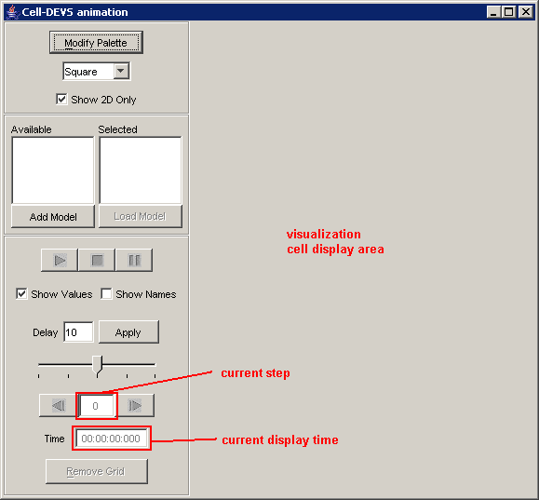
Figure 102: Cell-DEVS Animation window

2) A model must first be loaded before it can be visualized. The loading of models will be described in upcoming sections.

3) The appearance of the visualization can be modified before the visualization starts. (The appearance of the visualization can also be modified while the visualization is running.) The options available for changing the appearance of the visualization will be described in upcoming sections.

4) The individual steps/displays in the visualization can be navigated to directly or indirectly. Navigating through the visualization will be described in upcoming sections.

Thus, steps 2, 3, and 4 are the main steps for visualizing an atomic Cell-DEVS model. Each of the steps can be further broken down, as shown in the following figure and list.

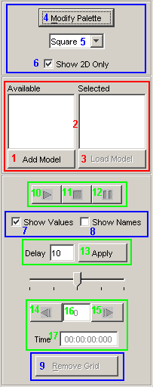
The Cell-DEVS animation visualization window has functions that can be grouped according to the step in which the function is involved. (See Figure 103)
-loading models to be visualized
-modifying the appearance of the visualization
-running/navigating the visualization

For each of the main steps, there are several functions.

For loading models to be visualized, functions include:
-adding models to be made available (1)
-selecting available models to be loaded (2)
-loading models to be visualized (3)

For modifying the appearance of the visualization, functions include:
-modifying the palette of the loaded models (4)
-selecting the lattice type (5)
-toggle between 2D and multidimensional display (6)
-showing the cell values of the loaded models (7)
-showing the names of the loaded models (8)
-toggle the visibility of the grid of the lattice (9)

For running/navigating the visualization, functions include:
-playing/starting the visualization (10)
-stopping the visualizaton (11)
-pausing the visualization (12)
-set the delay between steps of the visualization (13)
-go to the previous/next step in the visualization (14, 15)
-go directly to a particular step in the visualization (16)
-go directly to a particular time in the visualization (17)

Figure 103: Options for cell DEVS animation.

The following example demonstrates the functionality of the Cell-DEVS animation visualization window, using the atomic Cell-DEVS model Fire. Additional examples for a 3D atomic Cell-DEVS model (SatelliteClouds) and a coupled-DEVS model (RiceField) follow.

Cell-DEVS animation Example of Atomic Cell-DEVS: Fire
To run this example, download the Fire project.
Fire is a 2D (two-dimensional) atomic Cell-DEVS model.

Loading models to be visualized
A model must first be loaded before it can be visualized.
To load a model, the appropriate model must first be added to the Available list. From the Available list, the appropriate model(s) to be visualized must be selected (ie. to the Selected list). Once the models to be visualized are in the Selected list, the models can then be loaded. These functions are described in the following sections.

Adding models to the Available list
1) To add an atomic cellular model to the Available list, left-click the Add Model button. The Choose a CD++ DRW or Model File dialog will be displayed.
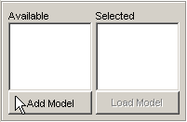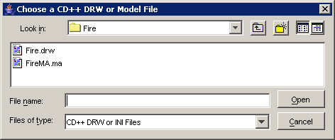
Figure 104: Adding an atomic cellular model

2) Two options are available: (a) choose a .ma file and a .log file, or (b) choose only a .drw file.

(a) Choose the appropriate .ma file, and left-click the Open button.
The Choose a CD++ LOG File dialog will be displayed. Choose the appropriate .log file (corresponding to the .ma file), and left-click the Open button.
In this example, FireMA.ma is chosen in conjunction with FireLOG.log.
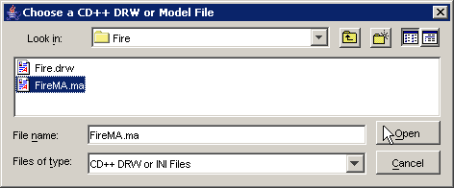
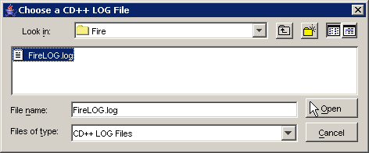
Figure 105: opening the Fire model

(b) Choose the appropriate .drw file, and left-click the Open button.
In this example, Fire.drw is chosen.
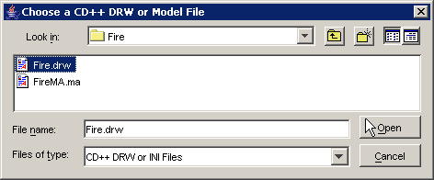
Figure 106: Choosing the appropriate drw file

3) The atomic cellular model name will appear in the Available list. The format of the model name (displayed in the Available list) depends on the option chosen:

(a) <componentName>@<modelLog.log>
where:
- <componentName> is an atomic cellular model listed included in the .ma file
(ie. components : ) *
- <modelLog.log> is the actual file name of the .log file

In this example, the format of the model name will be forestfire@FireLOG.log.
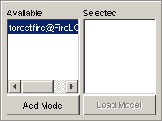
Figure 107: forestfire@FireLOG.log
(b) <modelDrw.drw>
where:
- <modelDrw.drw> is the actual file name of the .drw file **

In this example, the format of the model name will be Fire.drw.
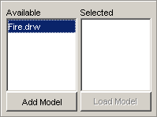
Figure 108: Fire.drw

* Note: (a) If the model in the .ma file contains multiple atomic cellular models in the components: parameter, each of the atomic cellular models will appear in the Available list. All of these atomic cellular models will use the same .log file. (See the RiceField example for more details.)
** Note: (b) Each .drw file corresponds to only one atomic cellular model. (This differs from option (a), where a single .ma file may contain multiple atomic cellular models.)

4) To remove an atomic cellular model from the Available list, left-click on the model name in the Available list, and press Delete on the keyboard.

Selecting available models to be loaded
1) To select an atomic cellular model (ie. to the Selected list), left double-click on the model name in the Available list.
In this example, the model name (a) forestfire@FireLOG.log, and (b) Fire.drw, are selected.

2) The atomic cellular model name will appear in the Selected list. The format of the model name displayed in the Selected list will be the same as in the Available list.

(a)
In this example, the format of the model name remains as forestfire@FireLOG.log.
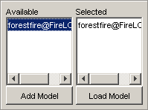
(b)
In this example, the format of the model name remains as Fire.drw.
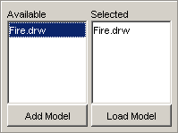

Figure 109: selecting forestfire@FireLOG.log Figure 110: Selecting Fire.drw

Once an atomic cellular model is in the Selected list, the Load Model button will be enabled. (If the Selected list is empty, ie. does not contain any atomic cellular models, the Load Model button will be disabled.)

3) To remove an atomic cellular model from the Selected list, double left-click on the model name in the Selected list. Alternatively, left-click on the model name in the Selected list, and press Delete on the keyboard.

Note: All atomic cellular models in the Selected list will be loaded (and visualized) concurrently when the Load Model button is pressed.

Note: After a cellular model is selected from the Available list, the model will be placed in the Selected list. If the model name in the Available list is deleted, the model in the Selected list will not be affected (ie. the model in the Selected list can still be loaded and visualized as usual).

For the following section, this example will be considered, where forestfire@FireLOG.log and Fire.drw have been added to the Available list, and Fire.drw has been selected (ie. to the Selected list).

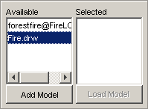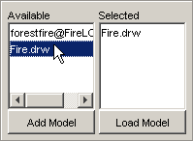
Figure 111:Selecting an from an available list

Loading models to be visualized
1) To load the atomic cellular models in the Selected list, left-click the Load Model button.
In this example, only Fire.drw is in the Selected list, so only Fire.drw will be loaded.

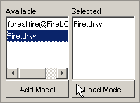
Figure 112: Loading an atomic cellular model

Note: After pressing the Load Model button, please wait until all selected models have been loaded to the visualization cell display area. The number of models in the Selected list corresponds to the number of models to be loaded and visualized. In general, the waiting time required to load the models will increase with the number of models in the Selected list.

2) The atomic cellular models in the Selected list will be loaded into the visualization cell display area.

In this example, after Fire.drw is loaded, the cell values of the Fire model are displayed, as seen below.

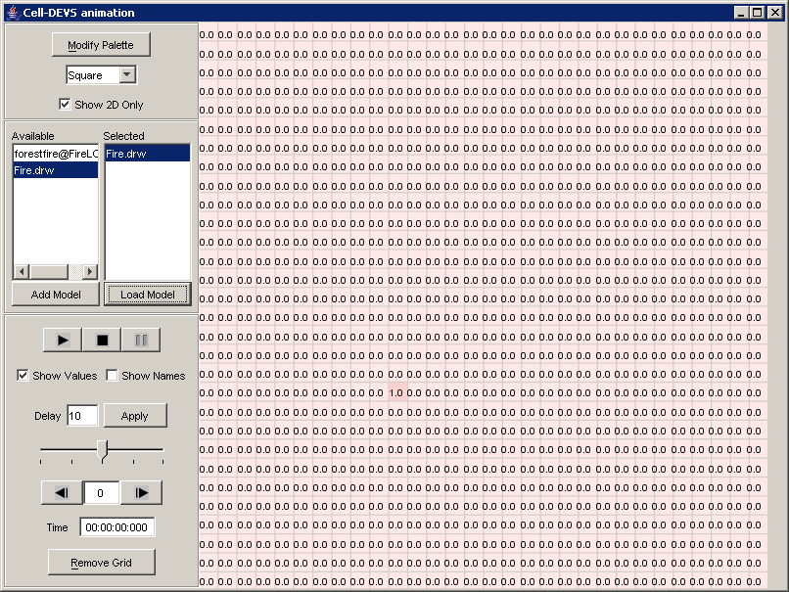
Figure 113:Displayed cell values for fire.drw
The size of the Cell-DEVS animation visualization window can be changed to fit the dimensions of the visualization cell display area.

Some of the options for modifying the appearance of the visualization are automatically set by default.
If a palette (.pal) file exists with the same name as the first model in the Selected list, then the .pal file will automatically be applied to the visualization. In this example, Fire.pal is automatically used for the visualization of Fire.drw. Also, by default: a square lattice is selected; only two dimensions are shown; the cell values are shown; the names of the loaded models are not shown; and the grid is visible.
Modifications to the appearance of the visualization will be described in the following sections.

Modifying the appearance of the visualization
After the appropriate atomic cellular models have been loaded, the appearance of the visualization can be modified before the visualization starts. (The appearance of the visualization can also be modified while the visualization is running.) Several options are available for changing the appearance of the visualization:
The palette (or colour scheme) of the loaded model(s) can be modified.
The lattice type can be selected as square, hexagonal, or triangular.
The display of the loaded model(s) can be multi-dimensional or restricted to two dimensions.
The cell values of the loaded model(s) can be shown.
The names of the loaded model(s) can be shown.
The grid of the lattice can be removed/added.
These options are described in the following sections.

Modify the palette of the loaded model(s)
A palette file contains preset colour settings for the visualization of a model. Each setting contains a colour that corresponds to a range of values. When a cell value falls within the range of values of a setting, the colour of the setting will be applied to the cell.
1) Left-click the Modify Palette button. The Modify Palette dialog will be displayed.
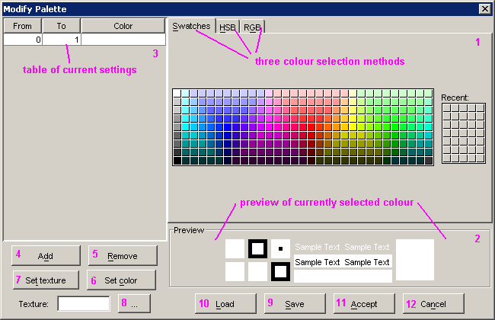
Figure 114: modifying the palette

For modifying the settings of the palette (.pal) file used for the visualization, functions include:
-selecting a colour (1)
-previewing the selected colour (2)
-changing the ranges for the current settings (3)
-adding a setting (4)
-removing a setting (5)
-setting the colour of a setting (6)
-setting the texture of a setting (7)
-selecting the texture to be set (8)
-saving the current settings in a .pal file (9)
-loading settings from an existing .pal file (10)
-accepting the current settings for the visualization (11)
-cancelling the modify palette operation (12)
Select and preview a colour
1) On the upper-right panel, left-click on one of the three tabs: Swatches, HSB, RGB.
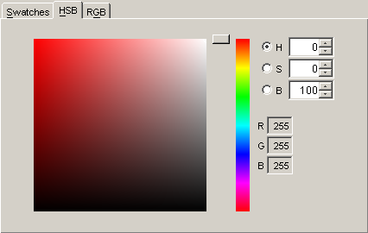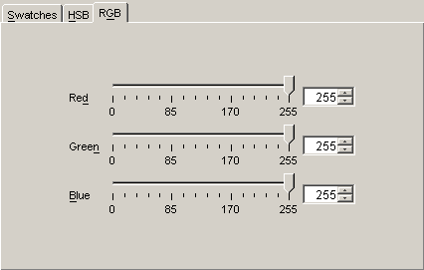
Figure 115: Previewing color
2) From one of the three tab panels, select a colour. The selected colour will be displayed in the lower-right Preview panel.

Load settings from an existing .pal file
1) To load settings from an existing .pal file, first left-click on the Load button. The Open dialog will be displayed.

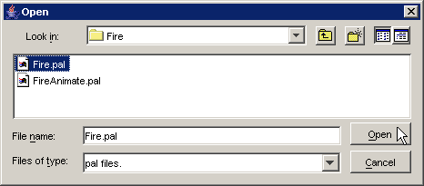
Figure 116: Loading settings from an existing file

2) Choose the appropriate .pal file, and left-click the Open button. The settings from the chosen .pal file will be displayed in the left panel, in the table of current settings.
In this example, Fire.pal is chosen for the visualization of Fire.drw. The settings range from -100 to 180.
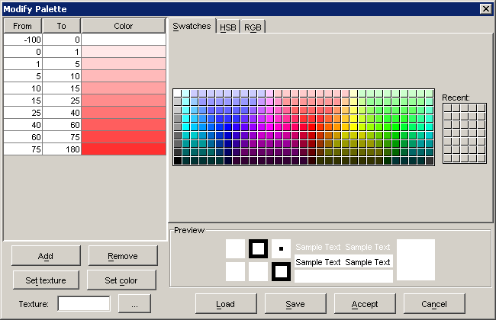
Figure 117: Exisiting palette
Add a setting
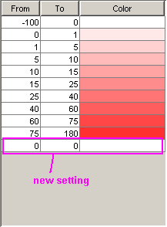
1) To add a new setting to the table of current settings, first left-click the Add button.

A new setting will appear at the bottom of the table of current settings.
By default, the new setting has a range [0,0], with white set as the colour corresponding to the range.

In this example, a new setting is added to the bottom of the table of settings loaded from Fire.pal. Figure 118:Adding a new setting

Change the range of a setting
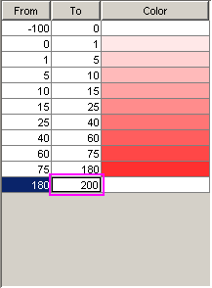
1) To change the range of values for a particular setting, left-click on the From/To field.

2) Type in the appropriate value(s).

In this example, for the most recently added setting, the From field has been changed to 180, while the To field is being changed to 200.

Figure 119: Changing the range of values
Set or change the colour of a setting
1) To set or change the colour of a particular setting, first select the appropriate colour from one of the three right tab panels. The selected colour will be placed in the Recent colours list.
In this example, the colour (204,255,255) is selected from the Swatches tab, as seen in the figure below.
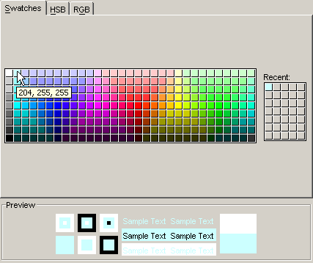
Figure 120: Setting or changing the color of a setting

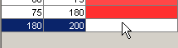
2) Left-click on the particular setting.

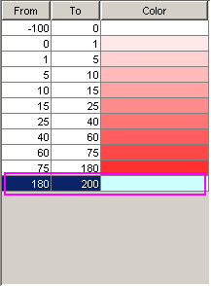
3) Left-click on the Set color button.

The selected color will be displayed in the setting, alongside the range of values.

In this example, for the most recently added setting, the colour (204,255,255) has been set to correspond with the range [180,200].

Figure 121:Setting the color
Set the texture of a setting
1) To set the texture of a particular setting, first left-click the browse button beside the Texture field.
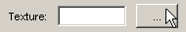
The Open dialog will be displayed.
2) Select the file containing the appropriate texture. Left-click Open. The selected file name will be displayed in the Texture field.
3) Left-click on the particular setting.
4) Left-click the Set texture button.
The selected file name will be displayed in the setting, alongside the range of values.

Remove a setting
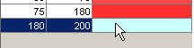
1) To remove a particular setting from the table of current settings, first left-click on the particular setting.

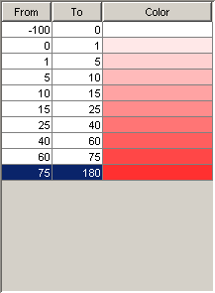
2) Left-click the Remove button.

The selected setting will be removed from the table of current settings.

In this example, for the most recently added setting, with range [180,200] and colour (204,255,255), was removed from the table of current settings.

Figure 122: Removing a setting
Save the current settings in a .pal file
1) To save the current settings (displayed in the table in the left panel) in a .pal file, first left-click the Save button. The Save dialog will be displayed.

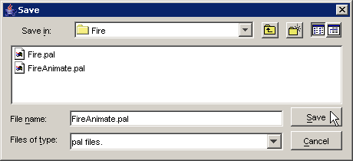
Figure 123: Saving the current settings in a .pal file

2) Specify the appropriate existing or new .pal file name, and left-click the Save button. The current settings will be saved to the specified .pal file. (The specified .pal file can be loaded using the same procedure as any existing .pal file.) The current (saved) settings will remain displayed in the left panel, in the table of current settings.
In this example, the current settings will be saved in FireAnimate.pal.

Accept the current settings for the visualization
1) To accept and apply the current settings (displayed in the table in the left panel) to the visualization, left-click the Accept button. The Modify Palette dialog will close, and the current settings will be applied to the visualization of the loaded model(s).

In this example, the settings for FireAnimate.pal are accepted and applied to the visualization of Fire.drw.

Cancel the modify palette operation
1) To cancel the modify palette operation, left-click on the Cancel Button. The Modify Palette dialog will close, and no changes will be applied to the visualization of the loaded model(s).

Select the lattice type
Three lattice types are available: Square, Triangular, and Hexagonal.
By default, a Square lattice is selected.

1) Left-click the lattice drop-down list.
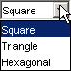

2) Select the appropriate lattice type, depending on the lattice type of the loaded model(s).

For example, if Fire.drw is visualized with a Triangle lattice type, the cells are displayed as follows.
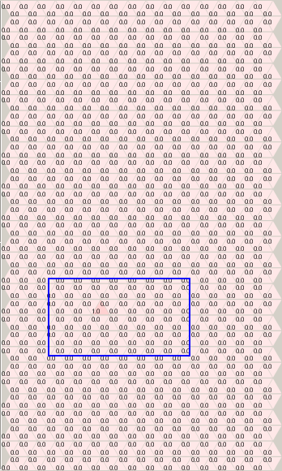

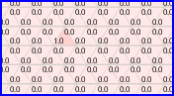

If Fire.drw is visualized with a Hexagonal lattice type, the cells are displayed as follows.
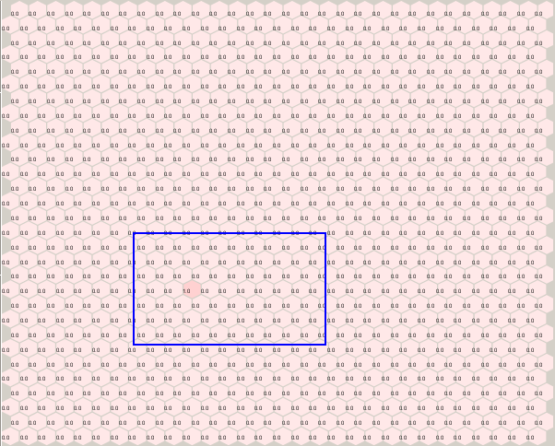

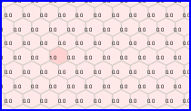

For this example, Fire.drw should be visualized with a Square lattice type.

Note: If the selected lattice type does not match the lattice type of the loaded model(s) (eg. if a hexagonal or triangular lattice is used for a square-latticed model), the results will not be visualized as intended.

Show two-dimensional or multi-dimensional display
- For visualization of 1D or 2D models, this option is ignored.
- For visualization of 3D models, if Show 2D Only is checked, only cells with the coordinates (x,y,0) are displayed (ie. only cells in the first plane). If Show 2D Only is not checked, the cells in the planes are displayed from left to right, with the sequence: (x,y,0), (x,y,1), (x,y,2), etc.
- For visualization of multi-dimensional models, if Show 2D Only is checked, only cells in the first plane are displayed, ie. cells with coordinates (x,y,0,0,...,0). If Show 2D Only is not checked, the cells in the planes are displayed from left to right, with the sequence: (x,y,0,0,...,0), (x,y,1,0,...,0), ..., (x,y,D2,0,...,0), (x,y,0,1,...,0), ..., (x,y,D2,D3,...,DN).

By default, Show 2D Only is checked.
1) To restrict the visualization of the loaded model(s) to only two dimensions, check Show 2D only.
2) To show all the dimensions of the loaded model(s) in the visualization, uncheck Show 2D Only.

In this example, Fire.drw represents a two-dimensional model, so the Show 2D Only option is ignored. (See the example for a 3D atomic Cell-DEVS model, SatelliteClouds, for more details about the Show 2D Only option.)

Show cell values of the loaded model(s)
By default, Show Values is checked.
1) To show the cell values of the loaded model(s) in the visualization, check Show Values.
2) To remove the cell values of the loaded model(s) in the visualization, uncheck Show Values.

In this example, if Show Values is unchecked for the visualization of Fire.drw, the cells are displayed as follows:
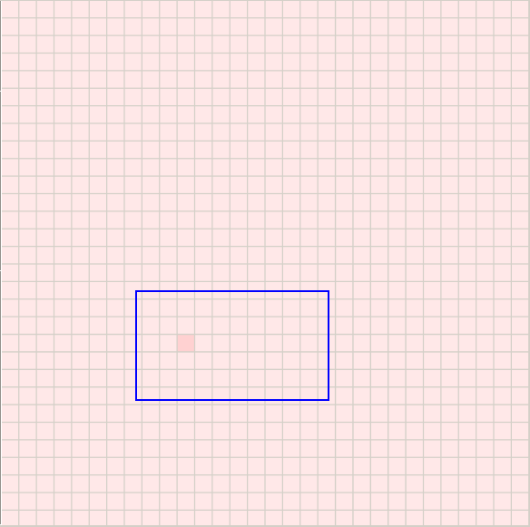

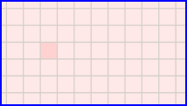

Show names of the loaded model(s)
For models of the form <componentName>@<modelLog.log> , this option is ignored.
This option is only available for models of the form <modelDrw.drw>.

By default, Show Names is not checked.
1) To show the names of the loaded model(s) in the visualization, check Show Names.
2) To remove the names of the loaded model(s) in the visualization, uncheck Show Names.

In this example, if Show Names is checked for the visualization of Fire.drw, the name 'Fire.drw' is displayed in the upper-left corner of the display, as follows:

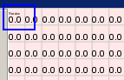

Note: If Show Names is checked for a model of the form <componentName>@<modelLog.log>, the name of the model will not be displayed.

Remove/add the grid of the lattice
By default, the grid of the lattice is visible.
1) To remove the grid of the lattice from the visualization, left-click Remove Grid. The Remove Grid button will be replaced by the Add Grid button.
2) To add the grid of the lattice to the visualization, left-click Add Grid. The Add Grid button will be replaced by the Remove Grid button.

In this example, if Remove Grid is pressed, the visualization for Fire.drw will be displayed as follows:
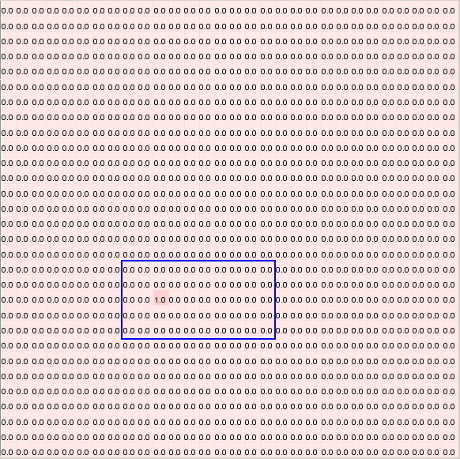

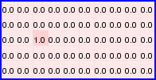

Running/Navigating the visualization
Once the appearance of the visualization has been modified as desired, the visualization can be run/navigated. The individual steps in the visualization can be navigated to directly or indirectly.
Navigating indirectly involves playing/starting, stopping, and pausing the visualization.
Navigating directly includes going to the previous/next step in the visualization, and going directly to a particular step or time in the visualization.
Running the visualization also requires setting the delay between the steps of the visualization.
These functions are described in the following sections.

Set the delay between steps
In general, the larger the delay value, the longer the amount of time between each step during the visualization. By default, the delay is set at 10. (units?)
1) Type the appropriate delay length in the Delay field. Left-click Apply.
In this example, the delay has been set to 250.

The delay can be set while the visualization is running (ie. after the visualization has been started), after the visualization has been stopped, or while the visualization is paused (ie. after the visualization has been paused).

Play/start the visualization
1) To start the visualization, left-click the start button. The visualization will start at the beginning of the simulation (ie. the beginning of the .log file).
The graphical results will be updated and displayed sequentially, along with the corresponding display step and time (according to the message times of the .log file).

In this example, the visualization of Fire.drw has been started, and has the current display time of 00:04:47:892 and current step of 6, with the corresponding cell values visible in the display area.
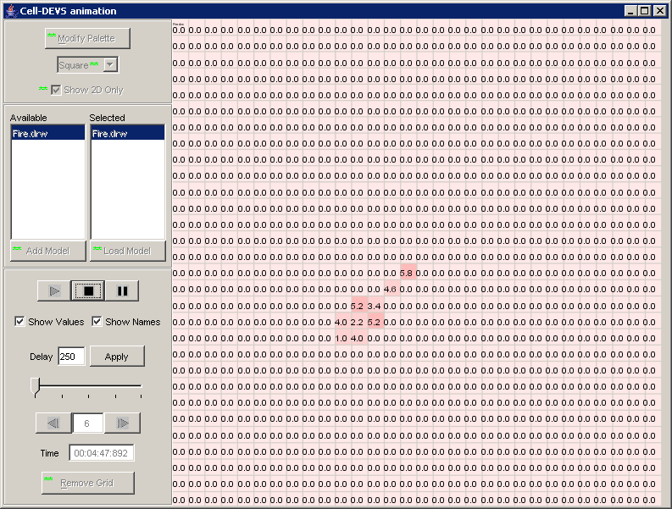
Figure 124: Play/Start Visualization

** Note: While the visualization is running (ie. After the visualization has been started), the following appearance options cannot be changed: Modify Palette, Select lattice type, Show 2D Only, Remove/Add Grid. Also, models cannot be added/loaded while the visualization is running.

Note: In general, to allow the visualization to update the cell display area more quickly, uncheck Show Values.

2) After the visualization has started, it can be run to the end of the simulation time, stopped, or paused.

- After the visualization has started, if no other buttons are pressed, the visualization will continue until it reaches the end of the simulation (ie. The last message time in the .log file).
Note: Once the end of the simulation has been reached, in order to replay the visualization, the stop button must be pressed.
In this example, after pressing the Start button, if no other buttons are pressed, the visualization will continue until it reaches 01:59:40:578 (ie. Step 386), which is when the simulation ends in the .log file.
- The stop and pause buttons are described in the following sections.

Stop the visualization
- To stop the visualization, left-click the stop button. The visualization will stop at the current display time.
The cell values occurring at the current display time will not be visible; instead, the cell values occurring at the beginning of the simulation will be visible.

In this example, the visualization of Fire.drw is about to be stopped at the current step of 7 and current display time of 00:05:22:995. The cell values visible in the display area correspond to the current display time.
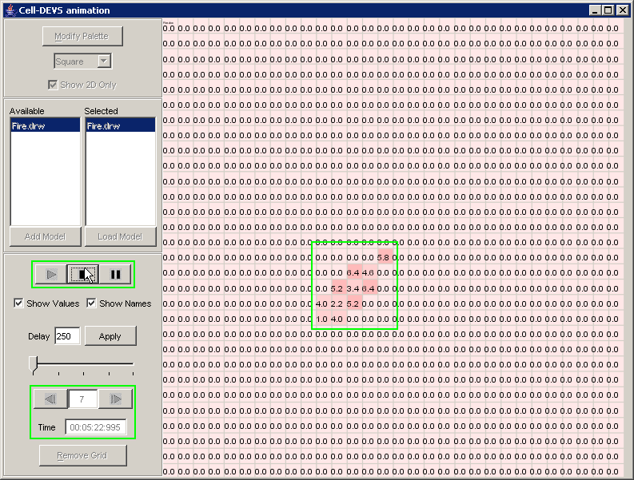
Figure 125: Visualization Stopped

In the following figure, the visualization has been stopped. The display time and step, as well as the cell values visible in the display area, correspond to the beginning of the simulation (ie. at 00:00:00:000).
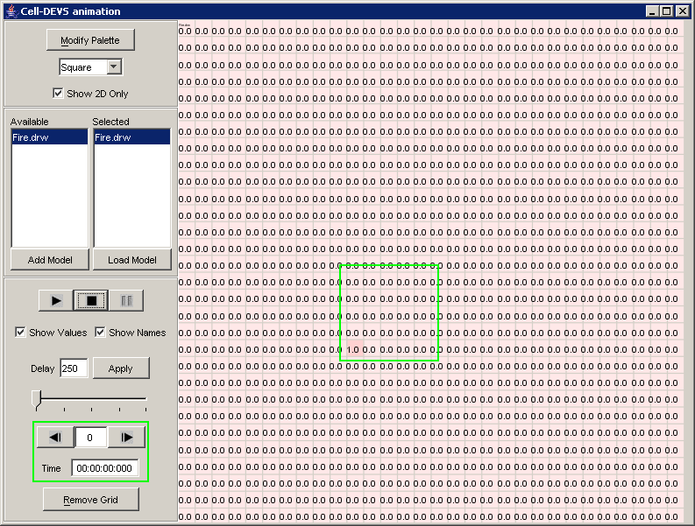
Figure 126: Values displayed on stopped visualization

2) After the visualization has stopped, it can be restarted (at the beginning of the simulation).

- After the visualization has stopped, if the start button is pressed, the visualization will restart only at the beginning of the simulation, ie. at 00:00:00:000. The visualization will not restart at time at which the visualization was stopped.
- The start button is described in the preceding section.

Pause the visualization
1) To pause the visualization, left-click the pause button. The visualization will pause at the current display time. The cell values occurring at the current display time will remain visible on the graph.

In this example, the visualization of Fire.drw has been paused at the current step of 16 and current display time of 00:08:57:147. The cell values visible in the display area correspond to the current display time.

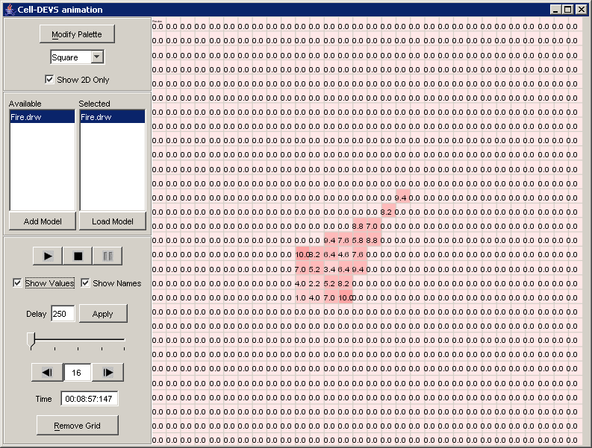
Figure 127: : Cell values corresponding to the current display time

2) After the visualization has paused, it can be restarted (at the current display time), stopped, or decremented/incremented to the previous/next step.

- After the visualization has paused, if the start button is pressed, the visualization will restart at the current display time.
- The start and stop buttons are described in the preceding sections.
- The previous and next step buttons are described in the following sections.

Go directly to a particular time
This function is not valid while the visualization is running.
1) To go directly to a particular time of the visualization, type the particular time in the Time (current display time) field. Ensure the format of the time corresponds to ##:##:##:### . Press Enter (on the keyboard).
The visualization will display the particular time, corresponding step, and corresponding cell values in the display area.

Note: If a particular time does not occur in the .log file, then the results (Time, step, and cell values) corresponding to the next smaller time in the .log file will be displayed.

Go directly to a particular step
This function is not valid while the visualization is running.
1) To go directly to a particular step of the visualization, type the particular step number in the current step field. Press Enter (on the keyboard).
The visualization will display the particular step, corresponding time, and corresponding cell values in the display area.

In this example, step 25 of the Fire.drw visualization has been accessed directly, with corresponding display time 00:11:22:860.
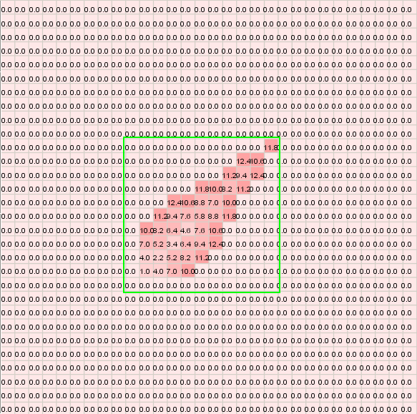
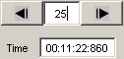
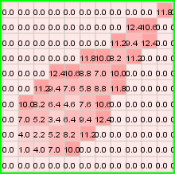

Figure 128: Going directly to particular step
Note: If a step number is larger than the current step and larger than the largest step of the visualization, then the results (Time, step, and cell values) corresponding to the current step will remain displayed.

Go to the previous/next step
This function is not valid while the visualization is running.
1) To go to the previous step in the visualization, left-click the previous button.
The visualization will decrement to the previous step, updating the display time (according to the .log file) and the cell values in the display area.

This example continues from the previous section - 'Go directly to a particular step'. In this example, step 24 (the previous step in the visualization of Fire.drw) has been accessed directly. The visualization is decremented to the previous display time of 00:11:21:093.
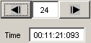
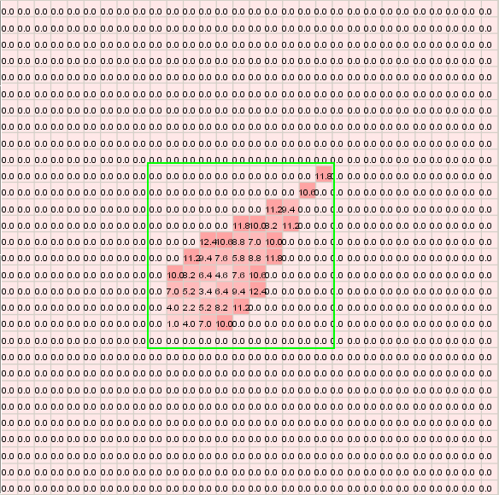
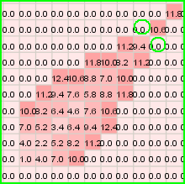

Figure 129: Visualization at 00:11:21:093

Note: If the visualization has reached the smallest step/time of the simulation, then the visualization will not decrement.

2) To go to the next step in the visualization, left-click the next button.
The visualization will increment to the next step, updating the display time (according to the .log file) and the cell values in the display area.

This example continues from the previous section - 'Go directly to a particular step'. In this example, step 26 (the next step in the visualization of Fire.drw) has been accessed directly. The visualization is incremented to the next display time of 00:11:30:766.
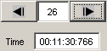
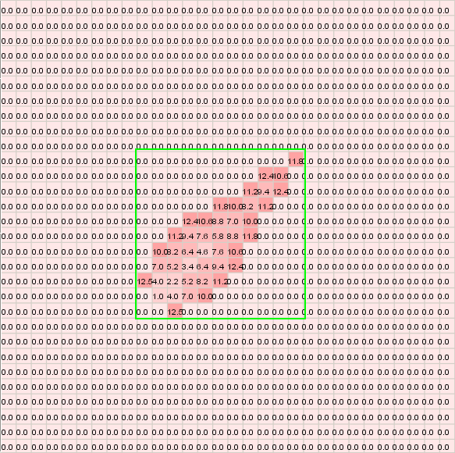
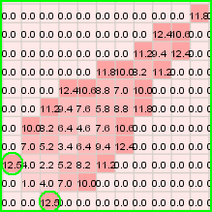

Figure 130: Visualization at 00:11:30:766

Note: If the visualization has reached the largest step/time of the simulation, then the visualization will not increment.

3) After the visualization has decremented/incremented to the previous/next display, it can be restarted (at the current display time), stopped, or decremented/incremented again to the previous/next display.

- After the visualization has decremented/incremented to the previous/next display, if the Start button is pressed, the visualization will restart at the current display time.
- The Start and Stop buttons are described in the preceding sections.
- The previous/next buttons are described in this section.

Cell-DEVS animation Example of multiple Atomic Cell-DEVS: Fire, SatelliteClouds
To run this example, download the Fire and SatelliteClouds projects.
Fire is a 2D (two-dimensional) atomic Cell-DEVS model.
SatelliteClouds is a 3D (three-dimensional) atomic Cell-DEVS model.
In this example, SatelliteClouds will be used as a 2D atomic Cell-DEVS model.
(SatelliteClouds will be used as a 3D model in the next Cell-DEVS animation example.)

The main functionality of the Cell-DEVS animation visualization window described in the previous example (Fire) also applies for this example. However, while the previous example (Fire) illustrated the visualization of a single atomic Cell-DEVS model, this example (Fire & SatelliteClouds) illustrates the visualization of multiple (unrelated) atomic Cell-DEVS models.

The differences in the functions of the Cell-DEVS animation visualization window when used for displaying multiple atomic Cell-DEVS model will be described.
For loading multiple models to be visualized:
-adding models to the Available list
-selecting multiple available models to be loaded
-loading selected models to be visualized
For running/navigating the visualization:
-play/start the visualization

Loading multiple (unrelated) models to be visualized
The multiple (unrelated) atomic models must first be loaded before being visualized.
The appropriate atomic models must first be added to the Available list. From the Available list, the models to be visualized must be selected (ie. to the Selected list). Once the atomic models to be visualized are in the Selected list, the models can then be loaded.

Adding models to the Available list
Using the same procedure as for the previous example (Fire), add the appropriate models to the Available list.
For the following sections, this example will be considered, where satelliteclouds.drw and Fire.drw have been added to the Available list.
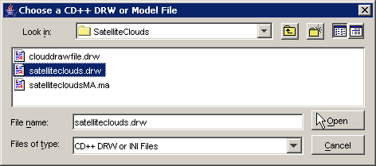
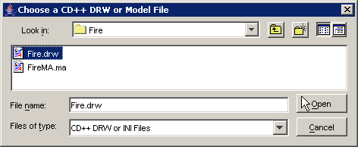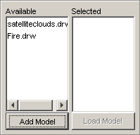
Figure 131: Adding models to available list

Selecting multiple available models to be loaded
Using the same procedure as for the previous example (Fire), from the Available list, select the models to be visualized.
Continuing this example, Fire.drw and satelliteclouds.drw have been selected from the Available list (ie. to the Selected list).
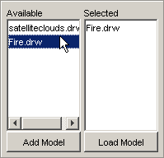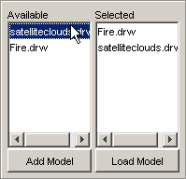
Figure 132:Selecting multiple available models
Note: When loaded, the order of the models in the Selected list influences the appearance of the visualization.

Loading selected models to be visualized
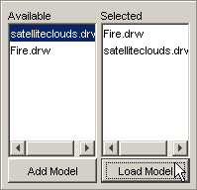
Using the same procedure as for the previous example (Fire), load the models in the Selected list.
In this example, Fire.drw and satelliteclouds.drw will be loaded (and visualized) concurrently.

Reminder: Please wait until all selected models have been loaded to the visualization cell display area. Since multiple models are being loaded, the waiting time required to load the models will be greater than if a single model was being loaded.

Figure 133: Loading models
The cell values of the Fire model and SatelliteClouds model will be displayed in the visualization cell display area, as seen below.
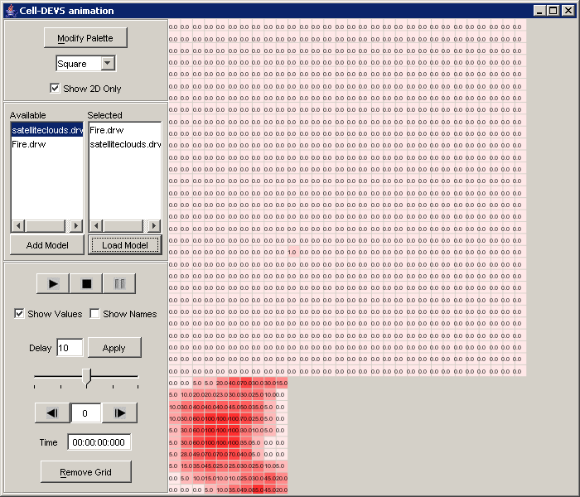
Figure 134: Visualizing loaded models
Reminder: The size of the Cell-DEVS animation visualization window can be increased/decreased to fit the multiple models in the visualization cell display area.

When multiple atomic models are loaded and visualized, the order of the models in the Selected list influences the appearance of the visualization.
- By default, the order of the models in the visualization cell display area corresponds to the order of the models in the Selected list. The first model in the Selected list will be displayed at the top of the cell display area. Each consecutive model in the Selected list will be displayed consecutively below the previous model in the list. (Check Show Names to display the names of the loaded models.)
- By default, if the first model in the Selected list has a palette (.pal) file with the same name as the model (ie. .drw file), then the .pal file will automatically be applied to all models in the visualization. In this example, since Fire.drw is the first model in the Selected list, Fire.pal is automatically used for the visualization of both Fire.drw and satelliteclouds.drw. (Note: If the first model in the Selected list does not have a .pal file of the same name, then the .pal file of the previously-loaded visualization is used.) Thus, each loaded model in the visualization must use the same .pal file (ie. the .pal file of the first model in the Selected list).

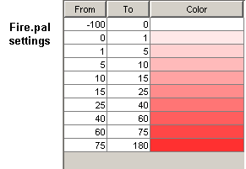
From the previous figure, the order of the Selected list is: Fire.drw, satelliteclouds.drw.

Since Fire.drw is first in the Selected list, by default:
- Fire is located at the top of the cell display area, while SatelliteClouds is located directly below.
- Fire.pal is used for both loaded models.

Conversely, consider when the Selected list order is reversed: satelliteclouds.drw, Fire.drw.
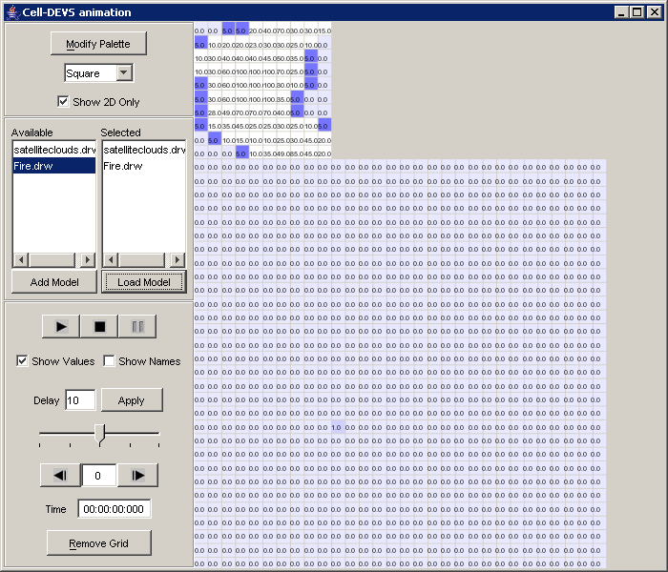
Figure 135: Visualization with list order reversed
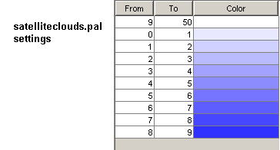
Since satelliteclouds.drw is first in the Selected list, by default:
- SatelliteClouds is located at the top of the cell display area, while Fire is located directly below.
- satelliteclouds.pal is used for both loaded models.

Running/Navigating the visualization
Once the appearance of the visualization has been modified as desired, the visualization of the multiple models can be run/navigated.

Play/start the visualization
Using the same procedure as for the Fire example, the visualization can be started.

The visualization will start at the earliest message time (of the .log files) of all loaded models.
After the visualization has started, if no other buttons are pressed, the visualization will continue until it reaches the last message time (of the .log files) of all loaded models.
(ie. If the loaded models have different simulation times, the visualization will continue until the end of the longer simulation time.)

Also, if the loaded models have overlapping simulation times (ie. occur during the same time range), the individual visualizations of the loaded models will run concurrently.
If the loaded models do not have overlapping simulation times, the model of shorter simulation time will remain visible in the cell display area while the visualization of the model of longer simulation time runs.

For the .drw files used in this example:
The simulation of the SatelliteClouds model starts at 00:00:01:000, and ends at 00:00:30:000.
The simulation of the Fire model starts at 00:01:11:973, and ends at 01:59:40:578.

If the SatelliteClouds model was visualized individually, it would start at 00:00:01:000 (ie. step 1) and end at 00:00:30:000 (ie. step 30). (In the accompanying figures, the SatelliteClouds model is displayed with the palette Fire.pal applied.)
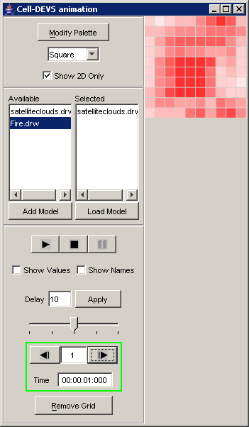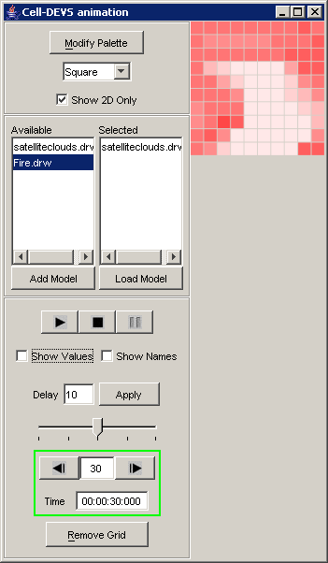

Figure 136: Model displayed with .pal applied
If the Fire model was visualized individually, it would start at 00:01:11:973 (ie. step 1) and end at 01:59:40:578 (ie. step 386).
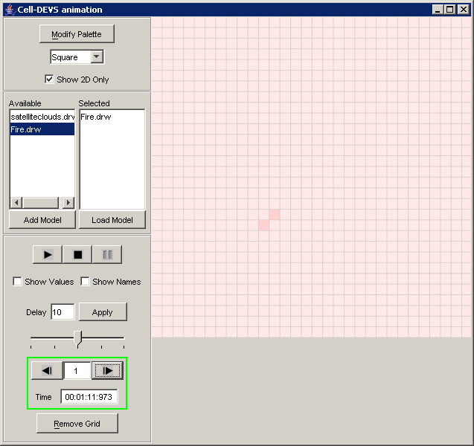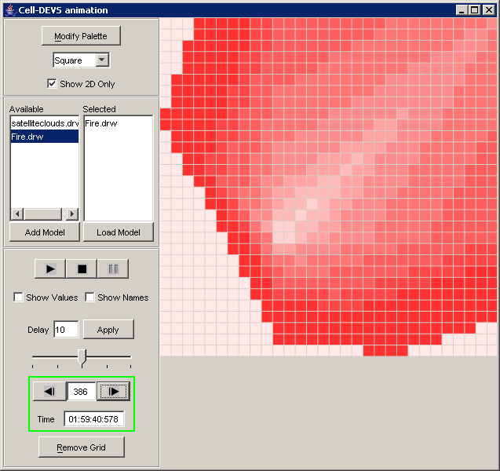
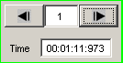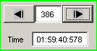

Figure 137: Fire model viewed individually

In this example with both the SatelliteClouds and Fire models loaded, after pressing the Start button, if no other buttons are pressed:

A)- The visualization will start with the SatelliteClouds model, which will run starting at 00:00:01:000 (ie. step 1) until 00:00:30:000 (ie. step 30).
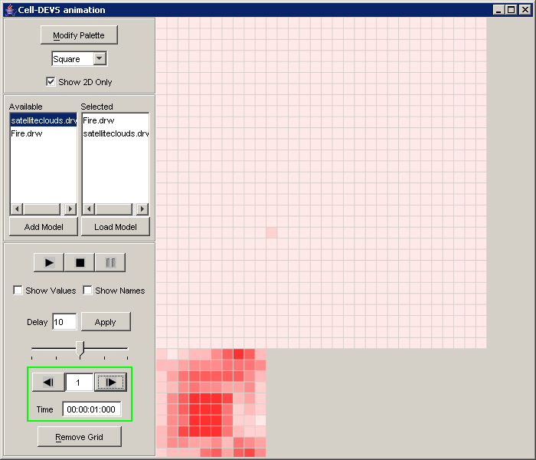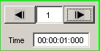

Figure 138: Starting visualization of SatelliteClouds model

B)- Since the message times of the SatelliteClouds and Fire models do not overlap, the visualization of SatelliteClouds will be complete before the visualization of the Fire model starts. After the SatelliteClouds visualization has completed (ie. after step 30), the cell values occurring at step 30 will remain visible (in the SatelliteClouds cell display area) until the end of the entire visualization.
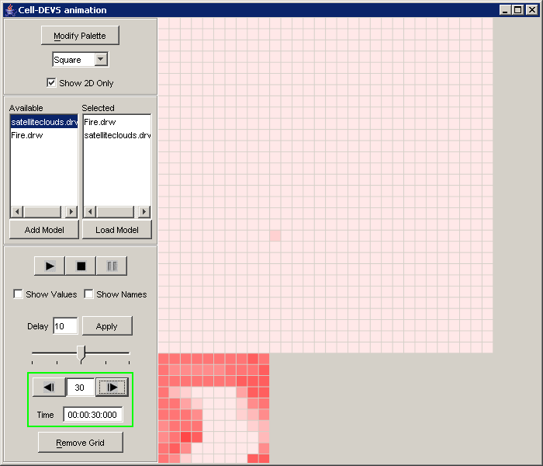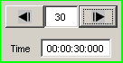
Figure 139: Viewing cell values (step 30)

C)- The visualization of the Fire model will run, starting at 00:01:11:973 (ie. step 31) until 01:59:40:578 (ie. step 416).
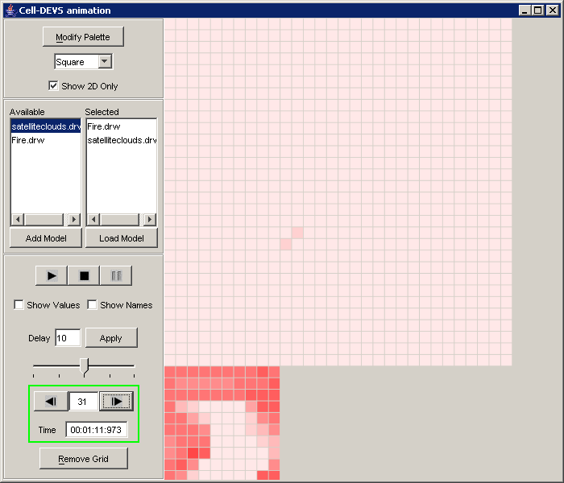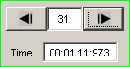
Figure 140: Visualization of fire model (step 31)

D)- The entire visualization will end upon reaching the last message time (ie. at step 416) of the Fire model.
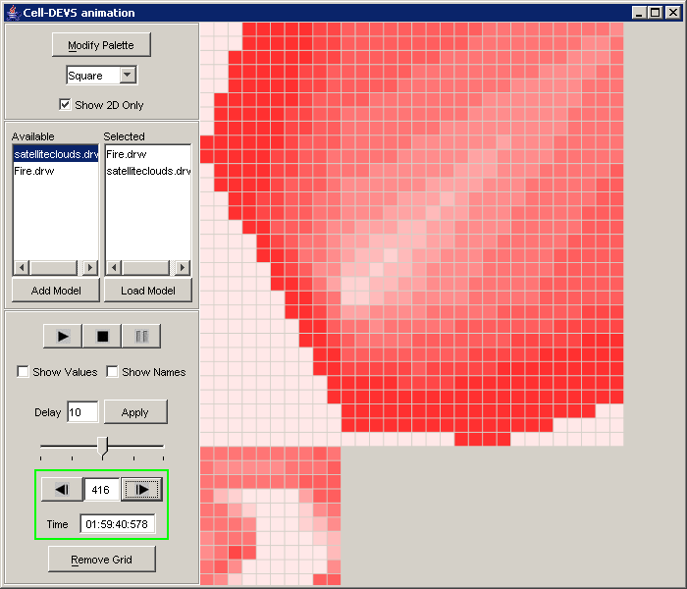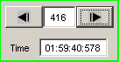
Figure 141: Visualization of Fire model (Step 416)

Cell-DEVS animation Example of 3D Atomic Cell-DEVS: SatelliteClouds
To run this example, download the SatelliteClouds project.
SatelliteClouds is a 3D (three-dimensional) atomic Cell-DEVS model.

The main functionality of the Cell-DEVS animation visualization window described in a previous example (Fire) also applies for this example. However, instead of illustrating the visualization of a 2D atomic Cell-DEVS model (as in Fire), this example (SatelliteClouds) illustrates the visualization of a 3D atomic Cell-DEVS model.

The differences in the functions of the Cell-DEVS animation visualization window when used for displaying a 3D atomic Cell-DEVS model will be described:
For modifying the appearance of the visualization:
-showing multiple dimensions of the loaded models

Show multi-dimensional display of loaded models
- For visualization of 3D models, if Show 2D Only is checked, only cells with the coordinates (x,y,0) are displayed (ie. only cells in the first plane). If Show 2D Only is not checked, the cells in the planes are displayed from left to right, with the sequence: (x,y,0), (x,y,1), (x,y,2).
- For visualization of multi-dimensional models, if Show 2D Only is checked, only cells in the first plane are displayed, ie. cells with coordinates (x,y,0,0,...,0). If Show 2D Only is not checked, the cells in the planes are displayed from left to right, with the sequence: (x,y,0,0,...,0), (x,y,1,0,...,0), ..., (x,y,D2,0,...,0), (x,y,0,1,...,0), ..., (x,y,D2,D3,...,DN).

By default, Show 2D Only is checked.

In this example, the 3D atomic model SatelliteClouds is displayed as a 2D model when loaded. (In the accompanying figure, the SatelliteClouds model is displayed with Show Values unchecked.)
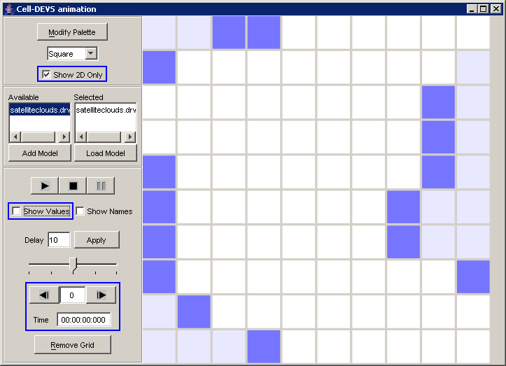
Only plane (x,y,0) of SatelliteClouds is visible in the cell display area.

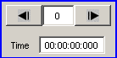
Figure 142: 3D model displayed as 2D model

After unchecking Show 2D Only, SatelliteClouds is displayed as a 3D model.
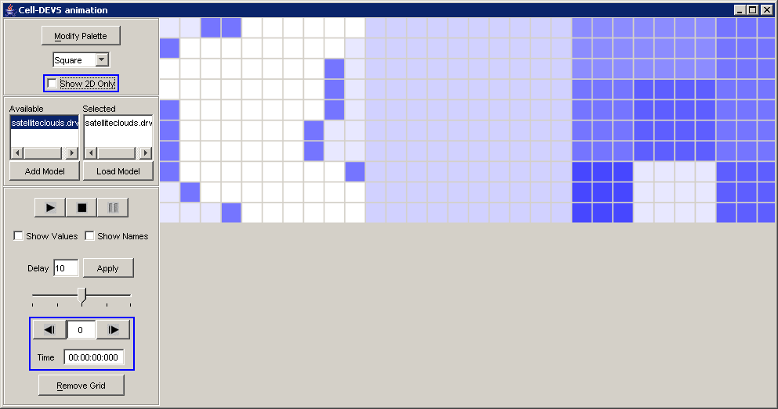
From left to right, the 3 planes of the SatelliteClouds model are visible: (x,y,0), (x,y,1), (x,y,2).

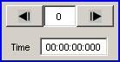
Figure 143: Displayed as 3D Model

Cell-DEVS animation Example of Coupled-DEVS: RiceField
To run this example, download the RiceField project.
RiceField is a coupled-DEVS model composed of multiple atomic Cell-DEVS models.
The two component atomic Cell-DEVS models of RiceField are: diffusion, field.

The main functionality of the Cell-DEVS animation visualization window described in a previous example (Fire & SatelliteClouds) also applies for this example. However, instead of illustrating the visualization of multiple unrelated atomic Cell-DEVS models (as in Fire & SatelliteClouds), this example (RiceField) illustrates the visualization of multiple related atomic Cell-DEVS models.

The differences in the functions of the Cell-DEVS animation visualization window when used for displaying multiple related atomic Cell-DEVS model will be described:
For loading multiple models to be visualized:
-adding a coupled model to the Available list
-loading selected models to be visualized
For modifying the appearance of the visualization:
-modify the palette of the loaded models: load settings from an existing .pal file
(Running/Navigating the visualization will also be described.)

Loading multiple models to be visualized
The components of a coupled model must first be loaded before being visualized.
The appropriate coupled model must first be added to the Available list. From the Available list, the component models to be visualized must be selected (ie. to the Selected list). Once the component models to be visualized are in the Selected list, the component models can then be loaded.

Adding a coupled model to the Available list
To add a coupled models (consisting of multiple atomic cellular models) to the Available list, the same procedure as for the Fire & SatelliteClouds example is used.
As described in the Fire example, two options are available: (a) choose a .ma file and a .log file, or (b) choose .drw files.

(a) Choosing a coupled model's .ma file (and corresponding .log file) will add all the component models (of the coupled model, as specified in the component: parameter of the .ma file) to the Available list. All the component (ie. atomic cellular) models will use the same .log file.
Thus, all atomic cellular models of a coupled model can be made available by specifying an .ma/.log file (corresponding to the coupled model).

In this example, for the coupled model RiceField, rice.ma is chosen in conjunction with rice.log.
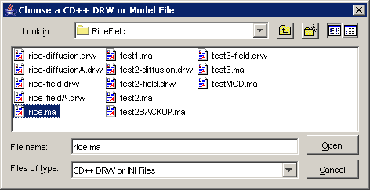
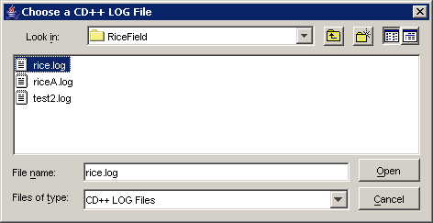
Figure 144: Choosing the rice model
Since the RiceField model consists of two components (ie. diffusion and field), both component models will appear in the Available list with the same .log file.
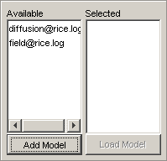
Figure 145: rice.log appears in the list
(b) Choosing a .drw file will add one component model (of the coupled model) to the Available list. (ie. Each .drw file corresponds to one atomic cellular model.) When using .drw files, each component's .drw file must be individually added to the Available list.
Thus, only one atomic cellular model can be made available my specifying a .drw file (corresponding to one component of the coupled model).

In this example, for the diffusion component of the RiceField model, rice-diffusion.drw is chosen, and appears in the Available list.
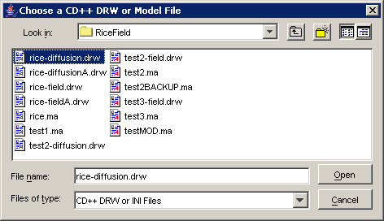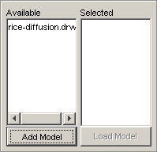
Figure 146: Choosing the diffusion component of the rice model

Also, for the field component of the RiceField model, rice-field.drw is chosen, and appears in the Available list after rice-diffusion.drw.
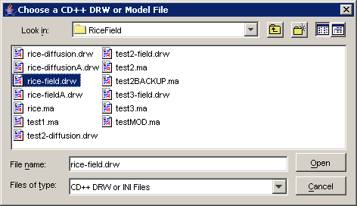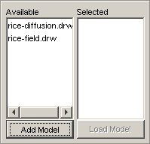
Figure 147: Choosing the field component of the rice model

For the following sections, this example will be considered, where rice-diffusion.drw and rice-field.drw have been added to the Available list.

The same procedure as for the Fire & SatelliteClouds example can be used for selecting multiple available models to be loaded.
Continuing this example, both rice-diffusion.drw and rice-field.drw have been selected from the Available list (ie. to the Selected list).

Reminder: When loaded, the order of the models in the Selected list influences the appearance of the visualization.

Loading selected models to be visualized
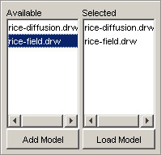
Continuing this example, rice-diffusion.drw and rice-field.drw will be loaded (and visualized) concurrently.

Reminder: Please wait until all selected models have been loaded to the visualization cell display area. Since multiple models are being loaded, the waiting time required to load the models will be greater than if a single model was being loaded.

Figure 148:Loading files
The cell values of the selected component models (ie. diffusion and field) of the RiceField model will be displayed in the visualization cell display area, as seen below.
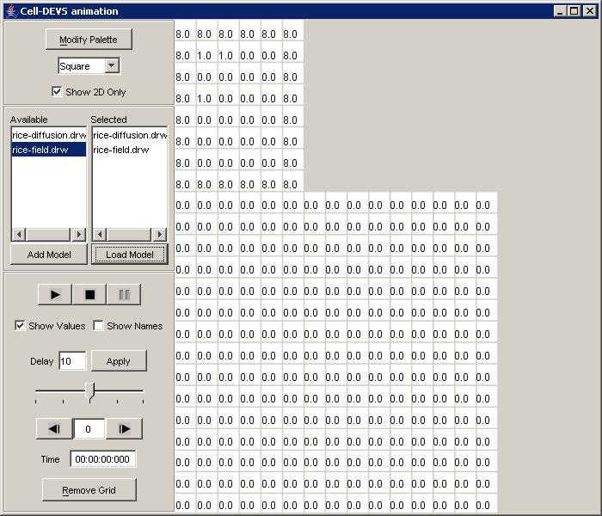
Figure 149: Cell Values displayed concurrently
Reminder: The size of the Cell-DEVS animation visualization window can be increased/decreased to fit the multiple models in the visualization cell display area.

Reminder: By default, if a palette (.pal) file exists with the same name as the first model in the Selected list, then the .pal file will automatically be applied to all models in the visualization.

From the previous figure, since rice-diffusion.drw is first in the Selected list, rice-diffusion.pal would be used by default. However, since rice-diffusion.pal does not exist, no palette is applied by default.

Conversely, consider when the Selected list order is reversed: rice-field.drw, rice-diffusion.drw.
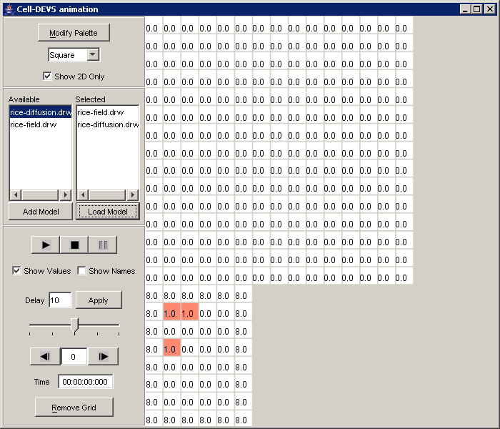
Figure 150: Concurrent display with reversed list order

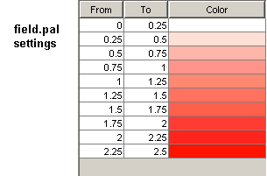
From the previous figure, since rice-field.drw is first in the Selected list, field.pal would be used by default. So, field.pal is applied to both the field and diffusion components in the visualization.

Modifying the appearance of the visualization
The appearance of the visualization for a coupled model can be modified using standard procedures, as described in previous examples.

Modify the palette of the loaded models
For the RiceField model, the .pal corresponding to the diffusion component is named ditch.pal.

Load settings from an existing .pal file
Continuing with the example where the order of the Selected list is: rice-diffusion.drw, rice-field.drw.
In the Modify Palette dialog, the settings from ditch.pal can be loaded and accepted.
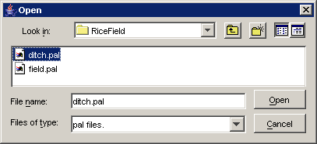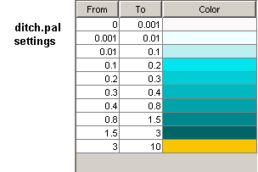
Figure 151: Modifying palettes of the loaded models
The settings of ditch.pal will be applied to both the diffusion and field components in the visualization.
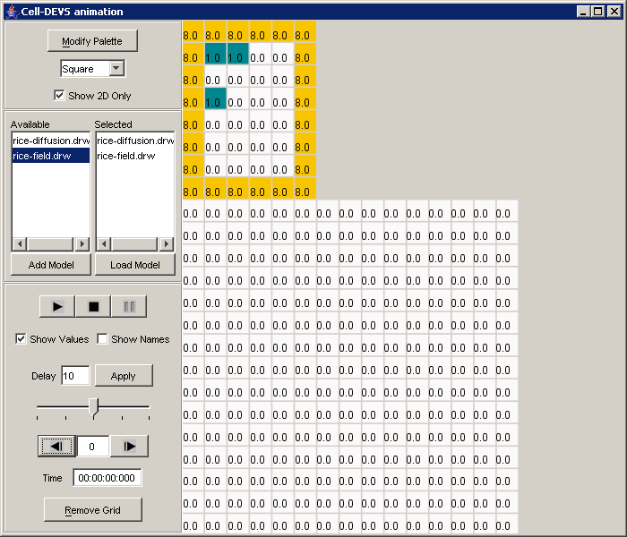

Figure 152: Settings applied to both loaded visualizations

Running/Navigating the visualization
The visualization of a coupled model can be run/navigated using standard procedures, as described in previous examples.

Continuing with this example, using the palette (ie. ditch.pal) for the diffusion component of the RiceField model, the cell display area at the end of the visualization appears as follows:
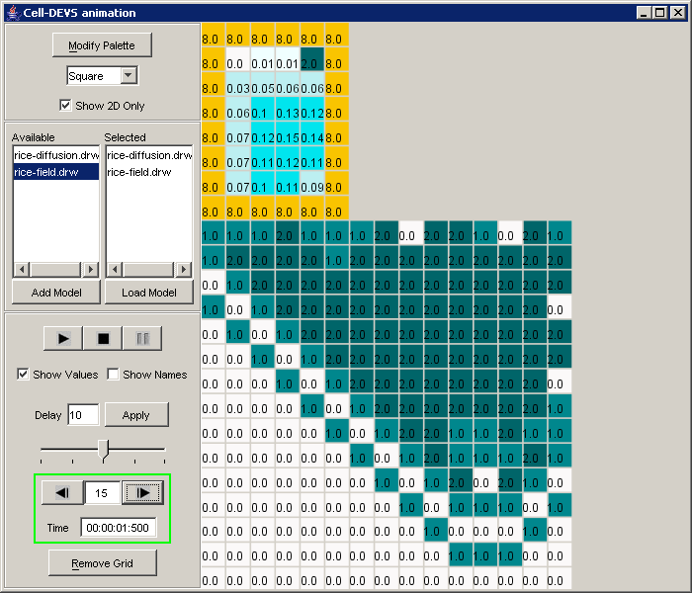

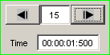

Figure 153: Using ditch.pal for the diffusion component
With Show Values unchecked, Show Names checked, and the Grid removed, the start and end of the visualization appear as follows:
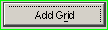

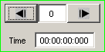
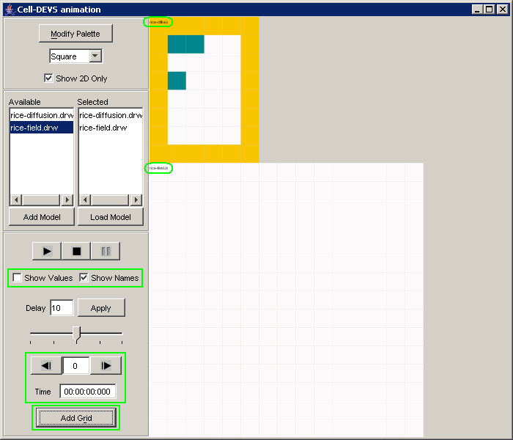
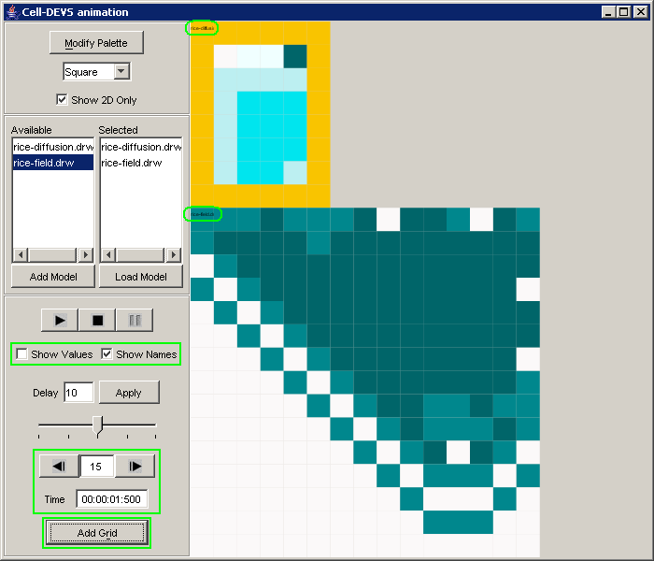
Figure 154: Display for a specific set of options
Note: When trying to view the results for a particular component of a coupled model, use the palette corresponding to the component.

Consider when the palette (ie. field.pal) for the field component of the RiceField coupled model is used. The cell display area at the start and end of the visualization will appear as follows:

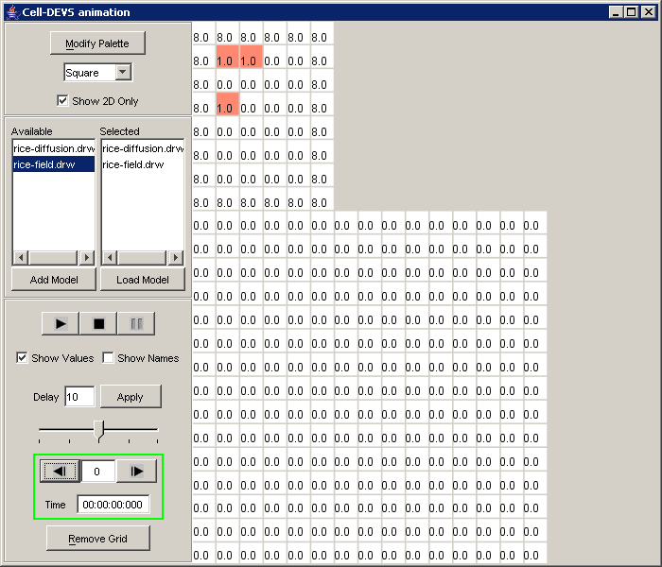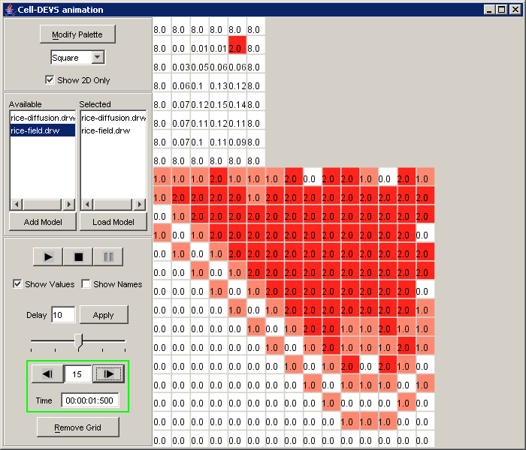
Figure 155: Cell display at start and end

With Show Values unchecked, Show Names checked, and the Grid removed, the start and end of the visualization appear as follows:

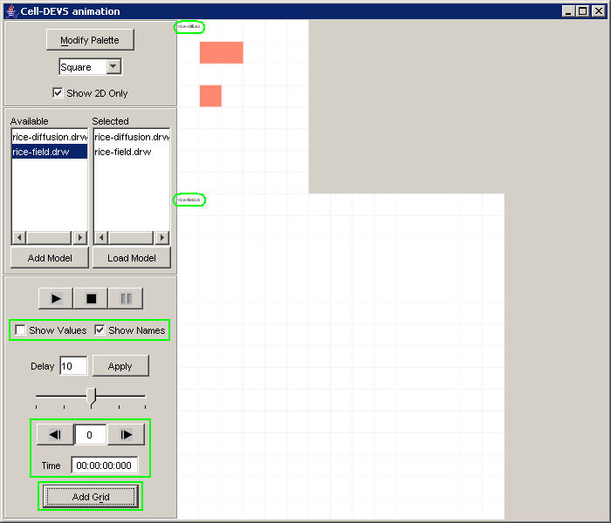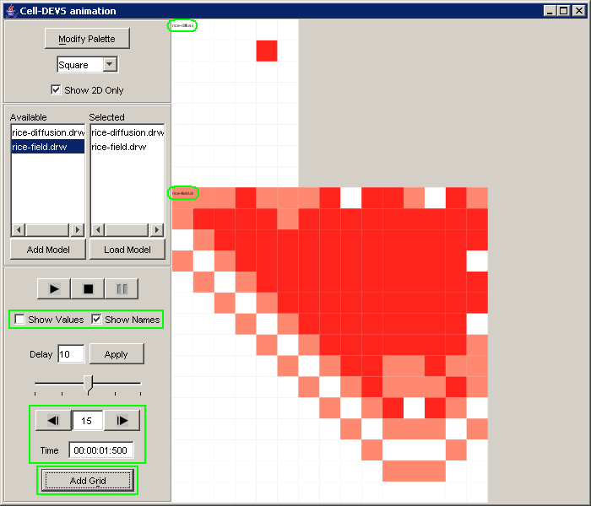

Figure 156: Start and end of visualization with a specific set of settings

ther tools (using the Execute menu commands)
This section describes the commands in the Execute menu, which are used for simulating DEVS models. (These commands seem similar to the tools in the CD++ Builder plugin for Eclipse.)

From the main menubar, left-click on Execute. The following menu will be displayed. Select the appropriate command, depending on the tool to be used for simulation.
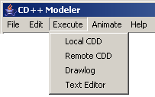
Figure 157: Execute Menu

The following sections describe the commands of the Execute menu for the newest stand-alone version of CD++ Modeler (as of Dec.1/2004), not the version included in the CD++ Builder plugin for Eclipse.

Local CDD
After selecting Local CDD (ie. left-click Local CDD from the Execute menu), the Run Simulator window appears:
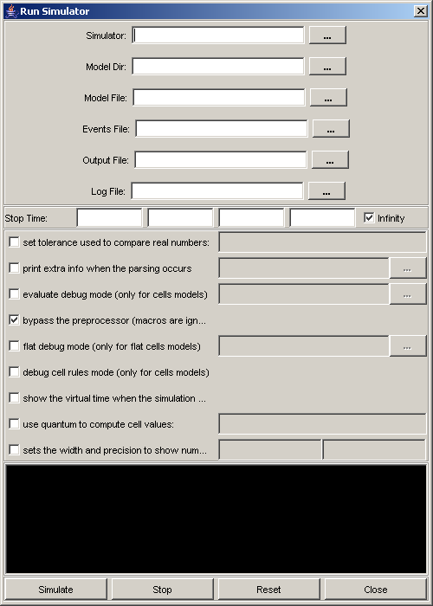
Figure 158: The Run Simulator Window
To simulate the specified Model File (using the specified Events File), press the Simulate button. The results will be output to the specified Output File and Log File.
To stop the simulation of the specified model at any time, press the Stop button.
To clear the dialog fields, press the Reset button.
To close the Run Simulator window, press the Close button.

For this example, the SatelliteClouds model was simulated, with the dialog fields filled as follows:
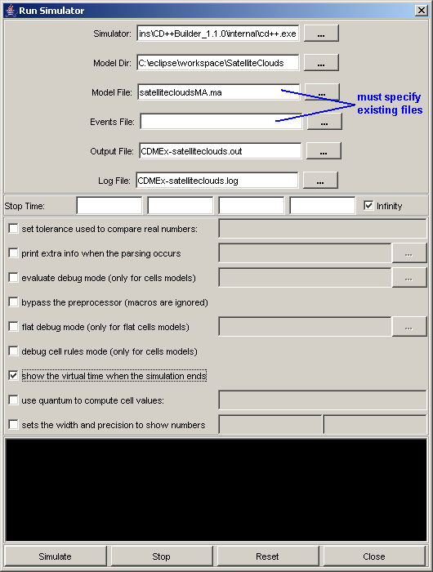
Figure 159: Specifying existing files
Note: The simulation for the SatelliteClouds model using Local CDD consumed more time than using the Simu! command in the CD++ Builder plugin. It is recommended that Local CDD is not used for simple models.

When the simulation of SatelliteClouds was stopped (before the simulation had completed), the console appeared as follows:

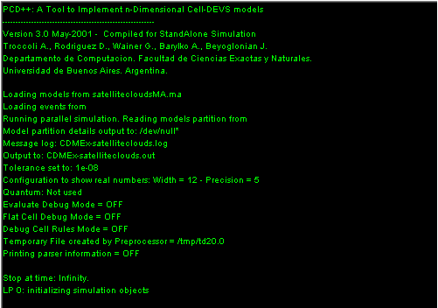
Figure 160:Console view after Simulation Stopped
Note: Local CDD appears to be a tool for parallel simulation. When testing the SatelliteClouds model, numerous log files (of the form *.log#, where # = {1,..., >100} ) were generated.
(Please see Appendix D.)

Note: More testing is required for this tool.

Remote CDD
After selecting Remote CDD, a Run Simulator window appears which is identical to the Run Simulator window for Local CDD.

Text Editor
After selecting Text Editor, the following window appears:

After this window is resized:
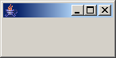

Note: Text Editor appears to be non-functional.
(Please see Appendix D.)

Drawlog
After selecting Drawlog, the Run Drawlog window appears:
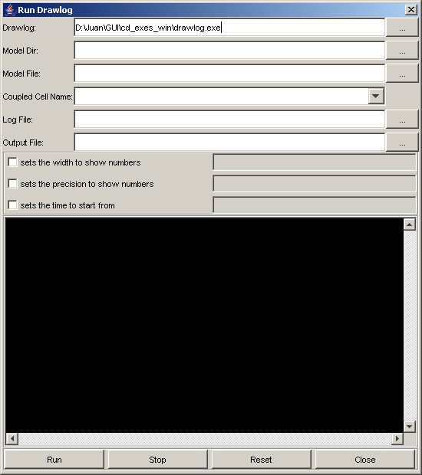
Figure 161: The Drawlog Window
To drawlog the chosen Coupled Cell Name of the specified Model File, press the Run button. The results will be output to the specified Log File and Output File (.drw).
To stop drawlog-ing the specified model at any time, press the Stop button.
To clear the dialog fields, press the Reset button.
To close the Run Drawlog window, press the Close button.

For this example, the SatelliteClouds model was drawlog-ed, with the dialog fields filled as follows:

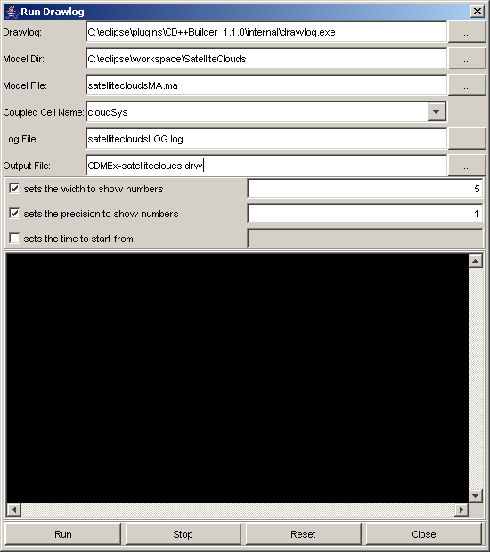
Figure 162: Entering Parameters in the Drawlog window
During the drawlog of SatelliteClouds, the console appeared as follows:
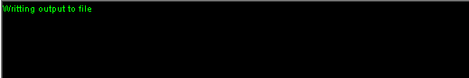
Figure 163: Console View While running Drawlog
When the drawlog of SatelliteClouds had completed, the console appeared as follows:
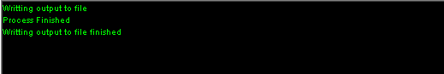
Figure 164:Console view after process has finished
This was also how the console appeared when the drawlog of SatelliteClouds was stopped before the drawlog had completed.
(Please see Appendix D.)

CD++ Modeler: Suggestions & Bugs
The following are known bugs found in CD++Modeler. Suggestions for fixing these bugs are included for each bug.

Creating a Graphical Coupled Model (.gcm)
Note: "Resource panel" refers to the top lateral panel of the CD++ Modeler design space.
SCENARIO: Importing .cpp files.
CURRENT BEHAVIOUR: After importing a .cpp file of an atomic model, the atomic model does not appear in the Resource panel.
SUGGESTED BEHAVIOUR: After importing a .cpp file of an atomic model, the atomic model could appear in the Resource panel, in the Atomic folder.
CURRENT SOLUTION: Import the register.cpp file in which the atomic model is registered. The atomic model will appear in the Resource panel, in the Atomic folder.
ADDENDA: The current solution also has some functionality issues...

SCENARIO: Adding ports to resource models (imported via register.cpp).
CURRENT BEHAVIOUR: After importing a register.cpp file, the atomic models (registered in the register.cpp file) appear in the resource panel. After creating a unit of the atomic model, ports cannot be added to the unit within the Modelling panel.
CURRENT SOLUTION: Before creating a unit of the atomic model, right-click on the atomic model in the Resource panel. In the popup menu, to add a port to the atomic model, left-click Add Port, and type in the appropriate parameters in the dialog box. Once all ports have been added to the atomic model in the Resource panel, a unit of the atomic model can be created. The newly-created unit does not require (and does not allow) ports to be added.
SUGGESTION: The Resource panel could also display the ports available for each imported model.
ADDENDA: Once ports are added to a model, and units of the model are created, the ports of the units must be linked...

SCENARIO: Linking ports between units of models.
CURRENT BEHAVIOUR: A port cannot be accessed individually before a link is created involving the port.
CURRENT SOLUTION: To create a link between two ports, first create a link between the two units that contain the ports. Right-click on the link. In the popup menu, left-click Properties. Select the ports of the two units that are to be linked.

SCENARIO: Importing resources for an exploded model.
CURRENT BEHAVIOUR: After exploding a new coupled model, there are no resources in the Resource panel. The resources available in the "parent" editor are not automically available for the exploded model. The exploded model must import all resources it requires.
SUGGESTED BEHAVIOUR: After exploding a new coupled model, the resources available in the "parent" editor could be automically made available for the exploded model. So, the exploded model will not need to re-import the resources that the "parent" editor uses.

SCENARIO: CD++ Modeler frozen after period of time not in use.

AtomicAnimate: Suggestions & Bugs

Example: FunctionEval

UNKNOWN: units of values in From/To fields
ADDENDA: For the FunctionEval example only, the units for the From/To fields appear to correspond to milliseconds (since FunctionEval is a single atomic model, whose .log file messages occur at millisecond intervals).

SCENARIO: Showing the values of the output signal on the plot.
CURRENT BEHAVIOUR: For a given time interval, the Values checkbox is unchecked. The values are no longer visible on the plot. After the Previous/Next/Jump button is pressed (ie. the interval is changed), the Values checkbox is still unchecked. However, the values are visible on the plot of the current interval. When the Values checkbox is re-checked, the values are no longer visible on the plot of the current interval.
SUGGESTED BEHAVIOUR: For a given time interval, the Values checkbox is unchecked. The values are no longer visible on the plot. After the Previous/Next/Jump button is pressed (ie. the interval is changed), the Values checkbox is still unchecked. The values should not be visible on the plot of the current interval. When the Values checkbox is re-checked, the values should become visible on the plot of the current interval.

Example: 4BitCounter

INITIAL BEHAVIOUR (DEFAULT)
-----------------------------------------------
- The available signals for the first component in the drop-down list will be displayed.

* Note: 'interval' refers to the values in the From and To fields.
'time' refers to an absolute value of time.
'instance' refers to a step in the simulation.
- For example, from the 4BitCounter example:
the start time = 00:00:00:000 the start instance = 0
the end time = 00:00:00:400 the end instance = 662

- If the number of steps in the visualization is less than 1000:
- the From field will contain the start instance/step (corresponding to the first message time in the simulation's .log file, usually 0);
- the To field will contain the end instance/step (corresponding to the last message time in the simulation's .log file).
- The initial interval spans the entire simulation. For example, from the 4BitCounter example, the initial interval is [0,662].
- If the number of steps in the visualization is greater than 1000:
- the From field will contain the start instance/step (corresponding to the first message time in the simulation's .log file, usually 0);
- the To field will contain the value 1000.
- This indicates an initial interval of [0,1000].
-----------------------------------------------

Note: The refresh button refreshes the display of the plots in the visualization window.

SCENARIO: Available output signals (for particular component) exceed space in left column.
CURRENT BEHAVIOUR: For example, for an interval spanning the entire simulation, after selecting the top component from the drop-down list, the fields (for setting the vertical scale) below the signal names are not entirely visible. There is not enough space in the left column to display the fields, and so it is not possible to set the vertical scales.
SUGGESTION 1: Horizontal scrollbar for left column. Would increase visibility of signal names and fields in left column. Could reduce the need to continually resize the visualization window.
SUGGESTION 2: Instead of displaying Set button and fields (for setting the vertical scale), could have a pop-up menu that appears when the signal name is right-clicked. In the pop-up menu, could have a 'Set vertical scale' command, in which a 'Set vertical scale' dialog (with a Set button and fields) could appear. The pop-up menu could also have other commands. Would reduce amount of space required for displaying signal names in left column.

SCENARIO: After changing interval, selected component not in drop-down list.
Refer to:
AtomicAnimate Example of Coupled-DEVS: 4BitCounter >
Availability of signals for the selected model/component
CURRENT BEHAVIOUR: For a given interval, a particular component is selected. If the interval is changed, and the currently selected component does not have any available signals for the current interval, the component will remain selected (even though it is not in the drop-down list). The available signals displayed will correspond to the first component in the drop-down list, not the currently selected component. (Also, if another component is selected from the drop-down list, then it is not possible to re-select the originally selected component, until the interval is changed - in which the originally selected component has signals available.)
SUGGESTION: Visually indicate that the currently selected component does not have any available signals.
SUGGESTION 1: Do not display any signals, since none are available for the currently selected component.
SUGGESTION 2: Change the colour or disable the currently selected component.
SUGGESTION 3: As part of the visualization window, display a list of all components/models and their signals, ie. in a tree structure where left-clicking on a component name will expand a branch for corresponding signal names. For a given time interval, if a component has signals that are available, highlight/emphasize the component(s) and corresponding signal names. Could also have a pop-up menu when a signal name is right-clicked. In the pop-up menu, could have option for setting the colour of the signal's plot (and display a small colour box beside the signal name to indicate what colour is currently set for the signal's plot).
ADDENDA: Would help to clarify which signals correspond to which components.

SCENARIO: Colours of available signals.
CURRENT BEHAVIOUR: Colours of available signals automatically assigned based on order of signals in left column.
SUGGESTION: Allow user to associate particular colour with particular signal of particular component.

SCENARIO: Display of available signals for single component.
CURRENT BEHAVIOUR: The available signals of only one component can be displayed in the visualization window.
SUGGESTION: Allow available signals of multiple component to be displayed in the visualization window.

BUG SCENARIO: In the initial interval spanning the entire simulation, the out signal is unchecked.
So for any interval of the visualization, the plot of the out signal should not be displayed (until the out signal is rechecked).
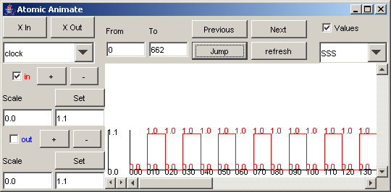

CURRENT BEHAVIOUR: For any interval, since only the in signal is checked, only the plot of the in signal can be displayed.

- However, in some intervals, where (1) only the out signal is available, (2) the out signal is appropriately in the left column, but (3) the out signal is checked and displayed:
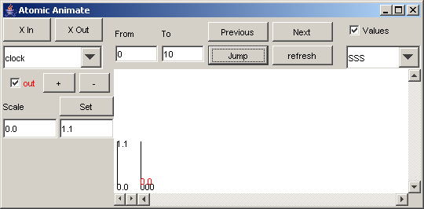
THIS IS A BUG!

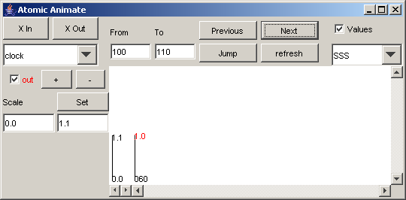
THIS IS A BUG!

SUGGESTED BEHAVIOUR: The out signal should not be checked, and should not be displayed.

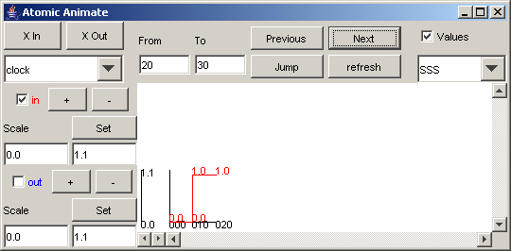
- In other intervals, where (1) both the in signal and out signals are available, (2) both signals are appropriately in the left column, and (3) the in signal is properly displayed and the out signal is properly unchecked:

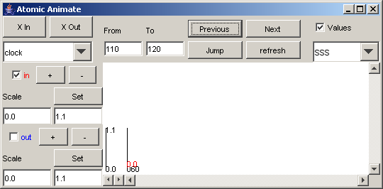
THIS BEHAVIOUR IS CORRECT.

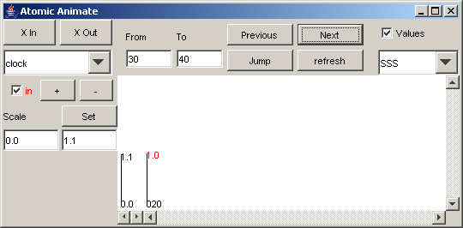
- In other intervals, where (1) only the in signal is available (and the out signal is unavailable), (2) the in signal is appropriately in the left column (and the out signal is appropriately not in the left column), and (3) the in signal is properly displayed:

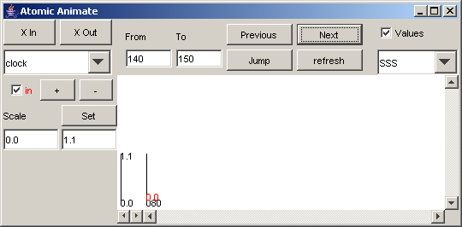
THIS BEHAVIOUR IS CORRECT.

Cell-DEVS animation: Suggestions & Bugs

UNKNOWN: functionality of horizontal scrollbar

UNKNOWN: units of value in Delay field
ADDENDA: assume units of milliseconds, but not verified during testing

Note 1: When adding a coupled model using an .ma file and a .log file, all cellular components of the coupled model will be added to the Available list.
Note 2: When adding a model using a .drw file, only the model specific to the .drw file (ie. one specific model/component) is added to the Available list.

SCENARIO: Organization of visualization window commands.
SUGGESTION: Organize components of visualization window according to command type, ie. for (1)loading model, (2) modifying appearance of visualization, (3) running/navigating visualization.

SCENARIO: Single palette file applied.
CURRENT BEHAVIOUR: Each loaded model (in the Selected list) uses the same .pal file.
SUGGESTION: Allow each loaded model (in the Selected list) to use different .pal files

SCENARIO: Loading both time-supported ('regular' .drw files, with border) and non-time-supported (.drw files created using the -f option in Drawlog) models.
Refer to the excerpt (on the following page) from the original manual.
CURRENT BEHAVIOUR: If both time-supported and non-time-supported models are in the Selected List when the Load Model button is pressed, an error dialog will appear.
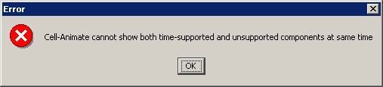

Visualizing Cell-DEVS models

- The display sequence of selected models is in the order of their names in selected list. At any time after you have made changes to the selected list, press load model button to re-display the new selected models. In case of the selected list is empty, the load model button is automatically disabled.

- When all selected models have been loaded, CDModeler tries to load PAL file according to the name of the first entry in selected list as following. If such pal file does not exist or values are not defined in PAL file, CDModel now use white (previous use BLACK) as default.

Model name | Searched PAL file
<modelname> | <modelname>.pal
<modelname>@<log_filename> | <log_filename>.pal

- Currently, CDModeler does not allow loading both time-unsupported and time-supported models at same time. An error message is generated when that happens.

Model Type | Model Generated from
Time-unsupported model | Drawlog with –f argument
Time-supported model | Drawlog without –f argument
Time-supported model | Load directly from log file

Display simulation results for multiple models

4. Multiple Models from DRW Files and Log Files
- This can be used to validate the newly-added functionality.
Step 1. Load segment1a.drw file.
Step 2. Load traffic.ma, traffic.log files.
Step 4. Choose segement1a, crossing1a, segment1a@traffic and crossing1a@traffic models by double-clicking on them. Load the models by clicking on the Load Model button.

Figure 165. Traffic Models: from DRW and LOG Files

- Here, we can clearly see the bug of drawlog program: at this time, the (0,0) cell of both segment1a and crossing1a models send value 2 and 1 out through in_space port, but these values are considered as value of (0, 0) cells. The lower two models loaded from log file are displayed correctly.

Execute menu commands: Suggestions & Bugs

Local CDD
Notes:
- Appears to be a tool for parallel simulation.
- Takes up a lot of processing time (ie. can't use other running applications while waiting for Local CDD simulation to finish).
- Not recommended for simple models.
- Can't copy from console.

Text Editor
Notes:
- Non-functional, empty dialog.
- No menus/commands.
- Cannot input/edit text.

Drawlog

FIX: spelling in console output messages

SCENARIO: Console output for stopping drawlog prior to completion is the same as console output for drawlog completed in entirety.
CURRENT BEHAVIOUR:
(1) After the Run button is pressed, when the drawlog of a model is complete, the console outputs the messages: > Writing output to file. > Process Finished. > Writing output to file finished.
(2) If, after the Run button is pressed, before the drawlog of the model is complete, the Stop button is pressed, the console will output the same messages as (1).
SUGGESTION: For case (2), different messages should be output, indicating the drawlog was stopped by the user prior to completion. The same messages should not be output for both (1) and (2).

SCENARIO: "Invalid parameter" warning generated in resulting .drw file.
CURRENT BEHAVIOUR: After the drawlog of SatelliteClouds was complete, in the generated CDMEx-satelliteclouds.drw file, there is a warning at the top of the file:
Warning... invalid parameter >CDMEx-satelliteclouds.drw!
When the name specified for the Output File (.drw) was changed to satellitecloudsDRW.drw, the warning was still generated:
Warning... invalid parameter >satellitecloudsDRW.drw!
ADDENDA: Not sure what format the name of the Output File (.drw) should take so that a warning is not generated.

SCENARIO: Results in .drw file end prematurely.
CURRENT BEHAVIOUR: In the CDMEx-satelliteclouds.drw file (as well as the satellitecloudsDRW.drw file), the results at end the beginning of 00:00:29:000.
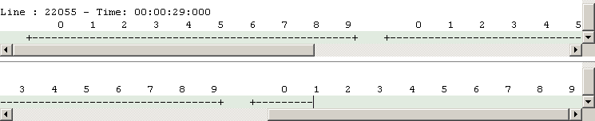
SUGGESTED BEHAVIOUR: The results should end after 00:00:30:000, such as in the .drw files generated using the Drawlog command in the CD++ Builder plugin.

